Tiffany Skogan

DGL123 – DLU1

Semester Project Milestone 1

**Bookish App:**

**Project definition (your "big idea")**

I want to create an app that brings the best parts of a daily journal and a book tracker together.

This app is a blend between a personal journal and a book tracker. It will be a one stop to keep track of some daily habits as well as the books you are reading, your feelings on them and favorite parts about those books, ex. tracker, ratings, current reads, if it’s part of a series, etc.

The minimum amount that needs doing is to have a journal page and an add book page.

The journal page will have:

* notes section – Enter whatever notes you have about that day
* habit tracker table – rows: add daily habits, columns: days of the week, check boxes for intersect
* emojis to describe the emotion of the day
* to do checklist

Add book:

* Add book cover image section
* Title, author, genre content blocks
* Part of a series content block – Y/N – N selected nothing opens, Y selected opens content line for series name and book number for series ie. 3/5
* Section for buttons – Finished, Currently Reading, TBR, DNF
* Star rating and spice rating sections – use of stars to fill in and fire or pepper for spice rating

**Similar work: (App links)**

Goodreads:

<https://apps.apple.com/ca/app/goodreads-book-reviews/id355833469>

TBR bookshelf:

<https://apps.apple.com/ca/app/tbr-bookshelf/id1614891654>

Bookly - book tracker library:

<https://apps.apple.com/ca/app/bookly-book-tracker-library/id1085047737>

Planner & Journal - Zinnia:

<https://apps.apple.com/ca/app/planner-journal-zinnia/id1485310935>

**Lo-fi sketches of your interface:**

­

Figure - Sign up Page

Figure - Sign in Page

Figure – Choose where to go

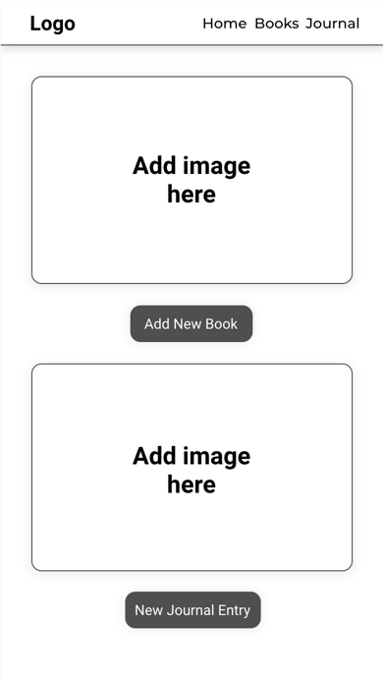

Figure - Add Book page

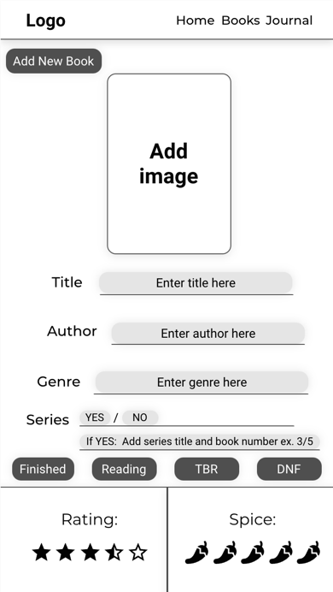

Figure - Add Journal Entry

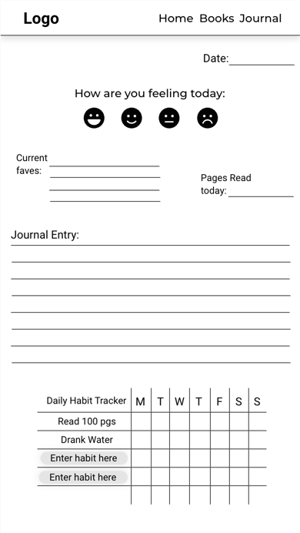

**Link to user flow:**

<https://app.uizard.io/p/bb33b457>

Opens to Sign in Page. From there you can choose to enter your information or follow the sign-up link to get an account.

The home page is a choice between a new Journal entry and the Add new book page.

On the add new book page you can enter information about a book ie. Title, author, whether you finished it, rating, etc.

On the journal page you can add notes, a habit tracker, how you’re feeling that day.

There are more pages that can be built into the app, but these are the basic pages to get a minimally functioning app for the client.

**Data model concept:**

This app will need:

* Log in: email and password fields
* Forgot password field
* Sign up
* Database storing their ‘add new book’ info
* Database storing journal entries

**Initial sketches of basic concepts for the app:**

**Rubric:**

DGL123 - Semester Project Rubric - Milestone 1

This Milestone has three parts.

1. Project Definition

2. Lo-fi Sketches

3. Storyboards

4. Data Model

For each part, score yourself as follows (16 points):

0 - no work completed on this portion of the assignment

2 - work was done, but it clearly has significant room for improvement

3 - a good effort was made, and the result was solid

4 - the work is excellent in every regard and could not be further improved

Self Evaluation Questions (4 points, one point each):

1. How much time did you spend on this assignment/project?

3 – I spent approx. 3-5hrs on this part of the project. Researching ideas, coming up with a concept, initial sketches, etc.

1. How difficult did you feel this project was? Was it too easy, too difficult, or about right for you?

(Please explain!)

3 – I really enjoyed this part of the project. I would’ve liked to have more time for the design part of it as I really enjoy the design and layout portion of a project.

1. What challenges did you come across while working on this project? (Detail any sticking points.)

3 – The challenges I am having are my mental process on how I will make this function. As I have mentioned in other rubrics, I am having a really difficult time learning this language and my struggle is that I’m not going to be able to turn this idea into something functional.

1. What things would you like to learn more about after having worked on this assignment? (What don’t you know that you now want to know more about?)

3 – I personally want to know more about all of it. I should be more clear. I would like my brain to understand it more clearly and start grasping the concepts. I have a feeling it’s going to be a matter of time and practice.

Total Score (out of 20): 12