Figure Guide: CMS Flicker Experiment

1. Diagnostic Figures (→ Appendix)
These figures verify that the statistical assumptions required for ANOVA are met. They are not primary results figures and are typically placed in the Appendix.
fig_qq_ttc.png — QQ Plot: Normality Check for TTC
Data points from each frequency condition are plotted against a theoretical normal distribution (red reference line). The closer the points follow the line, the more normally distributed the data. This verifies that the normality assumption required for ANOVA is reasonably met. Results show general conformity with a few outlying points that do not compromise the analysis.
→ Placement: Appendix
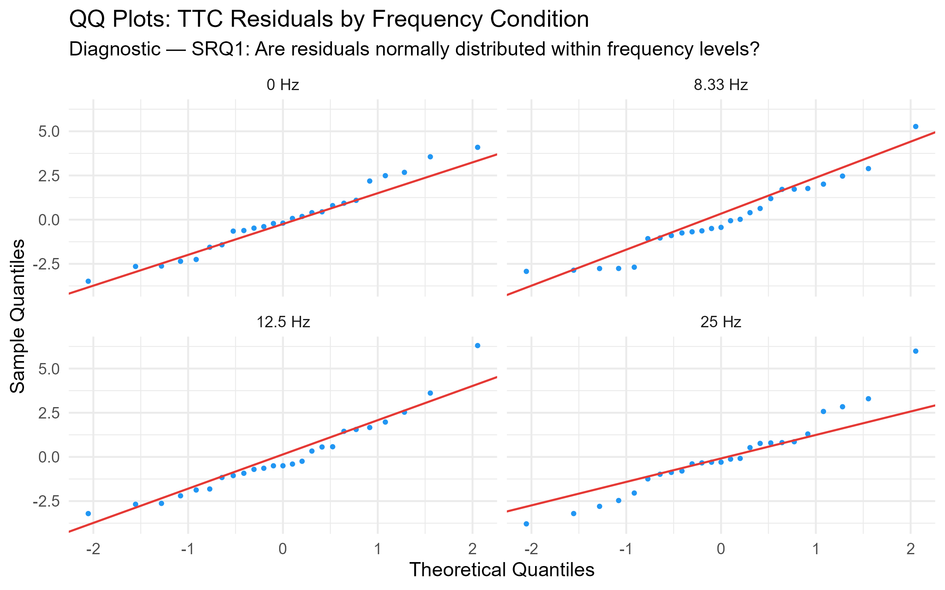

fig_outlier_ttc.png — TTC Extreme Outliers Labelled
A boxplot with extreme outliers highlighted in red and labelled by participant ID (e.g., P15, P16). This demonstrates that outliers were identified and examined rather than silently removed, supporting analytical transparency and justifying the sensitivity analyses that exclude them.
→ Placement: Appendix
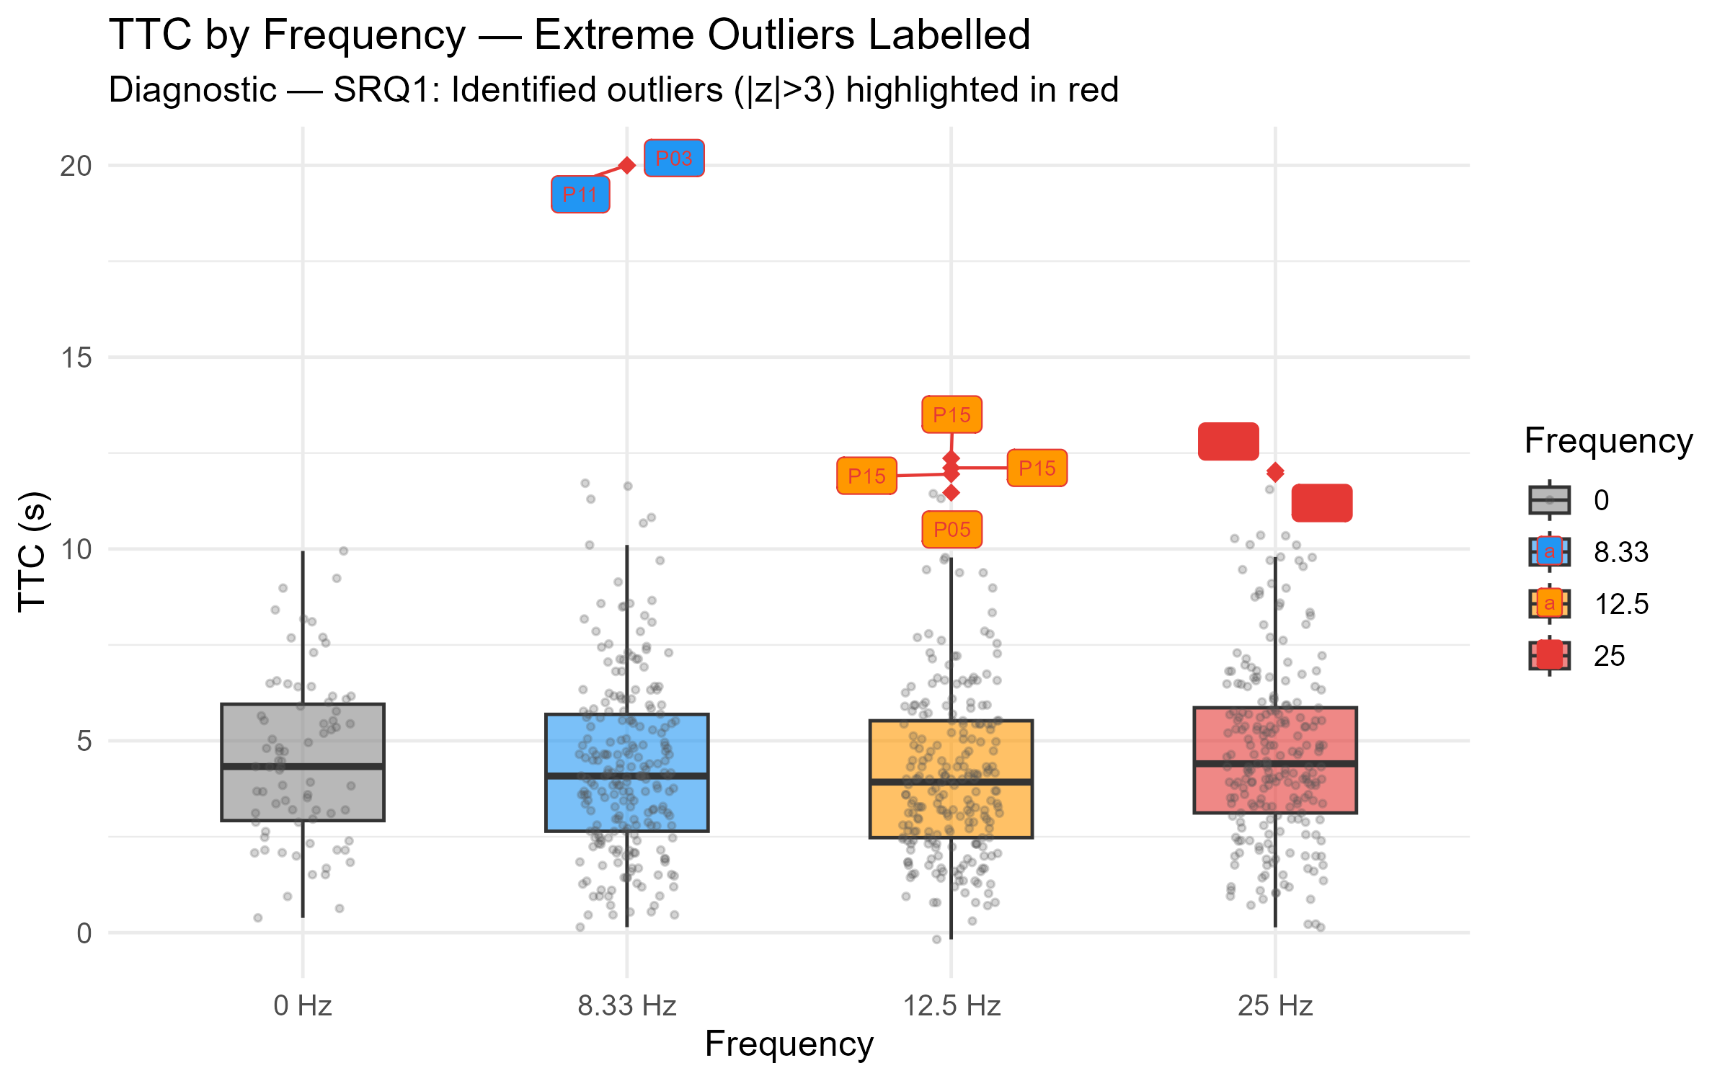

fig_resid_ttc.png — TTC Residual Diagnostics
The left panel checks whether residuals are randomly scattered around zero (no systematic pattern); the right panel shows the residual distribution shape. Together they confirm the RM-ANOVA model is well-specified. Residuals are approximately random and normally distributed.
→ Placement: Appendix
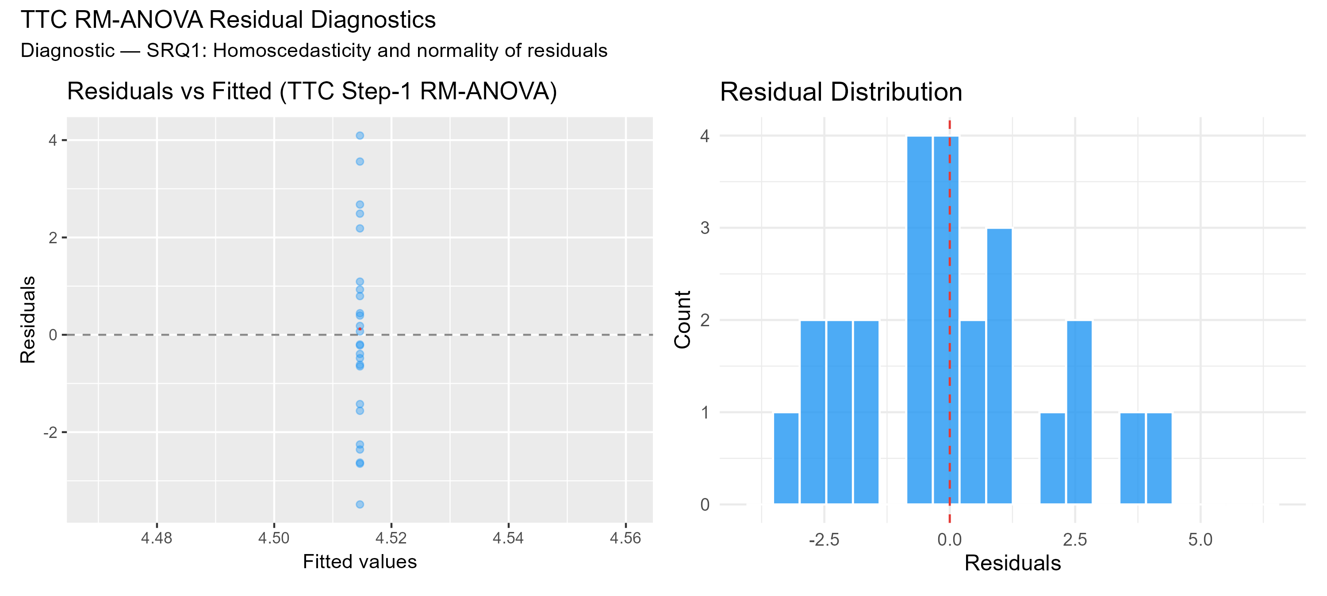

2. Behavioural Results: TTC (→ Main text, Section 3.1)
These figures present the core behavioural outcome — time-to-collision.
fig_ttc_box.png — TTC Distribution Across 10 Conditions
A boxplot with individual participant data points overlaid, showing TTC distributions across all 10 experimental conditions. At a glance it reveals which conditions produced more conservative (longer TTC) or more aggressive (shorter TTC) lane-change timing across the full frequency and depth design.
→ Placement: Main text — Results, Section 3.1
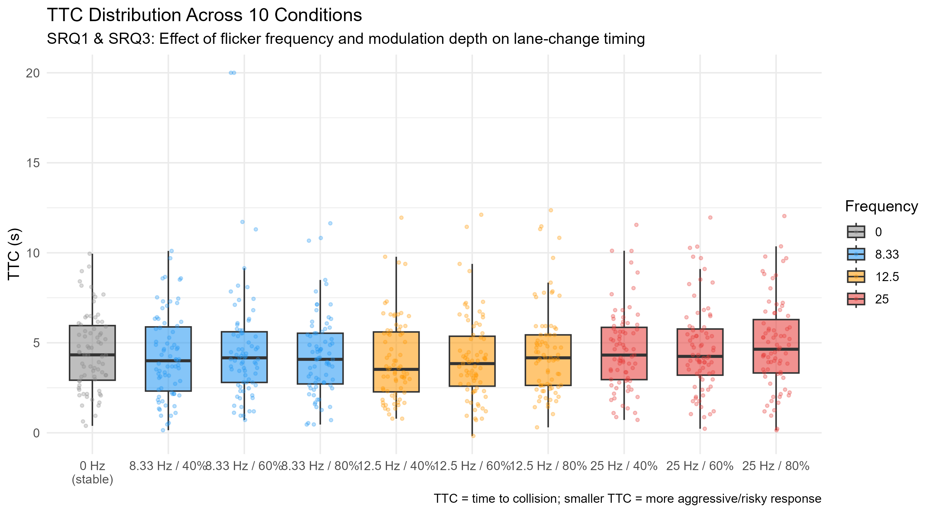

fig_ttc_interaction.png — TTC: Frequency × Modulation Depth Interaction
Restricted to the three flickering frequencies, with three lines representing 40%, 60%, and 80% modulation depth. The near-parallel lines confirm the absence of a significant interaction (p = .18), meaning frequency and depth influence TTC independently rather than amplifying each other.
→ Placement: Main text — Results, Section 3.1
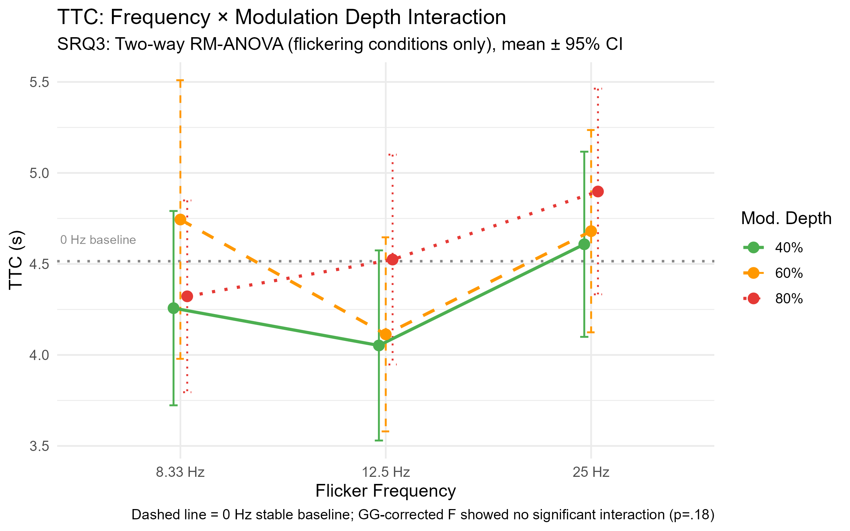

fig_ttc_spaghetti.png — Individual TTC Trajectories ("Spaghetti Plot")
Each thin blue line represents one participant's TTC across the four frequency conditions; the thick red line is the group mean. The wide spread of individual lines — compared to the nearly flat group mean — visually demonstrates that between-person variability dominates TTC variance (ICC = 0.942). This is the strongest visual argument for discussing individual differences in the thesis.
→ Placement: Main text — Results or Discussion
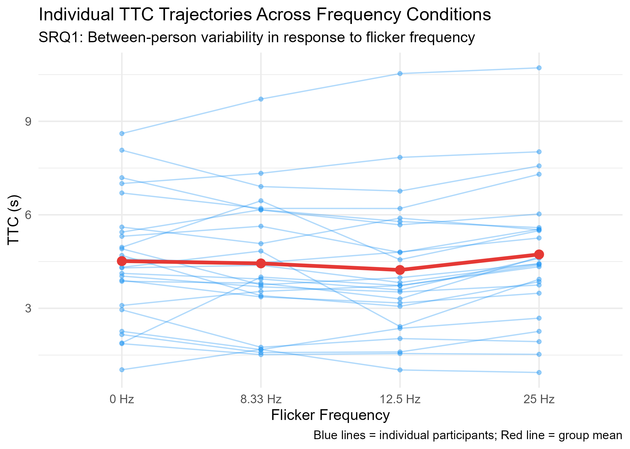

3. Subjective Rating Results (→ Main text, Section 3.2)
fig_ratings_unified_emm.png — Subjective Ratings by Frequency (Unified Negative Direction)
Four panels show estimated marginal means for Visual Discomfort, Mental Demand, Effort, and Decision Uncertainty, all scaled so that higher = worse. The grey bar (0 Hz stable) is clearly lower than all flickering conditions across every dimension, providing the core visual evidence that flicker increases subjective burden — directly supporting the subjective component of H1.
→ Placement: Main text — Results, Section 3.2
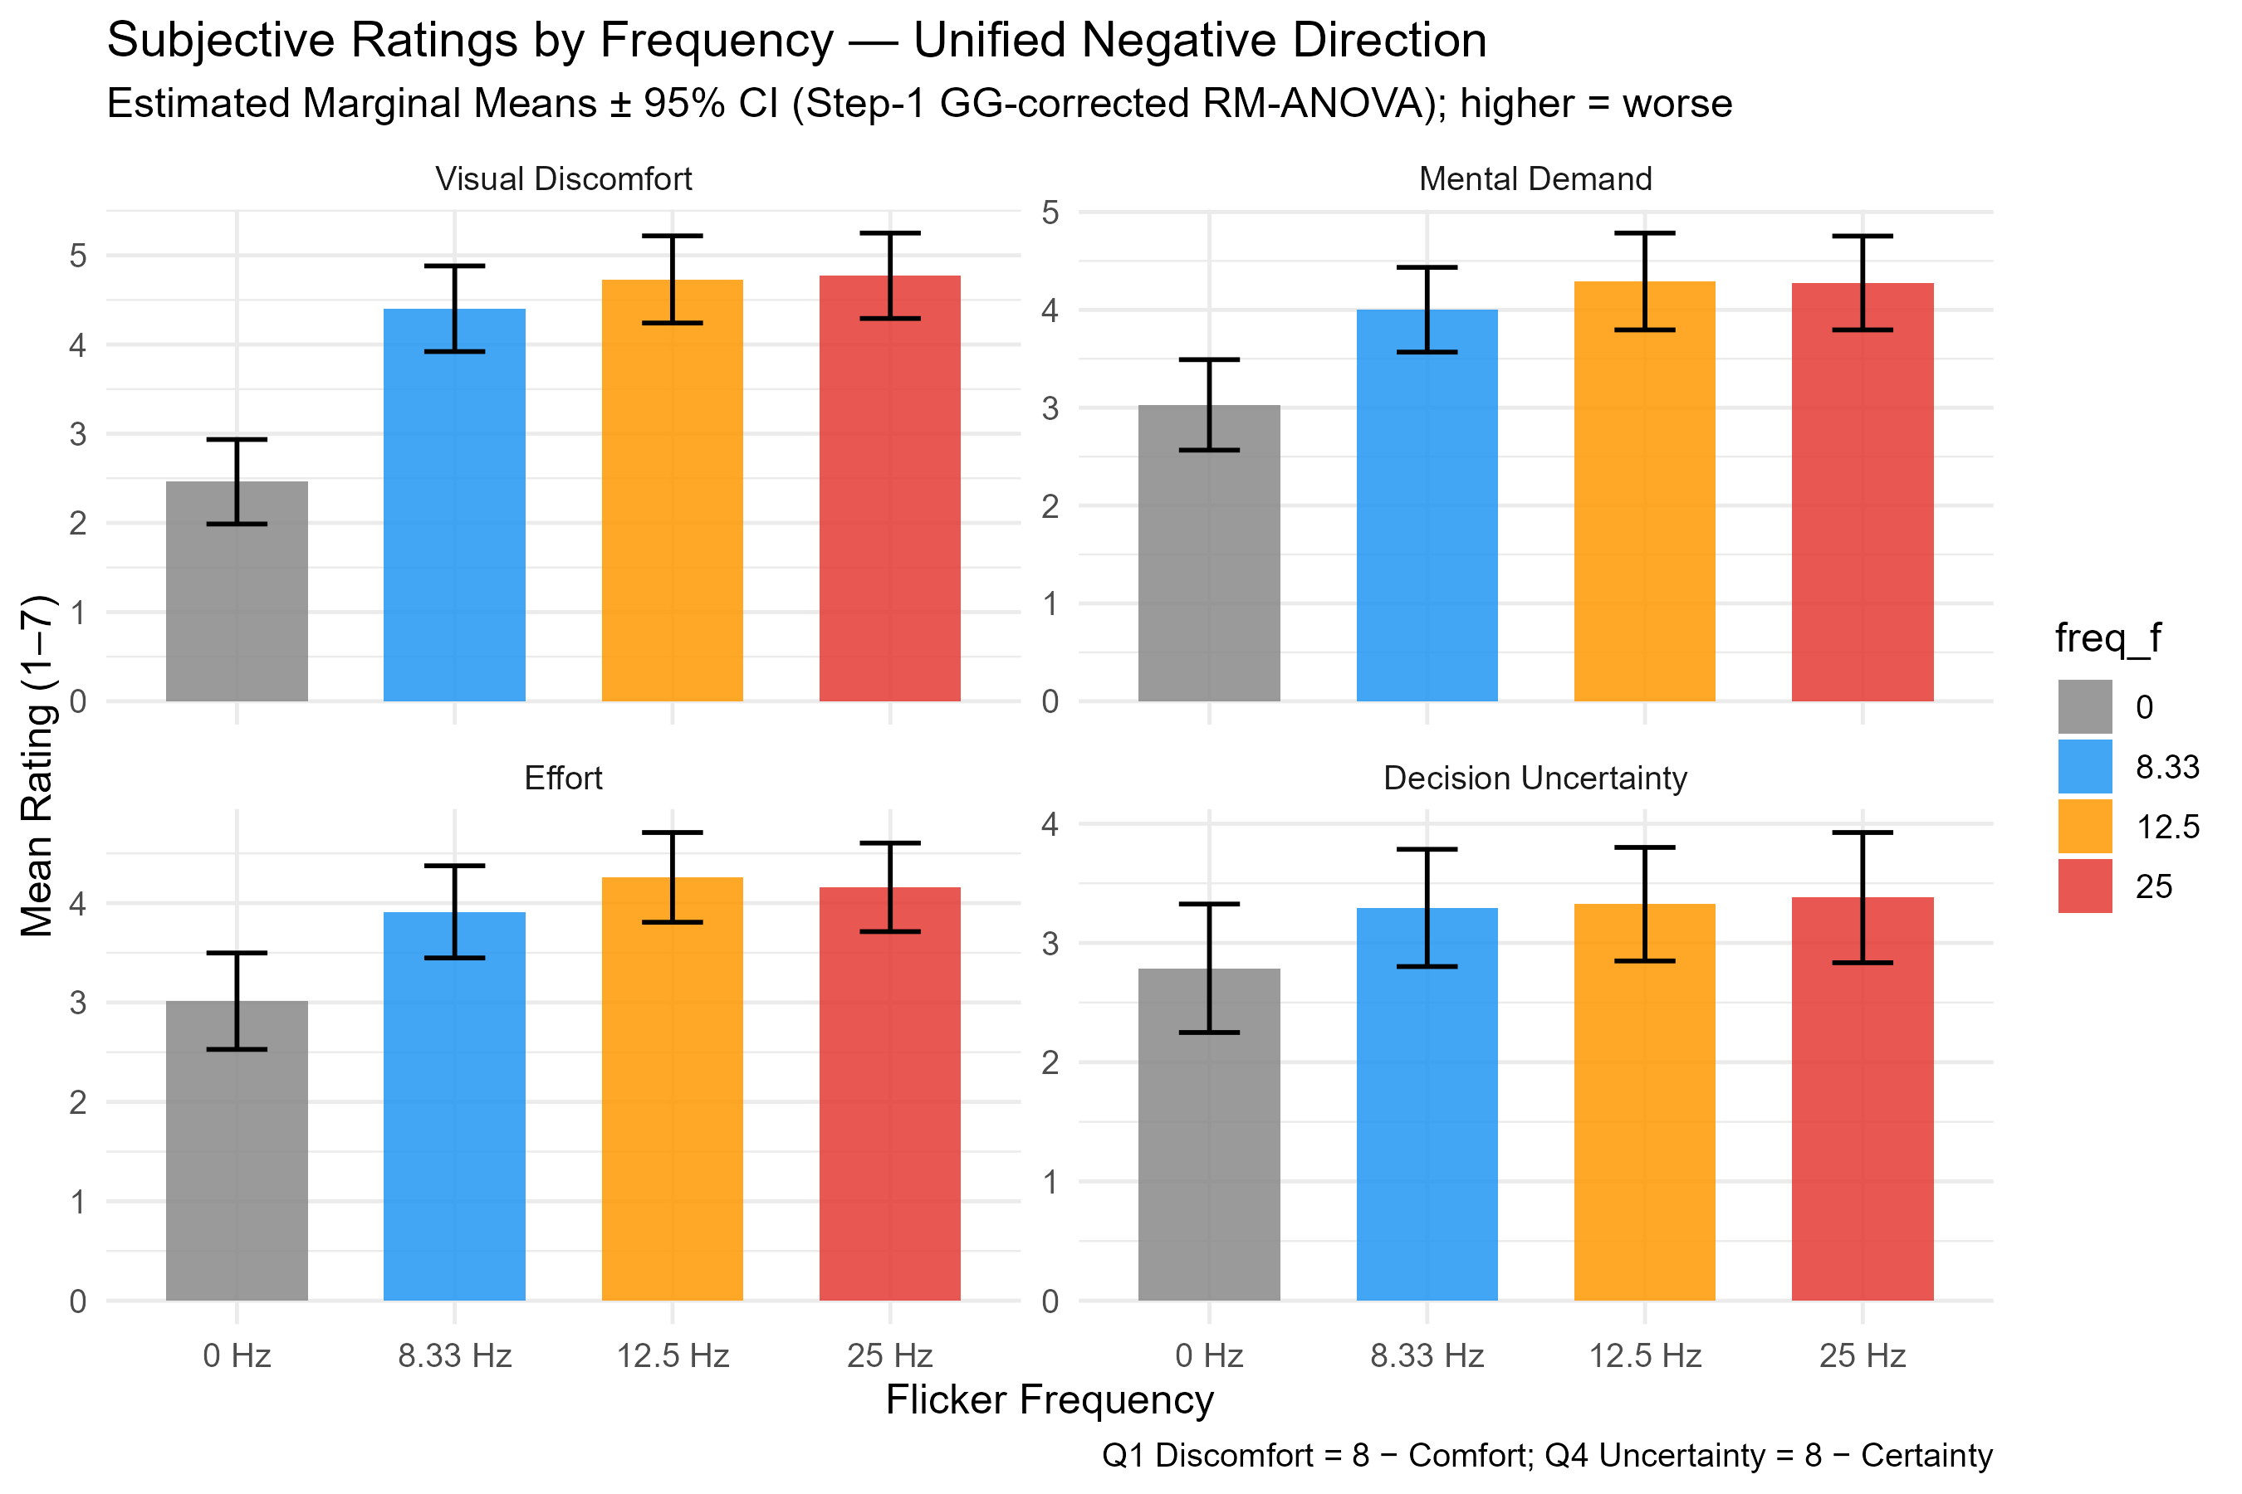

fig_ratings_unified_depth.png — Modulation Depth Effect on Subjective Ratings
A line graph showing all four rating dimensions as a function of modulation depth (40% to 60% to 80%), averaged across frequencies. All lines rise consistently with depth, with Visual Discomfort (red) showing the steepest gradient. This figure makes the case that modulation depth — not frequency — is the primary driver of subjective disruption.
→ Placement: Main text — Results, Section 3.2
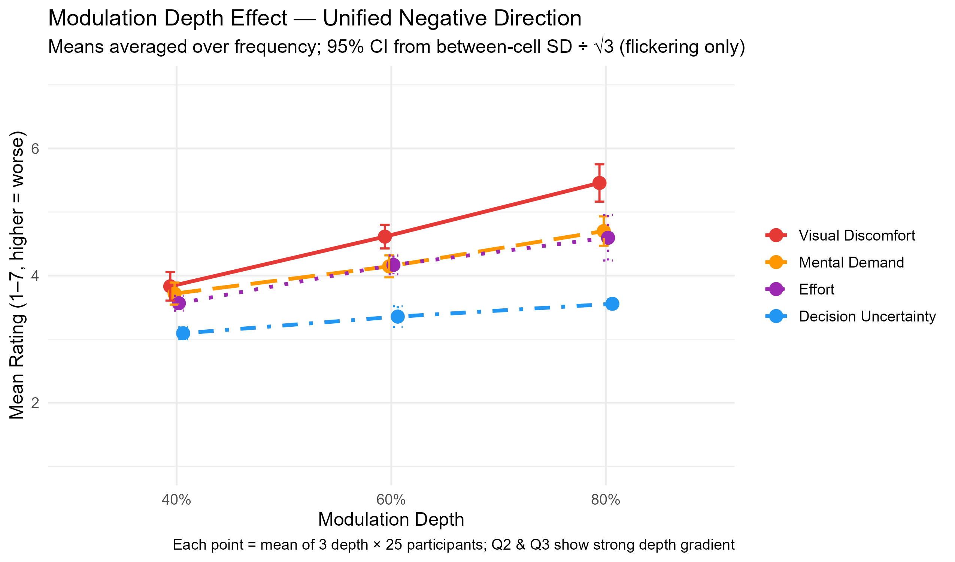

fig_ratings_unified_heatmap.png — Subjective Ratings Heatmap: 10 Conditions x 4 Dimensions
Rows are the four rating dimensions; columns are the 10 experimental conditions; colour intensity indicates severity (darker red = worse experience). The darkest cells appear at 12.5 Hz/80% and 25 Hz/80%, particularly for Visual Discomfort — immediately showing which condition combinations are most aversive.
→ Placement: Main text — Results, Section 3.2
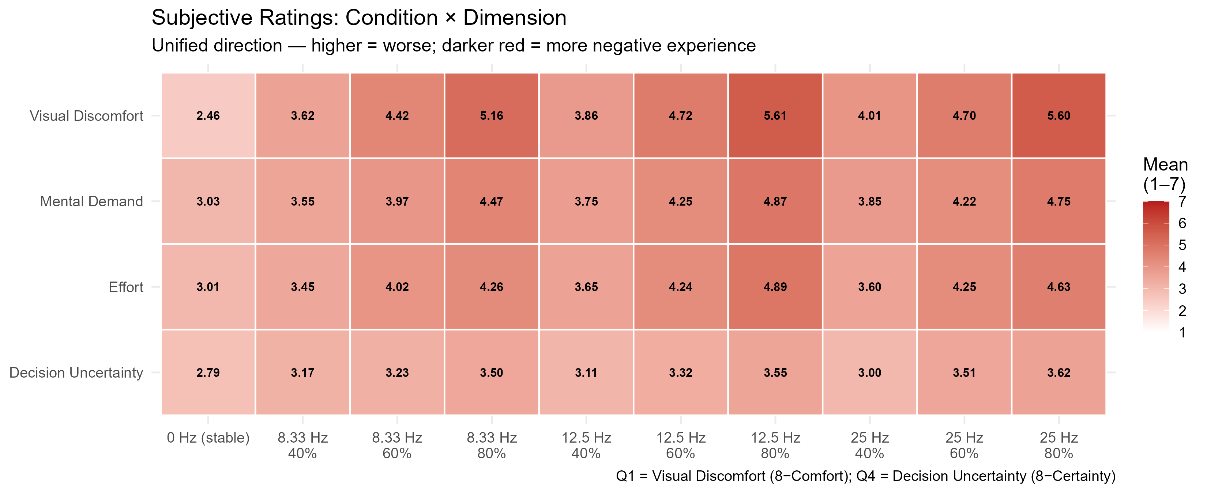

fig_ratings_likert.png — Likert Response Distribution by Frequency
Stacked bar charts showing the proportion of responses at each scale point for Q1-Q4, broken down by frequency. Rather than showing only means, this reveals the full shape of the response distribution — Q1 Visual Comfort shifts visibly from blue-dominant (comfortable) at 0 Hz to red-dominant (uncomfortable) under flickering, confirming the effect is a genuine distributional shift rather than a few extreme responses pulling the mean.
→ Placement: Main text or Appendix
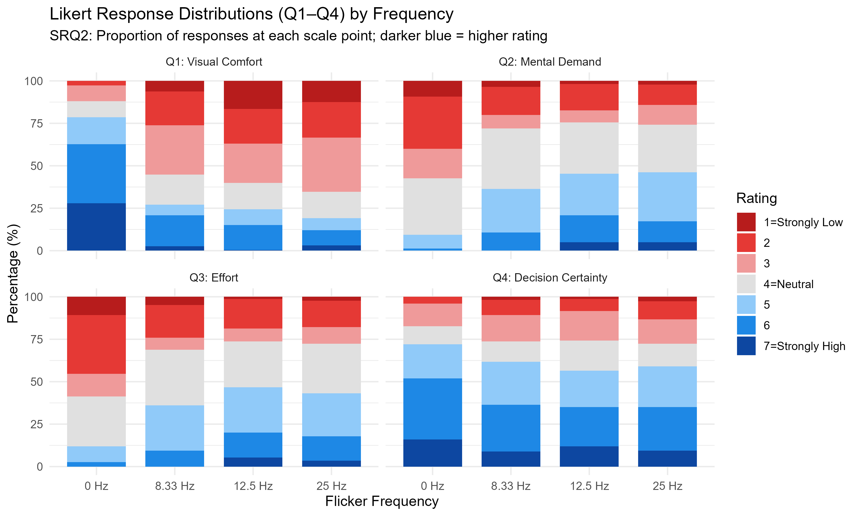

fig_ratings_heatmap.png — Subjective Ratings Heatmap (Original Scale Direction)
Identical structure to the unified heatmap above but with Q1 and Q4 in their original coding direction (higher = more comfortable / more certain). Used as an internal data check to confirm that direction-reversal did not alter the pattern of results.
→ Placement: Appendix
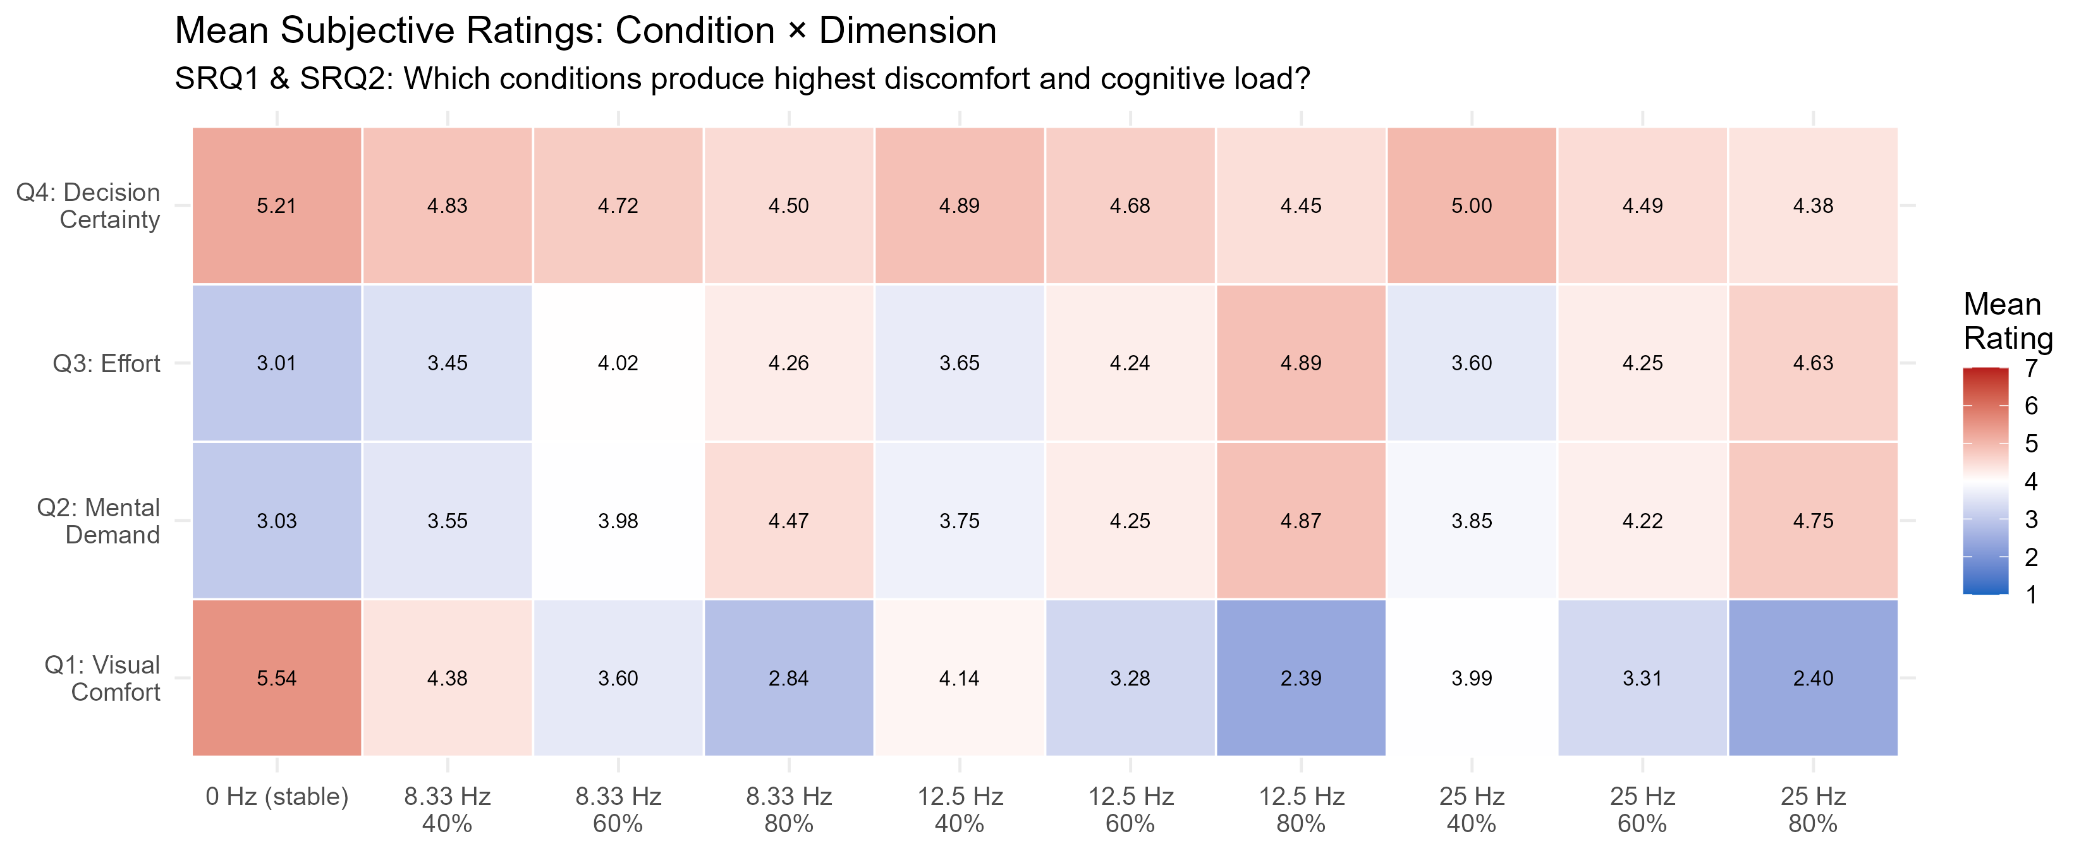

fig_ratings_bar.png — WARNING: Rendering Issue (Do Not Include)
This figure was intended to show estimated marginal means by frequency for all four rating dimensions, but frequency labels are displayed as "NA Hz" due to a data-passing error during generation. The content is fully superseded by fig_ratings_unified_emm.png.
→ Placement: Do not include
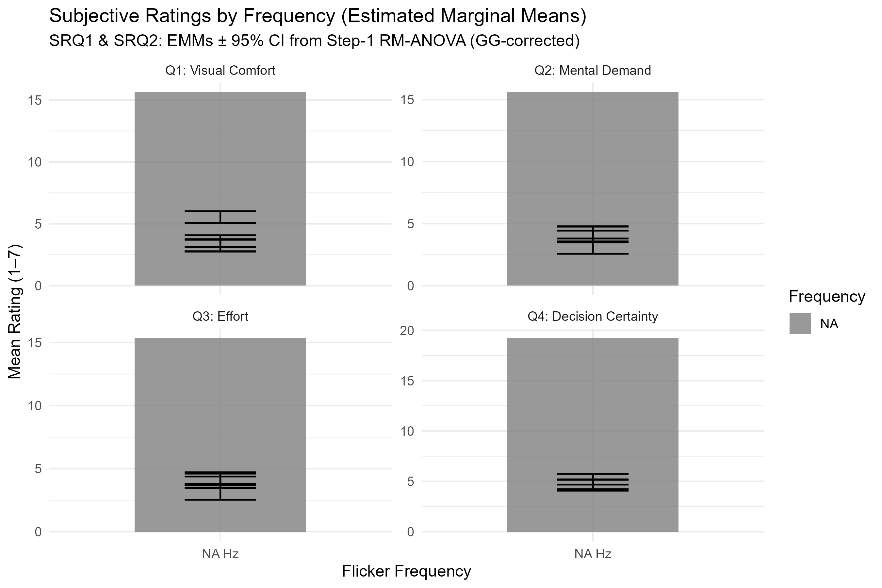

4. Eye-Tracking Results (→ Main text, Section 3.3)
fig_eye_dwell.png — Dwell Time Allocation: CMS vs Road vs Other
Bar chart showing how much gaze time participants allocated to the CMS region across all 10 conditions. The bars are nearly identical in height regardless of flicker frequency or depth. This is direct visual evidence that gaze allocation does not change with flicker — the core finding of the subjective-behavioural dissociation.
→ Placement: Main text — Results, Section 3.3
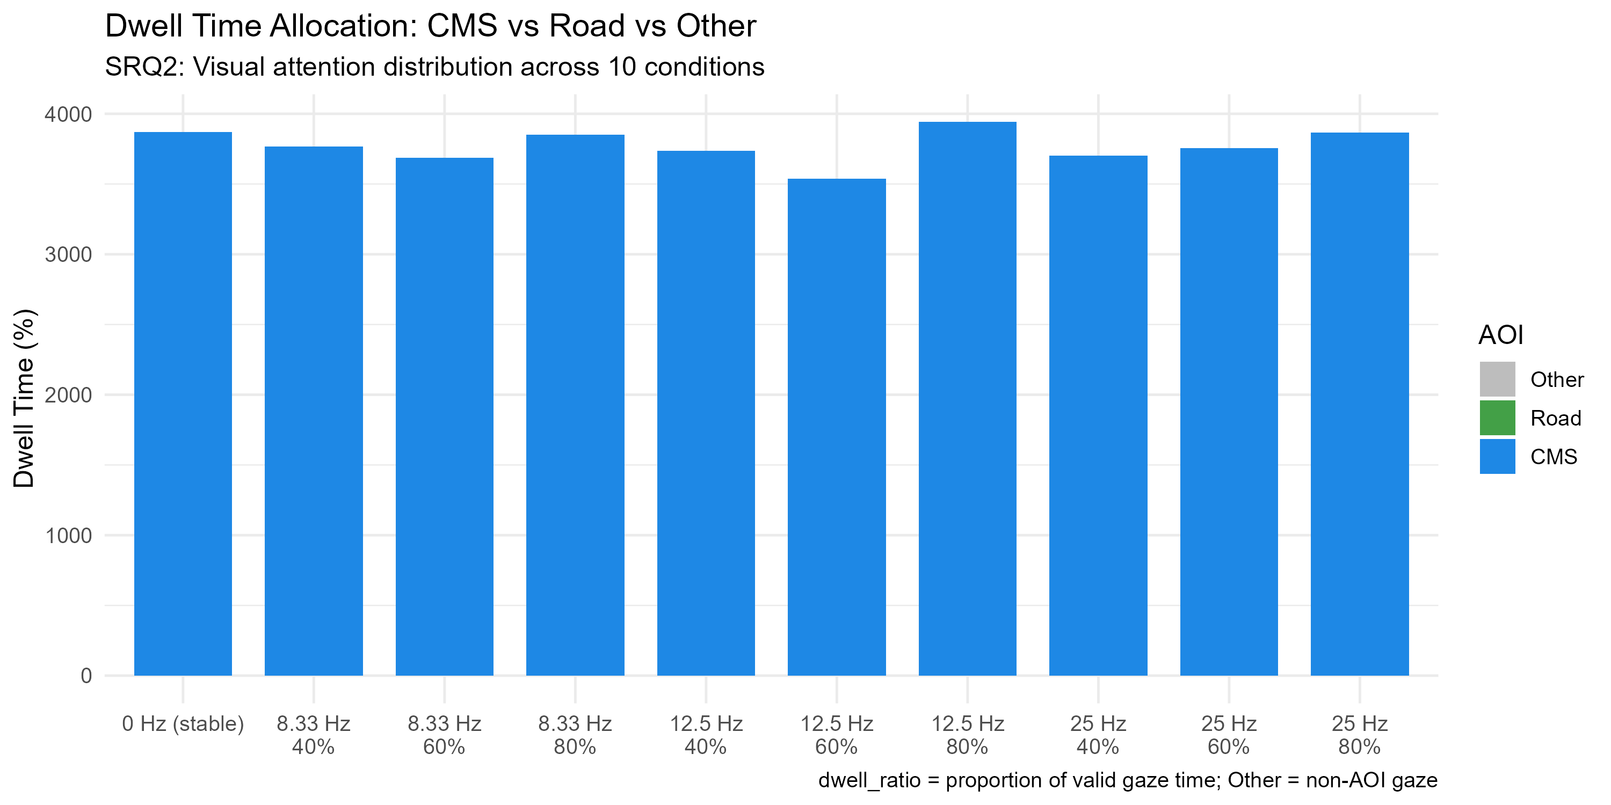

fig_eye_firstfix.png — First Fixation to CMS: Two-Stage Analysis
Stage 1 (left): the proportion of trials on which participants fixated the CMS at all (~99-100% across conditions). Stage 2 (right): the latency to first CMS fixation. Both measures are stable across conditions, indicating that flicker did not cause participants to avoid or delay looking at the CMS. Note: Stage 2 has a label rendering issue ("NA Hz") and should not be included without correction.
→ Placement: Stage 1 — Main text; Stage 2 — after fix, or omit
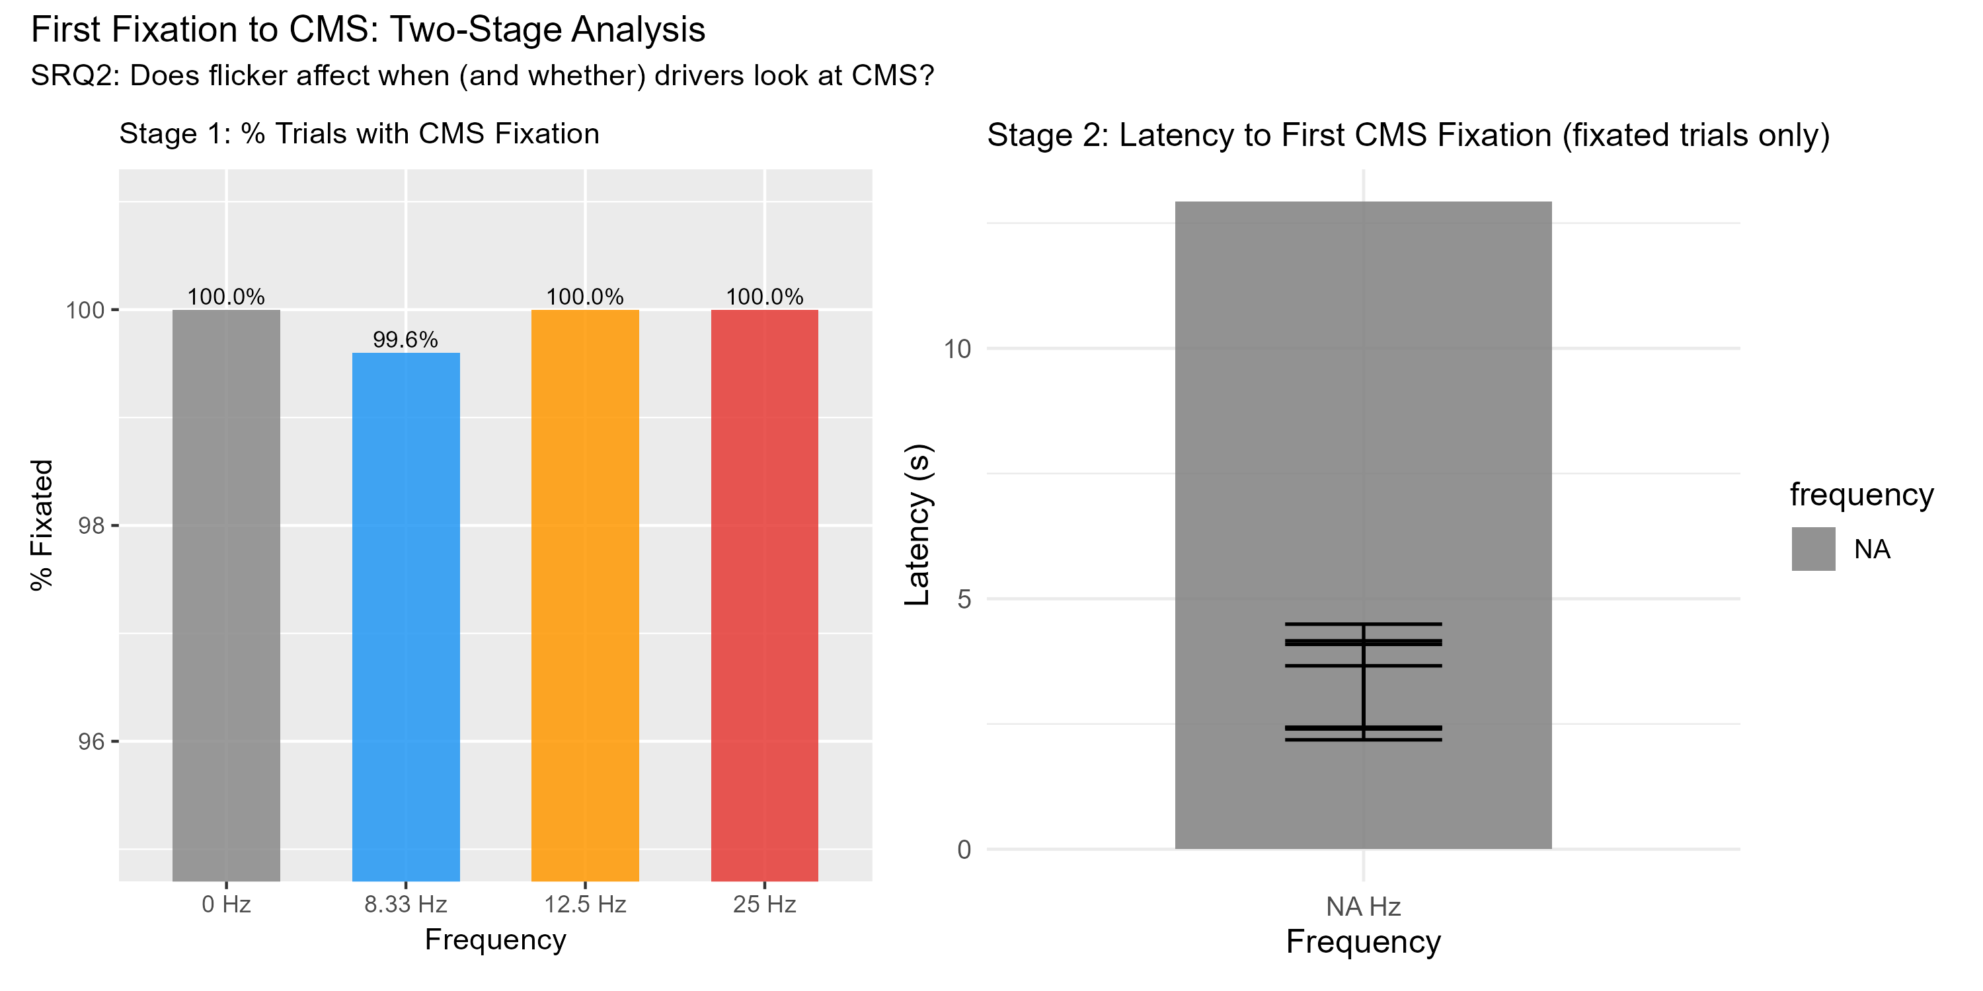

fig_eye_interaction.png — Mean Fixation Duration and Transition Count by Frequency
Two panels showing estimated marginal means for CMS fixation duration (ms) and CMS-to-Road transition count across frequency conditions. Wide, overlapping confidence intervals confirm no significant frequency effect on either metric (all p > .15). The null result here, contrasted against the large subjective effects, is itself a key finding. Note: frequency axis labels show "NA Hz" due to a rendering issue.
→ Placement: Main text after fix, or describe in text without figure
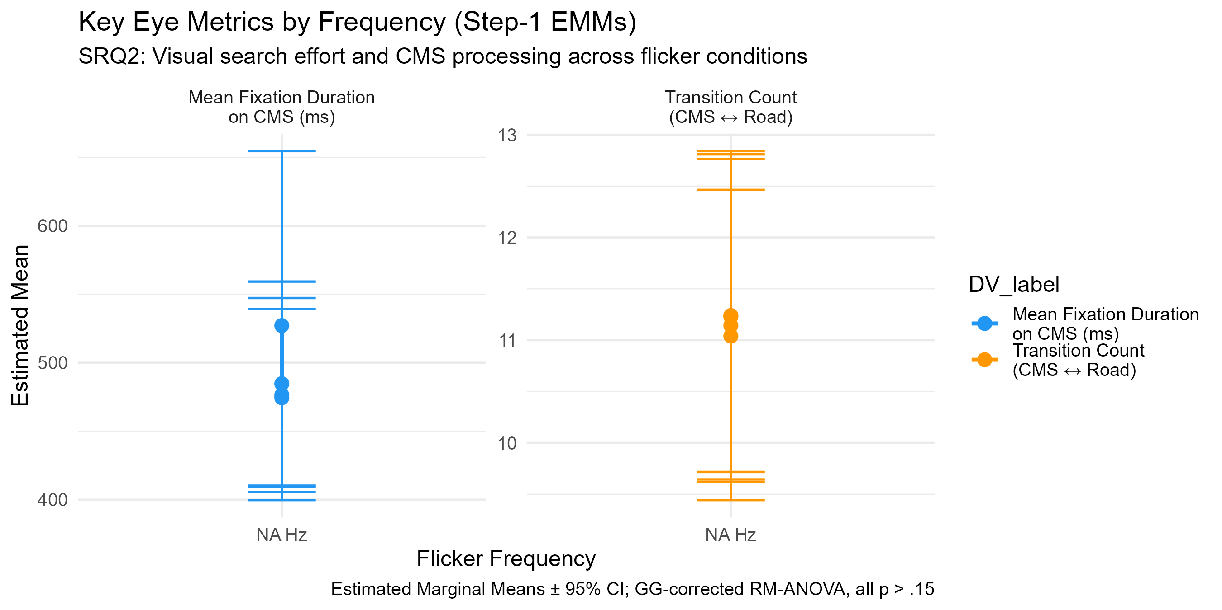

5. Simulator Sickness (SSQ) (→ Main text, Section 3.4)
fig_ssq_prepost.png — SSQ Pre- vs Post-Test Comparison
Three panels show Nausea, Oculomotor, and Total Severity scores before and after the experimental session. Each grey line is one participant; the red line is the group mean. The upward shift — especially in Oculomotor symptoms — confirms that the simulated driving session induced genuine physiological discomfort, and the correlation with Q1 comfort ratings serves as convergent validity evidence for the subjective measures.
→ Placement: Main text — Results, Section 3.4
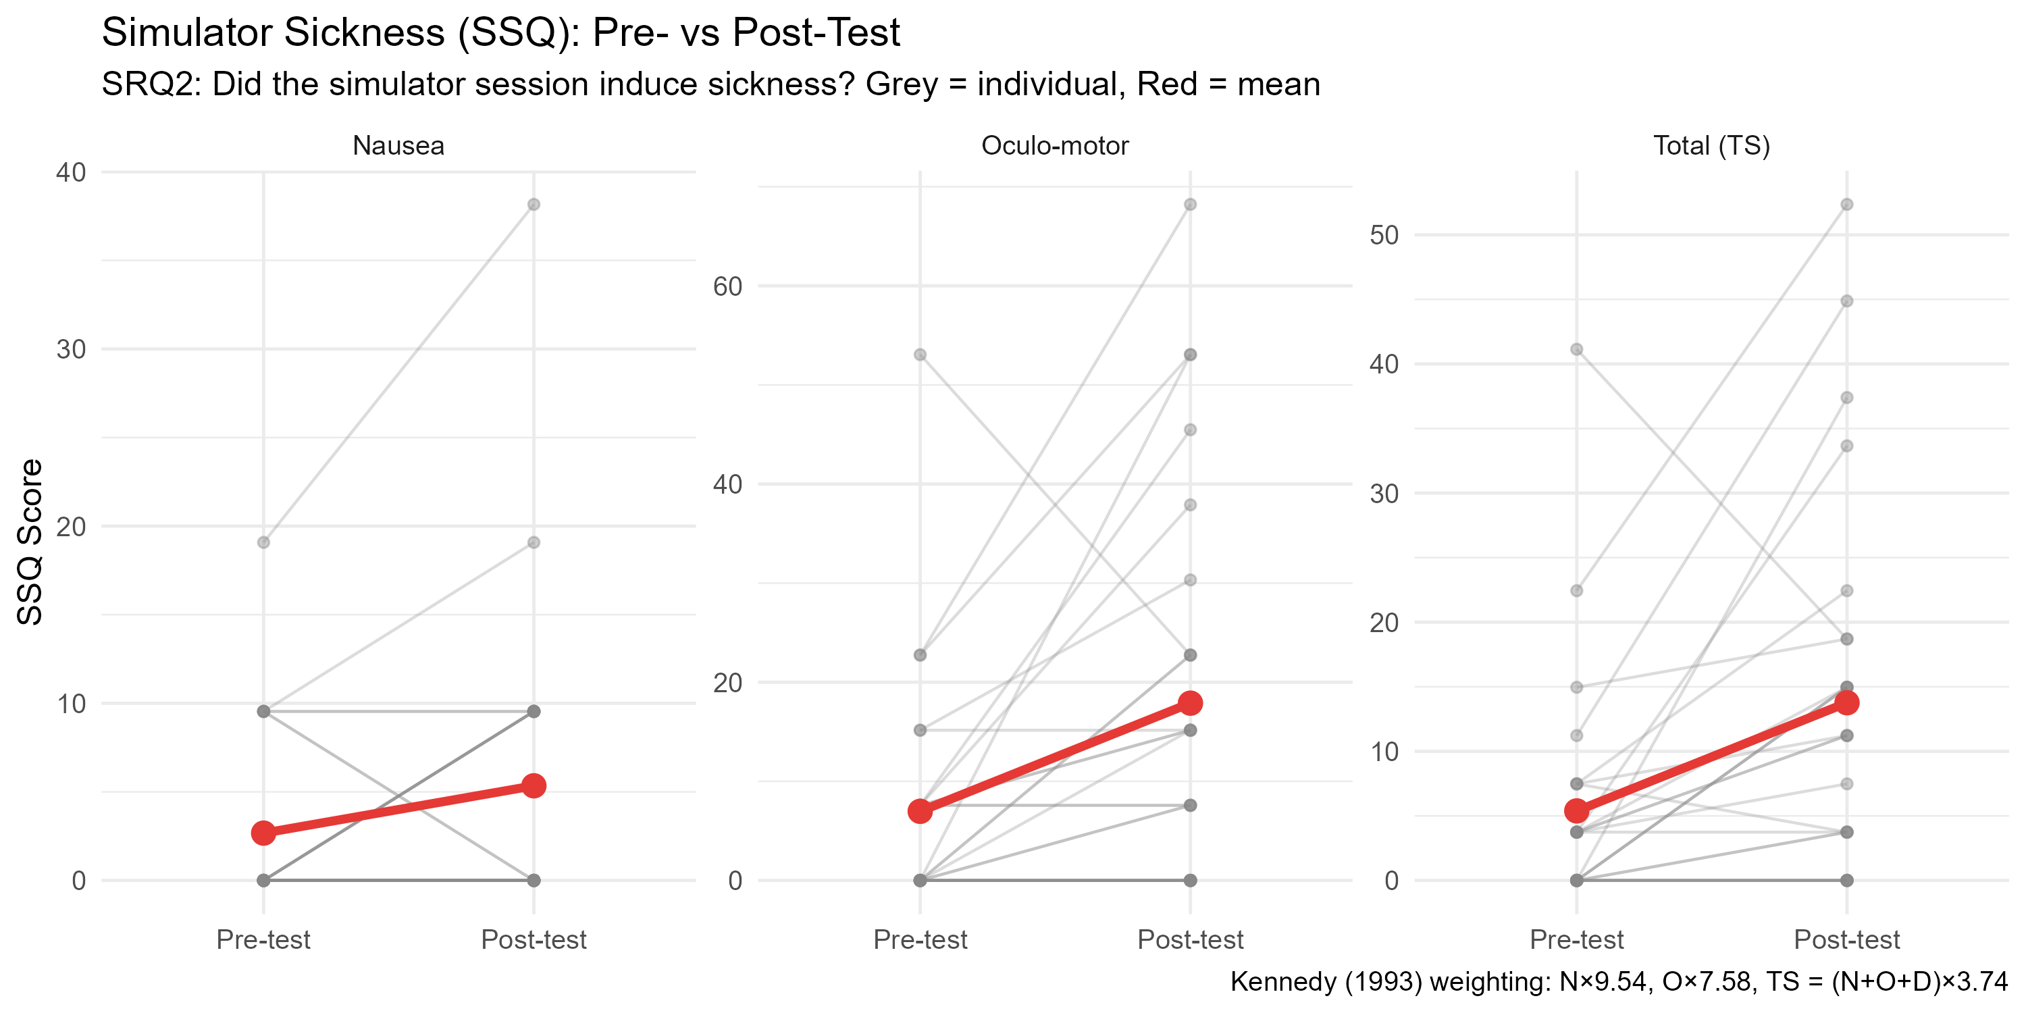

6. Effect Size Overview (→ Main text, Results opening or Discussion)
fig_effectsize_forest.png — Forest Plot: Frequency Effect Sizes Across All DVs
A single figure summarising the partial eta-squared and 95% CI for the frequency main effect across every dependent variable, colour-coded by domain (red = behaviour, orange = subjective ratings, blue = eye-tracking). The contrast is stark: subjective ratings show large, significant effects; TTC shows a medium significant effect; all eye-tracking metrics cluster near zero and are non-significant. This is the most efficient single figure for conveying the overall pattern of results and motivating the dissociation discussion. Strongly recommended for the thesis.
→ Placement: Main text — Results overview or Discussion
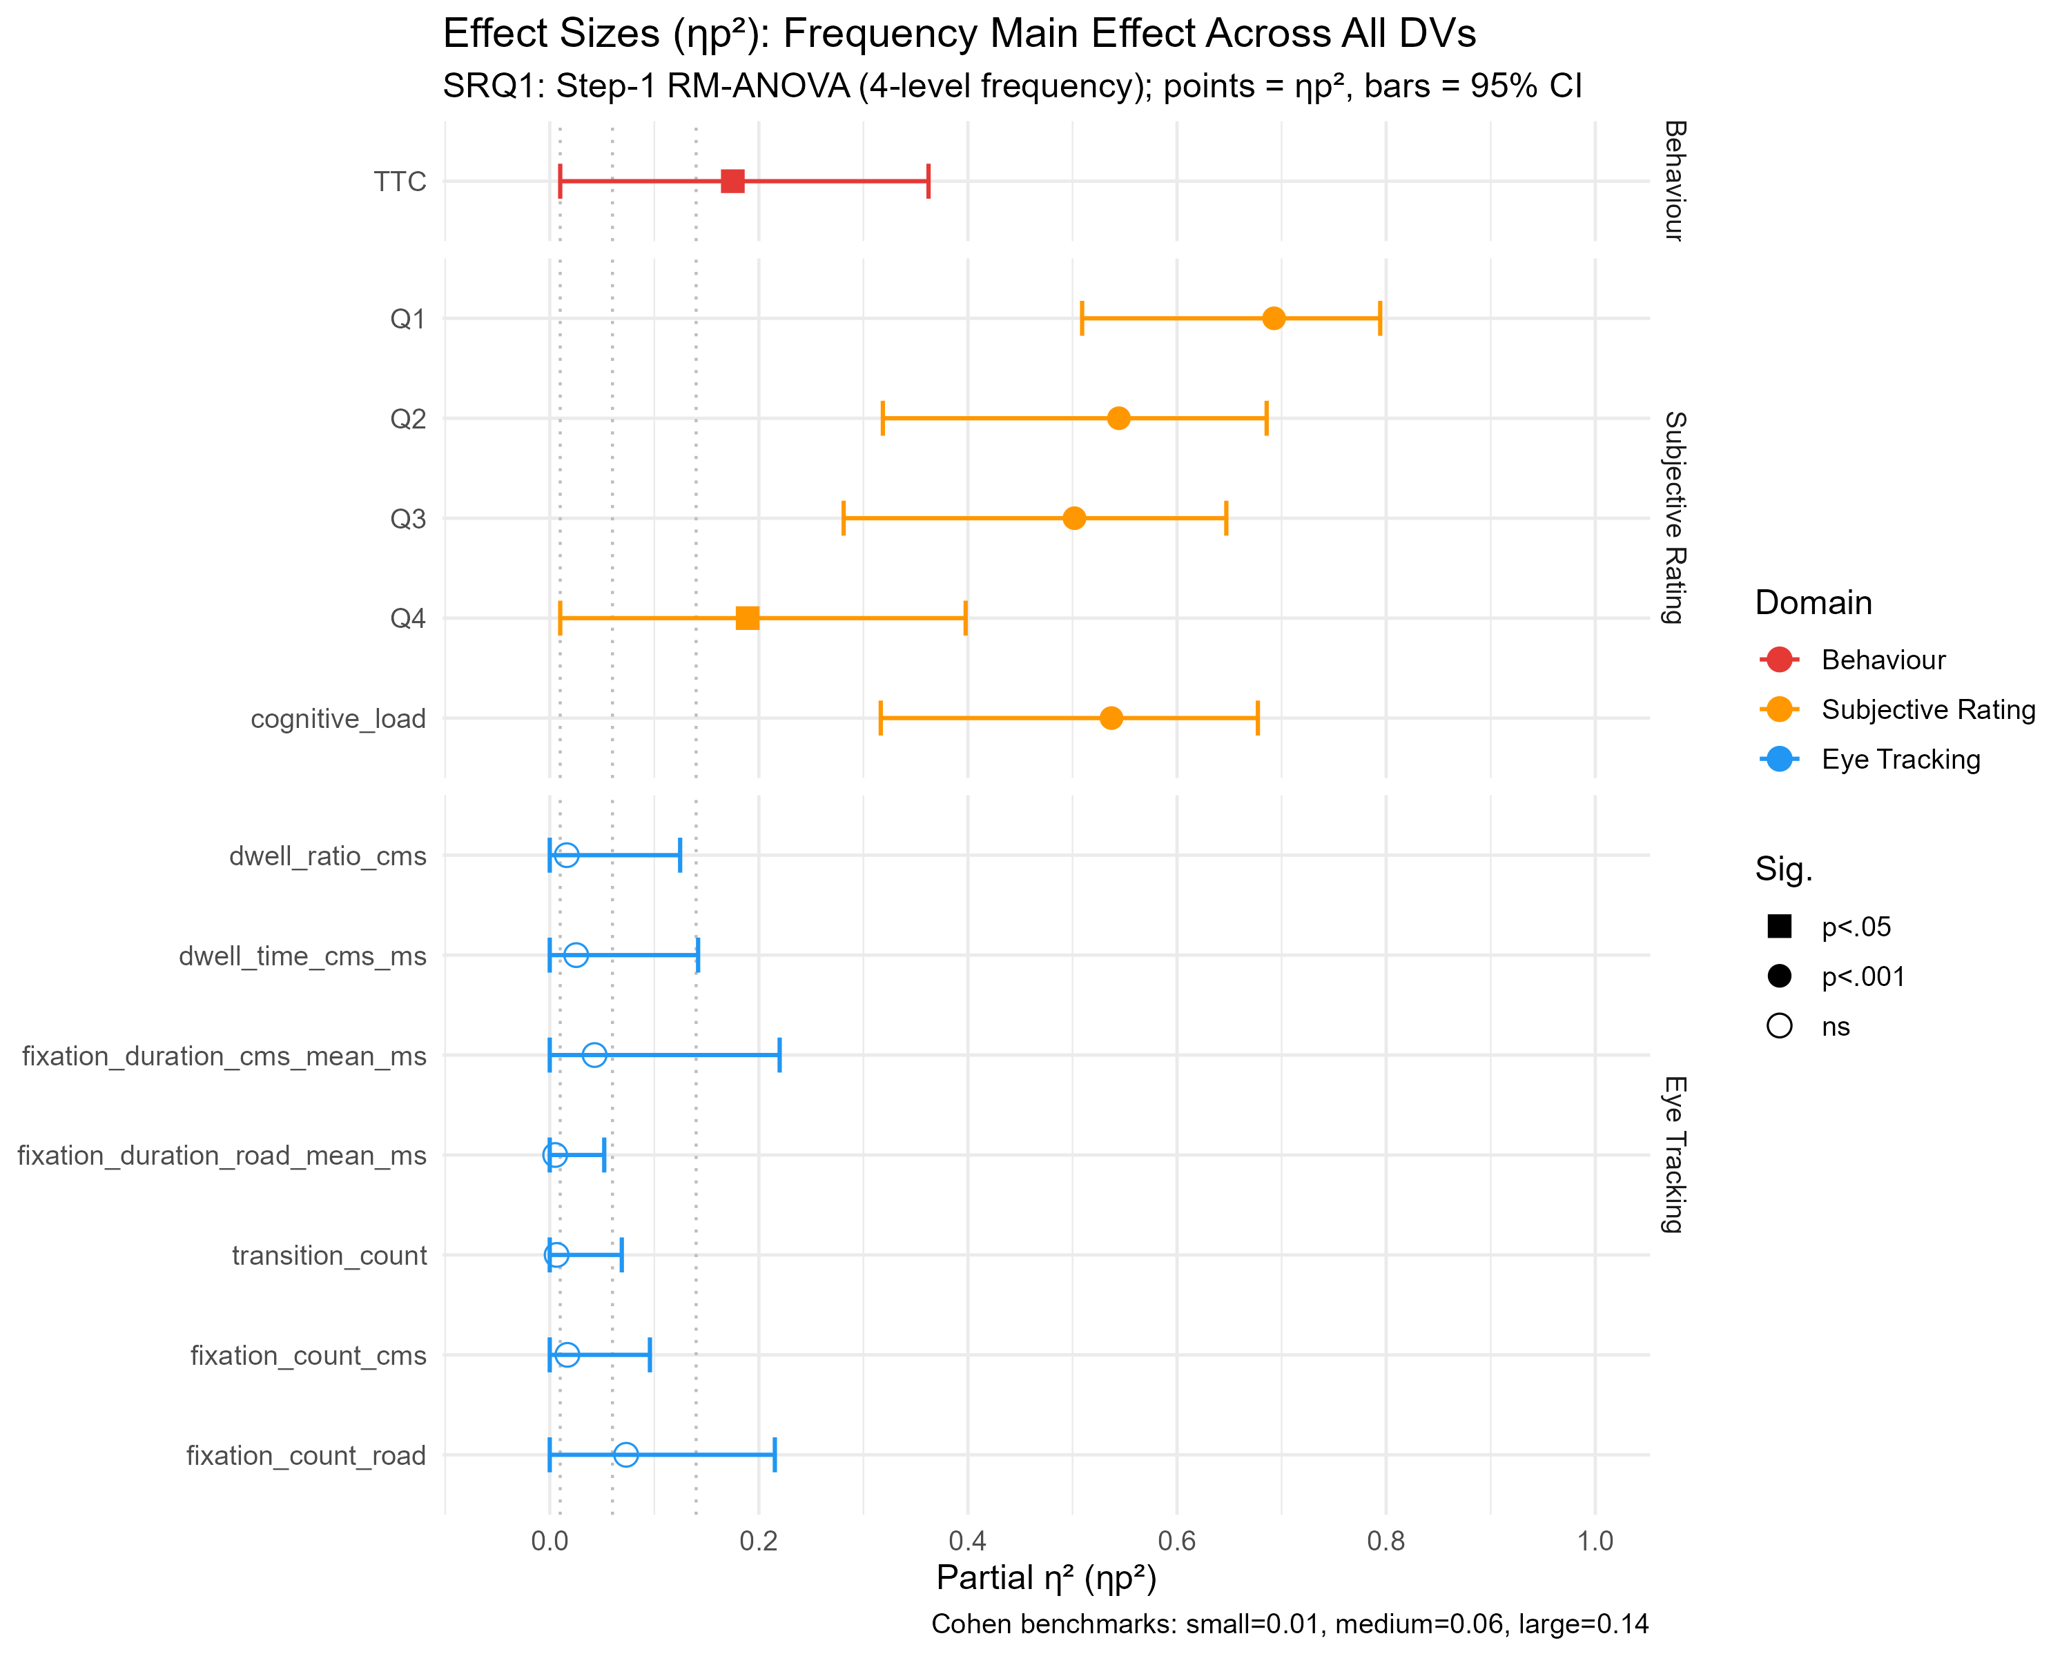

7. Post-Experiment Questionnaire (→ Main text, Section 3.5)
fig_post_survey_stacked.png — Post-Experiment Questionnaire: Response Distribution
Stacked horizontal bar charts for all nine questionnaire items, with a dashed line marking the median. Provides a complete picture of how participants experienced the task: for instance, Q8 (flicker noticeability) shows nearly all responses in the "very" or "extremely noticeable" categories, confirming the manipulation was clearly perceived.
→ Placement: Main text — Results, Section 3.5
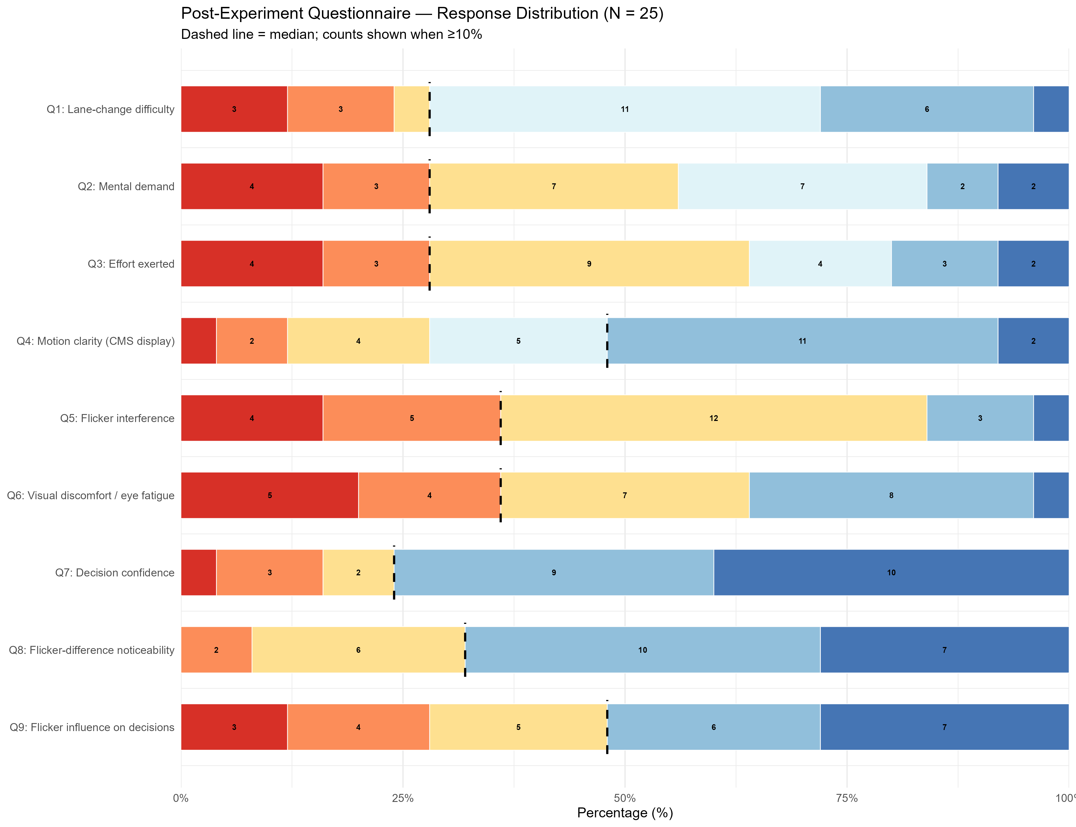

fig_post_survey_summary.png — Post-Experiment Questionnaire: Summary Point Plot
All nine items normalised to a 0-1 scale, with median (red dot), mean (blue diamond), and IQR (blue bar) displayed together. Enables direct cross-item comparison: Q7 Decision Confidence sits notably to the right (high confidence), while Q1 Difficulty and Q9 Flicker Influence also score high — visually capturing the confidence-difficulty dissociation that mirrors the behavioural and gaze findings.
→ Placement: Main text — Results, Section 3.5
