**INVESTMENT ANALYSIS AND GLOBAL PORTFOLIO MANAGEMENT**

**HOMEWORK 1**

THE GEORGE WASHINGTON UNIVERSITY

FINA 6275 SECTION 11

28TH JANUARY 2021

PROFESSOR JOSTOVA

TIFFANY TIONO

SALEH ALKHALIFA

**6. Prepare a report to be submitted describing the data. Specifically:**

**a. Plot the time-series of each ETF return on a separate graph. You can plot them in the same graph in 9 different subplots: use command subplot (3,3,1) for the first one, subplot (3,3,2) for the second one, … or use a loop 3 for i=1:9, subplot(3,3,i); plot(R(:,i)); set(gca,'Xlim',[1 length(dates)]); title(names(i)'); end**

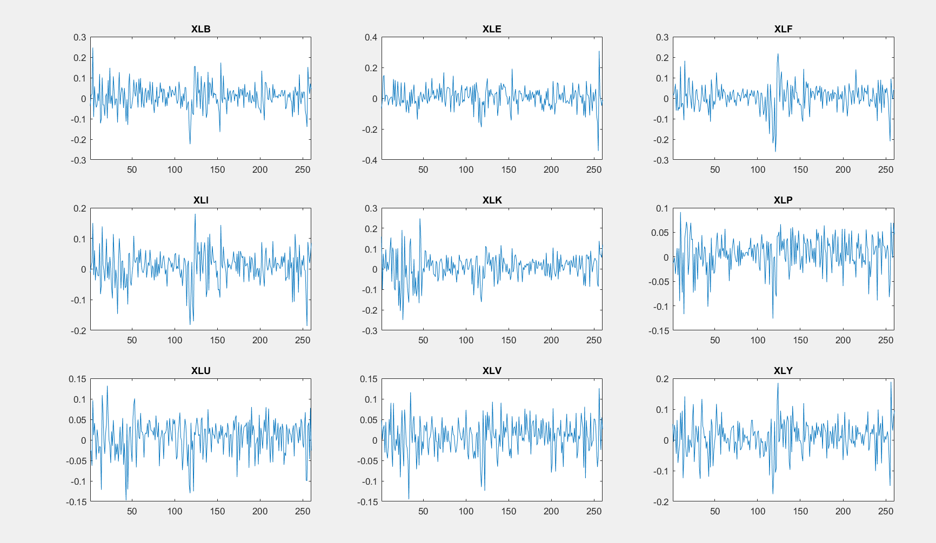

**b. Display the histogram of each ETF return on a separate subplot. Again use a loop and subplot(3,3,i); hist(R(:,i),50);…**

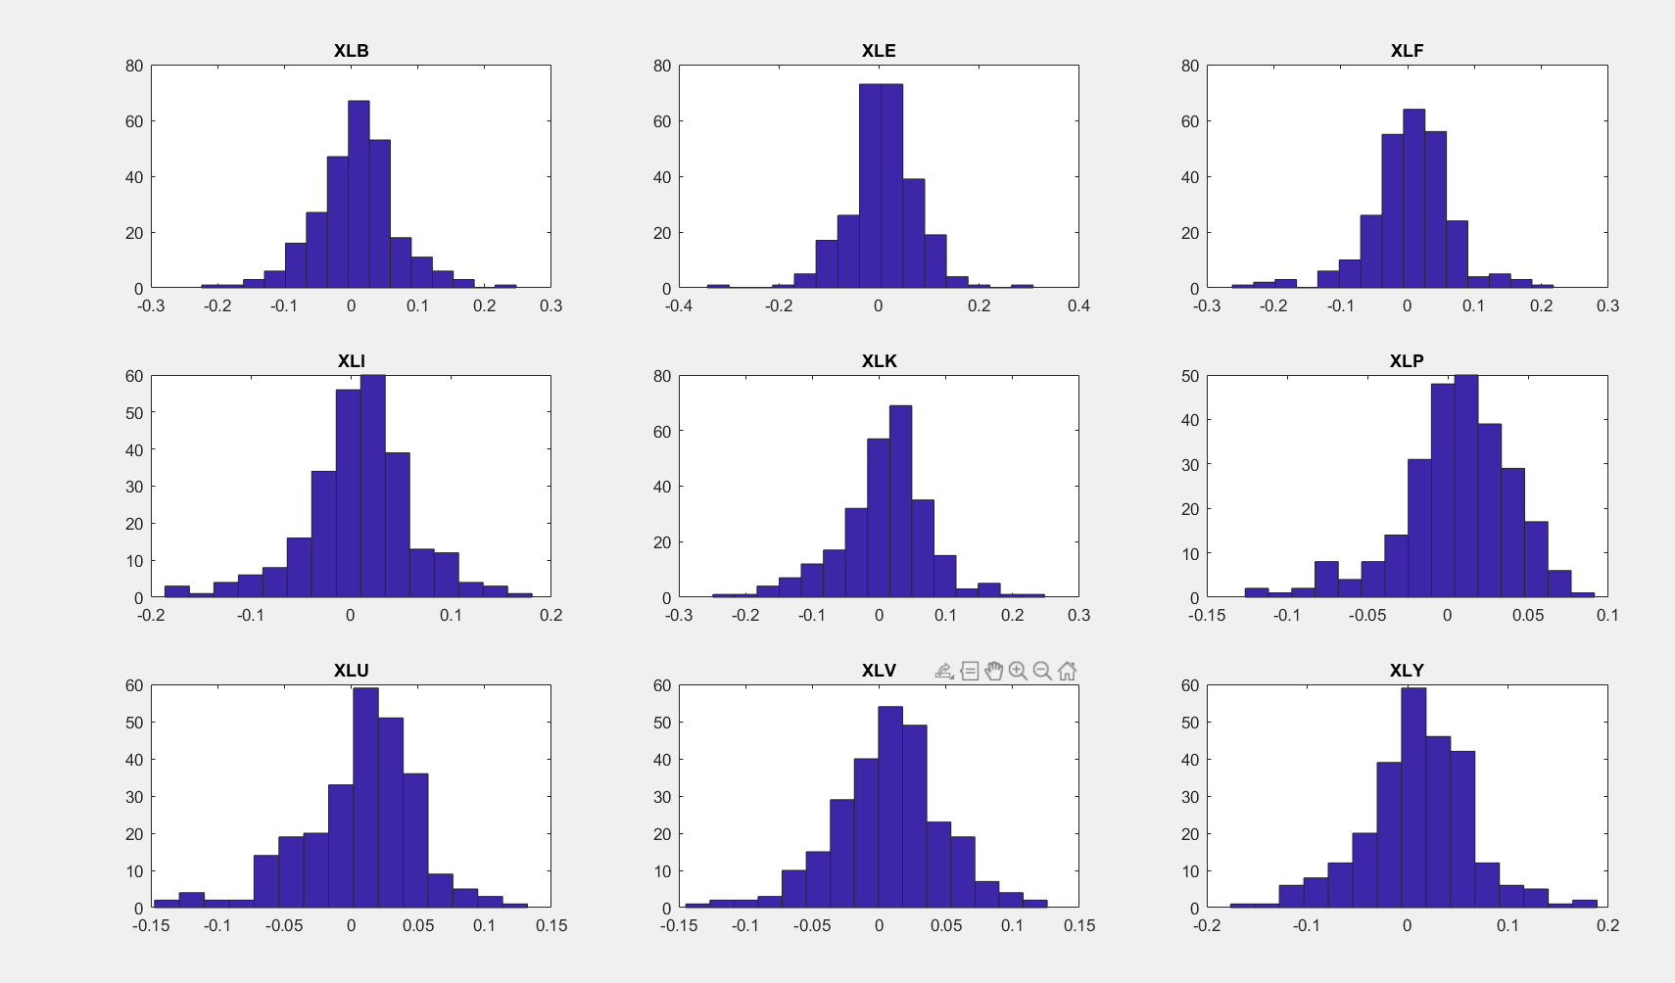

**c. Obtain the 9x1 vectors of mean return (r), standard deviation (s), skewness (skew), and kurtosis (kurt) for each ETF.**

**Note: Columns 1 through 9 consist of the data for XLB, XLE, XLF, XLI, XLK, XLP, XLU, XLV, XLY respectively.**

* **Mean return:**

Columns 1 through 8

0.0078 0.0059 0.0047 0.0075 0.0084 0.0059 0.0065 0.0075

Column 9

0.0092

* **s (Standard Deviation):**

Columns 1 through 8

0.0612 0.0686 0.0619 0.0539 0.0670 0.0351 0.0429 0.0408

Column 9

0.0536

* **Skew (Skewness) return:**

Columns 1 through 8

**0.0085**  -0.2866 -0.5449 -0.4541 -0.3677 -0.7891 -0.6968 -0.3781

Column 9

-0.1478

* **Kurtosis return:**

Columns 1 through 8

**4.4570** 6.3749 5.8223 4.6212 4.5375 4.1792 4.1759 **3.8574**

Column 9

4.1083

**d. Do these monthly portfolio returns look normally distributed? Do they exhibit skewness or kurtosis? (Hint: Base your conclusion on a visual inspection of the histograms and the statistics obtained in c). You DO NOT need to do normality tests.)**

The terms for the normal distribution are the skewness must be equal to 0; the kurtosis must be equal to 3. According to our result in histograms, skewness, and kurtosis results of the monthly return, the XLB histogram visually looks like a normal distribution. Moreover, the skewness in XLB is closer to zero, so there is a large possibility that XLB monthly return is a normal distribution. Additionally, there is also a possibility that XLV is also normally distributed as the XLV histogram looks like a normally distributed and the kurtosis is closer to 3 compared to other ETF returns. On the other hand, the rest of the ETF returns (XLE, XLF, XLF, XLI, XLK, XLP, XLU, and XLY) visually look heavy-tailed to the right or the left. The kurtosis values also justify that these sectors have a higher value of kurtosis (larger than 3), and they also have negatively skewed distributions.

**e. Report the variance-covariance (S) and correlation (C) matrices of returns.**

**Note: Columns 1 through 9 consist of the data for XLB, XLE, XLF, XLI, XLK, XLP, XLU, XLV, XLY respectively.**

* **S (Covariance):**

Columns 1 through 8

0.0037 0.0028 0.0027 0.0028 0.0024 0.0010 0.0010 0.0016

0.0028 0.0047 0.0022 0.0024 0.0019 0.0009 0.0012 0.0012

0.0027 0.0022 0.0038 0.0027 0.0022 0.0012 0.0010 0.0016

0.0028 0.0024 0.0027 0.0029 0.0024 0.0011 0.0010 0.0015

0.0024 0.0019 0.0022 0.0024 0.0045 0.0008 0.0006 0.0017

0.0010 0.0009 0.0012 0.0011 0.0008 0.0012 0.0008 0.0008

0.0010 0.0012 0.0010 0.0010 0.0006 0.0008 0.0018 0.0007

0.0016 0.0012 0.0016 0.0015 0.0017 0.0008 0.0007 0.0017

0.0025 0.0019 0.0026 0.0024 0.0025 0.0010 0.0008 0.0015

Column 9

0.0025

0.0019

0.0026

0.0024

0.0025

0.0010

0.0008

0.0015

0.0029

* **C (Correlation Coefficient):**

Columns 1 through 8

1.0000 0.6739 0.7112  **0.8510**  0.5746 0.4742  **0.3694** 0.6385

0.6739 1.0000 0.5275 **0.6453** 0.4073 0.3896 **0.3973** 0.4454

0.7112 0.5275 1.0000 **0.8060** 0.5286 0.5600 **0.3640** 0.6373

0.8510 0.6453 0.8060 **1.0000** 0.6638 0.5574  **0.4219** 0.6987

0.5746 0.4073 0.5286 **0.6638** 1.0000 0.3327 **0.2169** 0.6114

0.4742 0.3896 0.5600 **0.5574** 0.3327 1.0000  **0.5502** 0.5451

0.3694 0.3973 0.3640 **0.4219**  0.2169 0.5502 **1.0000** 0.3913

0.6385 0.4454 0.6373  **0.6987** 0.6114 0.5451  **0.3913** 1.0000

0.7716 0.5236 0.7773  **0.8259**  0.7082 0.5428 **0.3344** 0.7040

Column 9

0.7716

0.5236

0.7773

0.8259

0.7082

0.5428

0.3344

0.7040

1.0000

**f. Which ETF returns are the least/most correlated? Are you surprised (why or why not?)**

Based on our result above (e section), the most correlated ETF return in 9 ETF returns is XLI (industrials sector). As we see in the XLI matrix, the first column shows a correlation between XLI (industrials sector) and XLB (materials sector), which we can see that there is a strong correlation between XLI (industrial sector) and XLB (materials sector) compared to the other matrices in the same column. Moreover, we can see that overall, XLI (industrials sector) has the strongest correlation to other ETF returns. On the other hand, XLU (utility sector) has the least correlation to other ETF returns since almost all the correlations values are below 0.5, which shows that there are very low to no correlations to other ETF returns. I am not surprised that XLI (industrials sector) has the strongest correlation because the industrials sector depends on the manufacturing process and customer targets. In this process, they need raw materials, transactions, and customers. So, indirectly, what happened in the industrial sector, would eventually affect other sectors. Additionally, the utility sector provides goods and services by itself. The utility sector is more likely independent from other sectors, and it is why the utility sector has the least correlation to almost all sectors.