20TH FEBRUARY 2021

HOMEWORK 2

INVESTMENT ANALYSIS AND GLOBAL PORTFOLIO MANAGEMENT

THE GEORGE WASHINGTON UNIVERSITY

PROFESSOR JOSTOVA

FINA 6275

1. **You can only invest in one ETF:**

**NOTE:**

**A=5**

**Rf=0.0005**

1. **Plot all portfolios in a Mean-Variance framework (i.e., average return – standard-deviation graph). Note: Plot all portfolios in the same graph, include labels so the portfolios can be identified. ‘hold on’ to this graph so you can plot additional things on it later.**

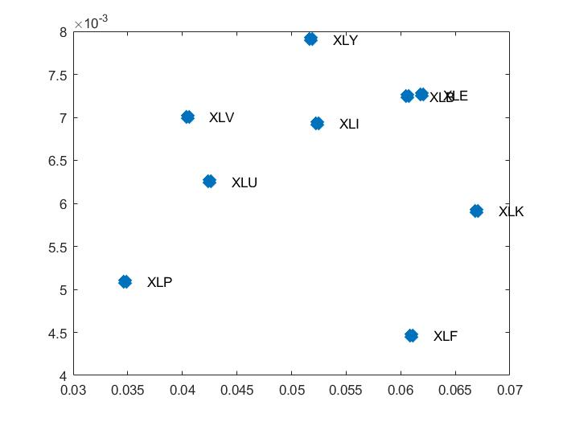

1. **What is the utility of the investor from holding each industry portfolio separately? (9 utilities)**

* -0.0019

-0.0023

-0.0048

0.0001

-0.0053

0.0021

0.0017

**0.0029**

0.0012

1. **Which portfolio would this investor prefer?**

* **XLV** has the highest utility **0.0029**.

1. **Plot the investor’s indifference curve across his preferred portfolio (you still need to show the other industry portfolios on the graph, these portfolios lie below this curve).**

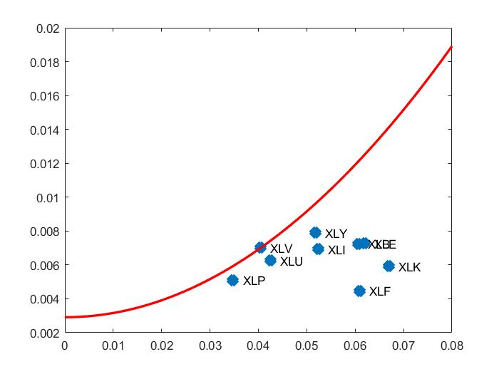

1. **You can invest in one ETF and the risk-free rate**
2. **If the investor can allocate his money between the risk-free rate and one of the ETFs, which ETF would he choose and why?**

* SR =

0.1112

0.1093

0.0650

0.1228

0.0808

0.1321

0.1355

**0.1608**

0.1431

* He would choose **XLV** because it has the highest sharpe ratio which is measured risk and return in the portfolio.

1. **Plot the best capital allocation line of this chosen ETF (the graph needs to include all previous steps).**

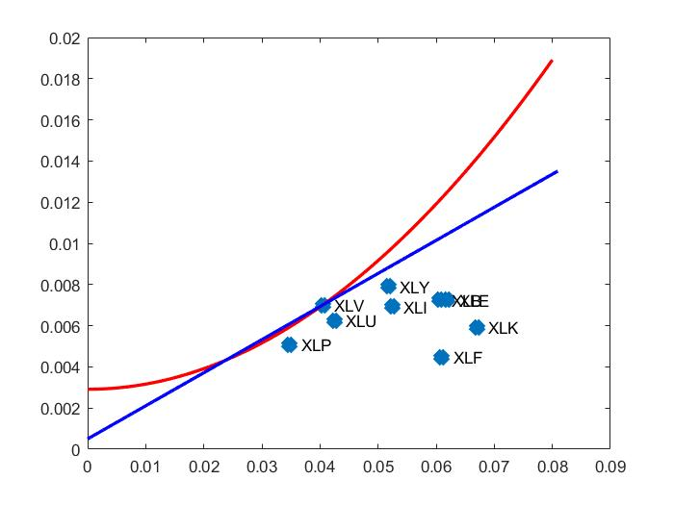

1. **How much should this investor allocate to the risk-free asset and how much to the preferred ETF to maximize his utility? (Assume the borrowing rate is the risk-free rate.)**

* Best_Value_y = **0.7950**

1. **What is his utility at this optimal allocation? Has his utility improved due to the existence of a risk-free rate?**

* The utility at this optimal allocation is **0.0031**. The investor's utility **has improved** due to the existence of a risk-free rate.

1. 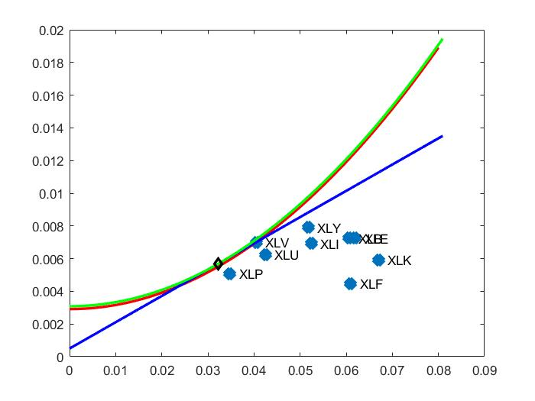**Plot the investor’s new best indifference curve (the graph needs to include all previous steps).**
2. **Combining all ETFs: Efficient Frontier of RISKY assets (WITHOUT the risk-free rate)**

* + 1. 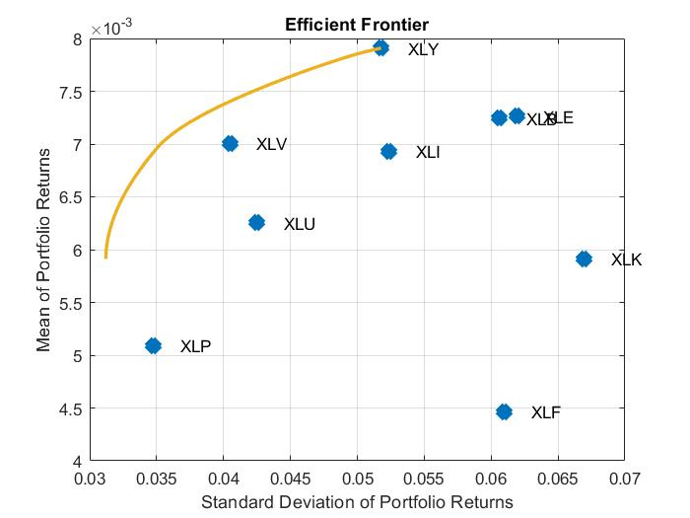 **Plot the efficient frontier based on all ETFs**
    2. **Find (numerically) the optimal portfolio for the investor (the one with the highest utility) and report its weights. (Hint: Calculate the utility for all portfolios along the frontier: you have the risk and return of all portfolios. Then find the maximum utility point and see what its weights are.)**

* The weights of optimal portfolio for the investor:

**0 0.0636 0 0 0 0.0734 0.3101 0.3856 0.1673**

* Maximum Utility Point: **45**

* + 1. **What is the utility of the investor at this optimal portfolio?**

* The utility of the investor at this optimal portfolio is **0.0039**.

* + 1. **Plot the indifference curve across the optimal portfolio. (The graph needs to show all ETFs, the efficient frontier, and the indifference curve!)**

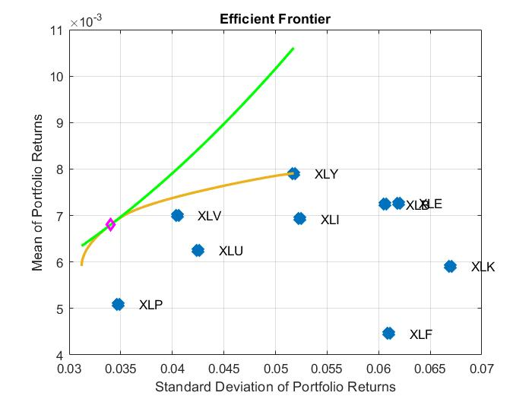

1. **All Risky and Risk-free assets: Optimal OVERALL portfolio: combining the risk-free asset with the optimal RISKY portfolio**

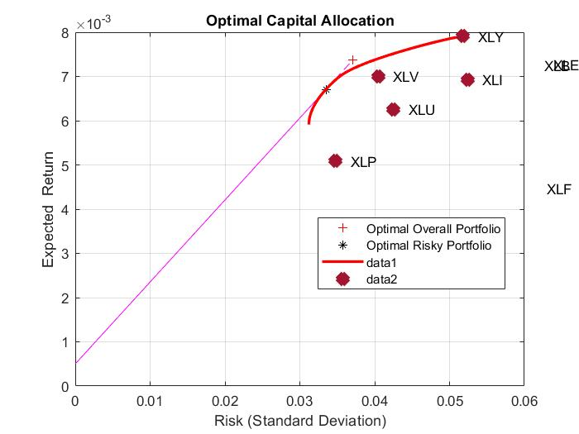**Plot the new efficient frontier with the risk-free rate based on the portfolios. (Start a new graph, stop holding on to the old one in section III. The graph needs to show all ETFs). (Hint: all answers for ii. to v. can be found in the output of portalloc)**

**What are the weights of the different industries in the optimal “RISKY” portfolio?**

* The weight of the different industries in the optimal risky portfolio is:

RiskyWts = **0 0.0611 0 0 0 0.1147 0.3001 0.3771 0.1470**

**What is the return and standard deviation of the optimal RISKY portfolio?**

* The return of the optimal risky portfolio is:

RiskyReturn = **0.0067**

* The standard deviation of the optimal risky portfolio is:

RiskyRisk = **0.0335**

**What is the asset-allocation (i.e., weight of the risky asset) in this investor’s optimal “OVERALL” portfolio?**

* The asset-allocation in this investor’s optimal overall portfolio is:

RiskyFraction = **1.1069**

**What is the risk and standard deviation of the investor’s optimal OVERALL portfolio?**

* The risk of the investor’s optimal portfolio overall portfolio is:

OverallRisk = **0.0371**

* The standard of deviation of the investor’s optimal portfolio overall portfolio is:

OverallReturn = **0.0074**

**What is the utility of the investor at this optimal overall portfolio? (Hint: use the return and standard deviation of that optimal portfolio).**

* The Utility of the investor at this optimal overall portfolio is **0.0039**.

**Summary: Now compare the utility that the investor had under the following investments:**

1. Just one ETF: **0.0029**

2. Just one ETF combined with the risk-free rate: **0.0031**

3. A portfolio of all ETFs only: **0.0039**

4. A portfolio of all ETFs with the risk free: **0.0039**