|  |
| --- |
| FINA 6271 |
| ASSIGNMENT 1 |
| FINANCIAL MODELLING/ECONOMETRICS |

|  |
| --- |
| THE GEORGE WASHINGTON UNIVERSITY  Hailee Kim  Tiffany Tiono  Professor Mejia  5th November 2020 |

# **Introduction**

Time series analysis for having a better understanding of the past and predicting the future using the R program for modeling the projection. The purpose of this assignment is to address the importance of time series methods for making predictions using past data sets. As a result of these predictions, we can have better decision-making for the prospect in the future. Moreover, as the original time series model doesn’t clearly show the effect of seasonal, trend, and random components in one period of time, we need to conduct a time series decomposition to see further how it affects the original model. From the decomposition time series method, we can see how the original time series model is affected by seasonality, trend, and random components.

We use the R program to model the projected growth of a new one-family house sold in the United States, Real Gross Domestic growth, and the CPI for all urban in the U.S. city average with the original time series model and the combination of the trend, seasonality, and noise components. To conduct analysis of these data, we used “setwd” to locate the file for our first step. Then, we made the variable and used “read.csv” to read the file content. After that, we used the “plot.ts” function to produce plot data over time with the data in x variable by year. Then, we need to convert the original table into a time series using the “ts” function. Next, we used the “decompose” function to decompose a series into the components trend, seasonal effect, and residual components. Then, we used another “plot” function to plot the decomposition time series model. Next, we used “dec.var1.ts” to run the R program to show the decompose data component by component. Then, we used another “plot” function to identify and start plotting the trend component produced through decomposition function. We used the “data.frame” function to convert decomposition output to a data frame. Next, we used the “head” function to check if there are ‘NA’ missing values. Then, we used the “complete.cases” function to exclude NA variables. Next, we used the “seq.int” function to create a time variable starting at t=1, just a time indicator and we put t=10. Then, we used the “cyc.lm,” “cyc.cyclical,” and “cyc.puretrend” functions to estimate regression, output residuals and predicted linear trend. We used the “plot” function to plot pure linear and cyclical trend components. I repeated the same process for the “A191RL1Q225SBEA.csv” and “CPIAUCSL.csv” and differentiate the variable names to avoid error when we run the R program.

**R Decomposition Outputs**

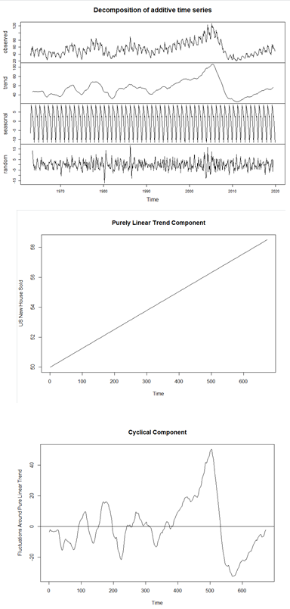**New One Family Houses Sold: United States (HSN1FNSA)**

**Real Gross Domestic Product (A191RL1Q225SBEA)**

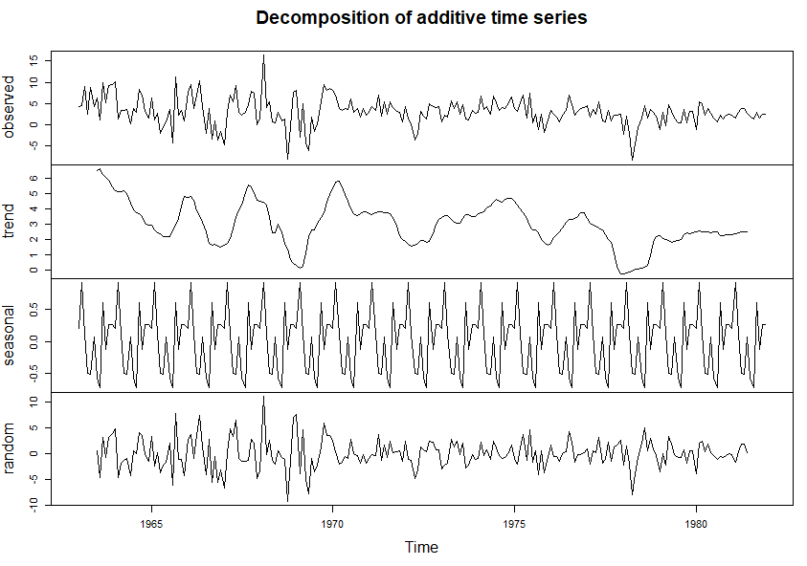

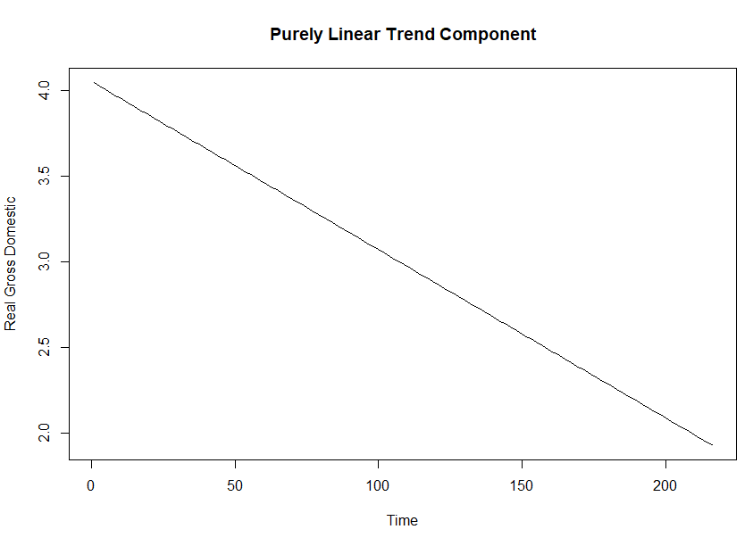

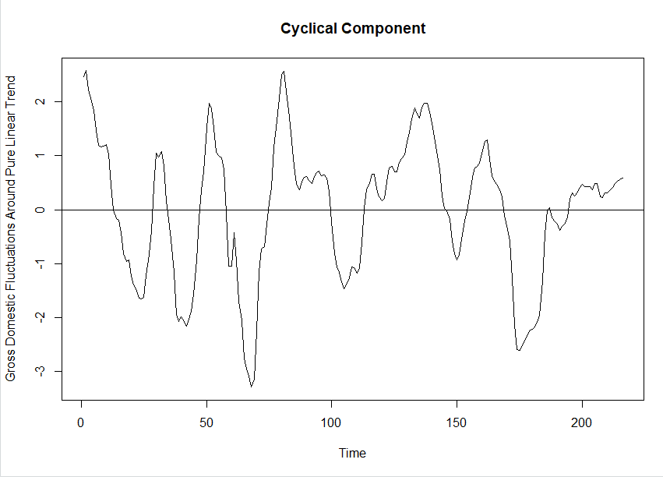

**Consumer Price Index for All Urban Consumers: All Items in U.S. City Average (CPIAUCSL)**

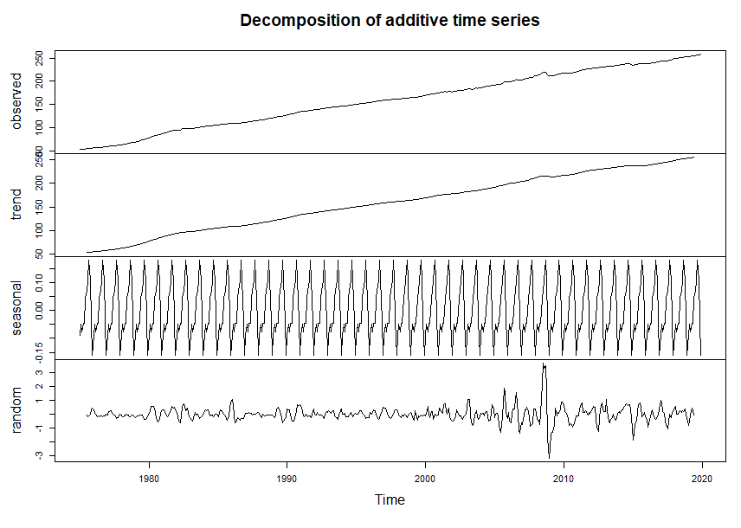

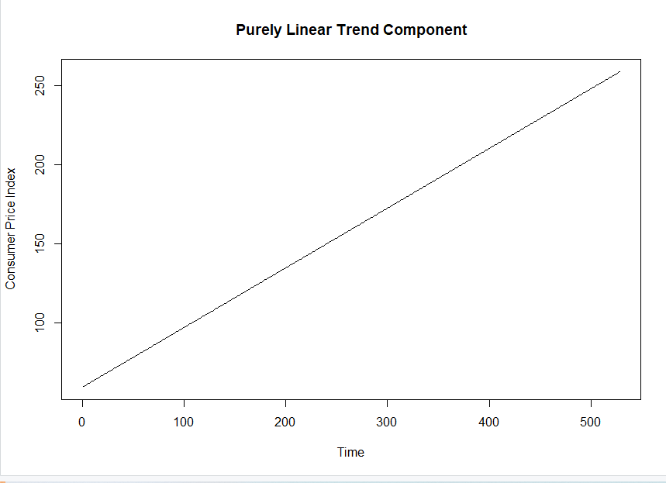

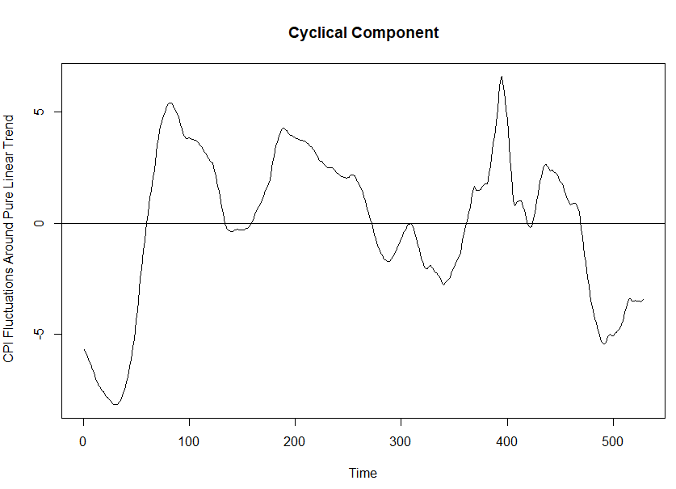

# **Interpretation of the Results**

* **How the decomposition results differ among the time series and the components.**

First of all, both of time series model in “New One Family Houses Sold: United States” (HSN1FNSA) and “Consumer Price Index for Consumers” (CPIAUCSL), the results are positive trends with upward trend, whereas the time series model “Real Gross Domestic Product” (A191RL1Q225SBEA) has a downward trend, which shows a negative trend pattern. Secondly, we can see that the time series model has more cyclical variation in the house sold series. The house sold time series model tends to have a more significant downward trend in 2001 and another significant downward trend in 2009. It has found that as the result from the cyclical component, where it shows a higher pure linear trend in 2001 and 2009 during the market recession, which highly follows the economic cycle and shows the expansion and contraction period remarkably.

On the other hand, both the GDP and CPI time series models have lower or no cyclical component compared to the house sold time series model. It has shown in their cyclicality where it has no concise downturns during the recession for both time series models. For the noise component, the house sold time series model has the highest degree of randomness, followed respectively with the GDP and CPI time series models. Finally, seasonal components are discovered through the repetitive pattern that occurs within the series model over a period of a year. The houses sold time series model makes zig-zag patterns with the fastest speed factor, following by the CPI and GDP series models respectively in the short period of time. In the other words, time series model for the house sold moves relatively high expected patterns, whereas the series moves relatively slower in repetitive patterns for the GDP and CPI series.

* **Which one you think is the dominant component for each series. Explain why.**

We think that the house sold time series model has a dominant in trend component. It shows that there is an obvious trend component that happens to be higher in magnitude as the seasonal and random component. Moreover, the GDP time series model seems to have noise components that have the largest magnitude, which determines the noise component is more dominant. Additionally, the dominant component for the CPI time model series is the seasonal component. The trend is not large in magnitude, and it shows that the trend is flat, which indicates that it is not a dominant trend component. On the other hand, the seasonal component has the largest magnitude compared to its random component, so, as the result, we determine that the seasonality component is more dominant than other components.

* **Implications related to certain components being more dominant than others across the time series.**

We think that some external factors could affect the time series models although in certain time series models, they have their dominant components. For example, in the CPI time series model, they have a dominant in seasonality component. The trend and the noise components are still matter in this time series model. As we can use this model to predict the consumer price index in the long-term period, this time series model could be affected by unprecedented external factors such as recession, which eventually affect the CPI time series model in that period. Moreover, it is important to not only focus on the magnitude but also on the variability. Magnitude is an important element to determine what series is dominant in the time series model, but also, it is not always the one that determines what is dominant in one time series model. For instance, the time series model is where the trend isn’t at a large magnitude, and the trend is flat. Then, we can conclude that it is not a dominant trend. It is why we should always look to the other components like the seasonal or the noise components because it is possible that the trend component is not always the determining dominant factor in one time series model.