HAILEE KIM

TIFFANY TIONO

Assignment 2

econometrics/financial modelling

THE GEORGE WASHINGTON UNIVERSITY

PROFESSOR MEJIA

FINA 6271

November 19, 2020

**Describe the forecast you obtain, for example the direction, how it compares with recent trends, etc. (max. 100 words). Paste appropriate SAS outputs and/or excel graphs to illustrate the results.**

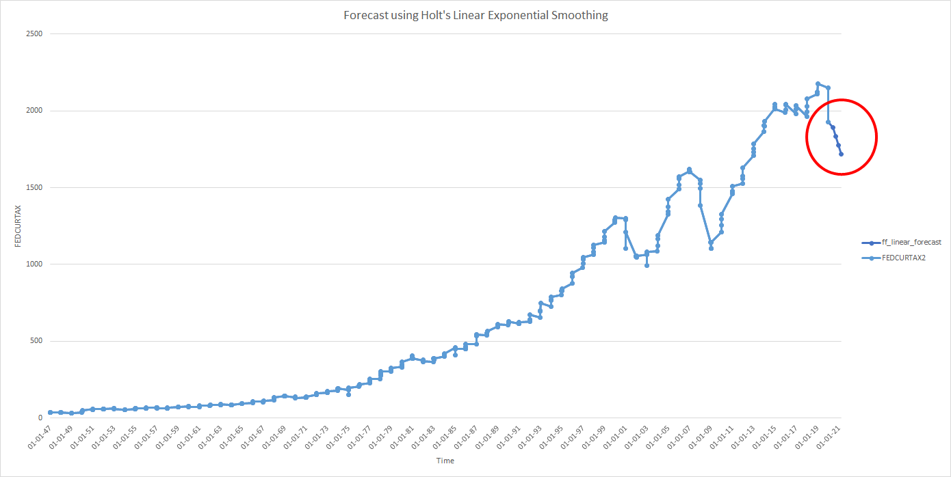

The forecast shows a downward sloping, which tells us that the expected output is diminishing in some extrapolation that carries from the most recent trends. By looking at the chart, the red dot shows as it weighs more heavily toward the most recent data set instead of using a whole data set as the weight for the forecast. The forecast model is more reasonable for the short-term forecast since the level of uncertainty will go larger when it comes to projections for a long-term forecasting.

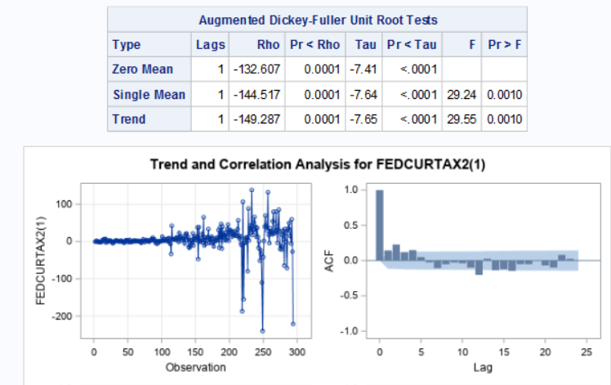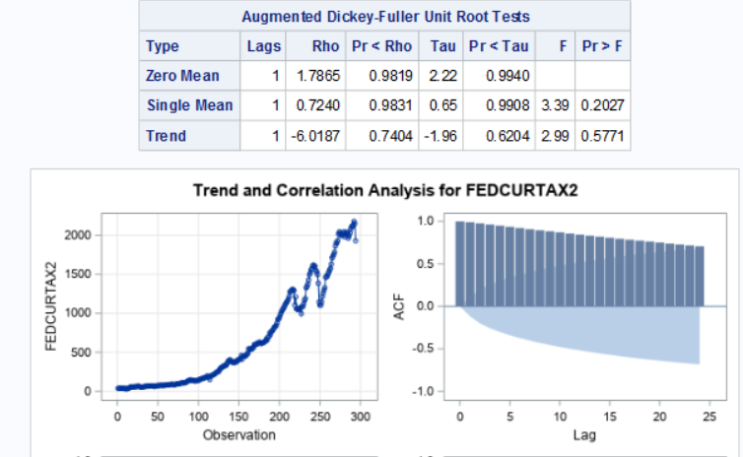**Determine whether the original series is stationary. If it is not, explain what steps you took, and why you took them, to make it stationary (max. 100 words).**

One-Period Difference Model

The Original Model

We can see that the original series is not stationary since the ACF visually declines slowly. Moreover, the Pr < Rho is greater than 0.05, as the result, we cannot reject the null hypothesis that the model is non-stationary. As the series needs differencing, we took a step to make a one-period difference. On the other hand, the result of the SAS output in the one-period difference, the ACF visually decreases gradually. Additionally, the Pr < Rho is less than 0.05, so we can reject the null hypothesis as non-stationary. Therefore, the one-period difference model is stationary.

**Generate and examine the ACF and PACF and other relevant charts for the stationary series. In modeling the series, model the AR component, i.e., determine the ‘p’ lags to be included in the model. For this exercise, there is no need to consider the ‘q’ lags. Explain your choice of ‘p’ lags, specifically what charts you looked at, what parts of the chart you considered when making the choice, etc. (max. 100 words).**

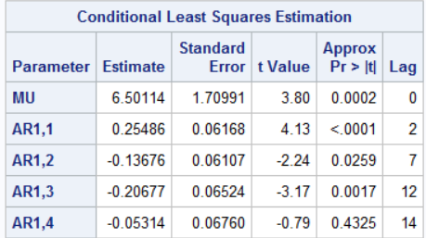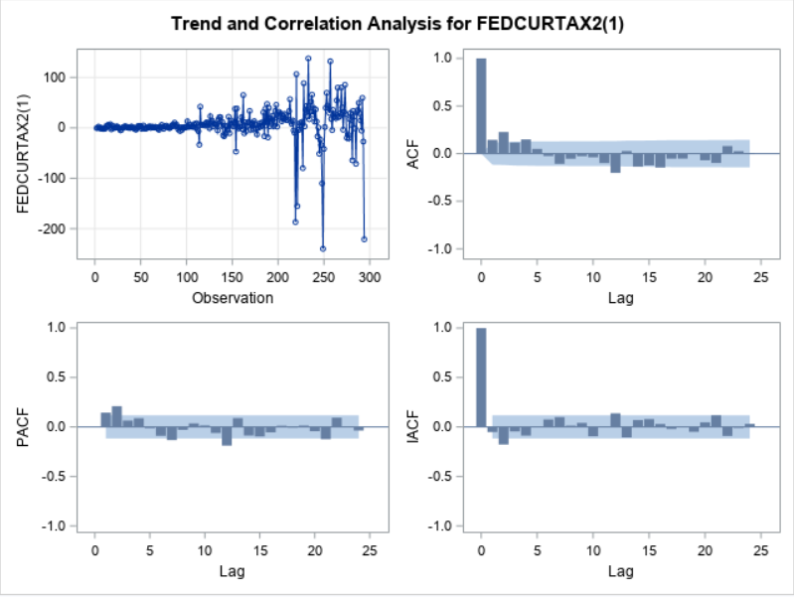

The best place to look is the PACF to identify the best lags for the autoregressive components (AR). I also consider the magnitude level of the lag is beyond the error area (the shades area) for choosing my “p” lag. As the result, by using the PACF output, I choose four observations the estimated parameters “p” at lag 2,7,12, and 14. As a result, The ARIMA parameters at lag 2,7, and 12 are statistically significant since those p-values are less than 0.05, except for lag 14, which is not significant.

**Are remaining errors white noise? Explain what you considered to determine if the errors are white noise. Explain your response (max 100 words).**

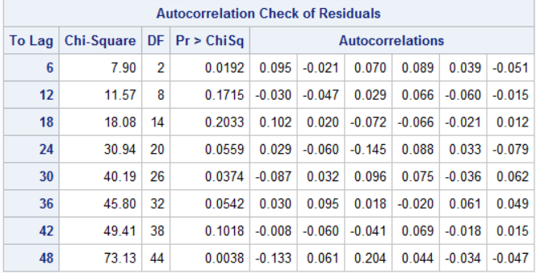

In this case, we use the Portmanteau test to decide whether the error is a white noise or not. Based on our SAS output, after we build our ARIMA model, with different series, we can conclude that we cannot reject the null hypothesis that the series is white noise. Therefore, the remaining errors are white noise, since the Pr > Chi value is less than 0.05.

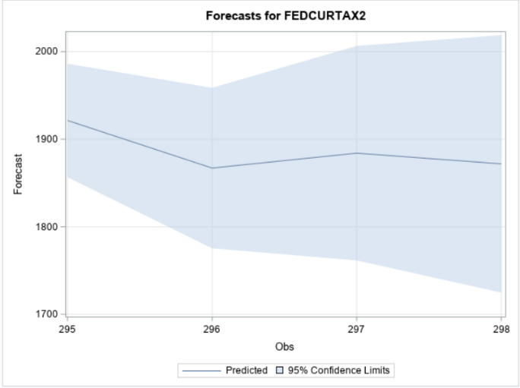**Produce a 4-quarter forecast. Describe the forecast you obtain, for example the direction of the forecast, how it compares with recent trends, etc. (max. 100 words). Paste appropriate SAS outputs and/or excel graphs to illustrate the results.**

A 4-quarters forecast shows three-month and one-year forecasts, which is a short-term forecast that seems more reasonable and accurate. These forecasts are generated by optimization procedure, indicating that there are several loops running around until they converge. The shorter horizon, the closer they are going to be. As we do six-month forecasts, or twelve-month forecasts, we can see that the residual errors (shades area) are wider as the time goes to the longer period.

**COMPARE THE TWO FORECASTS YOU PRODUCED Compare the linear exponential smoothing and the ARIMA forecasts. Discuss differences and/or similarities between the two forecasts. Do they look similar? Do they look different? In what ways? Discuss what you see (max 100 words).**

Holt’s Exponential Linear forecast uses weights more heavily from a recent data set to get the short-term forecast seems more reasonable and accurate. Moreover, the ARIMA aims to forecast the future outcome. Any estimated AR model corresponds to, which indicates that it has some lag errors. Moreover, the similarity in Holt’s method and ARIMA results are that we can reduce lag errors and the short-term forecasts should weigh down the error to the least as possible. However, the difference is that Holt's exponential smoothing from ARIMA results is that none of the basic extrapolation techniques used ADF test.

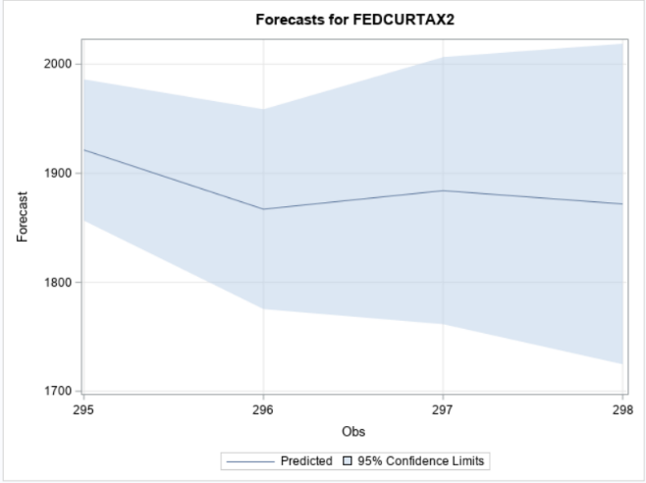**Given the two forecasts you obtained, how would you go about choosing a final forecast. Please note, you are not being asked to come up with a final forecast. That task would require significant expertise in the federal tax receipts area. You are being asked to discuss what elements you would consider or what steps you would take if you had to propose a forecast given the similarity or divergence (whatever you found) in the exponential smoothing and ARIMA results. Explain clearly (max. 100 words).**

We would consider trend elements compared to the two forecasts we obtained from ARIMA and Holt’s method. The trend looks similar for both time series forecast models which show a downward sloping in both time forecast series models. However, the divergence in these models shows that the ARIMA model shows a zig-zag pattern while the Holt’s model shows a gradual decline. If we look at the bigger picture in both data trends, there is a zig-zag pattern for both models. However, we can conclude that Holt’s model is more accurate because Holt’s model uses the most recent data to forecast.