11th December 2020

This research provides a brief empirical and conceptual about relationship between Short-Term Treasury Bills and Unemployment Rate, also The Implied Forward Rate

RESEARCH PAPER

CORPORATE FINANCE/FINANCIAL MODELLING

THE GEORGE WASHINGTON UNIVERSITY

HAILEE KIM

TIFFANY TIONO

FINA 6274

PROFESSOR HANDORF

**Overview**

Treasury Bill Yield rises as unemployment rate drops below average. For instance, the Ten-year U.S. Treasury Note rate jumped 8 basis points to reach 0.70 percent and the U.S. Thirty-year Treasury Bond rate hit 1.42 percent by 8 basis points gained. These increases on the yields are affected by the fact that the Unemployment Rate dropped significantly to 8.4 percent from 10.2 percent in July 2020 due to the pandemic in the US.[1] Moreover, the graph illustration in **Figure 1** supports our first theoretical relationship between the 3-Month Treasury Bill yield and Unemployment Rate from the 2002 to 2019 time period. It shows that when the Treasury Bill yield goes down, the unemployment rate goes up.

On the other hand, the yield curve plots rates on similar assets with different maturities, such as the 10-year Treasury Note and the 6-month U.S. Treasury Bill. The difference between the terms of spread (between the rates) is positive, in that longer-maturity assets have a higher return than shorter-maturity assets. One reason for the positive spread is a liquidity premium. The liquidity premium lowers the price on these bonds, which increases the yield (or return). Yield curve inversions occur when the rates on short-term assets rise above long-term asset rates, leading to a negative yield spread. If we assume that the liquidity premium has not changed, there are two primary reasons the spread could become negative; first of all, it could increase the risk, and second, there would be lower expectations about the future outcomes such as a recession. [2]

In this research, we want test the significance of the first model is that we want to know if there is a significant relationship between the 3 months U.S. Treasury Bill and the Unemployment Rate or it is just a “noise” in the market. Also, we want to construct our second model of the implied forward rate of interest of a three-month rate three months in the future and we need to lag it by three months. Then, we want to test the term structure whether this model fully supports the pure expectation or the liquidity preference term theoretical term structure. Moreover, we analyze how both models with two different independent variables would give an impact to the 3-month Treasury Bill. Additionally, we also want to analyze how the independent variables and dependent variables behave in the business cycle in the U.S. for the 2002 to 2019 time period using descriptive summary. So, for the overall purpose of this research is to determine in which model that we can use for illustrate the effect between those independent variables and dependent variables.

**First Model: The 3-Month U.S. Treasury and Unemployment Rate**

In this analysis, we use Unemployment Rate monthly data as our independent variable in the 2002 to 2019 time period. This data is using a seasonally adjusted, taken by monthly data from January 2002 to December 2019 by average percentage for each month. Using this independent variable, we develop a simple regression using the 3-month U.S. Treasury Bill monthly data as our dependent variable. Our null hypothesis for the first model is that we want to know if there is no significant relationship between the 3-month U.S. Treasury Bill and the Unemployment Rate in the period of 2002 to 2019. At the same time, we also state our alternative hypothesis that there is some significant level in the relationship between the 3-month U.S. Treasury and the Unemployment Rate in the period of 2002 to 2019 or the independent variable is just a “noise” in the market.

We analyze using SAS to see if the model fits the data, the correlation and the significance relationship between 3-month Treasury Bill and Unemployment Rate using 95 percent confidence level. As a result, we find that the model fits the data since the Coefficient Variance is relatively high **(Table A)**. However, this model shows a lower correlation proportion, which is only 33.83 percent **(Table A)**. Moreover, as we see the parameter estimate in Table B, we can reject our null hypothesis statement as the model shows some significant relationship between the 3-month Treasury Bill and Unemployment Rate.

As we confirm our hypothesis and other terms above, whether that is if there is a significant relationship between the 3 months U.S. Treasury Bill and the Unemployment Rate or it is just a “noise” in the market, we conclude that the independent variable is a noise in the market. Although we have a significant model and the Coefficient Variance is relative high, we also have a lower R-squared.

**Second Model: The 3-Month U.S. Treasury and Implied Forward 3-Month Rate for 3 Months in the Future**

In this section, we are going to model between Implied Forward 3-Month Rate for 3 Months in the Future with lag 3 for every month as our independent variable and 3-month Treasury Bill as a dependent variable by using 95 percent confidence level. First of all, our null hypothesis for the second model is that we want to know if there is no significant relationship between the 3-month U.S. Treasury Bill and implied forward 3-month rate for 3 months in the future. At the same time, we also state our alternative hypothesis that there is a significant relationship between the 3-month U.S. Treasury and implied forward 3-month rate for 3 Months in the future. Secondly, we want to test the term structure whether the model is supporting the theoretical pure expectation or liquidity preference. We would have supported pure expectations if the intercept was not different from zero and slope not different from one. And, we would have supported liquidity preference if the intercept was less than zero and/or slope less than one.

For the first analysis to test the significance, we use SAS to generate the result from the data that we already calculated for the implied forward 3-month rate for 3 months in the future. As a result, we conclude that we reject our null hypothesis as there is a significant relationship between the 3-month U.S. Treasury Bill and implied forward 3-month rate for 3 months in the future as we got the p-value is less than 0.05 **(Table E)**. For the second analysis to test the term structure for our second model, we determined that our model term structure is supporting liquidity preference since the slope of our model here; Y= 0.0356 + 0.1012 (X) + 0.001689, is less than one.

In conclusion, our second model has a significant relationship between the 3-month U.S. Treasury and implied forward 3-month rate for 3 Months in the future and our second model also supports the liquidity preference theoretical term structure.

**Comparison Two Regression Models**

The first simple regression model is presented in the formula of Y= 4.24653 - 0.48247(X) + 0.04613, with the 95 percent confidence interval. Moreover, it is also followed with the R-squared output for 33.83 percent for R-Squared **(Table A)**, 0.04613 for SER, -10.46 for T-Statistics, and 0.0001 for P-Value **(Table B)**. The second regression model is presented in the formula of Y= 0.0356 + 0.1012 (X) + 0.001689, with the 95 percent confidence interval. Moreover, it is also followed with the supportive outputs of 94.45 **(Table D)** percent for R-Squared, 0.001689 for SER, 59.93 for T-Statistics, and 0.0001 for P-Value **(Table E)**.

The better models are likely to have a higher R-Squared and the lower SER. As a result, from our comparison above, the second regression model has a higher R-Squared and the lower SER than the first model. Based on this result, we conclude that the second regression model can have a better regression model.

**How and Why Will Higher Unemployment Rates or Forward Yield Rate Impact T-Bill Yield?**

The variance measures how far a set of data is spread out whereas the MSE measures the average of the squares of the errors, that is, difference between the estimator and what is estimated. MSE indicates how different the values of the estimator and the actual values of the parameters are. Simply, the lower the value of MSE, the better it is as “MSE is equal to 0” indicates that the model is perfect. While the MSE for the first model is driven as 1.52122 **(Table C)**, much higher than that of the second model, 0.12924 **(Table D)**, very close to zero, we can signify that T-Bill Yield is impacted better by forward yield rate, not by unemployment rate. The reason why we chose the lower value of MSE to conclude the significance between the independent and dependent variables is that the lower value of MSE is an indicator of whether the model has been constructed more correctly, and the predicted results are better enough to be deviated from the actual number.

Additionally, it is supported by the small residual standard deviation of 1.512667 **(Table F)** since the smaller the residual standard deviation is, the closer is the fit of the estimate of the actual data. It certainly implies that the model is more predictive and useful. With the 94.45 percent **(Table D)** of high R-Squared and low standard deviation, we can say the values correlate well to each other, and the regression line fits well the data. Therefore, the slope of the regression, 0.1012 **(Table E)**, is reasonable and small enough to conclude that the model supports liquidity preference, and is supportive enough to reject the null hypothesis. As a result, the higher forward rates impact T-Bill yields to drop significantly. Therefore, the relationship between the two variables is indicated to be statistically significant.

**Business Cycle in the U.S. in the Time Period of 2002 to 2019**

In this section, we want to identify how the rates behaved in the business cycle in the U.S. in the time period of 2002 to 2019. We use descriptive statistics for each variable that we want to identify. The most important here is that we want to see the level of the volatility of each rate by analyzing each standard deviation. The smaller the standard deviation is, the more predictive and useful the model is. Therefore, the forward rate will allow us to get better prepared for when something unexpected occurs, such as economic recession or expansion during the business cycle.

Based on the chart in **Figure 2**, it shows that the U.S. business cycle in the 2002 to 2019 time period. It is interesting to see in the time period of 2008 -2009 (red box area), we can see that the 3-month T-Bill and 6-month T-Bill were gradually dropped in the 2008-2009, where there was a U.S. economic recession. At the same time, the unemployment rate gradually went up. For the forward implied yield, we can see that the rate is relatively stable over the 2002 to 2019 time period, and it was relatively stable during the recession cycle. So, when we look up the standard deviation from descriptive summary, we conclude that the unemployment rate (**Table H**) and 3-month T-Bill (**Table F)** and 6-month T-Bill (**Table G**) have a higher volatility to change and are sensitive to economic factors such as recession, while the forward implied rate (**Table I**) has less volatility to the business cycle progression.

We also analyze using descriptive summary statistics to analyze how volatile each rate to the economic factors in the U.S. business cycle in the time period of 2002 to 2019. We argue that the data is very reasonable as the chart in **Figure 2**, supports our statement that the forward rate is less volatile and has the smallest standard deviation value. At the same time, Unemployment rate, 3-month T-Bill and 6-month T-Bill have an average approximately 1.6 to 1.7 of standard deviation, which are relatively high volatility and relatively subtle to the business cycle progression.

**Conclusion**

In conclusion, we modelled two regression models using SAS in 95 percent confidence interval. Therefore, we run the T-test to see how it provides a formal hypothesis test for the relationship between our models and the response variables, which shows the overall significance of whether the relationship is statistically significant. For our first model, we identify that the unemployment rate is merely noise in the market as we get a lower R-squared and at the same time, we have relatively high coefficient variables. The test result also shows that there is a significant relationship between independent and dependent variables, we can conclude that there is an inverse relationship between the unemployment rate and the yields; to explain, a decrease in the unemployment rate causes the yields to increase. For our second model, we identify that our model is statistically significant and also supports the liquidity preference theory in the term structure theory as we have a slope that is less than one.

Moreover, we conduct MSE and standard deviation of Y (dependent variable) to find how the unemployment rate or forward rate would affect 3-month T-Bill. We want that the data has a lower spread of variance in the data set (the lower the MSE, the better model we get). As a result, we found that the second model has a better model since the second model has lower spread of data from the actual prediction. It means that the predicted data spread in the second model is not far from the actual prediction. We also compared two different models of regression to see which models are the better model by identifying the R-Squared, T-Statistic and the SER values. As a result, we determined that the second model has a higher R-squared and lower SER than the first model, so the second model is the better one.

Finally, in the U.S. business cycle during the time period of 2002 to 2019, we conducted analysis of how each rate behaved during the business cycle. From our analysis, we determined that the unemployment rate and 3-month T-Bill and 6-month T-Bill have a higher volatility to change and are sensitive to economic factors such as recession, while the forward implied rate has less volatility to the business cycle progression since the forward rate has the lowest standard deviation value. Overall, we can conclude that we can use the second model as a useful model to forecasting the future outcome.

**APPENDICES**

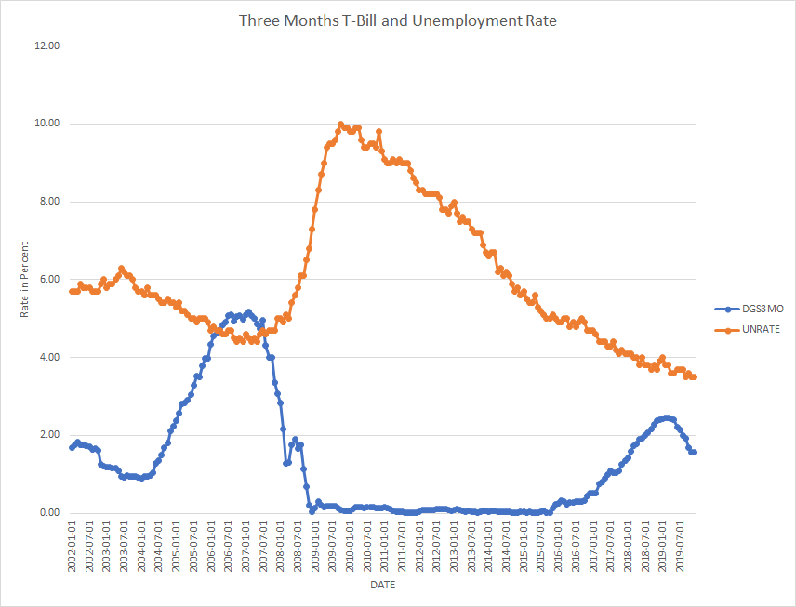**Figure 1**

Sources: U.S. Bureau of Labor Statistics, “Unemployment Rate” and Board of Governors of the Federal Reserve System (US), “3-Month Treasury Constant Maturity Rate”, retrieved from FRED, Federal Reserve Bank of St. Louis

**Figure 2** 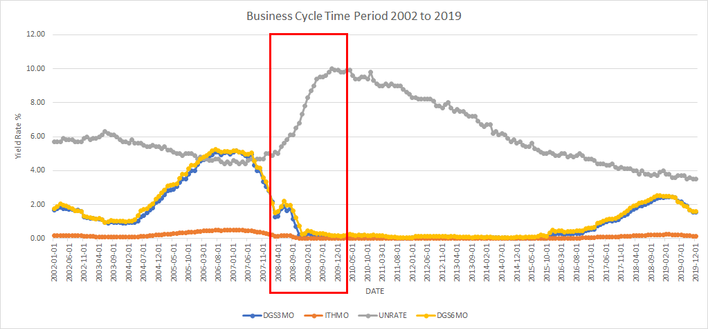

Sources: U.S. Bureau of Labor Statistics, “Unemployment Rate” and Board of Governors of the Federal Reserve System (US), “3-Month Treasury Constant Maturity Rate”, and “6-Month Treasury Constant Maturity Rate”, retrieved from FRED, Federal Reserve Bank of St. Louis; Wall Street Journal: Bonds and Rates, U.S. Treasuries Yield

**Table A**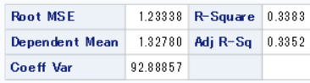

Sources: U.S. Bureau of Labor Statistics, “Unemployment Rate” and Board of Governors of the Federal Reserve System (US), “3-Month Treasury Constant Maturity Rate”, retrieved from FRED, Federal Reserve Bank of St. Louis

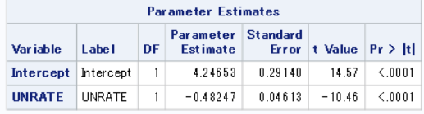**Table B**

Sources: Sources: U.S. Bureau of Labor Statistics, Unemployment Rate and Board of Governors of the Federal Reserve System (US), “3-Month Treasury Constant Maturity Rate”, retrieved from FRED, Federal Reserve Bank of St. Louis

**Table C**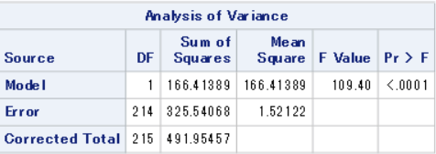

Sources: Sources: U.S. Bureau of Labor Statistics, Unemployment Rate and Board of Governors of the Federal Reserve System (US), “3-Month Treasury Constant Maturity Rate”, retrieved from FRED, Federal Reserve Bank of St. Louis

**Table D**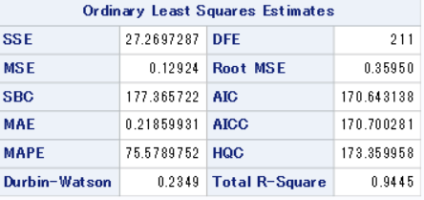

Sources: Board of Governors of the Federal Reserve System (US), “3-Month Treasury Constant Maturity Rate”, retrieved from FRED, Federal Reserve Bank of St. Louis and Wall Street Journal: Bonds and Rates, U.S. Treasuries Yield

**Table E**

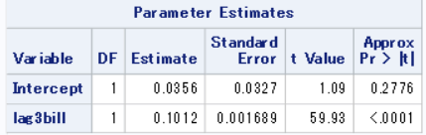

Sources: Board of Governors of the Federal Reserve System (US), “3-Month Treasury Constant Maturity Rate”, retrieved from FRED, Federal Reserve Bank of St. Louis and Wall Street Journal: Bonds and Rates, U.S. Treasuries Yield

**Table F**

|  |  |
| --- | --- |
| *3-Month T-Bill* | |
|  |  |
| Mean | 1.327802 |
| Standard Error | 0.102924 |
| Median | 0.939004 |
| Mode | 0.074286 |
| **Standard Deviation** | **1.512667** |
| Sample Variance | 2.288161 |
| Kurtosis | 0.457592 |
| Skewness | 1.206963 |
| Range | 5.151729 |
| Minimum | 0.011429 |
| Maximum | 5.163158 |
| Sum | 286.8053 |
| Count | 216 |
| Confidence Level (95.0%) | 0.202869 |

Source: *Descriptive Summary* from Board of Governors of the Federal Reserve System (US), “3-Month Treasury Constant Maturity Rate”, retrieved from FRED, Federal Reserve Bank of St. Louis

**Table G**

|  |  |
| --- | --- |
| *6-Month T-Bill* | |
|  |  |
| Mean | 1.442734 |
| Standard Error | 0.105046 |
| Median | 1.015299 |
| Mode | 0.1195 |
| **Standard Deviation** | **1.543859** |
| Sample Variance | 2.383502 |
| Kurtosis | 0.305707 |
| Skewness | 1.156477 |
| Range | 5.225 |
| Minimum | 0.0415 |
| Maximum | 5.2665 |
| Sum | 311.6306 |
| Count | 216 |
| Confidence Level (95.0%) | 0.207053 |

Source: *Descriptive Summary* from Board of Governors of the Federal Reserve System (US), “6-Month Treasury Constant Maturity Rate”, retrieved from FRED, Federal Reserve Bank of St. Louis

**Table H**

|  |  |
| --- | --- |
| *Unemployment Rate* | |
|  |  |
| Mean | 6.049537 |
| Standard Error | 0.124073 |
| Median | 5.6 |
| Mode | 5 |
| **Standard Deviation** | **1.82349** |
| Sample Variance | 3.325116 |
| Kurtosis | -0.61188 |
| Skewness | 0.745724 |
| Range | 6.5 |
| Minimum | 3.5 |
| Maximum | 10 |
| Sum | 1306.7 |
| Count | 216 |
| Confidence Level (95.0%) | 0.244555 |

Source: *Descriptive Summary* from U.S. Bureau of Labor Statistics, “Unemployment Rate”, retrieved from FRED, Federal Reserve Bank of St. Louis

**Table I**

|  |  |
| --- | --- |
| *Forward Yield Rate 3-Month for 3 Months* | |
|  |  |
| Mean | 0.127469 |
| Standard Error | 0.009881 |
| Median | 0.090144 |
| Mode | 0.007131 |
| **Standard Deviation** | **0.145216** |
| Sample Variance | 0.021088 |
| Kurtosis | 0.457592 |
| Skewness | 1.206963 |
| Range | 0.494566 |
| Minimum | 0.001097 |
| Maximum | 0.495663 |
| Sum | 27.53331 |
| Count | 216 |
| Confidence Level (95.0%) | 0.019475 |

Source: *Descriptive Summary* from Board of Governors of the Federal Reserve System (US), “3-Month Treasury Constant Maturity Rate”, retrieved from FRED, Federal Reserve Bank of St. Louis and Wall Street Journal: Bonds and Rates, U.S. Treasuries Yield

1. Li, Yun. “10-year Treasury yield jumps to 0.7% after unemployment rate drops.” *CNBC,* 4. Sep. 2020. cnbc.com/2020/09/04/treasury-yields-higher-amid-stock-market-rout.html.
2. Owyang, Michael. “Is the Yield Curve Signaling a Recession?” *St. Louis Fed*. 24 March, 2016. stlouisfed.org/on-the-economy/2016/march/is-yield-curve-signaling-recession.