**Handson 2**

CIE5141 Computer Vision in Construction

Student_ID Student_Name

**1.1 Using OpenCV convert original image to grayscale image**

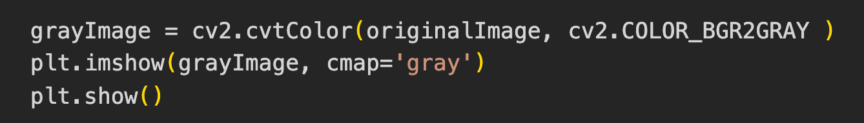

**1.2 Converting Gray to Black and White Image**

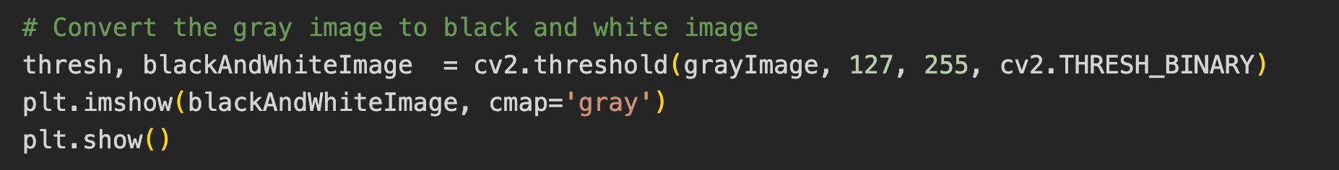

**1.3 Using Pillow Library convert original image to grayscale image**

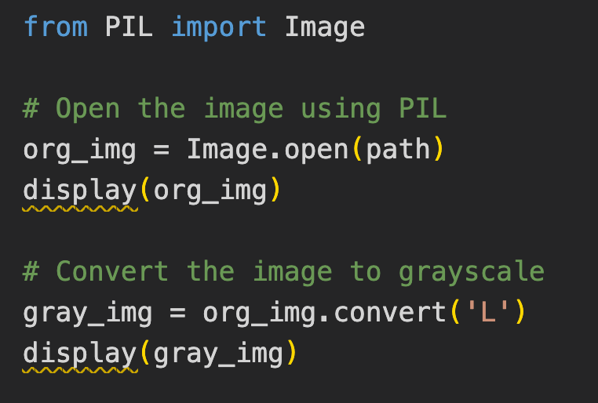

**2.1 Use OpenCV for color channel manipulation**

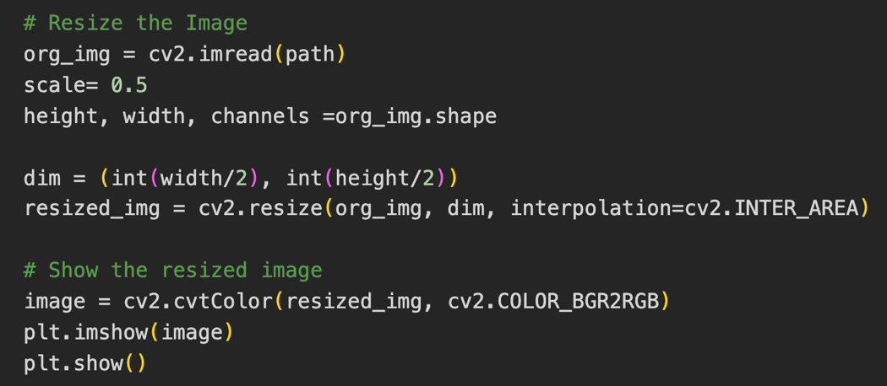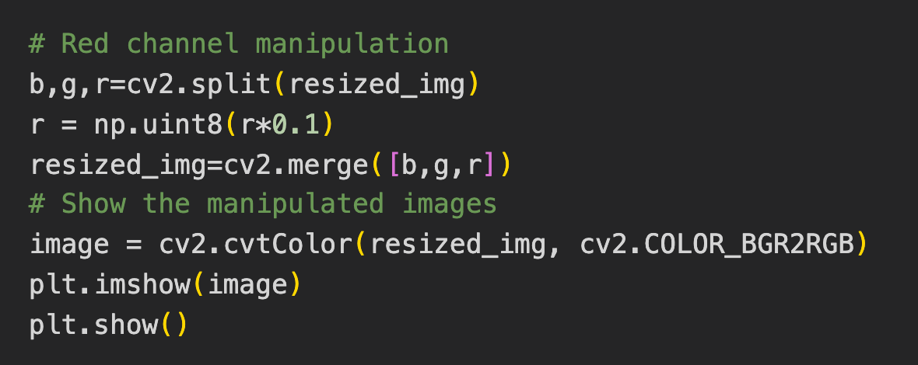

**2.2 Creating color mask using OpenCV**

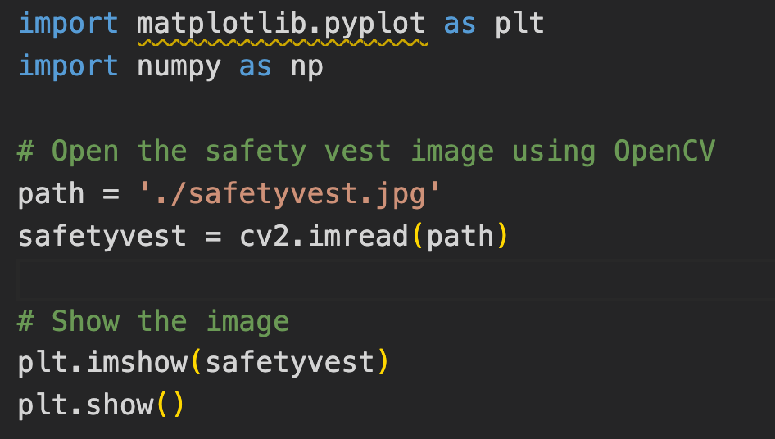

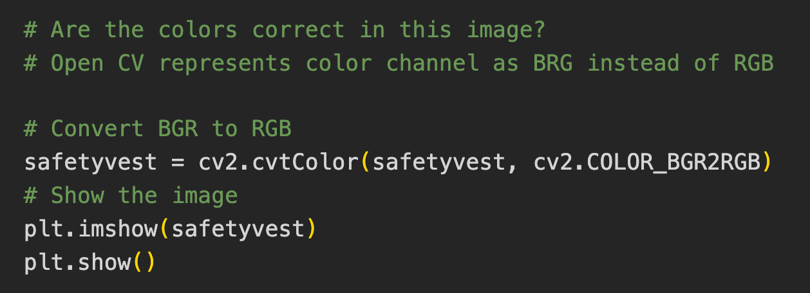

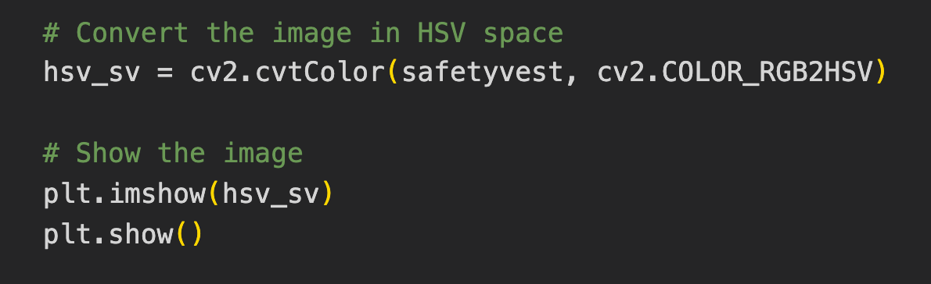

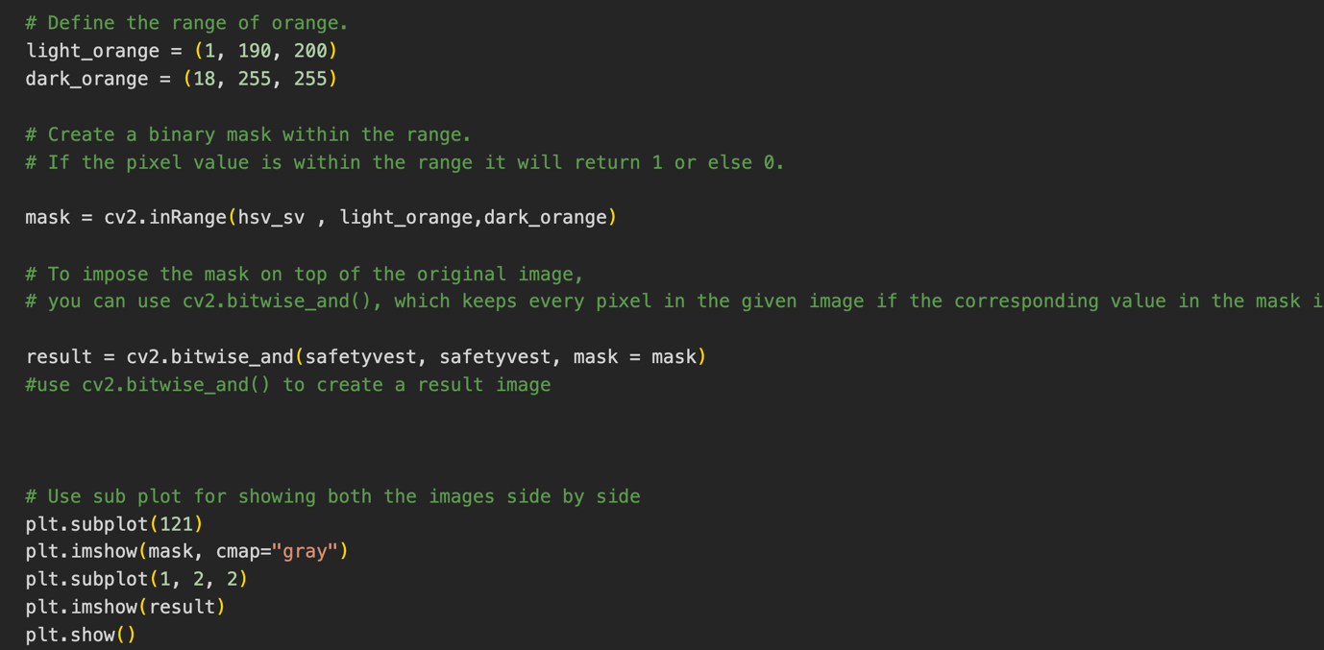

**3.1 Bonus**

