Oct. 26, 2018

Tiffany Liu (manhsual)

Programming Usable Interfaces Section B

Assignment 6: Adding Functionality to a Website with JS

**Low and High-Fidelity Prototypes**

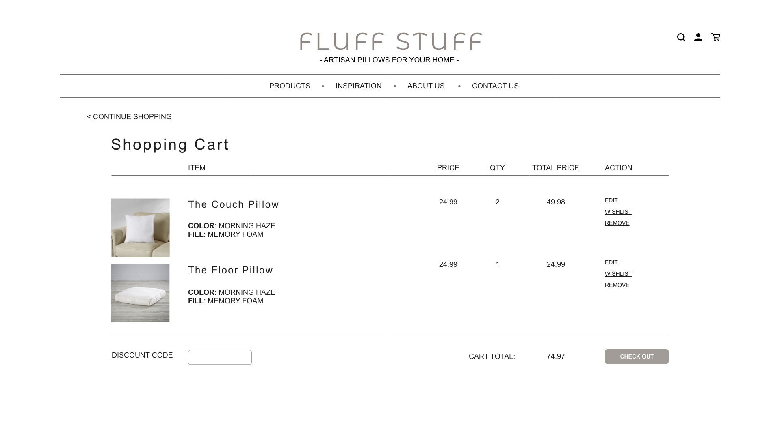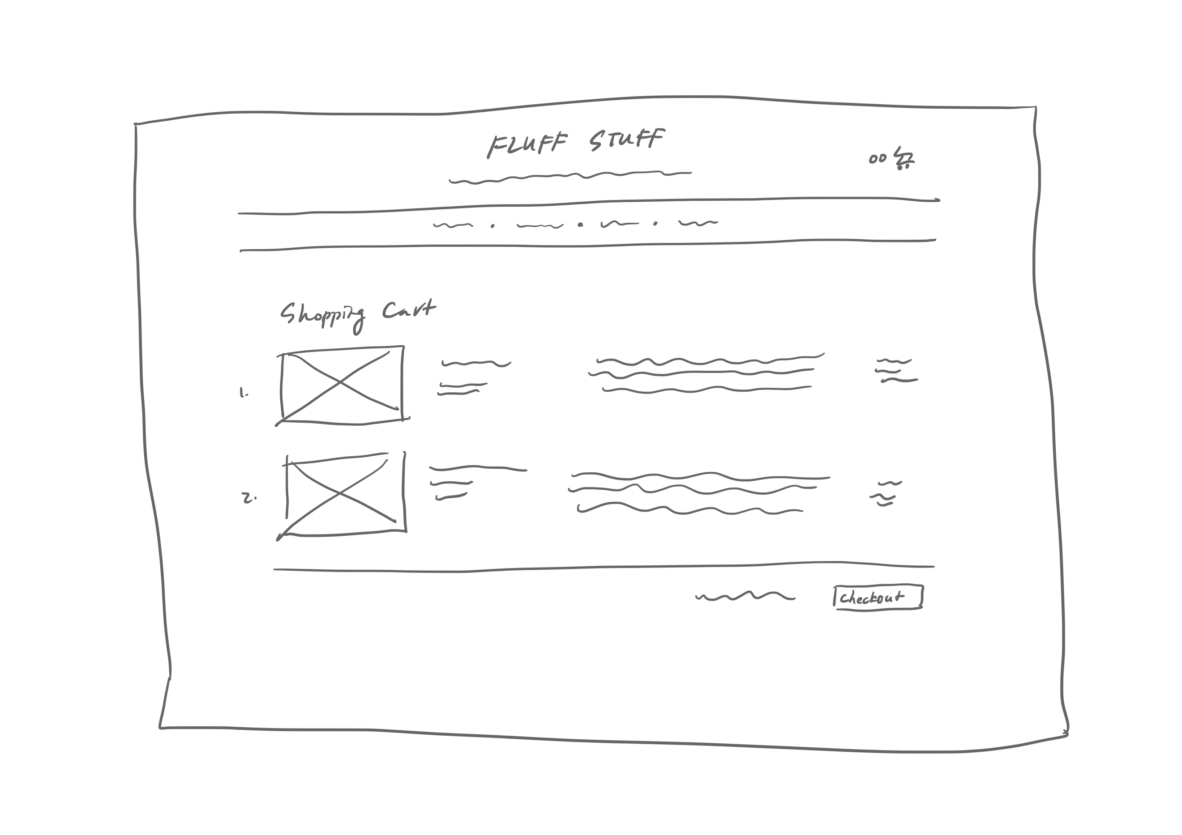

For my low fidelity prototype of the shopping cart (left), I carried over my header section, which included the clickable logo and navigation bar, to my shopping cart page to ensure consistency across the entire website. I placed the shopping cart logo in the top right corner to accommodate website conventions. I decided to go with a table layout for the actual shopping cart, as I believed it provided all the information in the most organized and clear manner. With this design, users can glance across rows to identify each item and their corresponding detail. Going down each column would provide information within the same category, such as price or quantity.

For the high fidelity prototype of the shopping cart (right), I included more details on top of the rough layout and design from the low fidelity prototype. I included a clear heading that identified the page as the shopping cart. Above the title, I added a “Continue Shopping” button that would bring the shopper back to the product browsing page in accordance to the heuristic rule “User Control and Freedom”. I also included a header row at the start of the table with labels for each column, as well as a summary row at the end of the table to provide summary information such as cart total, total quantity, and the checkout button. I also included additional action buttons for each item to lay out all possible actions to the shopper. Finally, I applied the color scheme of grays and browns to the item division lines and buttons to ensure consistency across all web pages.

**Reflection**

This assignment was a bit difficult as I did not have a lot of experience with JavaScript and JQuery prior to this assignment. At the start of coding, I actually had trouble identifying which places to use JavaScript and which to use JQuery, and how to use the two together. I was also unsure of how to apply one main JavaScript page across all my product type pages. I solved this problem by including an ID that identified the product type of each page, and calling on the ID in the main JavaScript file to identify the product before proceeding with any functions. I also struggled for a while with the item removal function, as I had to make sure to remove the exact item that was being selected. I resolved this problem by including an index attribute in each item object when storing them to the cart.

Aside from the writing the JavaScript code and functions, it was time consuming and labor intensive to debug the code. Console in Google Chrome was a great help in testing code and identifying problems, but even then, it was sometimes hard to understand and resolve the identified bugs. I relied on a lot of resources throughout the process. This included lab activities and class resources, such as the To-Do List and animal website activities, and the TA sample provided on piazza. I also referenced external sources such as w3school.com and Stack Overflow when learning more about the functionalities of the various elements in JavaScript and JQuery. Overall, this assignment was really helpful in developing my JavaScript and JQuery skills, as well as learning how the languages fit in with the other components of HTML and CSS that we learned previously.