class4.R

2pmti

2024-10-11

#class4 script  
x <- 1:50  
plot(x)

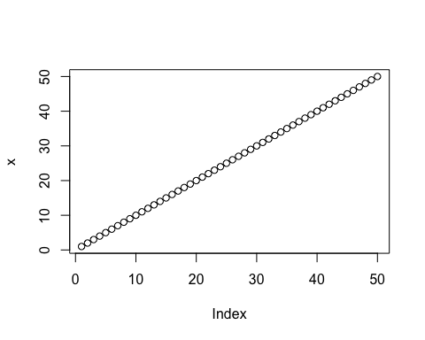

plot(x, sin(x), typ='l', col='green')

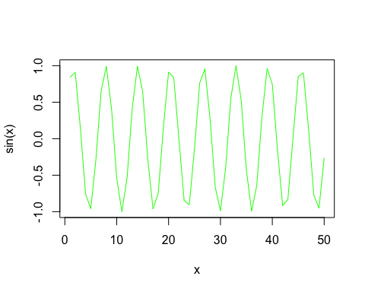

plot(x=x, y=sin(x), typ='l', col='green')  
  
log(10) #this will do default base

## [1] 2.302585

log(10, base=10)

## [1] 1

log(10, 10)

## [1] 1