
SDC HACKATHON 2026
Phase 1: Preliminary Project Proposal
Hosted by Xiamen University Malaysia (XMUM) AI Club
Submission Deadline: 25 October 2026
Instructions: Complete every field below and submit as a single PDF document named “SDC2026_TeamName_Preliminary.pdf” before the deadline above. Answers must comply with the word limits stated for each open-ended question. Incomplete submissions may not be eligible for review.

1. Team & Project Overview
Team Name | bug+work=feature

Selected Domain | Domain 2 – Orbyte Smart SME Challenge (“Less Busywork, Better Business”)

Selected SDG Track (1–17) | SDG 8 – Decent Work and Economic Growth

Project / Solution Name | DealPilot – AI WhatsApp Sales Copilot & Deal Pipeline CRM for Malaysian SMEs

Name (Leader) | Ng Jing Xuan

Email & Phone (Leader) | tiffanyxuan06@gmail.com | [leader phone number]

University Affiliation(s) | Universiti Teknologi Malaysia (UTM)

Number of Team Members | 5

2. Executive Summary & Problem Statement

2.1 The Problem Context
Describe the specific, real-world challenge your team is tackling. Who is affected by this problem, and why does it matter? Highlight the critical social, environmental, or economic issues involved.
[Maximum 250 words]
Malaysia’s micro, small and medium enterprises (MSMEs) generate 39.1% of GDP and employ 7.86 million people – 48.5% of the national workforce (DOSM, 2024). For many of them – aircond contractors, hardware shops, wholesalers and F&B suppliers – the sales counter is WhatsApp, the communication app of 97.7% of Malaysian internet users (Statista, 2022).
Yet every WhatsApp sale is still run by hand. A customer writes “Boss, 3 unit Daikin 1.5HP, can nego sikit?”; the salesperson scrolls an Excel price list, works out totals on a calculator, types a reply, and re-enters the deal into a spreadsheet at night. Four problems follow:
– Slow, error-prone quotes – prices and totals are calculated manually.
– Forgotten follow-ups – in a 2,241-company audit, the average first response to a sales lead took 42 hours and 23% of leads were never answered, while firms that replied within an hour were nearly seven times more likely to qualify the lead (Oldroyd et al., HBR, 2011).
– Margin leakage – reps give ad-hoc discounts that the owner only discovers at month end.
– Double entry – chats, quotes and won orders are re-typed for the bookkeeper and LHDN e-Invoicing.
Accounting software (AutoCount, SQL Account) cannot see WhatsApp conversations, and generic WhatsApp chatbots cannot see the business’s price list, margins or approval rules. The result is lost sales, eroded margins and long unpaid admin hours for small teams – holding back productivity and decent work in the sector that employs half of Malaysia’s workers.

2.2 The Proposed AI Solution
Provide a high-level overview of your proposed application. How does it apply artificial intelligence to solve the problem stated above? Briefly mention the tools or technical skills gained from the SDC Phase 1 workshops (e.g., GenAI APIs, database architecture, cloud hosting) that you intend to leverage.
[Maximum 300 words]
DealPilot is an AI sales copilot that lives inside WhatsApp Web, plus a web dashboard that turns every chat into a tracked deal.
How AI is applied
– Understanding messy chats: a Chrome extension reads the open customer chat; a multimodal LLM (Qwen3-VL-8B-Instruct on RunPod Serverless GPU) detects intent – inquiry, discount request, payment or complaint – and extracts products and quantities from English, Bahasa Melayu and Manglish, including photos of order slips and receipts.
– Drafting replies: the AI writes reply options in different tones; the salesperson inserts one into WhatsApp with one click and decides whether to send. DealPilot never sends a message by itself.
– Deterministic “Layer-B” guard: the AI never calculates money. Prices, totals, discounts, margins and commission are computed in Python from the SME’s own price list, and every amount in an AI draft is checked. Discounts below the margin floor go to an Owner Approval inbox.
What the business gets
– A deal pipeline (Inquiry → Quoted → Follow-up → Payment pending → Won/Lost) with follow-up reminders and recorded loss reasons.
– Owner/Staff roles, an audit log and a commission leaderboard.
– One-click quotation PDFs, won-order CSV and Excel exports with LHDN TIN/SSM numbers for the bookkeeper.
– 60-second onboarding with industry presets and a built-in WhatsApp simulator.
SDC Phase 1 workshop skills we apply
– GenAI APIs: an OpenAI-compatible chat-completions client with prompt design, JSON extraction, retries and a rule-based fallback when the model is cold or offline.
– Database architecture: a relational schema (deals, customers, products, approvals, audit log) in SQLAlchemy 2.0 with versioned SQL migrations.
– Cloud hosting: FastAPI deployed on Replit with keys in Replit Secrets, GPU inference on RunPod, and Supabase sign-in.

3. Technical Architecture & Implementation Plan

3.1 Conceptual Tech Stack
List the technologies, frameworks, APIs, and databases you plan to use to build a functional, deployed prototype. Describe (or attach as an appendix) a simple system block diagram showing how the workshop elements connect into one architecture.
Did your project utilize any official SDC sponsor-provided GenAI API or Cloud Platform? If yes, specify which one and how it is used.
– Frontend (WebApp): HTML5, vanilla JavaScript (ES6+), Tailwind CSS 4 (browser build), IBM Plex fonts.
– WhatsApp integration: Chrome Extension, Manifest V3 (content script + service worker) on web.whatsapp.com, with click-to-chat links (web.whatsapp.com/send?phone=…). No WhatsApp Business API or Meta approval needed.
– Backend: Python 3.12, FastAPI, Uvicorn, Pydantic v2 / pydantic-settings, httpx.
– Database: SQLite through SQLAlchemy 2.0, versioned SQL migrations (001–004) and JSON industry presets; PostgreSQL-ready through DATABASE_URL.
– GenAI API: RunPod Serverless endpoint running vLLM with Qwen/Qwen3-VL-8B-Instruct (OpenAI-compatible /chat/completions) for chat understanding and photo/receipt reading; LM Studio for local development; rule-based fallback.
– Authentication & security: Supabase Auth (JWT verified with PyJWT against the project JWKS; Owner/Staff role), server-side permission checks, append-only audit log.
– Documents & exports: openpyxl (Excel), pypdf (reading PDF orders), built-in quotation PDF writer, CSV export.
– Hosting & DevOps: Replit workspace, Secrets and Deployments (Cloud Run target); public GitHub repository; pytest suite with 272 unit tests.
Sponsor-provided GenAI API / Cloud Platform: Yes. (1) RunPod – all cloud AI inference runs on a RunPod Serverless GPU endpoint (vLLM + Qwen3-VL-8B-Instruct). The backend calls its OpenAI-compatible API to classify intent, extract products and quantities, draft reply wording and read receipt photos; the API key stays on the server. (2) Replit – our shared development workspace and production host: the FastAPI backend and WebApp run as a Replit Deployment, with API keys stored in Replit Secrets.
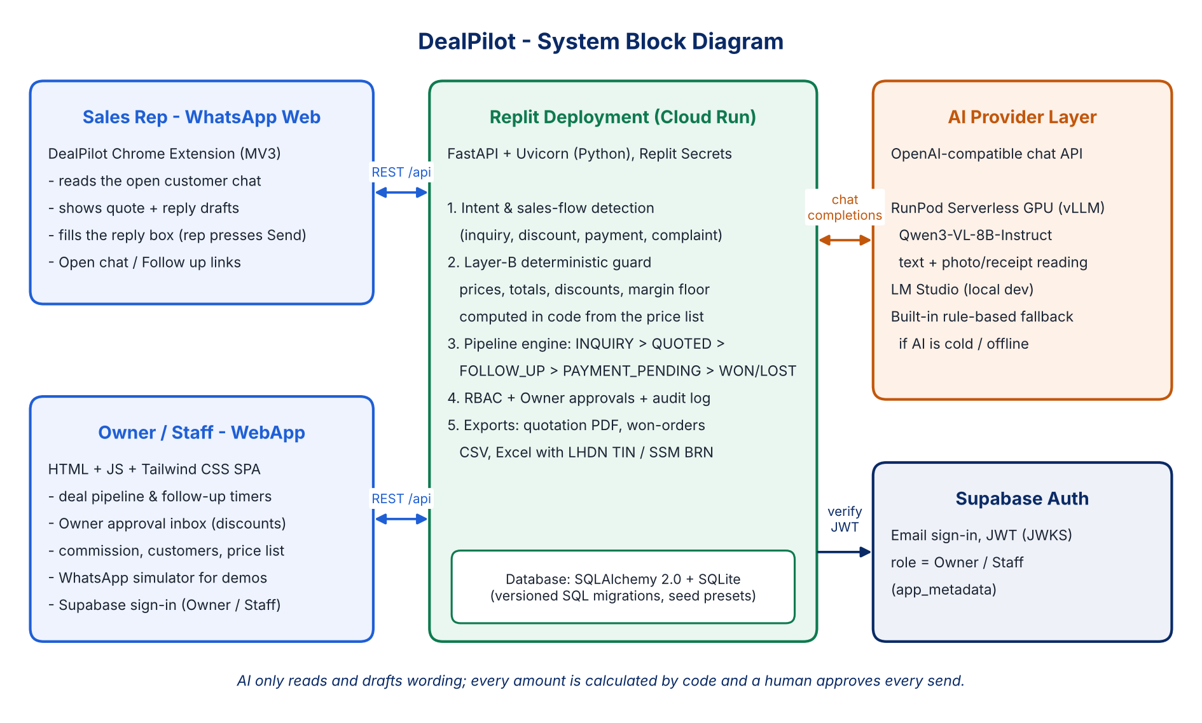
Figure 1. DealPilot system block diagram

3.2 Design-Thinking & Deployment Strategy
Explain how your team applied design-thinking methodology to ensure this solution is technically viable, user-friendly, and ready for real deployment by Phase 2.
[Maximum 200 words]
Empathise: we mapped how Malaysian micro-SMEs (3–20 staff) really sell – on WhatsApp, with an Excel price list and a calculator, while the owner only sees results at month end.
Define: “A salesperson needs to quote correctly and follow up on time without leaving WhatsApp, while the owner keeps control of margins.”
Ideate: our first concept was a cash-and-stock hub. Mentor feedback showed that accountants resist tools that touch their books, and the Domain 2 rubric asks for a capability Orbyte does not already have, so we narrowed to one clear use case: quote → follow up → close, handing accounting a single export file.
Prototype: a Chrome extension instead of the WhatsApp Business API (no Meta verification or template approval, human always in the loop), plus a one-page WebApp.
Test: 272 automated tests, scripted English/Malay/Manglish chats, a WhatsApp simulator and three industry presets.
Deployment-ready: FastAPI on Replit Deployments; RunPod and LM Studio behind one OpenAI-compatible switch with a rule-based fallback; Supabase sign-in with Owner/Staff permissions; secrets kept out of code; a PDPA-aligned privacy notice.

4. Preliminary Environmental & SDG Impact Framework
To align with SDC’s focus on meaningful global sustainability, establish your project’s impact baseline before building the prototype. Use estimated data, published research, or public benchmarks where exact figures are unavailable. Provide the citation of any sources used.
The target, baseline, and KPI you provide here will be used by judges during shortlisting to assess Innovation and Creativity as well as Feasibility of build. Vague or unsupported projections may weaken your case for advancing to Phase 2.

Metric Category | Your Response
Target SDG Sub-Target(s)  Identify the exact UN SDG sub-target your project addresses  e.g., Target 11.6 “Reduce the adverse per-capita environmental impact of cities, focusing on air quality and waste management.” | Target 8.2 – “Achieve higher levels of economic productivity through diversification, technological upgrading and innovation, including through a focus on high-value added and labour-intensive sectors.”  Target 8.3 – “…encourage the formalization and growth of micro-, small- and medium-sized enterprises…” (via LHDN TIN/SSM records and bookkeeper-ready exports).
Current Problem Baseline  What is the starting condition of the problem, expressed as a number?  e.g., “The target infrastructure currently experiences 35% energy inefficiency due to unoptimized scheduling.” | – MSMEs: 48.5% of Malaysian jobs; RM78,035 output per worker (DOSM, 2024).  – Sales leads: 42 h average first response; 23% never answered (HBR, 2011).  – ~10–15 min of manual work per WhatsApp inquiry (price look-up, calculation, typing, Excel re-entry) – team estimate, to be validated in Phase 2 trials.  – Discounts: no margin check until month end.
Core Measurable KPI  The specific unit you will track  e.g., % reduction in power consumption, processing-latency improvement, or kg of resource waste avoided. | – Inquiry-to-quote time (minutes from customer message to a priced quote in the reply box).  – Follow-up coverage (% of open quotes followed up within 48 hours).  – Pricing accuracy (% of quoted amounts matching the price list and margin rules).
Phase 2 Impact Target  Your realistic, percentage-based target by the final prototype presentation  e.g., “20% improvement in computational resource use.” | – ≥60% reduction in inquiry-to-quote time (from ~10–15 min to ≤4 min).  – ≥90% of open quotes followed up within 48 hours.  – 100% of quoted amounts computed by code (zero AI-calculated prices); every below-floor discount routed to owner approval.  Measured: 50 scripted inquiries (English/Malay/Manglish), ≥5 SME users, manual vs. DealPilot.
Sources: Department of Statistics Malaysia (2024), Micro, Small & Medium Enterprises (MSMEs) Performance 2023, dosm.gov.my. Oldroyd, J. B., McElheran, K. & Elkington, D. (2011), “The Short Life of Online Sales Leads”, Harvard Business Review, March 2011. Statista (2022), Favourite communication apps among internet users in Malaysia. United Nations (2017), Global indicator framework for the SDGs, A/RES/71/313.

5. Eligibility & Readiness Checklist
Tick all boxes that apply before submitting.
All team members have completed the mandatory GenAI, Database, and Cloud Deployment upskilling workshops.

 | The project concept addresses a verified real-world problem mapped directly to one or more UN SDGs.
  ✓

 | The proposed solution targets a functional, deployed application rather than a theoretical business case study.
  ✓

 | All fields in this template have been completed within the word limits stated.
  ✓

6. IP & Originality Declaration
6.1 Pre-Existing / Prior-Owned Work
Does this submission include any code, design, research, or other work that any team member created or owned before the start of this hackathon?
☐ Yes ☒ No
If yes, briefly describe what was pre-existing and which team member(s) owned it:
Not applicable – the DealPilot repository was created on 21 October 2026 and all project code, design and content were produced by the team during the hackathon.

6.2 Third-Party Code, Datasets, or Models
Does your project use any third-party code libraries, open-source frameworks, public/private datasets, or pre-trained AI models that your team did not create?
☒ Yes ☐ No
If yes, list them below (open-source use is permitted provided it is declared and properly licensed/attributed):
Name | Type (code/dataset/model) | License
FastAPI, Uvicorn | Code (Python web framework / server) | MIT / BSD-3-Clause
Pydantic, pydantic-settings | Code (validation, settings) | MIT
SQLAlchemy 2.0, SQLite | Code (ORM / embedded database) | MIT / Public domain
httpx, python-multipart | Code (HTTP client, uploads) | BSD-3-Clause / Apache-2.0
openpyxl, pypdf | Code (Excel export, PDF reading) | MIT / BSD-3-Clause
PyJWT (cryptography) | Code (sign-in token checks) | MIT (Apache-2.0 / BSD)
pytest | Code (testing) | MIT
Tailwind CSS 4.1.11 | Code (WebApp styling) | MIT
supabase-js 2.45.4 | Code (WebApp sign-in) | MIT
IBM Plex Sans / Mono | Font (Google Fonts) | SIL OFL 1.1
vLLM (RunPod serverless worker) | Code (model serving) | Apache-2.0
Qwen3-VL-8B-Instruct | Model (pre-trained, not fine-tuned) | Apache-2.0
Qwen3-VL-4B / Qwen2.5-7B-Instruct | Model (local dev via LM Studio) | Apache-2.0
Datasets | None – all demo data is synthetic, written by the team | –

6.3 Employment-Related IP Conflicts
Is any team member currently bound by an employment, internship, or consulting agreement under which their employer could claim ownership of work they create during this hackathon?
☐ Yes ☒ No
If yes, please describe the nature of the agreement and which member it concerns:
Not applicable.

7. Declaration
By submitting this proposal, the team leader confirms that the information provided is accurate to the best of the team’s knowledge and that the project will be original work created during the SDC 2026 hackathon period.

[Signature] – Ng Jing Xuan, Team Leader (bug+work=feature)
Date: 24 October 2026

