
SDC HACKATHON 2026
Technical & Tools Declaration
Hosted by Xiamen University Malaysia (XMUM) AI Club
Submission Deadline: 25 October 2026
Instructions: Declare every API, cloud service, AI tool, dataset, model, and sponsor resource your team used to build the project. Complete every section; where a category does not apply, tick “No” or write “None” – do not leave it blank. Submit as a single PDF document named “SDC2026_TeamName_TechDeclaration.pdf” together with your project submission. Undeclared third-party resources discovered at judging may affect your score or eligibility.

1. Team & Project Overview
Team Name | bug+work=feature
Project / Solution Name | DealPilot – AI WhatsApp Sales Copilot & Deal Pipeline CRM for Malaysian SMEs
Name (Leader) | Ng Jing Xuan
Email & Phone (Leader) | tiffanyxuan06@gmail.com | [leader phone number]
University Affiliation(s) | Universiti Teknologi Malaysia (UTM)
Live Prototype URL | https://dealpilot.replit.app (Chrome extension download: /static/extension.html)
Code Repository URL (public / access granted to judges) | https://github.com/tiffanyxuan06-png/DealPilot (public)

2. Architecture & Technology Stack

2.1 System Architecture Overview
Describe how the components declared in this document connect end-to-end (e.g., user interface → backend → AI model/API → database → cloud hosting). Attach a system block diagram as an appendix if available.
[Maximum 200 words]
DealPilot has two user interfaces that share one backend. (1) The DealPilot Chrome extension (Manifest V3) runs on web.whatsapp.com: when a registered customer’s newest message arrives, or the rep clicks Rescan, it sends the open chat to the backend and shows a priced quote and reply drafts, which the rep inserts into WhatsApp and sends personally. (2) The WebApp (HTML, JavaScript, Tailwind CSS) gives owners and staff the deal pipeline, approvals, customers, price list, commission and exports.
Both call the FastAPI backend over REST, hosted as a Replit Deployment. The backend detects intent and sales stage, then calls the AI provider layer: RunPod Serverless GPU (vLLM serving Qwen3-VL-8B-Instruct through an OpenAI-compatible API), or LM Studio for local development, with a rule-based fallback when the model is cold or offline. Deterministic Python code then computes every price, total, discount and margin from the price list. Data is stored in SQLite through SQLAlchemy with versioned migrations. Supabase Auth issues sign-in tokens that the backend verifies (JWKS) before enforcing Owner/Staff permissions. API keys live in Replit Secrets.
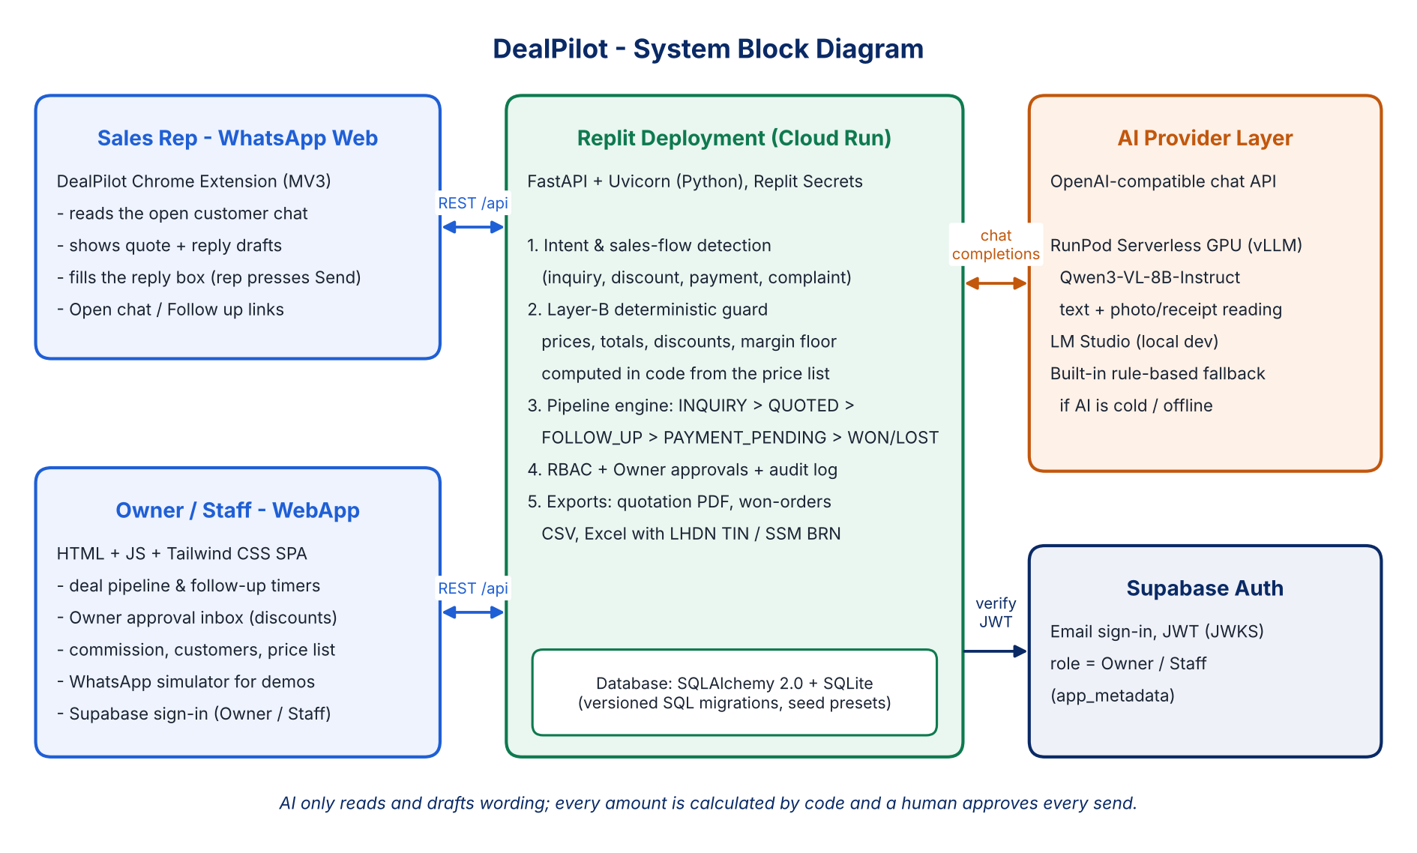
Figure 1. DealPilot system block diagram

2.2 Languages, Frameworks & Libraries
List the main programming languages, frameworks, and third-party libraries that your team did not create. Open-source use is permitted provided it is declared and properly licensed/attributed.
Name & Version | Purpose in Project | License
Python 3.12 (3.11+ supported) | Backend language (Replit runtime) | PSF License
JavaScript (ES6+), HTML5, CSS3 | WebApp and Chrome extension | Open web standards
FastAPI ≥0.110, Uvicorn ≥0.28 | REST API framework and ASGI server | MIT / BSD-3-Clause
Pydantic ≥2.11, pydantic-settings ≥2.0 | Request/response validation; .env settings | MIT
SQLAlchemy ≥2.0, SQLite 3 | ORM and embedded database | MIT / Public domain
httpx ≥0.27 | HTTP client | BSD-3-Clause
python-multipart ≥0.0.9 | File uploads (order photos, receipts, price lists) | Apache-2.0
openpyxl ≥3.1 | Excel export and price-list import | MIT
pypdf ≥4.0 | Reading uploaded PDF orders and invoices | BSD-3-Clause
PyJWT[crypto] ≥2.8 | Verifying Supabase sign-in tokens | MIT (cryptography: Apache-2.0/BSD)
Tailwind CSS 4.1.11 (browser build) | WebApp styling (vendored file) | MIT
@supabase/supabase-js 2.45.4 | WebApp sign-in (jsDelivr CDN) | MIT
IBM Plex Sans & Mono | WebApp fonts (Google Fonts) | SIL OFL 1.1
Chrome Extensions API, Manifest V3 | Extension platform (content script, service worker, storage) | Google Chrome platform terms
pytest ≥8.0 | 272 automated unit tests | MIT

3. APIs & Cloud Services

3.1 External APIs
List every external API your solution calls (GenAI, maps, payments, messaging, data feeds, etc.). Do not include API keys or secrets in this document.
API & Provider | Purpose in Project | Access Tier (free / paid / sponsor-provided)
RunPod Serverless API – OpenAI-compatible /chat/completions (RunPod) | LLM + vision inference: intent detection, product/quantity extraction, reply wording, reading order and receipt photos | Sponsor-provided (SDC)
Supabase Auth API & JWKS (Supabase) | User sign-in; JWT verification; Owner/Staff roles | Free
LM Studio local server – OpenAI-compatible (LM Studio) | Offline AI for local development and testing (localhost:1234) | Free (runs on own laptop)
WhatsApp Web click-to-chat links (Meta) | web.whatsapp.com/send?phone=… opens the customer’s chat; the extension reads the open chat in the browser. No WhatsApp Business/Cloud API is called and nothing is sent automatically | Free
Google Fonts API (Google) | Web fonts for the WebApp | Free
jsDelivr CDN | Delivers the supabase-js library to the WebApp | Free

3.2 Cloud Platforms & Deployment
List every cloud service used for hosting, storage, databases, authentication, or compute, and indicate how the prototype is deployed.
Service & Provider | Purpose in Project | Plan / Region
Replit Deployments – Cloud Run target (Replit) | Hosts the FastAPI backend and WebApp at the live URL (python run_server.py, port 8000 → 80) | [plan, e.g. Autoscale] / Replit-managed [region]
Replit Workspace & Secrets (Replit) | Shared development; RUNPOD_API_KEY, RUNPOD_ENDPOINT_ID and Supabase keys stored as Secrets | Sponsor-provided (SDC)
RunPod Serverless – vLLM worker (RunPod) | GPU inference for Qwen3-VL-8B-Instruct; scales to zero when idle | Pay-per-second serverless, sponsor credits / [GPU type, region]
Supabase Auth (Supabase) | Owner/Staff user accounts and sign-in | Free plan / [region]
SQLite on the Replit deployment | Application database (deals, customers, price list, approvals, audit log) | Included in the Replit deployment
GitHub (GitHub) | Public source-code repository and pull requests | Free

4. AI Tools, Models & Datasets

4.1 AI Models Used in the Solution
List every AI model embedded in or called by your application, including pre-trained, fine-tuned, and self-trained models.
Model & Version | Source / Provider | Usage (pre-trained / fine-tuned / self-trained) | License / Terms
Qwen3-VL-8B-Instruct | Qwen team, Alibaba Cloud (Hugging Face: Qwen/Qwen3-VL-8B-Instruct); served with vLLM on RunPod Serverless | Pre-trained, used as-is with prompts (no fine-tuning) | Apache-2.0
Qwen3-VL-4B-Instruct | Qwen team; run locally in LM Studio (development) | Pre-trained | Apache-2.0
Qwen2.5-7B-Instruct (optional) | Qwen team; alternative local model in LM Studio | Pre-trained | Apache-2.0
DealPilot rule-based fallback (not ML) | Written by the team (backend/services) | Deterministic rules; no training | Apache-2.0 (our repo)
Self-trained / fine-tuned models | None | – | –

4.2 Datasets
List all datasets used for training, fine-tuning, evaluation, or in the running application. State clearly if a dataset contains personal or sensitive data.
Dataset Name | Source / URL | Type (public / private / self-collected / synthetic) | License | Personal Data? (Y/N)
Industry demo presets (aircond, F&B, mock, defaults) | Repo: backend/schema/seeds/*.json | Synthetic (written by team) | Apache-2.0 | N – fictional names, placeholder numbers
Demo WhatsApp chats (English/Malay/Manglish) | Repo: webapp/js/demo_chats.js | Synthetic | Apache-2.0 | N
Prompt few-shot examples | Repo: backend/services/prompts.py | Synthetic | Apache-2.0 | N
SME runtime data (price list, customers, chats, quotes) | Entered or uploaded by each SME user | Private, user-provided; not used for training | Owned by the SME | Y – customer names, phone numbers, chat text, TIN/BRN
Public training / evaluation datasets | None used | – | – | –

4.3 AI-Assisted Development Tools
Tools used to help write code, design, content, or documentation (e.g., chat assistants, code completion tools, image generators). Declaring these tools does not reduce your score; undeclared use may.
Did your team use any generative-AI tool to help create code, design, text, or other project material?
☒ Yes ☐ No
If yes, list them below:
Tool & Version | Used For | Extent of Use (minor / moderate / major)
Claude Code (Anthropic), Oct 2026 | Writing, refactoring and debugging backend, extension and WebApp code; unit tests; README and planning docs | Major
GitHub Copilot (GitHub) | Code suggestions and a few commits | Minor
[other tools, e.g. ChatGPT / Gemini / image generator – add or delete] | [e.g. mascot images, slides, pitch text] | [extent]

Briefly describe how your team reviewed, tested, and took responsibility for AI-generated output:
[Maximum 100 words]
AI-generated changes were made on separate branches and merged into main by team members, mostly through GitHub pull requests, after review. Every change had to pass our pytest suite (272 tests covering pricing, pipeline, permissions, sales flow, the RunPod client and extension behaviour) and was tested by hand on WhatsApp Web and in the built-in simulator with English, Malay and Manglish chats. We kept one firm rule: no AI-written code may let the model calculate prices. The team can explain every module and takes full responsibility for the submitted code.

5. Sponsor-Provided Resources
Declare any official SDC sponsor-provided GenAI API, cloud credits, tools, mentoring, or data that your team used.
Did your project use any official SDC sponsor-provided resource?
☒ Yes ☐ No
If yes, list them below:
Sponsor | Resource (API / credits / platform / data) | How It Was Used in the Project
RunPod | Serverless GPU endpoint (vLLM worker) [+ SDC credits – confirm] | Runs Qwen3-VL-8B-Instruct for all cloud AI: intent detection, product and quantity extraction, reply wording, and reading order and receipt photos.
Replit | Development workspace, Secrets and Deployments (hosting) | Shared coding environment; hosts the live FastAPI backend and WebApp (dealpilot.replit.app); stores API keys as Secrets.

Was the sponsor resource essential to the core functionality of the prototype, or could it be replaced? Explain briefly:
[Maximum 100 words]
Both are used in the deployed prototype: RunPod provides the cloud GPU behind the AI copilot and Replit hosts the live app. Neither is a hard lock-in. The backend talks to any OpenAI-compatible model server, so RunPod can be swapped for LM Studio or another vLLM host by changing environment variables, and if no model is reachable the rule-based fallback still produces quotes while the CRM keeps working. DealPilot is a standard Python FastAPI server (run_server.py) that runs on any host.

6. Security, Privacy & Responsible Use

6.1 Data Handling & Privacy
What user or personal data does your application collect, store, or send to third-party services (including AI APIs)? How is it protected, and how long is it kept? State “No user data is collected” if applicable.
[Maximum 150 words]
Collected: name, email and role of each signed-in user; the SME’s price list, sales reps, commission rates, deals and activity log; and, only for chats with registered customers, the customer’s name, phone number, chat messages, quotes, LHDN TIN/SSM numbers and payment-slip references. Chats with non-customers are not analysed or saved. No bank or card details are collected.
Shared with: RunPod (chat text and the price list without unit costs, to draft replies), Supabase (sign-in) and Replit (hosting). We do not sell data, use it for advertising or train models on it.
Protection: HTTPS, Supabase sign-in, server-side Owner/Staff permissions (staff never see unit costs or others’ commission), an append-only audit log, and API keys held only on the server. Data is kept while the SME’s account is active and deleted on request, as set out in our PDPA-aligned privacy notice (/static/privacy.html).

6.2 Known Limitations & Risks
Identify the main technical limitations of your AI components (e.g., hallucination, bias, rate limits, dependency on a single provider) and any mitigation you have implemented.
[Maximum 150 words]
– Hallucination: the LLM can misread products or invent numbers. The Layer-B guard computes all prices, totals and discounts in code and checks every amount in a draft.
– Manglish/Malay intent errors: few-shot prompts, and a human always reviews and sends each message.
– RunPod cold starts and latency: timeouts plus a rule-based fallback reply.
– Single-provider dependency: one OpenAI-compatible switch (RunPod or LM Studio).
– WhatsApp Web layout changes can break the extension: layered selectors and phone-number links.
– Photo/receipt reading errors: extracted items stay editable; discounts and won orders need Owner approval.
– Scale: SQLite suits the prototype; production would move to managed PostgreSQL.

7. Compliance & Readiness Checklist
Tick all boxes that apply before submitting.
☑ | All APIs, cloud services, AI tools, models, and datasets used in the project are declared in this document.
☑ | All third-party code, datasets, and models are used in accordance with their licenses, and attribution is provided where required.
☑ | No API keys, passwords, or other credentials are exposed in the code repository, prototype, or this document.
☑ | Any use of generative-AI tools for development has been disclosed and reviewed by the team.
☑ | Any use of official SDC sponsor resources has been declared in Section 5.
☐ | The prototype described here is accessible to judges through the links provided in Section 1.
☑ | All fields in this template have been completed within the word limits stated.

8. Declaration
By submitting this document, the team leader confirms that the information provided is complete and accurate to the best of the team’s knowledge, and that every API, cloud service, AI tool, dataset, model, and sponsor resource used in the project has been declared.
[Signature] – Ng Jing Xuan, Team Leader (bug+work=feature)
Date: 24 October 2026

