Tiffany Chan
Insurance Type As Causality For HPV Vaccination Completion Rate Project
Introduction:
This report examines the associations between several predictors and number of unhealthy days reported by study subjects in the 2013 Behavior Risk Factor Suveillance Survey (BRFSS). However, the association between homeownership and number of unhealthy days is the main association of interest. The methods used are based off of Zhou et al’s 2014 article entitled: “Models for Count Data with an Application to Healthy Days Measures: Are You Driving Screws with a Hammer?”. The article’s researchers used linear, logistic, Poisson, negative binomial and zero-inflated negative- binomial regressions to find the best fit model for the 2009 BRFSS dataset. What makes this task difficult is the amount of excessive zeroes, the abnormal distribution, and the amount of over-dispersion found in the number of unhealthy days outcome variable. This report will attempt to follow the article’s suggested models to determine whether the more current 2013 BRFSS dataset will yield the same patterns and results.
Statistical Program and Selection Criteria:
R is the statistical program used in this analysis. Similar to Zhou et al.’s article, only individuals who lived in Alabama, Arkansas, California, Hawaii, Illinois, Kansas, Louisiana, Nebraska, New Mexico, Oklahoma, South Carolina and Wisconsin were included in this analysis. The choice to discount all other states is twofold. First, not all states, as was explained by Zhou et al, had the same questionnaire because some states opted out of asking the optional social context module questions concerning homeownership to their residents. Second, given that there are limitations to the observational cohort study design, it is important to not introduce unnecessary confounders (like state residence) if homeownership or any of the other covariates have a causal relationship with the number of unhealthy days. Whichever state one lives in can determine the decision to own a home or rent an apartment and can affect one’s health. To eliminate the effects of a confounder like living location, individuals within a study sample should all share the same or very similar baseline characteristics (Thorpe, Schooling). For these reasons, residents of extraneous states other than the ones listed were not included in this study. In order to minimize extraneous factors that could potentially cause discrepancies from the true values of the studied associations, the following changes have been made to the 2013 BRFSS variables to match their counterparts found in Zhou et al’s investigation.
Creating the Variables:
Unhealthy Days: There were 2 variables used for unhealthy days: 1) a continuous one for linear, poisson, negative binomial, zero-inflated Poisson, and zero-inflated negative binomial regressions, and 2) a categorical variable solely for logistic regression. The number of unhealthy days was categorized as 0-13 days and 14-30 days for logistic regression and 0-30 days was a numerical/continuous variable for the other models.
Homeownership: For homeownership, there were only 2 categories: 1) home ownership and 2) non-homeownership, which accounts for renting or other living arrangements (such as: group home, staying with friends or family without paying rent).
Household size: Since there was no household size variable in the original BRFSS 2013 dataset, the number of adults and children of each participant’s responses were added to create this variable in an attempt to recreate the conditions presented in Zhou et al’s study. No data was collected about the number of pets the family may own, so it is assumed that the addition of adults and children within a household will suffice. Participants with missing data for number adults or number of children were excluded like shown for the “household size” variable in the article.
Household income: Like the study, missing data was recoded into an “Unknown” category and integrated into the results.
Education: The categories “less than high school”, “high school graduate to 4 years of college” and more than 4 years of college” were created. Students who attended high school but never graduated, those who refused to respond, those who were never asked and missing data, were excluded in order to preserve the education variable found in the article.
Employment status: The study’s participants were divided into “employed”, “unemployed”, “homemaker”, “retired” and “unable to work” categories. Students, those who refused to answer for employment status and missing data were excluded.
Marital Status: Those who were married were assembled into 1 category. Those who were either divorced, widowed or separated were another category, and those who never married were considered the third category. Individuals that did not belong to any of these groups were taken out of the study. Since BRFSS variable names corresponded to the ones in Zhou et al’s study, other listed categories for marital status in the BRFSS codebook were excluded. Those deleted include: individuals of an unmarried couple, people who refused to answer, and people with missing marital status data.
Race: Non-Hispanic Whites, non-Hispanic Blacks, and Hispanics all had separate categories. All other categories were assembled together to create a fourth category and labeled as “Others”. Those with missing data were not excluded from the study.
Age: As was previously mentioned, those who were 34 and younger were excluded from the study sample because they were less likely to own a home. There was no missing data, meaning nobody refused to disclose their age.
Sex: Everyone in the study sample was either male or female. Therefore, only two categories were created and nobody was excluded based on gender.
After coding for all variables, 69970 individuals of 491773 who answered questions for the BRFSS (14.23%) were eligible for this analysis.
ISSUES CONCERNING OUTCOME VARIABLE:
The main issue within this study is the nature of the outcome variable “Unhealthy Days”. 50666 individuals (72.41%) reported 0 unhealthy days, while 12164 (17.38%) reported 1-13 unhealthy days, 6099 (8.72%) reported 14-30 unhealthy days, and finally 1041 (1.49%) did not provide an answer or their responses were missing (Figure 1b). The mean number of unhealthy days was 3.371 days. The median was 0.000 days and the variance is 51.754. Given these results, it is important to realize that the variable is not normally distributed, and highly skewed towards the right (Figure 1a), has a surplus of zeros (Figure 1b), is over-dispersed, and is not truly a continuous variable. These issues will eventually pose problems because they will not always satisfy the conditions of certain regression models. This report will examine the possibility of fitting linear, logistic, Poisson regressions, negative binomial distribution and their zero-inflated model versions with the data.

a.
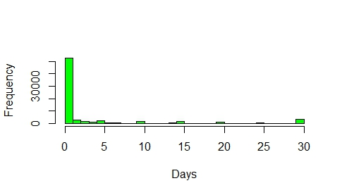
b.
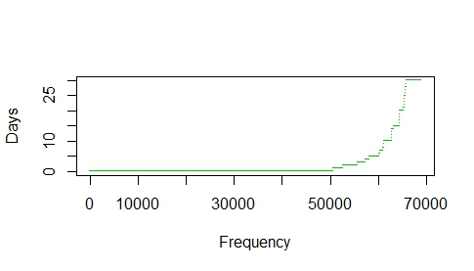
Figure 1a. Histogram showing Abnormal Distribution of Unhealthy Days. b. Plot showing the Frequency of Unhealthy Days.
The results from each regression will first be analyzed, followed by a discussion of whether the findings of Zhou et al’s paper stay true for this 2013 BRFSS dataset.
ANALYSIS:
The following table represents the results found for the association between homeownership and number of unhealthy days in the 2013 BRFSS in 12 states.
Table 1. Regression Model Results for Association between Homeownership and Number of Unhealthy Days in 2013 BRFSS in 12 States.
Model | Parameter Estimate | Std. Error | p | Method of Comparison between Models
 |  |  |  | R-squared
Linear | -0.527 | 0.078 | 1.52E-11 | 0.106
 |  |  |  | AIC | Log likelihood
Logistic | 0.15 | 0.036 | 3.60E-05 | 36523.97 | -18238.98
Poisson | -0.109 | 0.006 | 1.34E-79 | 667566.9 | -333760.5
Negative Binomial | -0.135 | 0.037 | 0.000239 | 198783.5 | -99367.76
Zero-inflated
Negative binomial component | -0.053 | 0.024 | 0.03 | 192604 | -96255
Zero-inflated component | 0.134 | 0.029 | 3.62E-26 | 192604 | -96255
Non-homeownership is the reference category.
Other variables are controlled for.
The rest of this section is dedicated to explaining why certain models are important to consider for this dataset and why others would not work.
ORDINARY LEAST-SQUARES (OLS) LINEAR REGRESSION
One common method to examine the association between a possible exposure and outcome is to use linear regression. This method assumes that the relationship between the independent and dependent variables is linear, that the data is normally distributed and that the variation of observations, or residual standard errors, that surrounds the regression line is homoscedastic or constant. In this study, however, the association between homeownership and number of unhealthy days, controlling for all other variables, does not display linearity, nor is it normally distributed. This can be verified by diagnostic plots plotted in R.

In the “Residuals vs. Fitted” plot, the x-axis shows the predicted or fitted number of unhealthy days (Ŷ) and the y-axis shows the residuals (or errors) (Figure 2a). If linearity is met, the red line shown below should be nearly flat. To verify homoscedasticity, the points should cloud around the line and show no pattern. The red line is not straight and the data does not surround the supposed line consistently. There are more data points around the second half of the red line and barely any under the first half. It could also be said that as the predicted values increase, the residuals or errors do not increase or decrease, but stay constant.
The Quantile-Quantile plot shows whether the data is normally distributed (Figure 2b). The x-axis shows the predicted residuals if the errors were normally distributed, and the y-axis represents the observed standardized residuals. Normal distribution is shown if the data points fall roughly on the diagonal line. In this scenario, the data points start off very close to the line but later wander far from expected. The closeness of the points in the beginning may be due to the excessive zeroes for the number of unhealthy days variable found in the dataset.
The clues provided by the diagnostic plots indicate 3 of the assumptions are already violated, suggesting that linear regression may not be the appropriate model suited for this data.
For the linear model, there are many numerical output extracted values that could be used to describe whether the model is appropriate to describe the data. For example, the multiple R² calculates the approximate variation in y that can be explained by the linear model. Accordingly, the linear model can only explain 10.58% of the variation in number of unhealthy days. The R² associated p-value could also show statistical significance. Since the p-value (<2.2*10⁻¹⁶) is less than the critical alpha of 0.05, this goes to show that the observed results are statistically different from the predicted, which means that another method other than linear regression should be applied.
Normally, for linear regression (an additive model), it would be reported that the mean of unhealthy days for individuals who own a home is lower than those who do not own a home by .53 days, after controlling for gender, household size, age, income, race, education level, employment, and marital status (Table 1). The p-value for this difference is less than 0.05, meaning that it is statistically significant, and that those who own a home versus those who do not own a home are statistically different from each other in regards to the number of unhealthy days. However, because the outcome is not truly a continuous variable but counts, and the relationship is not exactly linear, these linear regression discoveries can be overlooked.
a. b.
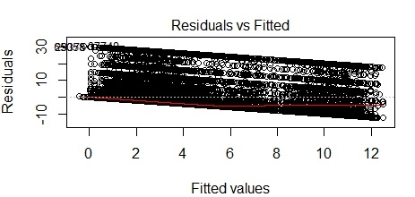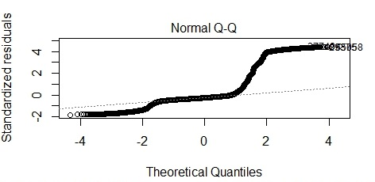
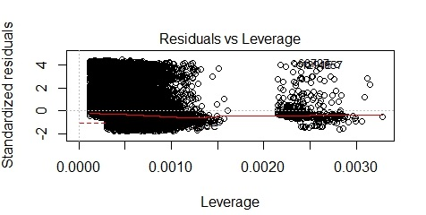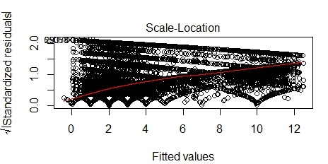
c. d.
Figure 2. Diagnostic Plots for Linear Regression Model. a. Residuals vs. Fitted Plot, b. Normal Quantile-quantile Plot, c. Residuals vs. Leverage Plot. d. Scale-Location Plot.
Since the number of unhealthy days is not normally distributed, there are 2 paths that researchers can take that both involve the use of the generalized linear model (glm) function (Figure 2). The first route or Path 1 indicated in the flow chart below is to use logistic regression and categorize the outcome variable. The second path or Path 2 is to use Poisson regression, then negative binomial distribution if over dispersion or under dispersion exists, and finally zero-inflated models of these two regression models to manage the outcome’s excessive zeroes.
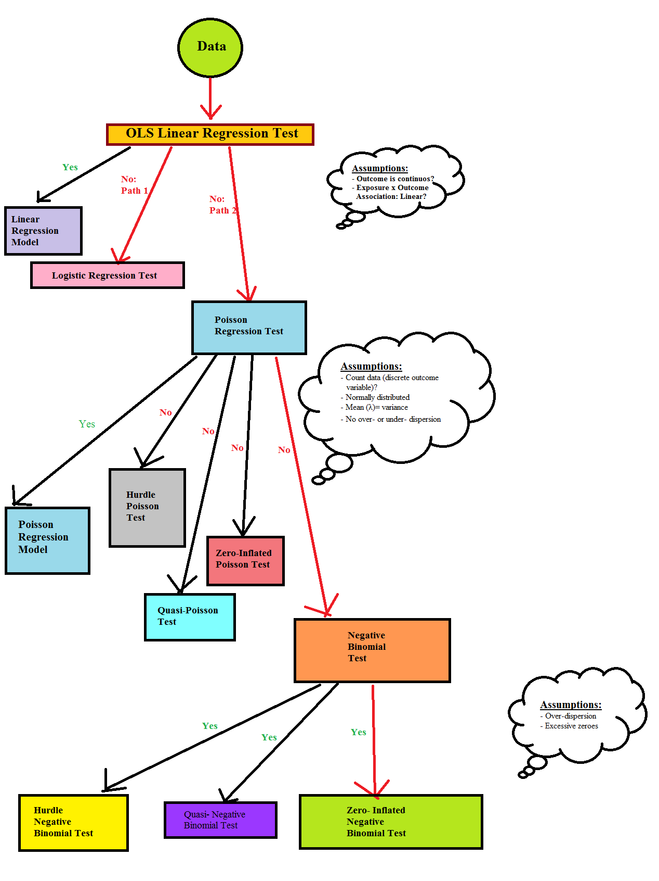
Figure 3. Flow Chart of Different Models One can Use to Test for Model Fit, and Assumptions. The Red Lines Depict the Statistical Journey Taken by Zhou et al.
PATH #1: LOGISTIC REGRESSION
Unlike the linear regression model, the number of unhealthy days are split into different categories for logistic regression. Logistic regression is another common model used to discover whether an association could exist between an exposure, predictors and an outcome. To examine the fit of the model, logistic regression output will usually give values for the null deviance, the residual deviance and the AICC. One can determine the fit by calculating the difference between the residual and the null deviance, and the difference between their degrees of freedom. This would determine if the model with predictors would fit significantly better than the null model (the model with only the intercept). This is also sometimes referred to as the log likelihood ratio test, which was found to be -18331.46 (df=18).
Another method to verify the fit is to compare the residual deviance to the Chi-square critical value at the same degrees of freedom (df= 68250) in a one-tail test. The critical value (68863.86) is higher than the residual deviance (36478), suggesting that the null hypothesis is not rejected and that the model with predictors is adequate relative to the null model.
The model design allows researchers to compare the odds of an outcome for those that are exposed versus those that are not exposed, using odds ratios as the main measure of association. The odds of having suffered 14-30 unhealthy days among individuals who own a home were 16.2% higher than those who did not own a home. It was found that the association between homeownership and unhealthy days was statistically significant (p=3.60*10⁻⁰⁵). Most other relationships, with unhealthy days as the outcome, were also found to be statistically significant. Some exceptions include groups with higher number of household size, with 1 or 2 people being the reference category, Hispanics and other minorities when Non-Hispanic white was the reference category.
Table 1. Reported Rates of Unhealthy Days from Logistic Regression
Variable | Categories |  | OR |  | 2.50% |  | 97.50% |  | p
 | (Intercept) |  | 7.563 |  | 6.235 |  | 9.189 |  | 6.51E-93
Homeownership | Own Home |  | 1.162 |  | 1.082 |  | 1.247 |  | 3.60E-05
Sex | Female |  | 0.734 |  | 0.689 |  | 0.781 |  | 2.12E-22
Household Size | 3 or 4 |  | 0.913 |  | 0.841 |  | 0.991 |  | 0.028381
 | 5 or 6 |  | 1.031 |  | 0.895 |  | 1.191 |  | 0.675746
 | 7 and more |  | 1.035 |  | 0.774 |  | 1.409 |  | 0.822421
Age group | 45-54 |  | 1.028 |  | 0.924 |  | 1.143 |  | 0.60842
 | 55-64 |  | 1.342 |  | 1.202 |  | 1.497 |  | 1.54E-07
 | 65-80 |  | 2.153 |  | 1.901 |  | 2.437 |  | 9.99E-34
Household Income | 25000 to < 50000 |  | 1.347 |  | 1.245 |  | 1.459 |  | 1.59E-13
 | >=50000 |  | 1.796 |  | 1.641 |  | 1.966 |  | 6.37E-37
 | Unknown |  | 1.455 |  | 1.323 |  | 1.603 |  | 1.57E-14
Race | Non-Hispanic black |  | 1.247 |  | 1.135 |  | 1.371 |  | 5.00E-06
 | Others |  | 0.929 |  | 0.842 |  | 1.027 |  | 0.14655
 | Hispanic |  | 0.916 |  | 0.812 |  | 1.035 |  | 0.153854
Education | High School Graduate to < 4 years of college | 1.153 |  |  | 1.006 |  | 1.318 |  | 0.038629
 | >= 4 years of college | 1.357 |  |  | 1.171 |  | 1.57 |  | 4.46E-05
Employment Status | Unemployed | 0.384 |  |  | 0.341 |  | 0.432 |  | 1.08E-56
 | Homemaker | 0.869 |  |  | 0.766 |  | 0.987 |  | 0.029288
 | Retired | 0.81 |  |  | 0.741 |  | 0.886 |  | 4.08E-06
 | Unable to Work |  | 0.172 |  | 0.157 |  | 0.187 |  | 0
Marital Status | Divorced/Widowed/Separated |  | 0.774 |  | 0.723 |  | 0.83 |  | 3.16E-13
 | Never married |  | 0.929 |  | 0.836 |  | 1.034 |  | 0.175295
OR, odds ratio; CI, confidence interval; p, p-value
Reference categories: Do not own home, Male, 1 or 2, 35-44, <25000, Non-Hispanic white,
 | Less than High School, Employed, Married
The logistic regression model has the lowest AIC, and the least negative log likelihood of all models, which would seem to suggest that it is a better fit model for the data than all the other ones explained in this assignment. Unlike the BRFSS 2009 findings, the beta coefficient is positive and the odds ratio suggests an increase in odds of having 14-30 unhealthy days for those who own a home, compared to those who do not own a home, which seems somewhat contradictory to the interpretations of results presented in other models. Further discussion and explanation on these discrepancies is found in the next section.
PATH #2: POISSON REGRESSION
The major issue at hand is the nature of the unhealthy days variable. It is not truly continuous, but rather a discrete variable. Because this variable is discrete, it violates general Ordinary Least Squares (OLS) assumptions. This is why a new model, like Poisson or negative binomial regression, is needed to handle this problem of discrete variables and count data.
Poisson regression is generally a model used for count data but some of its characteristics can be restrictive. The first assumption is that the outcome variable should be normally distributed, which in this case is not because of the excessive zero counts and the very minimal non-zero counts. The other requirement or assumption that is most often not met is that the variance of the outcome variable should equal its mean (λ). The mean was found to be 3.371 days and the variance was 51.754. Another method to check if the mean equals the variance is to examine whether the residual deviance exceeds the degrees of freedom. The residual deviance for this model is 600314 and its corresponding degrees of freedom is 68250. Once when the residual deviance is greater than the degrees of freedom, this would suggest over-dispersion, which would mean that the variance is greater than the mean and that the most restrictive Poisson regression assumption is violated. In most cases, when over-dispersion is found in Poisson regression, researchers will attempt to use negative binomial regression because, in this latter model, the Poisson assumption where the conditional variance of the counts must equal the conditional mean of the counts is lifted.
Though not perfect, the Poisson regression diagnostic plots are an improvement from the ones created for linear regression. In the Residuals vs. Leverage plot, the data points are getting closer to the predicted red line and there are not two separated sets of points, like what was seen previously (Figure 4c, Figure 2c). Also, in the Residuals vs. Fitted plot, as the predicted values increase, the residuals or errors decrease and are closer to the predicted red line, which was not the case in the linear model (Figure 4a, Figure 2a). There are no improvements in the Poisson Quantile-quantile plot however because the data points still taper off from the expected red line around the theoretical quantile of 1.
Poisson regression output for the association between homeownership and number of unhealthy days is statistically significant (p <0.05). If Poisson regression was the correct model to use on this dataset, the difference in the logs of expected number of unhealthy days is predicted to be 0.109 unit lower for homeowners compared to non-homeowners (Table 1).
a. b.
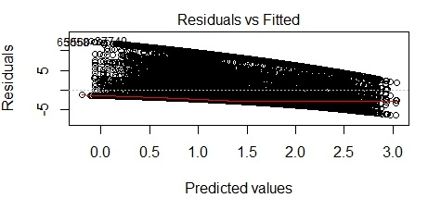 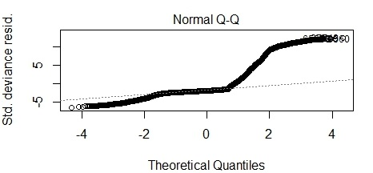
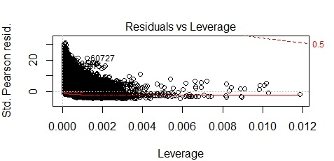 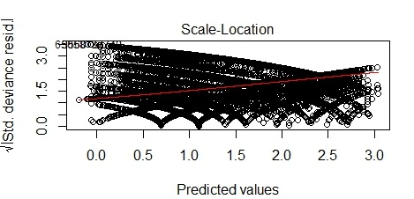
c. d.
Figure 4. Diagnostic Plots for Poisson Regression Model. a. Residuals vs. Fitted Plot, b. Normal Quantile-quantile Plot, c. Residuals vs. Leverage Plot. d. Scale-Location Plot.
The log likelihood for the Poisson model was calculated to be: -333760.5 (df= 23), while the AIC is: 667567 (Table 1). Better fit is defined with log likelihood values that are less negative, or values closer to zero, and lower AIC values. These values could be better if the issues of over-dispersion and the amount of excessive zeroes were addressed.
Since the number of unhealthy days in the dataset does not adhere to both assumptions that characterize Poisson regression, it is necessary to find another model that is more forgiving of the data’s distribution.
From here and onwards, there are many methods that can be used (Figure 3). There is, however, a way to improve the model fit before using negative binomial: make the Poisson regression more robust. This is called the quasi-Poisson model. Because this is done according to maximum likelihood estimation, the coefficients of the Poission regression output are consistent and will be the same, but the standard errors will be corrected. However, it may still ignore the excessive zeroes.
NEGATIVE BINOMIAL DISTRIBUTION:
The other more formal method besides quasi- Poisson regression that treats over-dispersion is to use negative binomial regression. Regression coefficients and standard errors for both these models are very similar. Thus, the two models will have similar predicted means and are both estimated by maximum likelihood (ML).
Since over-dispersion can be treated with negative binomial regression, the diagnostic plots for this model are better than the ones constructed from Poisson regression. Again, the data points are getting closer to the predicted line, the difference between the residuals and the fitted line decrease as the predicted values increase (Figure 5a). Unlike the Poisson Regression and linear regression quantile-quantile plots, the one for negative binomial saw better results (Figure 5b). The data points are closer to the predicted line. The reported log likelihood value (-99367.76, df= 24) and AIC (198784) for negative binomial distribution are also improvements from the Poisson model.
Negative binomial coefficients are interpreted in the same way as Poisson regression parametric coefficient estimates. The coefficient that defines the association between homeownership and number of unhealthy days can be interpreted as: the difference in the logs of number of unhealthy days is expected to be 0.135 unit lower for homeowners than for non-homeowners, while holding all other variables constant. This statistic is also found to be statistically significant.
a. b.
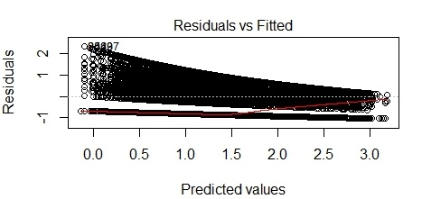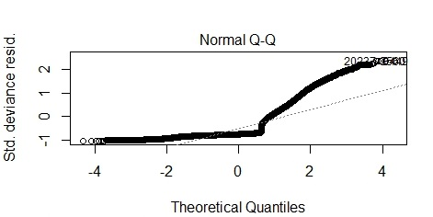
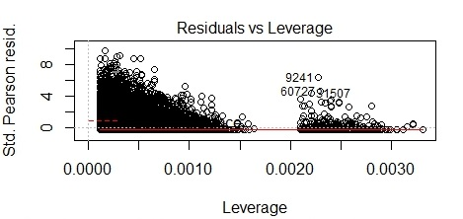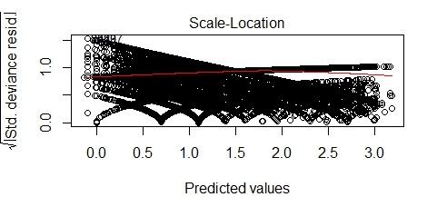
c. d.
Figure 5. Diagnostic Plots for Negative Binomial Regression Model. a. Residuals vs. Fitted Plot, b. Normal Quantile-quantile Plot, c. Residuals vs. Leverage Plot. d. Scale-Location Plot.
Though over-dispersion is treated, negative binomial regression still has not managed the issue dealing with the excessive zeros within the dataset. For this reason, the addition of the zero-inflation feature in the “MASS” package in R to negative binomial distribution may better fit our data.
ZERO-INFLATED NEGATIVE BINOMIAL:
Zero-inflated models help to handle excessive zero counts in the outcome variable. They are these 2-part models where a “zero point mass” is combined with Poisson, or negative binomial regression. In datasets like this one, there are 2 sorts of zeros: count zeros and excessive zeros.
The way in which one can see if the zero-inflated negative binomial model is indeed better than the regular Poisson and negative binomial regressions is to perform the Vuong test. After pe rforming this test on the negative binomial regression and the zero-inflated version of it, results showed that the zero-inflated negative binomial model was significantly better, with a p-value of 2.22*10⁻¹⁶. We can finally conclude, of all the tests perfomed by Zhou et al, that the most suitable Path 2 model for BRFSS2013 data is the zero-inflated negative binomial regression. So, for this assignment, the results for zero-inflated negative binomial regression, will be reported. Homeownership has an expected log count of unhealthy days of 0.053 lower than that of individuals who do not own a home, holding other variables constant. The log odds of being an excessive zero would increase by 0.13 for every additional individual who owns a home in the group of participants.
The figure below shows the residuals vs fitted and quantile-quantile plots for zero-inflated negative binomial regression (Figure 6). As the predicted values increase, the difference between the residuals and the predicted is a lot smaller than what was seen in the other models. In terms of the normal Q-Q plot, it can be observed that the residuals on the left side of the plot are very close to the predicted line, if not on it. Like other models, the residuals start to separate from the expected around the +1 theoretical quantile. However, as was demonstrated with the Vuong test results, the log likelihood and AIC values, these residuals are closer to the predicted line in this model.
a. b.
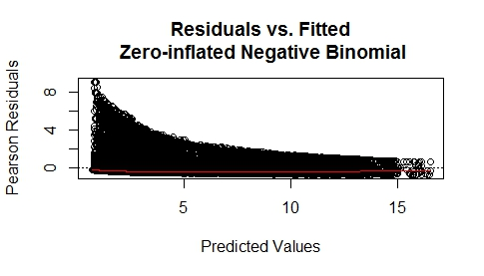 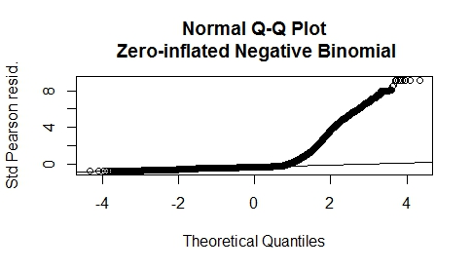
Figure 6. Zero-Inflated Negative Binomial Diagnostic Plot: a. Residuals vs. Fitted Plot, b. Normal Quantile-Quantile Plot.
As witnessed in this report, the zero-inflated negative binomial regression model is not perfect for this analysis, but some models that may rival this method include: quasi negative binomial regression model, and the hurdle negative binomial model (Li et al.). Though the results may be similar, there could be a slight chance that one of these other models could be more appropriate, since both also acknowledge excessive zeros and overdispersion.
DISCUSSION:
From the results seen in this analysis, it can be said that the patterns seen here do parallel somewhat to Zhou et al’s article. The decision to use zero-inflated negative binomial regression in their article is commendable because the results from this last model are superior to linear regression, Poisson regression and standard negative binomial regression due to its management of excessive zeros and over-dispersion. The 2013 BRFSS version of the data displays the same patterns of over-dispersion, abnormal distribution, and excessive zeroes.
Zhou et al’s results for homeownership and number of unhealthy days, controlling for all other variables, were not found to be statistically significant in all models except negative binomial regression. For the 2013 BRFSS dataset, all homeownership- number of unhealthy days associations were found to be statistically significant after performing the same model fittings. Though the BRFSS is a cross-sectional study, having these more recent results be statistically significant could possibly suggest a causal relationship between homeownership and number of unhealthy days. The literature also seems to agree on homeownership or the type of housing as the exposure and health being an outcome (McCarthy et al). Results show that those who own a home and those who do not own a home (what epidemiologists like to call a proxy for the counterfactual) are significantly different in their results of number of unhealthy days. However, given the limitations of a cross-sectional study design, causation is still difficult to prove.
The two contenders for best fit model for this dataset are: logistic regression and zero-inflated negative binomial regression. Logistic regression seems to be the best model for this dataset because of its least negative log likelihood value and its lowest AIC. However, zero-inflated negative binomial is a designed model usually fit for count data with excessive zeroes and over-dispersion. After careful consideration, zero-inflated negative binomial seems to be the best of all the tested models in this assignment. The positive coefficient in logistic regression that denotes the association between homeownership and number of unhealthy days is awkward and does not seem to follow the patterns expressed by other models. It suggests a positive increase in the number of unhealthy days for those who own a home versus those who do not own a home.
The rationale behind the awkward results in logistic regression could be due to the way the outcome variable is handled. Logistic regression handles the outcome of interest differently than any of the other models; number of unhealthy days is categorized and is not a continuous, or discrete variable. The outcome is transformed and may not be completely compatible with models where no change has been made. Those that experience 0 unhealthy days are lumped with those that experienced 13 unhealthy days. Because results are only grouped into two categories, the observed associations between independent variables and dependent variables will probably not be as close to the true values as results from alternative models mentioned in this report that use the continuous outcome variable, where 0 days does not equal 13 days. Logistic regression would probably yield poor validity but good reliability, whereas the other models could potentially achieve good validity with little reliability (Jones). For this reason, the log likelihood and the AIC may not always be reliable in determining the best model for the data.
CONCLUSION:
Defining why there was a shift from 2009 to 2013 in statistical significance between both groups in the association between homeownership and number of unhealthy days may be challenging. A possible reason why there was no significant difference between homeowners and non-homeowners in 2009 may be due the period effect of the housing bubble that lasted from 2007-2009- an economic downturn for the housing market. A period effect in epidemiology is defined as a global (or in this case, national) change in trends that influences the rate or risk of an outcome across all generations and age groups. Period effects are generally caused by population-wide exposures that happen at a specific point in time (Schooling). In 2009, house prices went down, people were unable to pay off their house mortgages and the government allocated 900 billion dollars in the hopes of recovering the dire situation. With the government helping, individuals who were not homeowners may not have experienced unhealthy days. However, 2013 saw a rise in housing prices, and this may explain why homeowners recall less unhealthy days compared to those who do not own a home. For those who are homeowners, they may feel more secure having already own a home, while those who do not unhealthily suffer the high costs of purchasing a home. In order to see whether period effect is affecting the change from 2009 to 2013, more studies using different models like quasi-negative binomial regression, and hurdle models would be useful in verifying the attitude and health of homeowners and non-homeowners in both years.
REFERENCES.
Zhou, Hong., Siegel, P., Barile, J., Njai, R., Thompson, W., Kent, C., Liao, Y. “Models for Count Data With an Application to Healthy Day Measures: Are You Driving in Screws With a Hammer?” Preventing Chronic Disease. 11.130252 (2014): 1-11. Web. October 22, 2014.
Thorpe, Lorna. “EPI 751/PH 820: Confounding and Bias.” April 2014. Powerpoint.
Schooling, Catherine. “Systematic Error: Confounding.” October 2013. Powerpoint.
Li, Shunbiao., Yang, Fang., Famoye, Felix., Lee, Carl., Black, Dennis. “Quasi-negative binomial distribution: Properties and applications.” Computational Statistics and Data Analysis. 55.7 (2011): 2363- 2371. Web. October 22, 2014.
McCarthy, P., Byrne, D., Harrison, S., Keithley, J. “Housing Type, Housing Location and Mental Health.” Social Psychiatry. 20.3 (1985): 125-130. Web. October 22, 2014.
Jones, Heidi. “PH 753:Validity and Measurement in Epidemiologic Research.” November 2013. Powerpoint.
Schooling, Catherine. “Worksheet 2-Age, Period, Cohort Effects.” Handout. Hunter School of Public Health. New York, NY. September 16, 2014.

