Tiffany Chan  Survival Analysis, Modeling for Overall Survival in Breast Cancer Patients  INTRODUCTION:  Breast cancer is the world’s leading cancer type among women. Its severity varies depending on the type of breast cancer, the extent of the disease, and the individual’s age. Survival rates are reported to be high in developed countries, with 89.2% of cases surviving for at least 5 years in the United States (SEER Stat Fact Sheet: Breast Cancer, 2014). In 2012 alone, there were approximately 1.68 million diagnosed cases and 522,000 deaths (World Cancer Report, 2014).  The purpose of this assignment is twofold. The first step is to decide on the best model consisting of a combination of clinical variables that can possibly predict prognosis or overall survival in breast cancer patients. These clinical variables include: age, pgr expression, er expression, her2 expression, grade (the severity of the disease), node (whether the disease has spread to the lymph nodes) and size (the size of the tumor). The data used for this analysis is the UNC4 dataset from the University of North Carolina’s Breast Cancer study described in Prat et al.’s article, entitled "Phenotypic and molecular characterization of the claudin-low intrinsic subtype of breast cancer." The second step of this assignment is to decide whether adding the OncotypeDX score or Oncotype risk category to the model will further increase any prognostic value.  METHOD:  The program used for this analysis is R and given the nature of this dataset, survival analysis was carried out. The main outcome variable is event (whether one has died over the course of the study), and it is accompanied by a “time to event” variable which gives the time it took before an event occurs. Using this information, one can determine which combination of variables maximizes the prognosis prediction in breast cancer participants. The predictors for overall survival for this study include: age, progesterone (pgr) expression, estrogen (er) expression, human epidermal growth hormone (her2) expression, grade, node, and size. However, only few of these listed variables will be best suited for prognosis using the Cox Proportional Hazards model. To determine which variables will be used and which will be excluded, assessment of collinearity between the covariates is necessary. Normally, in assessing collinearity, the relationships between correlated variables can be displayed in a scatterplot. However, since not all variables in this data are continuous, correlations were determined with two-by-two tables and the continuous variables were transformed into categorical ones solely for this purpose. However, all variables retained their original form for Cox proportional hazards regression. Table 1 shows the frequencies and the proportions within each variable, and includes continuous variables changed into categorical ones. All correlated associations between predictors were determined using the categories from this table. Figure 2, on the other hand, are boxplots for the continuous variables. Node-negative patients was the sample used in determining the best Cox model. After the final model has been created, the effectiveness of adding the continuous OncotypeDX score variable to the model will be evaluated against the contribution of the categorical OncotypeDX risk variable. These two additional variables were designed for this analysis by Prof. Waldron from Hunter College in the hope of determining whether they are advantageous in predicting overall survival among breast cancer patients.  DESCRIPTIVE STATISTICS OF SAMPLE AND VARIABLES:  a. Variables for Overall Survival Outcome.  There were in total 305 breast cancer participants in the University of North Carolina data. It was observed that 51 individuals (16.721%) died or “had an event” over the course of observation time, while 189 individuals (61.967%) survived. Additionally, there were 65 individuals (21.311%) who were lost to follow-up and whose survival status is unknown. More than half of the events (72.614%) happened within 0-50 months. As more time goes by, the number of events decrease, suggesting that the distribution is skewed to the right (Figure 1).  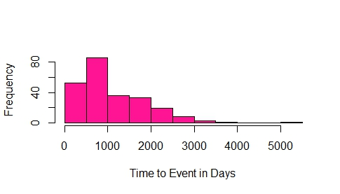  Figure 1. Time to Event (Death) in Days Histogram Shows that the Outcome Variable is Skewed to the Right for Breast Cancer Participants.  b. Predictors.  Apart from survival status, other personal information from the 305 individuals was provided in the UNC data.  Age:  Almost one third (31.148%) of the participants were 60 and older, while the 24-39 age bracket had the fewest amount of participants (9.508%) (Table 1). Boxplots are an efficient method in showing descriptive statistics for continuous variables (Waldron).The youngest was 24 years old and the oldest is 89 (Figure 2b). The mean of the group was 56.96 and the median was 55 (Figure 2b).  Hormone Expression:  In regards to the hormones, expression and non-expression were not evenly observed in “arms” for 2 hormone variables, namely estrogen and human epidermal growth factor receptor 2 hormone (Table 1). Among those who provided information for these two variables, only 60.87% expressed estrogen compared to those who did not and 22.222% expressed human epidermal growth factor receptor 2 hormone versus those who did not. The distributions among those who provided information about expressing progesterone were somewhat even between arms: 109 (46.383%) individuals expressed progesterone versus 126 (53.617%) did not.  There were also predictors that characterized the breast cancer that each individual had within the sample.  (Tumor) Grade:  For those who submitted a response for grade, more than half of the individuals (56.616%) had high grade cancers, which tends to suggest worse prognosis and undifferentiated cells (Table 1). Only 25 people have low grade cancer which is only 10.331% among those who had a response.  Size:  Size refers to the size of the tumor and is a continuous variable that ranges from 1cm to 6cm. The minimum tumor size was 1cm and the maximum size was 6 cm. The mean size was 3.072 cm and the median was 3 cm (Figure 2c). In seeing whether this variable was correlated with any others, the size variable was made into a categorical variable (Table 1) but size was kept as continuous throughout the regression analysis.  Node:  Node refers to whether or not the cancer has spread to lymph nodes or not. This is a binary categorical variable. With or without considering those who had missing information about their node status, the percentage of individuals who are node-positive was very similar to those who were considered node-negative (Table 1).  OncotypeDxscore:  This is a prognostic score and is a continuous variable that ranges from 0 to 100. The minimum score is 0. The mximum score is 100. The median is 53.90 and the mean was 55.98. It is calculated by Professor Waldron using microarray data from the UNC4 study. It is generated from the oncotypedx() function of the genefu.  OncotypeDxrisk:  This categorical variable (Table 1) is based off of the OncotypeDxscore and is also calculated by Professor Waldron using the same method.  a. b.  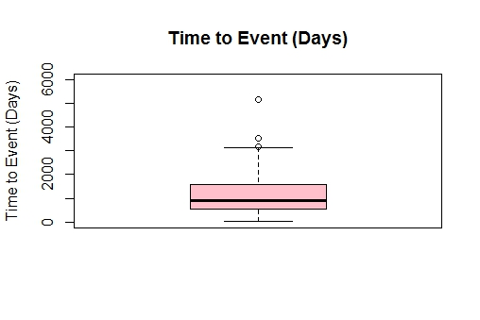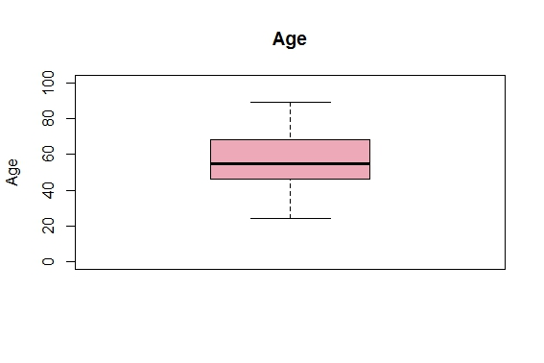  c. d.  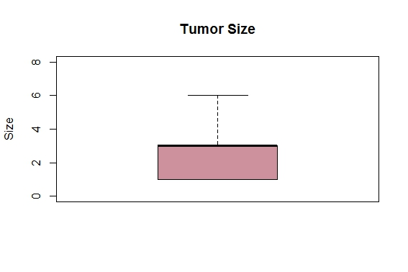 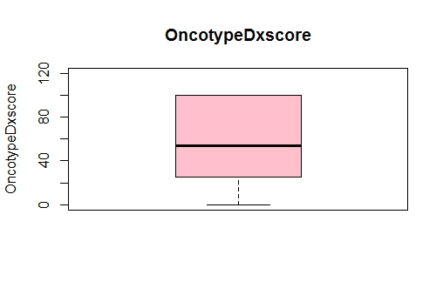  Figure 2. Boxplots of Continuous Variables. a. Time to Event: Minimum number of days to event = 30 days, , Median = 885 days Maximum number of days to event = 5190 days, 1st quartile = 540 days, 3rd quartile = 1590 days. b. Age: Minimum age = 24 years of age, Median age: 55 years of age, Maximum age = 89 years of age, 1st quartile = 46 years of age, 3rd quartile = 68 years of age. c. Size: Minimum tumor size = 1cm, Maximum tumor size = 6 cm, Median tumor size = 3 cm, Maximum tumor size = 6 cm, 1st Quartile = 1.00 cm, 3rd Quartile = 3.00 cm. d. OncotypeDxscore: Minimum score = 0.00, Median = 53.90, Maximum = 100, 1st Quartile = 25.63, 3rd Quartile = 100.  In this data, there are both continuous and categorical variables. As a means of comparison and to view the frequency trends between different variables, the continuous variables were categorized in Table 1 so that they could be viewed in a table alongside the other categorical predictors of overall survival. The original categorical variables include: “Event (outcome variable)”, “Progesterone (pgr)”, “Estrogen (er)”, “Human Epidermal Growth Factor Receptor 2 Hormone (her2)”, “Grade”, “Node”, and “OncotypeDx risk”. The rest of the variables are continuous- “Time to Event (outcome variable)”, “Age range”, and “Size”- were all converted to categorical variables for the frequency table (Table 1).  RESULTS:  Cox Proportional Hazards Model:  The Cox proportional hazards model is a log-linear model used for survival analysis. Survival analysis examines the time it takes for events to occur. The Cox model is a multiplicative model but also has a linear component. For best coefficient and hazard ratio estimates in a Cox regression, it is important to eliminate one variable of a correlated pair of predictors.  Collinearity or Correlation:  Since there are eight predictors for overall survival in this analysis, eliminating some of these predictors is necessary to provide the best Cox model. According to Vittinghoff et al., the inclusion of too many predictors could potentially inflate the standard errors of Cox regression coefficients and the goal is to eliminate variables that are not confounders and variables that have little influence or basically no independent association after adjustment with the outcome.  Establishing collinearity or correlation between covariates is important in determining which variables to keep and which to toss out. When two covariates are collinear, finding out whether these variables are measuring the same theoretical concept is essential because if both correlated variables are included into the model, there could be repetitiveness, meaning that the regression output will account for the variable twice. The best methods to rule out unnecessary factors are to consider the plausibility of a correlated association between both independent variables, to rely on the literature and to use statistical methods to support choices in variable elimination.  Of course, there are certain correlation issues concerning the nature of most of the data set’s variables that cannot be easily justified by available statistical tests. Currently, the common method in showing correlation is using scatterplot, but this is generally useful for continuous variables and not so much for categorical variables. Despite this, correlated relationships can be derived from observing relative frequencies from a regular two-by-two table between both possible categorical correlates (Çetinkaya-Rundel, Iowa State (Carlos)). For example, progesterone expression and estrogen expression were found to be collinear by examining relative frequencies (Figure 3). For example, in Figure 3a, since there are more individuals who expressed estrogen (133) versus individuals who did not express estrogen (71), raw counts cannot be used as a method of comparison. Therefore, calculating relative frequencies will give a better idea whether both variables are correlated. According to Carlos, an easy method to see if two variables are correlated in a table is to observe the proportions in diagonal cells. If the diagonal cells both have greater or smaller column percentages compared to the cells above or below it, this could highly suggest correlation.  Since there are so many pairs of predictors to analyze for correlation, only some important relationships that help to eliminate variables will be described below. For results concerning all potential associations, please refer to Table 2 below.  The Relationships between Progesterone, Estrogen and Human Epidermal Growth Hormone.  a. Progesterone x Estrogen (Figure 3a):  91.55% (65/71) of those who did not express estrogen also did not express progesterone, while 73.684% (98/133) among those who did express estrogen also expressed progesterone. These are large percentages compared to those who expressed one and did not express the other. 26.316% (35/133) expressed estrogen but did not express progesterone and 8.451% (6/71) did not express estrogen but expressed progesterone. This highly suggests that both are correlated. As one is expressed, the other is also likely to be expressed. As one is not expressed, the other is also not likely to be expressed. The Chi-square p-value is a lot less than 0.05, which suggests a strong association between both variables.  b. Progesterone x Human Epidermal Growth Factor Receptor 2 Hormone (Figure 3b):  Among those who did not express her2, the proportions of those who expressed and did not express progesterone are almost equal. 52.22% (94/180) of those who did not express her2 also did not express progesterone and 47.78% (86/180) did not express her2 but did express progesterone. Since they are almost equal, her2 expression does not seem to either express or not express progesterone. Also, the two cells on top have the higher proportions, meaning that for those who do not express her2, a marginal 52.22% (94/180) majority also do not express progesterone and for those who do express her2, 61.22% (30/49) majority also do not express progesterone. There seems to be no trend, suggesting that progesterone and human epidermal growth hormone are not truly correlated, and they are independent of each other. The Chi-square p-values exceeds 0.05, suggesting that the two variables are not likely associated.  c. Estrogen x Human Epidermal Growth Hormone (Figure 3c):  In comparing the relationships between diagonal cells, among those who do not express her2, 33.33% (59/177) also did not express estrogen. 44.68% (21/47) expressed her2 and estrogen. These proportions were less compared to the proportions of those who expressed one of the hormones and did not express the other. Within the group of those who expressed her2, 55.32% (26/47) did not express estrogen. Within the group of those who did not express her2, 66.67% (118/177) did express estrogen. Though these percentages are not as strongly correlated as those seen in the association between progesterone and estrogen, they are however somewhat inversely correlated. As her2 is expressed, estrogen is not that likely to be expressed and as her 2 is not expressed, estrogen is likely to be expressed. These two predictors are somewhat correlated. Like the association found between estrogen and progesterone, the p-value for this association is lower than 0.05.  Progesterone and human epidermal growth hormone are definitely independent of each other and should be variables in the final Cox model, while estrogen seems to be evidently correlated with progesterone and somewhat correlated with human epidermal growth factor receptor 2 hormone, suggesting that its presence in the final model would just distort the coefficients for overall survival.  a.  Chi-squared = 76.2334, df = 1, p-value <2.2e-16.  b.  Chi-squared = 0.9207, df = 1, p-value = 0.3373  c.  Chi-squared = 6.7187, df = 1, p-value= 0.009541  Figure 3a. Two-by-two Table for Progesterone and Estrogen Expression.  Both variables are highly correlated. b. Two-by-two table for Progesterone and  Human Epidermal Growth Hormone. Both variables are not correlated. c. Two-  by- two Table for Estrogen and Human Epidermal Growth Hormone. Both variables  are moderately correlated. The colored cells show the largest proportions or the  smallest proportions in the columns.  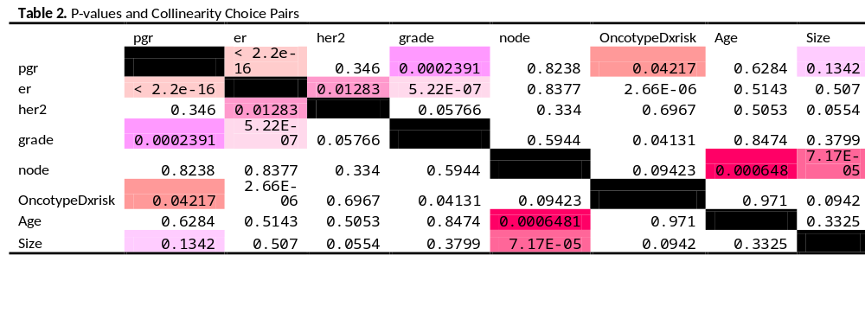  The different pink colored cells show correlated pairs of predictors using the diagonal method suggested by Carlos from Iowa State University. P-values are obtained from Chi-square tests for association.  The following table (Table 3) shows which pairs are collinear according to Çetinkaya-Rundel and Carlos and which pairs have a statistical significant p-value that shows an association between both variables.  Table 3. Correlated Variable Pairs and Chi-Square Tested Associated Variable Pairs  Looking at the different pairs, it is simpler to see which variables repeat themselves more frequently than others and eliminate those for the best Cox model. For example, grade appears twice on the left column and three times on the right column. Since grade is correlated with estrogen (er), and with progesterone, the contribution grade has to offer is probably repetitive or really similar. The same goes for node. Node is correlated with age and size. Age and size only appear once in both columns, meaning that they are more likely independent predictors, whereas node is just another variable that gives the same information that age and size gives. However, because the final Cox model is based off of only node-negative patients, node is not an issue. OncotypeDxrisk is definitely the same or very similar to pgr. Since they do show an association with er and grade from Chi-square tests, it is probably not an independent variable that will give an incredibly high contribution to the Cox model.  Chi-square tests can be a standard used to see if an association between both variables truly exists, even if it does not perfectly assure collinearity. Further discussion concerning Chi-square tests, and correlations will be explained further in the Disucssion section of this report.  UNIVARIATE ANALYSIS  To observe the effects of covariates on certain variables, it is important to first conduct an univariate analysis for every predictor on overall survival. Table 3 displays the hazard ratios of variables using the Cox Proportional Hazards model. |  |  |  |  |  |  |  |  | bveu
  Table 1. Descriptive Statistics of Variables
  Variables | Categories | N | Unweighted Percent (%) | Weighted Percent (%)
  Event | No death | 189 | 61.967 | 78.75
   | Death | 51 | 16.721 | 21.25
   | NA | 65 | 21.311
  Time to Event | 0-50 months | 175 | 57.377 | 72.917
   | 51-100 months | 60 | 19.672 | 25
   | 101-150 months | 4 | 1.311 | 1.667
   | 151-200 months | 1 | 0.328 | 0.417
   | NA | 65 | 21.311
  Age range | 24-39 | 29 | 9.508 | 11.789
   | 40-49 | 61 | 20 | 24.797
   | 50-59 | 61 | 20 | 24.797
   | 60-89 | 95 | 31.148 | 38.618
   | NA | 59 | 19.344
  Progesterone (pgr) | Not expressing | 126 | 41.311 | 53.617
   | Expressing | 109 | 35.738 | 46.383
   | NA | 70 | 22.951
  Estrogen (er) | Not expressing | 99 | 32.459 | 39.13
   | Expressing | 154 | 50.492 | 60.63
   | NA | 52 | 17.049
  Human epidermal growth factor receptor 2 hormone (her2) | Not expressing | 203 | 66.557 | 77.778
   | Expressing | 58 | 19.016 | 22.222
   | NA | 44 | 14.426
  Grade | Low Grade | 25 | 8.197 | 10.331
   | Intermediate Grade | 80 | 26.23 | 33.058
   | High Grade | 137 | 44.918 | 56.612
   | NA | 63 | 20.656
  (Tumor) Size | 1 cm or 2 cm | 61 | 20 | 26.18
   | 3 cm or 4 cm | 129 | 42.295 | 55.365
   | 5 cm or 6 cm | 43 | 14.098 | 18.455
   | NA | 72 | 23.607
  Node | Did not spread to the lymph nodes | 126 | 41.311 | 48.462
   | Did spread to the lymph nodes | 134 | 43.934 | 51.538
   | NA | 45 | 14.754
  OncotypeDx Risk Categorical Variable | Low Risk | 54 | 17.705 | 17.705
   | Intermediate Risk | 41 | 13.443 | 13.443
   | High Risk | 210 | 68.852 | 60
  NA= Missing, Individuals who were lost to follow-up.
  Time to event, age and size were all continuous variables that were categorized so that they could be viewed in a table alongside other categorical variables.
   |  | Estrogen expression
   |  | Not expressed | Expressed | Total
  Progesterone expression | Not expressed | 65 | 35 | 100
   | Expressed | 6 | 98 | 104
   | Total | 71 | 133 | 204
   |  | Human Epidermal Growth Hormone expression
   |  | Not expressed | Expressed | Total
  Progesterone expression | Not expressed | 94 | 30 | 124
   | Expressed | 86 | 19 | 105
   | Total | 180 | 49 | 129
   |  | Human Epidermal Growth Hormone expression
   |  | Not expressed | Expressed | Total
  Estrogen expression | Not expressed | 59 | 26 | 85
   | Expressed | 118 | 21 | 139
   | Total | 177 | 47 | 224
  Correlated pairs looking at relative frequencies, and using diagonal method (Çetinkaya-Rundel, Carlos) | Associated pairs of variables that have statistical ly significant p-values from Chi-square tests
  Pgr x er  er x her2  grade x pgr  grade x er  OncotypeDxrisk x pgr  Size x pgr  Age x node  Size x node | Pgr x er  Er x her2  Grade x pgr  Grade x er  OncotypeDxrisk x pgr  OncotypeDxrisk x er  OncotypeDxrisk x grade  Age x node  Size x node
 | Table 4. Univariate Analysis of Predictors for Overall Survival Using Cox Proportional Hazards Model
 | Variable | HR | 2.50% | 97.50% | Log-rank (p)
 | Pgr expressed | 0.216 | 0.102 | 0.455 | 9.62E-06
 | Er expressed | 0.3 | 0.17 | 0.53 | 1.17E-05
 | Her2 expressed | 2.022 | 1.031 | 3.964 | 0.03656
 | Grade: Intermediate | 1.872 | 0.413 | 8.491 | 0.02072
 | Grade: High | 3.918 | 0.934 | 16.427
 | Node: Spread to the lymph nodes | 3.194 | 1.663 | 6.137 | 0.000232
 | OncotypeDxrisk: Intermediate Risk | 0.635 | 0.22 | 1.829 | 0.6562
 | OncotypeDxrisk: High Risk | 0.964 | 0.487 | 1.909
 | Age | 0.997 | 0.978 | 1.017 | 0.9106
 | Size | 1.403 | 1.17 | 1.682 | 0.000858
 | OncotypeDxscore | 1.004 | 0.996 | 1.012 | 0.3168
Reference categories: Pgr not expressed, Er not expressed, Her2 not expressed, Grade: low
Node: Spread to the lymph nodes, OncotypeDxrisk: Low risk.
Interpreting hazards ratios is somewhat similar but also different from reporting results from linear regression. For example, the hazard ratio of a ten point increase for OncotypeDxscore from Table 4 can be calculated with the formula: e^{β*10}; this would give a hazards ratio of 1.041. The hazards ratio is only sligthtly higher than 1, suggesting a very minimal increased risk or decreased survival but because it is so close to 1, OncotypeDxscore has not much significant effect on overall survival.
There are many methods to test for the proportional hazards function. One method is to plot the Schoenfeld residuals plot for OncotypeDxrisk and see whether the proportional hazards assumption is evidenced by a random distribution with time. If the residuals are not random, then the proportional hazards assumption is not fulfilled. Figure 3 shows the Schoenfeld residuals for OncotypeDxrisk against time and the distribution does not seem random or homoscedastic in nature, signaling that the proportional hazards assumption may be violated.
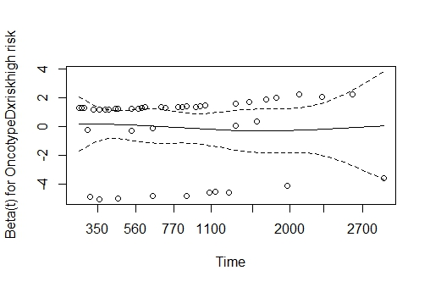
Figure 3. Schoenfeld Residuals Plot for OncotypeDxrisk.
The next step can be to evaluate the relationship between OncotypeDxrisk and time. If the relationship has a non-statistically significant relationship, then the proportional hazards assumption is met. If the association is statistically significant, then the assumption is violated.
The Chi-square test showed that the p-value was below 0.05, which could mean that the proportional hazards assumption is not entirely met.
BACKWARDS STEPWISE SELECTION:
It is clear that in choosing a model, the ideal is to find the best balance between model fit and complexity (Burnham and Anderson, 2002). Backwards stepwise selection is a process that helps to accomplish this because it combines selected variables which can best predict overall survival for the Cox Proportional Hazards model. It is a backwards process that includes all the predictors at first and then at each following step a predictor is removed. The Akaike’s An Information Criterion (AIC) is a generic function that describes the fit of the model and is in this assignment the final means of assessing which combination of variables gives the best fit. According to Stone (1977), the AIC and “leave-one out” crossvalidation are “asymptotically equivalent”.
For this data, the final Cox model should include: progesterone (pgr), human epidermal growth factor receptor 2 hormone (her2), age and size (Table 5). The AIC of the initial model that includes all variables was 61.19693 and it went down to 57.92907 for the final model. Two variables were eliminated: estrogen (er) and tumor grade (grade). Reasonable analysis that explains why these two predictors were eliminated will be discussed later.
Table 5. Backwards Stepwise Selection.
Variables Included in Cox Model | Akaike’s An Information Criterion  (AIC) | Conclusions.
pgr+er+her2+grade+size+age  (Starting Model) | 61.19693 | Take out variables one-by-one to get a better AIC.
pgr+her2+grade+size+age | 59.79456 | Taking out estrogen (er) yields a lower AIC.
er+her2+grade+size+age | 66.24968 | Taking out estrogen (er) yields a lower AIC.
pgr+er+grade+size+age | 63.22979 | Taking out estrogen (er) yields a lower AIC.
pgr+her2+size+age | 57.92907 | Taking out tumor grade (grade) yields a lower AIC
pgr+her2+age | 73.48523 | Taking out tumor grade (grade) yields a lower AIC
pgr+her2+size | 58.17043 | Taking out tumor grade (grade) yields a lower AIC
pgr+her2+age+size (Final Model) | 57.92907 | Final model includes: progesterone  (pgr), human epidermal growth factor receptor 2 hormone (her2), age and size.
RESIDUALS:
There are several diagnostic plots that can visually check for functional form and whether the data fulfills the linear assumption of the Cox Proportional Hazards Model. One of them is the Martingale residual plots (Figure 4).
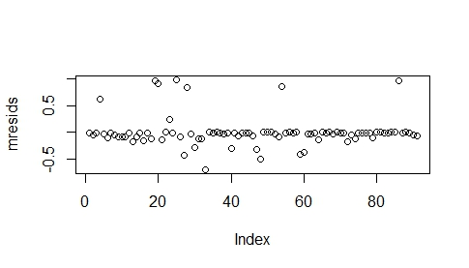
Figure 4. Martingale Residuals Plot for Final Model.
From this plot, it can be observed that the linearity assumption is for the most part satisfied. Normally, in Martingale residual plots, residuals will cloud near zero and show an asymmetrical distribution with a right-sided tail even when the fitted model is correct. This trend seems to be absent from this plot. There are, however few residuals that seem to be extreme outliers.

Generally, the limitation of the martingale residual is the skewness, especially in the single event setting of the Cox Proportional Hazards model. It will have a +1 maximum value but a - ∞ minimum. To achieve a more normally distributive and shapely curve, researchers will usually plot deviance residuals. Deviance residuals are normalized forms of the Martingale residuals. They tend to be more symmetrically distributed about zero and have a standard deviation of 1. Negative residuals have longer than expected survival time.
Since the Martingale residuals plot did show linearity, an even more evenly distribution curve is expected for the deviance residuals plot.
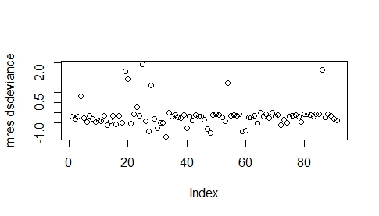
Figure 5. Deviance Residuals Plot.
There is linearity in the deviance residuals plot (Figure 5) but the residuals seem to be more dispersed and the outliers are even more further away from the others in comparison to the Martingale residuals. Large deviance residuals tend to be poorly predicted by the model. In summary, the Martingale residuals plot seems to be more fitting for this analysis in showing linearity. In the Deviance Residuals plot, however, there are a lot of negative residuals, showing that there are a lot of observations with longer than expected survival time.

Another plot is the Schoenfeld (or Schönfeld) residuals plot. What makes this plot different from the other previous ones is that there is a residual for each individual and for each predictor. However, Schoenfeld residuals do not highlight censored individuals. For this analysis, residuals can be plotted according to model object and because there are four covariates in the final Cox model, there will be four different Schoenfeld residuals plots (Figure 6).
a. b.
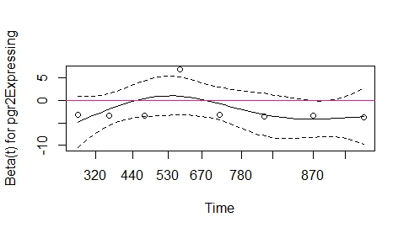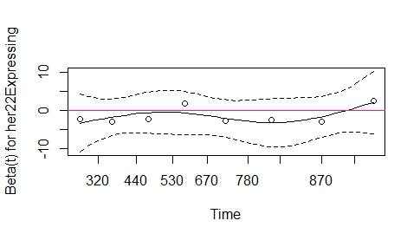
c. d.
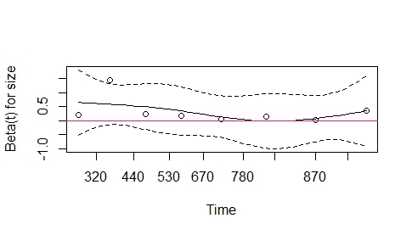 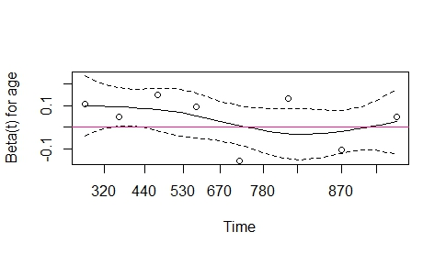
Figure 6a. Schoenfeld Residuals Plot for progesterone (pgr), b. Schoenfeld Residuals Plot for human epidermal growth factor receptor 2 hormone (her2), c. Schoenfeld Residuals Plot for size, d. Schoenfeld residuals plot for age.
The definition of the Schoenfeld residual is the covariate value for the individual who failed minus the expected value. The Schoenfeld residuals’ lowess fit is not perfectly aligned with the zero line but the plotted points for each variable float around the line, suggesting that they are somewhat independent of time and these plots show that the residuals have no pattern with time.
Adding “OncotypeDxrisk” and “OncotypeDxscore” variables to the Cox Regression Model.
As was mentioned before, “OncotypeDxrisk” is a categorical variable and “OncotypeDxscore” is a continuous variable. One of the goals of this assignment is to see whether adding these two variables will add any prognostic value to the final model. For model fit, the Akaike’s An Important Criterion (AIC) can again help to determine whether they improve or exacerbate Cox model fit. The final Cox model that was generated before consists of variables in their original form, that is categorical variables stayed categorical and continuous variables stayed continuous. One issue that was raised during this analysis was infinite beta values when it came to OncotypeDxrisk. This can occur when there are too few events (or in this case, death) in one or more of the categories and it can also occur when there are too few individuals with infrequent events within the reference group. A solution would be to collapse certain categories to make fewer ones so that the number of events becomes more frequent. In this scenario, it can be observed from crosstabs that there is only 1 death in the low risk category (Table 6). Though there is also only one event that that occurred in the intermediate risk category, the decision to merge both the low risk and intermediate risk categories into one was able to resolve the problem. Instead of having comparative results generated for 3 different categories of risk, a comparison can only be made between low-intermediate risk and high risk.
Table 6. OncotypeDxrisk x Event for Overall Survival Outcome.
 | No event (death) | Had an event (died)
OncotypeDxrisk: high | 66 | 10
OncotypeDxrisk: intermediate | 21 | 1
OncotypeDxrisk: low | 18 | 1

The following shows the output of the final Cox model when “OncotypeDxrisk” and “OncotypeDxscore” are separately added (Table 7 and Table 8).

Table 7. Final Cox Model with OncotypeDxrisk
Variable | HR | 2.50% | 97.50%
Pgr Expressed | 0.106 | 0.011 | 1.049
Her2 Expressed | 0.117 | 0.001 | 12.618
Age | 1.042 | 0.99 | 1.096
Size | 1.664 | 0.926 | 2.989
OncotypeDxrisk: High risk | 5.375 | 0.534 | 54.096
AIC | 57.122
HR= hazards ratio
Reference categories: Pgr not expressed, Her2 not expressed, OncotypeDxrisk: Low-intermediate risk.
AIC= Akaike’s An Important Criterion.

Table 8. Final Cox Model with OncotypeDxscore
Variable | HR | 2.50% | 97.50%
Pgr Expressed | 0.076 | 0.006 | 0.962
Her2 Expressed | 0.061 | 0 | 18.051
Size | 1.775 | 0.94 | 3.349
Age | 1.049 | 0.996 | 1.106
OncotypeDxscore | 1.026 | 1 | 1.053
AIC | 55.367
HR= hazards ratio
Reference categories: Pgr not expressed, Her2 not expressed, OncotypeDxrisk: Low-intermediate risk.
AIC= Akaike’s An Important Criterion.
Both variables do improve and add prognostic value to the final model. The OncotypeDxscore decreases the AIC to 55.36747, whereas the categorical OncotypeDxrisk only decreased the AIC to 57.12249. The continuous variable is also a more reliable because when there is categorization, information tends to get lost and measures are not as precise.
In any case, the unadjusted and adjusted hazards ratio for OncotypeDxrisk can still be reported.
Unadjusted Hazards Ratio Interpretation: There are 3.4336 times as many individuals having an event or are dying proportionally to the low-intermediate risk group at any time.
Adjusted Hazards Ratio Interpretation: From the adjusted Cox mode, it can be said that there are 5.375 times as many individuals having an event or are dying proportionally to the low-intermediate risk group at any time after adjusting for progesterone expression, human epidermal growth factor receptor 2 hormone(her2), size and age.
The adjusted hazards ratio is greater than the unadjusted hazards ratio and this is more likely due to the direction of confounding. The confounder that is causing this to happen could have be positively associated with the exposure and negative associated with the overall survival outcome.
KAPLAN-MEIER PLOTS
Within this group of node negative patients, the survival probability curves in the Kaplan-Meier plots between OncotypeDxrisk categories seem to start off very similarly from 0-500 days but they seem to separate from one another visually starting around 500 days (Figure 7). The survival probability drops a little more for those in the high risk than the low-intermediate risk category. The cumulative probability of survival for those in the low-intermediate risk group at 2820 days or 7.83 years was 64.9% and the cumulative probability of death at this time is 35.1%. The cumulative probability of survival for those in the high risk group was 42.6% at 2490 days or 6.82 years was 42.6% and the cumulative probability of death was 57.4%. The cumulative probability estimate in Kaplan Meier includes individuals if they have not been lost to follow up or had died of other causes in the denominator for a given time interval.
To determine if both groups are statistically significant and different from each other, a log-rank test can be performed and the Chi-square statistic and p-value can be obtained.
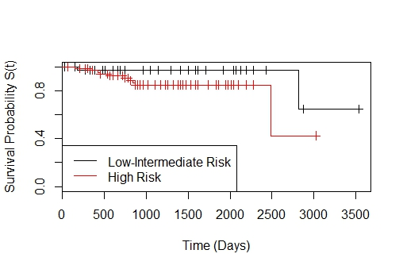
Figure 7. Unadjusted Kaplan Meier Plot for OncotypeDxrisk variable.
The Chi-square statistic from the Log-rank test is 2.6 on 1 degree of freedom and has a p-value of 0.108. If the critical value that determine significance is held at 0.05, then the null hypothesis (H₀) is not rejected and both the low-intermediate risk category is not statistically significant from the high risk category in terms of overall survival time. However, the p-value is marginally significant at the 0.10 critical value. Critical values are somewhat arbitrary, so it may be best if additional tests such as the generalized Wilcoxon Test and the Tarone-Ware Test were performed to ensure whether or not these categorical are indeed not statistically significant (Table 9). The generalized Wilcoxon Test puts more emphasis or more weight on lower values of time, while the Tarone-Ware Test does not really favor any particular values of time.
Table 9. Kaplan-Meier Tests for Statistical Significance Between
the Low-Intermediate Risk Group and the High Risk Group.
Test for Statistical Significance | p-value from Chi-square Test
Log-rank Test | 0.108
Wilcoxon Test | 0.103
Tarone-Ware Test | 0.102
Even after all these statistical tests, all p-values are still bordering the 0.10 critical value. Because it is slightly higher than 0.10, this report will consider no statistical difference in overall survival time between the two groups.
Adjusted Survival Curve:
According to Vittinghoff, adjusted survival curves will look a lot narrower than the unadjusted curves (Figures 7 and 8). The method used here to plot an adjusted survival curves is called: the “average covariate method” (Ghali). The average values of covariates are plugged into a proportional hazards regression equation to get adjusted survival estimates. It can be observed that the high risk category still has a lower survival probability curve than that of the low-intermediate group (Figure 8). The high risk group curve for the adjusted model also has a higher survival probability compared to the high risk curve shown in the unadjusted model.
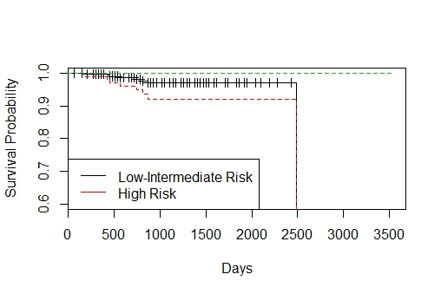
Figure 8. Adjusted Survival Curve of Final Model Covariates
and OncotypeDxrisk.
DISCUSSION:
In terms of epidemiology, the word “association” could mean either causation or reverse causation. Like for a cross-sectional study, only “associations” can be measured because the exposure can cause the outcome to the same extent that the outcome could also cause the exposure. For the cross-sectional study, there is no temporal order and the exposure of interest does not necessarily precede the outcome, so we cannot simply infer causation. In the same sense, the arrow between the two potential correlated variables could point either way in the DAG for this analysis. However, since Vittinghoff et al. already ruled out eliminating confounders, this could only mean taking out mediators will yield a stronger fit for the Cox model (Figure 3). This is sound because mediators are normally not included into regression models for adjustment (Thorpe, Horiuchi).
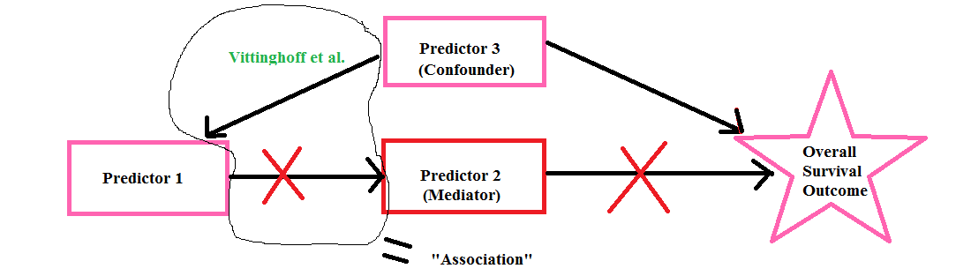
Figure 3. Direct Acyclic Graph (DAG) for Predictors and Overall Survival that Shows which Variables Should be Kept and Eliminated for the Cox Model. The pink variables should be kept within the model for adjustment and the red ones (mediators) should be dropped. According to the DAG and to Vittinghoff et al., predictors 1 and 3 are retained in the Cox model.
To summarize, there is a combination of 3 useful tools that can determine which variables are kept and which are dropped. The first is calculating relative frequencies between all 2x2 relationships. The second is to do a Chi-square test to see if an association exists and lastly, keep an eye open for mediators which are not to be included for adjustment in the final Cox model.
If we were to consider the reasons why estrogen and grade were eliminated variables in the study, it may be because they are mediators to at least one of the other predictors with which they are correlated. From the above results, estrogen can be considered a mediator on the causal pathway between progesterone and overall survival. Progesterone and estrogen have always worked together in the female body to prepare the endometrial lining for pregnancy. Increased progesterone levels will increase the body’s sensitivity to estrogen (Rind). Since both hormones’ functions are so intertwined in the human body, it is not surprising that the effects of estrogen will somehow be a method that progesterone uses to increase overall survival.
For tumor grade, progesterone and/or estrogen levels can stiumulate the growth of breast cancer cells (Susan B. Komen), which can determine the severity of the tumor. Cell differentiation or non-differentiation is a process of cell growth (MCAT: Biology Review Notes, Kaplan). Grade can be a mediator in the DAG between progesterone and overall survival.
Age is often included in regression models,as confounders that need to be adjusted along with variables like gender and race. These variables tend to be highly associated with various health indicators (Horiuchi, Research Note 2).
In terms of Oncotype Dxrisk versus OncotypeDxscore, it is somewhat evident that OncotypeDxscore will provide more prognostic value. OncotypeDxrisk is the categorical variable of OncotypeDxscore. Whenever a continuous variable is categorized, information is lost and the results will not be as valid. As was observed in the correlated pairs and associated variables, OncotypeDxrisk probably gives the same information as the progesterone expression variable. Because OncotypeDxscore is continuous and the results are more varied compared to OncotypeDxrisk, its inclusion in the Cox model will probably add more to the other variables in predicting overall survival than just another categorical variable like OncotypeDxrisk.

CONCLUSION:
Many of these predictors were correlated with one another. Perhaps, other predictors added to the model could have yielded a better and lower AIC than what was found in this report. There are many variables or items that could very well predict overall survival, such as physical exercise, genetics, diet, social economic status. Inclusion of these variables, though they may be difficult to measure, may also advantageously contribute to the Cox model. Since OncotypeDxrisk is correlated with progesterone, and maybe grade and estrogen, OncotypeDxrisk and OncotypeDxscore does not decrease the AIC that much. For this reason, other social factors may provide more information and may yield better estimates in predicting overall survival.
REFRENCES:
National Cancer Institute: Surveillance, Epidemiology and End Results Program, SEER Stat Fact Sheets: Breast Cancer. http://seer.cancer.gov/statfacts/html/breast.html
World Health Organization, World Health Report 2014, 1.1
Prat, A., Parker, J., Karginova, O., Fan, C., Livasy, C., Herschkowitz, J. “Phenotypic and molecular characterization of the claudin-low intrinsic subtype of breast cancer”. Breast Cancer Res 12.5 (2010): R68.
Waldron L, “PH 751: Principles of Biostatistics, Lecture 1: Data” September 9, 2013. Powerpoint.
Vittinghoff, E., Glidden, D., Shiboski, S., McCulloch, C. Regression Methods in Biostatistics: Linear, Logistic, Survival, and Repeated Measures Models. Second Edition. (2012). Web. November 18, 2014.
Çetinkaya-Rundel, Mine. “Exploring Relationships Between Categorical Variables.“ January 9, 2013. YouTube video, < https://www.youtube.com/watch?v=zLHunbpH5Hg>
Carlos. “Meaningful Collinearity”. Web. http://www.public.iastate.edu/~carlos/404/notes/section13.pdf
Burnham, K., Anderson D. Model Selection and Multimodel Inference: A Practical Information-Theoretic Approach, Second Edition, (2002).
Stone, M. An Asymptotic Equivalence of Choice Model by Cross-validation and Akaike’s Criterion, (1977).
Thorpe, L. “EPI 751/PH 820: Confounding and Bias.” April 2014. Powerpoint.
Horiuchi, S. “Research Note 2.” Handout. Hunter School of Public Health. New York, NY. May 2014.
Rind, Estrogen Dominance: http://www.drrind.com/therapies/estrogen-dominance
Susan B. Komen Foundation: Tumor Characteristics: http://ww5.komen.org/BreastCancer/TumorCharacteristics.html

