Tiffany Taylor

June 2, 2020

Classes in Python

Assignment08

GitHub Repo: <https://github.com/tiftaylor/IntroToProg-Python-Mod8>

Classes in Python

# Introduction

Assignment08 through “The Foundation of Programming” course with the University of Washington asks us to read through pre-written pseudocode (by the instructor) and create all code to perform the various tasks laid out by the pseudocode utilizing the ‘class’ feature of python.

# Read the Existing Pseudocode

When I read through the existing pseudo code, I realized this was going to be similar code to our “Task / Priority” script from the previous lesson. To keep me thinking in the correct direction, I opened code from that assignment to help me fill out my new main body of the script section as well as get an idea of some of the functions I’d be using in the IO (presentation) section of the script. Of course, lots of little things would be difference since we are working with a list and not a dictionary, and the menu options for this task are slightly different. But I at used the old assignment to help me create the bones of this current task.

# Main Body of Script First

I found it most useful to add code to the main body of the script first (where we call the various classes and functions). This is because, anything I would write in the Data, Processing or Presentation area of the script, would be used and exist in the main body. I referenced the “Task/Priority” assignment main body script to guide me in answering the pseudocode comments on the new assignment. I changed the names of functions or variables to match the application of Assignment08. Figure 1 shows you how I tried to answer each pre-existing comment in the main body to help shape what I’ll need to work on in the above sections.

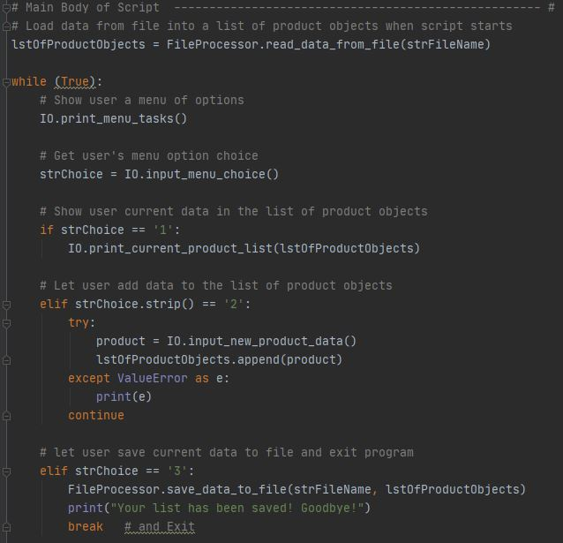

***Figure 1: Building out Main Script First***

# Presentation Section Second

I worked my way backwards up the script and after shelling out the main body, I decided to work on the interaction with the user in the presentation section. I was reminded of the “@staticmethod” use from the previous assignment and followed the previous format. I updated the functions in this section and read through each one to make sure the logic was going to do what I wanted it to. I also took this time to raise any obvious errors I could immediately foresee. For example, in Figure 2, I updated the old assignment code for getting the users data input to be applicable to this assignment and added the condition that if price is left empty to raise a ValueError with a note. We ‘handle’ this raised error in the main body of the script in a Try / Except block to continue back to the main menu when this error is raised.

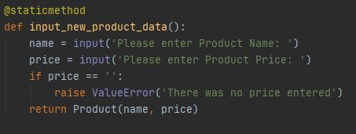

***Figure 2: Updating functions and raising errors***

# Processing & Data Section Last

After fleshing out the user interactions section in the presentation section. I moved up to the processing and data sections of the script to make sure the code will process the user input correctly and that the requests being made in the main body. The toughest part to think about was the Data section in the class Product. This is a fairly tough concept for me to grasp so I had to consult my network (a friend) to help me further understand the course material and the likely expectation for this block of code. I chose to keep it fairly basic and not add any conditionals at this time since I am barely grasping the concept at the moment. In Figure 3 we see my Product class code where we initialize the fields we’ll be using and then create property code for each field to control access to the attributes. I used the double underscore as that calls out a message to other engineers to not mess with ‘this’. Self is referenced to access each instance of the objects we create and make sure whatever data is created and used applies to its “self”.

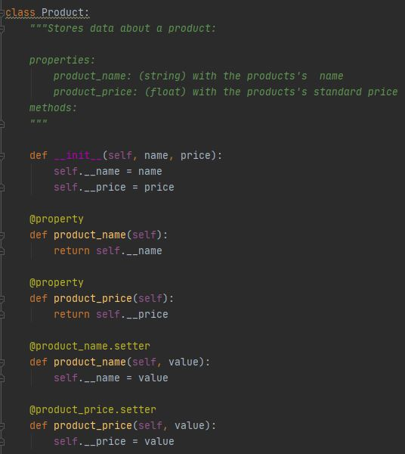

***Figure 3: Product class section***

After writing all the code in these two sections I ran the program for the first time and got the standard FileNotFoundError, which was a great reminder that if it’s the first time it’s being ran, a file doesn’t exist to read! So I added an exception handler in the read_data_from_file function to give us the hint (see Figure 4) that we see it’s your first time here and return an empty list so that it doesn’t shut the program down.

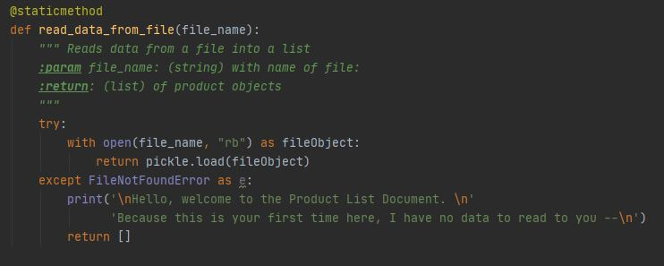

***Figure 4: Handling an error for a first time run***

# Summary

In summary, there are multiple ways to represent (store) data in python. One of these ways is using classes and object instances. This way can give you more control over the attributes (aka fields, aka variables) than dictionaries.