1. Download application process
To install the jWebSocket Management Desk application you should proceed to download the jWebSocket server and client packages (Table 1). jWebSocket Management Desk is included in these packages.
Below in the Table 1, you can see the links containing the installation manuals of the jWebSocket server and client. In this URLs are also the links to download these packages.

Package | Size | Link
jWebSocket Server | 12.4 MB | http://enapso.com/?q=node/156
jWebSocket Client | 13.6 MB | http://enapso.com/?q=node/161
Table 1 - Link of the jWebSocket client and server packages.
2. Setting options

  - Default user configuration
The application has a configurable authentication module. By default is defined the user "admin", with a password "admin" which allows access to the application without making any changes to the settings.

  - Changing the default user settings
If you want modify the authentication module configuration, you must access the folder that contains the jWebSocket server settings. In the settings edit the file "system.xml" located in the folder "SystemPlugIn". This file contains the following default settings:
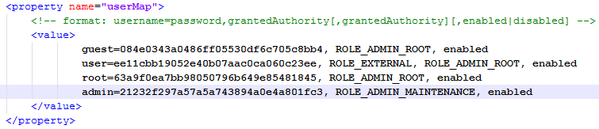
Note: for more information about the folder structure of the server, you can access to Folder Structure section.

To change the "admin" user you should consider the following aspects:
- The password must be encrypted with MD5.
- The credentials required for access to the application is "ROLE_ADMIN_MAINTENANCE".
- The user must be active for the authentication to work correctly.

  - Add a new user in the settings
To add a new user to the authentication module you must access to the settings file mentioned above and add a new line with the desired values. For example, if you want to add an "administrator" user with the "ROLE_ADMIN_ROOT" and "ROLE_ADMIN_MAINTENANCE" credentials the configuration file looks as follows:
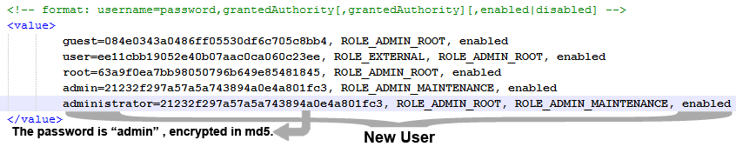

3. Switching on
To run the application you should start the jWebSocket server. In case that the server is running, you must restart the server to make effective the changes.

4. Management of the application
For the administration of jWebSocket Management Desk you can be supported with the user manual located in this link: http://enapso.com/?q=node/161.
In case of any problems during the application installation, contact with:
Alexander Schulze
Fon: +49 (0) 2407 902486
Fax: +49 (0) 2407 902487
Mail: a.schulze@jwebsocket.org

