1. Go to **http://www.revu.co.kr/frontier/** and **sign in with your Facebook account**

* P.S : **You can sign in with ‘**[**Auth Dialog Preview User**](https://developers.facebook.com/apps/189402831149686/roles?role=test+users)**’** (ID : 100004290247078)

* If you don’t use ‘[Auth Dialog Preview User](https://developers.facebook.com/apps/189402831149686/roles?role=test+users)’, you have to create new account with your facebook account

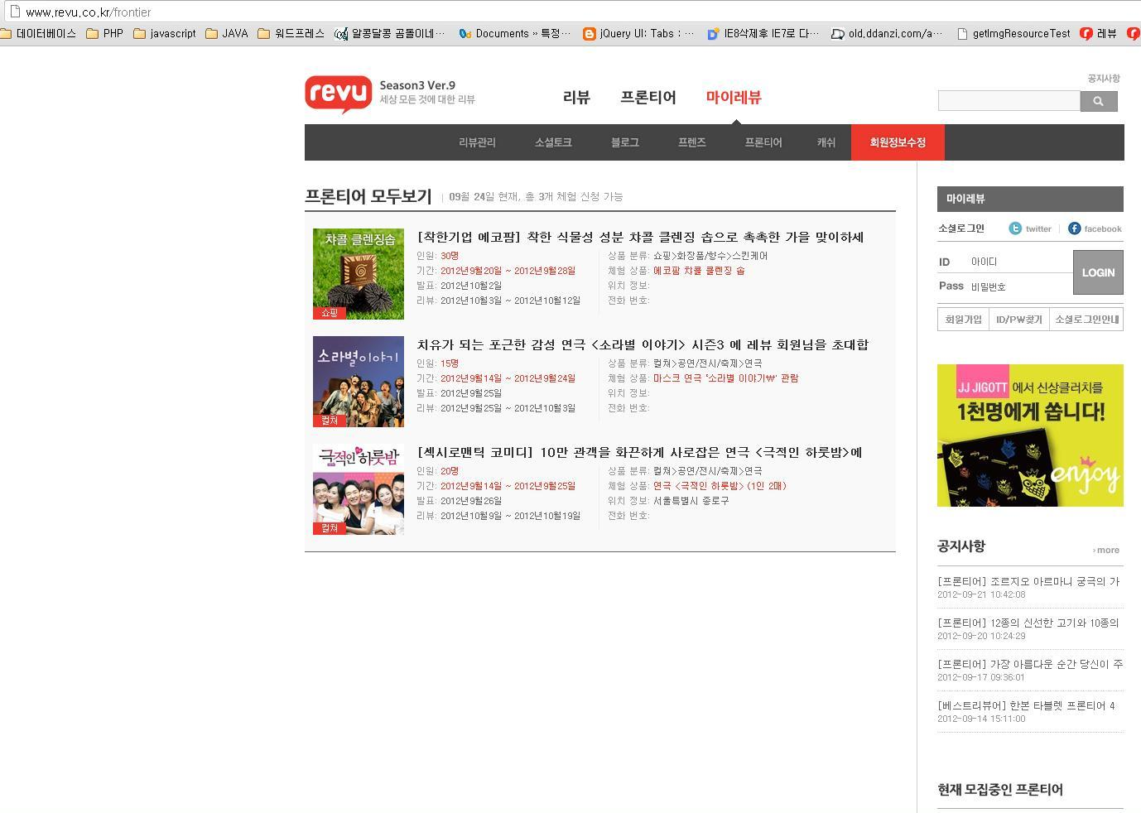

1-1 : **Screenshot** when you signed in with “Auth Dialog Preview User”

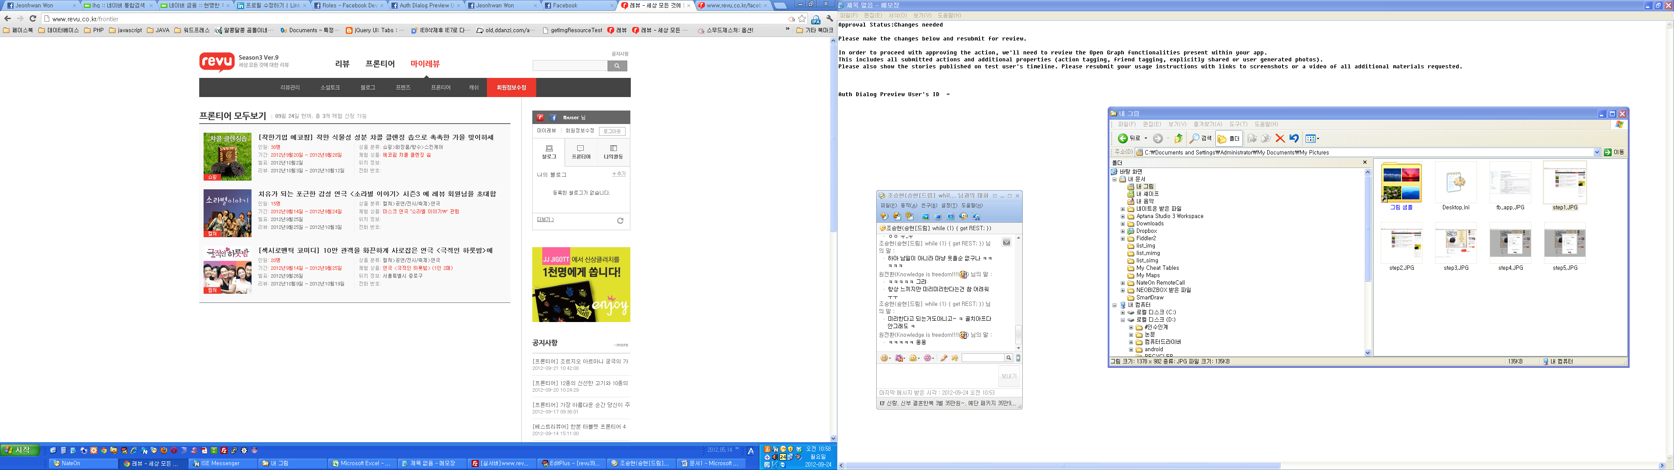

1. **Click** the content you want of the frontiers list



2-2. **Screenshot** when you clicked a content of the frontier list

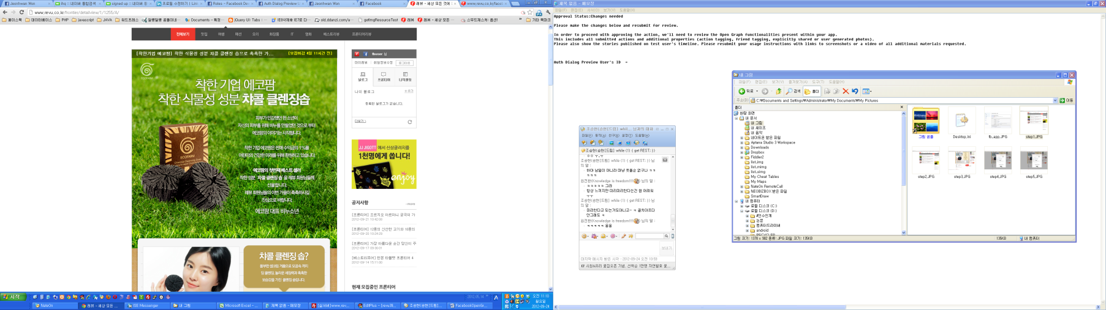

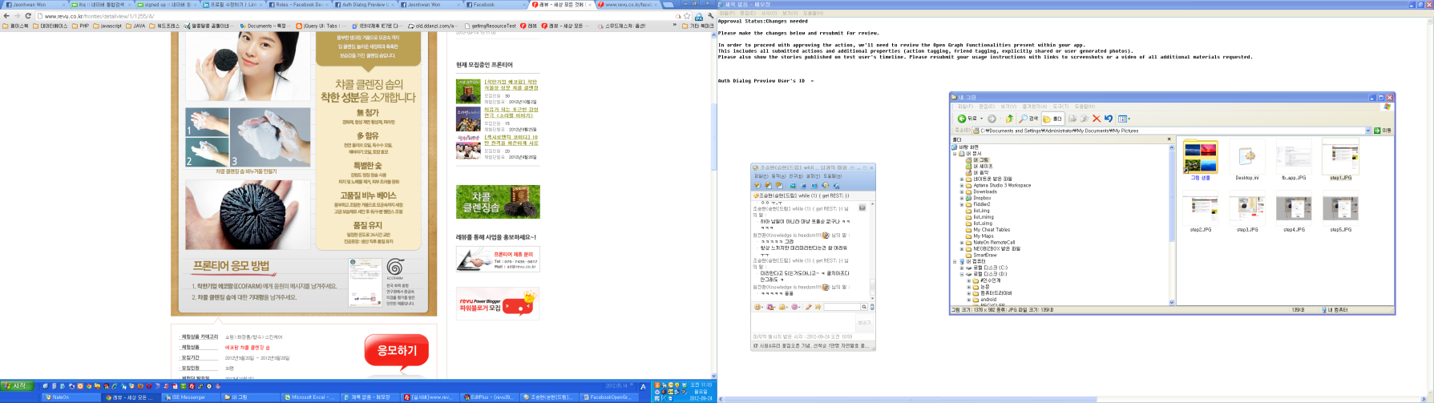

3. **Click the participate(응모하기) button** which is an image button with red color on the center of the site

- The participate button's url : <http://www.revu.co.kr/images/frontier/but_frontier_entry.gif>

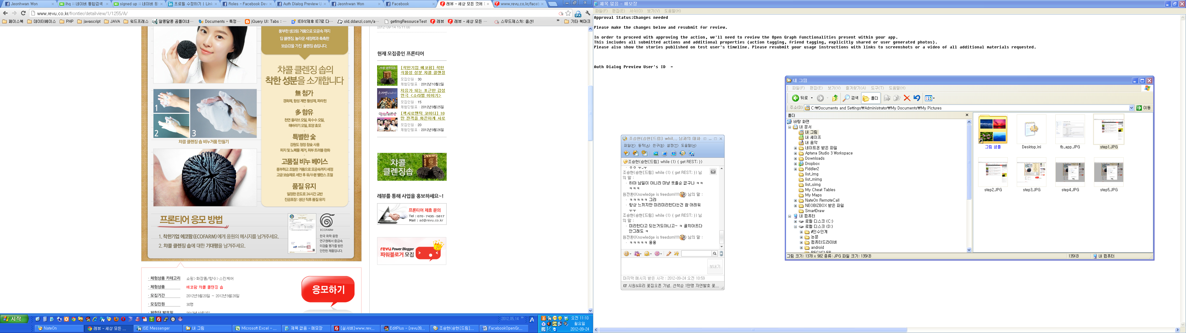

4. Write your detail information(name, phone, talk ...)

- Require field **(1) Talk(토크) , (2) Agree to rule(Checkbox)**

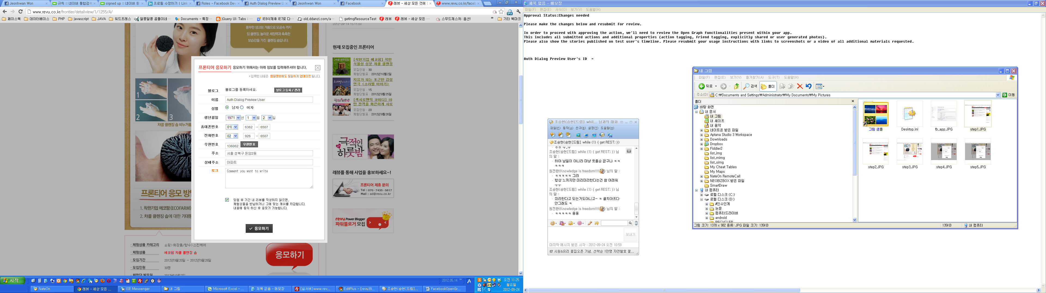

5. Finally, **click the participate button**. frontier's title, link will post to your ClothingApp account and Facebook timeline



P.S : The test ID's number = 100004290247078