便携式X射线机
Portable X-Ray Machine

使用说明书
Instructions

东莞市徳亿鑫电子科技有限公司
Dongguan Deyixin Electronic Technology Co., Ltd.

Preface

- Thank you for using our products.
- Please be sure to read the following precautions before use so that you can use this product correctly.
- Safety precautions:
- In order to use this product correctly, please read the "Safety Precautions" carefully before use.
- The precautions described here record important safety information in detail, please be sure to follow them.
Danger | If you ignore this instruction and use it, it may cause partial or complete damage to the machine.
warn | If the product is used without regard to this instruction, personal injury or damage to the product may occur.
Notice | If you ignore this instruction and use the product, incorrect operation or malfunction may occur.

- 图形标记的示列 warn
warn | Danger, warning and attention information are clearly described in text in the corresponding places.

Product structure, appearance and technical parameters are subject to change without prior notice.
Notice
To prevent danger and ensure safe use of this machine, please pay attention to the following matters:
- Please read the following precautions carefully and use the machine correctly.Before using the machine, please fully understand the operation of the machine before using it.
Do not use or store it in flammable and explosive places.Do not use or store it in an environment where the air pressure,temperature, and humidity exceed the allowable range.
Please avoid tilting, vibration, and impact (including when transporting).Please pay attention to the following matters before using the machine:
Please confirm the connection between the machine and the power supply and check whether the machine is working properly.
Please confirm that the machine is well grounded.
- When a fault occurs, please do not dismantle the machine at will. Stick a note with the words "Fault!" on the machine and contact our company.Do not modify the machine.
Maintenance and inspection
Please check the machine parts regularly.
If the machine has not been used for a period of time, when it is put into use again, be sure to confirm whether the machine is working normally and safely before use.
Environmental protection requirements
Environmental protection precautions:
This machine is an X-ray diagnostic device. During the machine's radiation output, the user should operate in the area behind the imaging, and can also wear effective protective equipment.
This machine meets the electromagnetic compatibility class B. In the living environment, it may cause electromagnetic interference when used. In this case, the user will be required to take some appropriate countermeasures.

1. Overview
The portable X-ray machine (hereinafter referred to as the X-ray machine) is a new type of X-ray diagnostic instrument independently developed by our unit. It consists of a host and an external switching power supply. The host adopts a C-arm structure to increase the object observation radius, and the material is ABS engineering plastic to improve the insulation.
Due to the use of a new type of LCD display X-ray detection equipment with compact structure, high gain and high resolution, a clear perspective image can be observed without a darkroom. The electrical control of the X-ray tube adopts advanced pulse width modulation technology and is equipped with multiple protection measures to improve the accuracy of various indicators, so that the machine has a higher working stability and no noise during operation.
Strict protective measures have been taken to reduce the leakage of X-rays. It is recommended that users be equipped with necessary protective measures.
2. Scope of application
This machine is used for low-dose X-ray inspection and detection.
Note: Pregnant women and patients who are not suitable for radiological examinations are prohibited from using X-ray machines for radiological examinations.

III. Indicators and conditions of use
1. Technical performance:
Effective field of view 5〞（105mm×75mm）
Observation thickness ≤300 mm
Tube voltage selection range 45～90KV manually continuo uslyadju stable
Tube voltage error -10%
Tube current selection range 0.25～0.5mA manually continuously adjustable
Tube current error -20%
Image resolution ≥30lp/cm
Grayscale ≥7 levels
Brightness ≥200lm
Leakage radiation under loading: The leakage radiation of X-ray tube assembly and X-ray source assembly under loading, when operating at nominal X-ray tube voltage under loading conditions equivalent to the specified maximum input energy of 1h, the average air-to-air ratio release energy within any 100cm2 area (main linear dimension not greater than 20cm) at 0.5m from the focal point shall meet the following requirements: For other various X-ray tube assemblies and X-ray source assemblies, it shall not exceed 1.0mGy/h.
2、Environmental conditions
Temperature 10oC--40oC
Relative humidity ≤75%
Atmospheric pressure 700hpa--1060hpa
3、Power supply conditions
Power supply voltage AC220V
Power supply frequency 50Hz±1Hz
Input power ≤200VA
Maximum allowable value of power supply network resistance 0.5 ohm
Power supply network overcurrent release 1 A
4、Dimensions and weight
Main unit (length × width × height) 560 × 210 × 380 (mm)
Aluminum box (length × width × height) 610 × 190 × 470 (mm)
Main unit weight 5 Kg
Gross weight 11.5 Kg

四、Working principle of the instrument
The X-ray machine consists of the parts shown in Figure 1. When the power is turned on and the start button is pressed, the whole machine starts to work. The pulse signal sent by the main controller is amplified by the power, and the voltage doubler circuit generates high voltage to the anode of the X-ray tube. Similarly, the pulse signal sent by the main controller II is amplified to heat the X-ray tube filament, so that the X-ray tube generates X-rays and displays the corresponding kilovolt value (kV/μA) through the digital display panel. At this time, the object to be measured is placed between the X-ray source and the ray receiving box, and the LCD screen displays a clear image of the object to be seen. In order to make the instrument work stably and reliably, the system adopts pulse width modulation technology to keep the tube current and tube voltage constant, and the X-ray tube works in the best state; and adopts high-voltage soft start technology to prevent the X-ray tube anode from high-voltage overshoot. The main controller uses micro-chip devices and works at a frequency of 20KHz, which greatly improves the efficiency of the entire system, eliminates working noise, provides a quiet use environment for operators, and also reduces the size. The external power supply of the X-ray machine adopts a high-frequency and high-efficiency switching power supply and has comprehensive protection measures. To ensure the safe use of the X-ray machine, the machine is equipped with a variety of protection devices to make it run more safely and reliably.
The high-voltage soft-start technology is used to prevent the anode of the X-ray tube from overshooting. The main controller uses micro-chip devices and works at a frequency of 20KHz, which greatly improves the efficiency of the entire system, eliminates working noise, provides a quiet environment for operators, and reduces the size. The external power supply of the X-ray machine uses a high-frequency and high-efficiency switching power supply and has comprehensive protection measures. In order to ensure the safety of the X-ray machine, the machine is equipped with a variety of protection devices to make it safer and more reliable.
五、Schematic diagram of host structure and digital display panel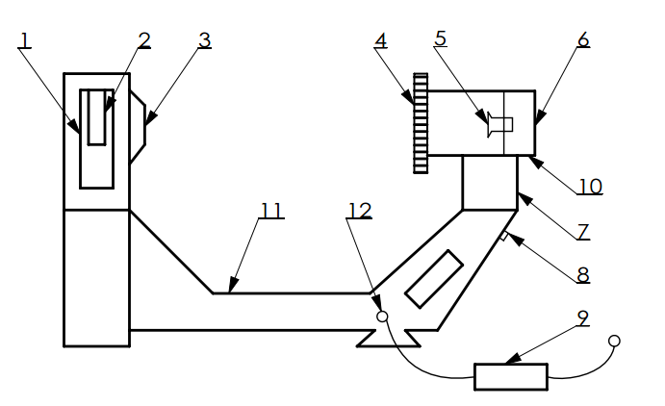
- Lead barrel 2、X-ray tube 3、Collimator 4、Shielding plate 5、CCD Camera 6、Imager
- Digital display panel 8、Working switch 9、Switching Power Supply 10、USB interface 11、frame 12、plug

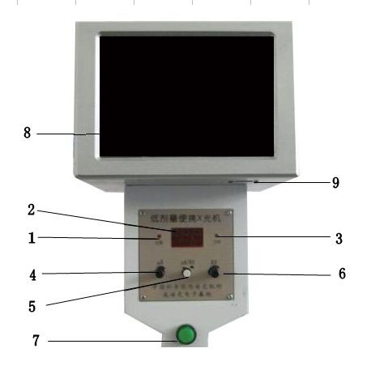
4

 | name | explain
1 | Over temperature indicator | When the instrument exceeds the effective working temperature, the instrument stops working and the over-temperature indicator light turns on.
2 | Three-digit LED digital display | Display X-ray tube voltage/current (KV/μA)
3 | Working indicator light | When X-rays are radiating, the instrument is in working state and the working indicator light is on.
4 | Tube current adjustment knob | Adjust the X-ray tube current clockwise to increase, and vice versa to decrease
5 | Digital display switch | Displays the X-ray tube voltage when not pressed, and displays the X-ray tube current when pressed
6 | Tube voltage adjustment knob | Adjust the X-ray tube voltage clockwise to increase, and vice versa to decrease
7 | Working switch | Press the working switch and the instrument is in working state.
8 | Imager | When in working state, it displays the image of X-ray penetrating the object being measured.
9 | USB interface | Connect to computer via USB cable
Figure 2. Schematic diagram of the digital display panel and LCD

Note: Class I equipment: Equipment that not only relies on basic insulation for protection against electric shock, but also has additional safety protection measures, connecting the equipment to the protective grounding conductor of the fixed wiring in the power supply device, so that the accessible metal parts will not be energized even when the basic insulation fails. Having basic insulation and grounding protection wires is a basic condition for Class I equipment.
Type B equipment: Equipment with a specific degree of protection against electric shock. Special attention should be paid to the reliability of the allowable leakage current and the protective grounding connection (if any). Applicable to instruments on the body surface and body cavity, but the contact part is not insulated. Not suitable for direct use on the heart.
Warning sign.

This graphic symbol indicates that a ray is being emitted or is about to be emitted.
This graphic symbol indicates that this product is a Class I, Type B device.

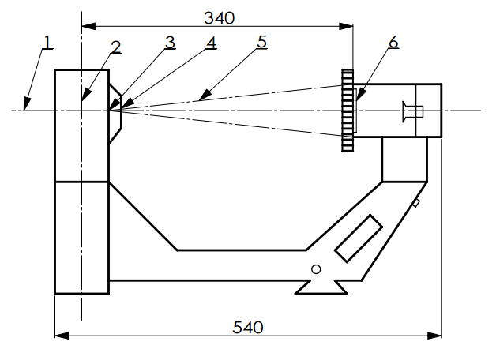
X-ray protection diagram
1. Reference axis 2. focus 3. Total filtration (2.5mm aluminum) 4. Beam limiter (1.0mm lead)
- Beam limiter 6.Lead Glass

X-ray tube parameters:
Nominal focal spot: 0.8 mm Target angle: 19º
Maximum operating voltage: 90 kV Anode heat capacity: 7 kJ
Maximum operating current: 2.0 mA
● X-ray tube initial loading test method:
Before loading into the whole machine, clean the X-ray tube and blow it dry.
Add filament voltage of about 3V, wait for 1 minute, then gradually increase the high voltage to 50kV, and stabilize the anode current at 1mA. If there is no spark, continue to increase to 55kV, wait for 1 minute, no spark, then increase to 60kV, wait for 1 minute, no spark, then increase to 65kV. Wait for 1 minute, no spark, then increase to 70kV, wait for 1 minute, no spark, and the aging is completed.
X-ray tube transportation and storage conditions
Transportation: According to customer requirements, it can be transported by car, train, air and sea, etc., and should be shipped as glassware or instruments.
Storage: The packaged X-ray tube should be stored in a clean room with a temperature not lower than 5°C, a relative humidity not greater than 80%, and no corrosive gases and good ventilation.
- Transportation: It can be transported by car, train, air or sea according to customer requirements. It should be shipped as glassware or instruments.
- Storage: The packaged X-ray tube should be stored in a clean room with a temperature not lower than 5°C, a relative humidity not higher than 80%, no corrosive gas, and good ventilation.
X-ray tube model: CT27-0.8/70.
六、How to use
Warning: Read this chapter carefully before use. The equipment has been debugged before leaving the factory. It is recommended to adjust according to the instructions in this manual. If there are any unsolvable problems, please stop adjusting immediately and contact the manufacturer.
1. Before use, first check whether the appearance of the instrument box is damaged during transportation. Unpack and check whether the host has any signs of collision damage.
2. Then take out the host, place the shielding plate on the front of the X-ray receiving box, and tighten the fasteners to fix the shielding plate.
3. Turn on the power of the whole machine (the machine end is connected to the aviation plug, and the male groove and the female protrusion can be aligned before insertion. See Figure 5; the other end is connected to a three-hole single-phase power socket with a ground wire), the switch power indicator light is on, the host digital display head is on, and the LCD imager screen is lit in a dark color.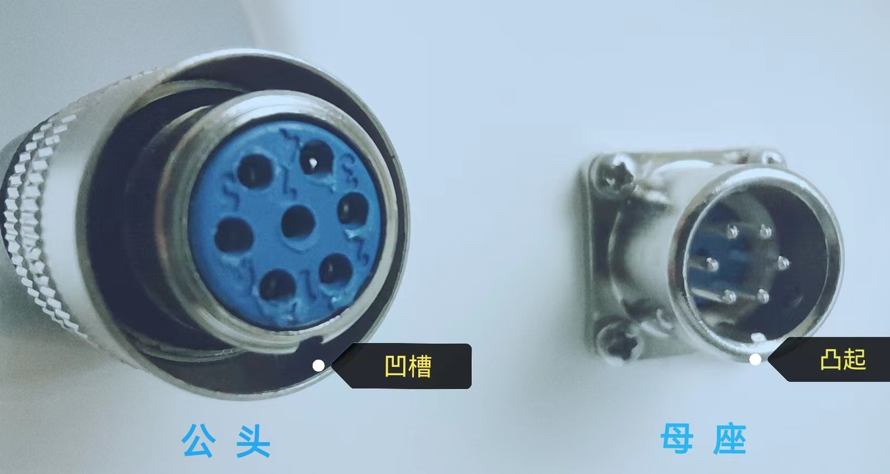
4. Press the start button, and the digital display will show the anode voltage (KV) or anode current (μA) of the X-ray tube (depending on the selected conversion switch). Press the conversion switch to display the anode current, and press the conversion switch again to display the anode voltage, indicating that the instrument is working properly. At this time, the LCD screen is bright gray.
5. Place the object to be measured between the voltage multiplier and the X-ray receiving box (the object should be as close to the X-ray receiving box as possible), and you can see the perspective image of the object on the fluorescent screen.
6. Adjust the tube current adjustment knob on the digital display panel to rotate clockwise, the anode current value increases, and counterclockwise to reduce the anode current value. Adjust the tube voltage adjustment knob to rotate clockwise, the anode pressure value increases, and counterclockwise to reduce the anode pressure value, until the image clarity on the imager is satisfactory.
7. Under the premise of ensuring the clarity of the image, low anode current value and low anode pressure value should be used for perspective as much as possible.
8. When you press the start button by hand, the X-ray tube emits rays, and the working indicator light on the digital display panel lights up. Release the start button or the timing time is up, and the X-ray tube stops working (the timing is set to automatically stop the X-ray output at about 1 minute. If you want to start the X-ray output again, repeat the above operation).
9. This instrument is an intermittent loading continuous working instrument. If the cumulative working time is long or the working environment temperature is too high and exceeds the effective working temperature range of this machine, the machine will automatically shut down the output of the radiation source. At this time, the over-temperature indicator light on the digital display panel will light up. The work can only be resumed after the temperature of the high-voltage radiation source part drops. The downtime depends on the ambient temperature.
10. During fluoroscopy, try to keep the patient away from the radiation focus and close to the X-ray receiving box to reduce the dose absorbed by the human skin (see Figure 6).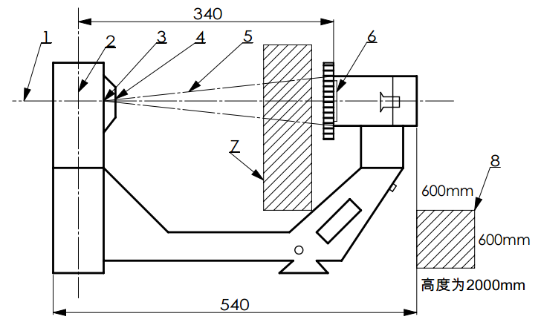
图六、X射线操作位置示意图

1. Reference axis 2. focus 3. Total filtration (2.5mm aluminum) 4. Beam limiter (1.0mm lead)
5. Focus distance 6.Lead Glass 7.Patient or object to be measured 8.Operator position
11、Battery (optional) Note: When using the battery for power supply or charging, you must press the battery switch (the switch is located on the side of the machine, see Figure 7). The battery warranty is three months.

12. If you use the computer connection function (see Appendix A).
VII. Maintenance
1. Daily maintenance and care
The X-ray machine should be placed in a clean room without corrosive gases. When not in use, it should be covered with a dustproof cloth or plastic cover, or placed in a box. The surface dirt should be cleaned with a fine gauze and detergent. Do not wipe the surface with alcohol or acidic or alkaline reagents to avoid damaging the surface finish of the X-ray machine.
2. Maintenance and care during operation
Strictly operate the X-ray machine according to the requirements of the instruction manual during operation.
3. Maintenance and care during long-term parking Parking environment
a. Ambient temperature: 10℃-40℃
b. Relative humidity: ≤75%
c. Atmospheric pressure: 700hPa-1060hPa
4. Environmental protection requirements
Environmental protection precautions:
This machine is an X-ray diagnostic device. During the machine's radiation output, the user should operate in the area behind the imaging, and can also wear effective protective equipment.
5. Disposal of environmentally friendly waste
After the machine has been used for a certain period of time, if the X-ray tube and transformer oil in the high-voltage generator need to be replaced, please go to our company or the local maintenance department designated by our company for replacement, and recycle the transformer oil at the same time.
6. Transportation precautions:
This product should be transported together with the outer packaging, and must not be mixed with harmful or corrosive items. It is forbidden to place it without a cover when it rains or snows, and heavy objects must not be pressed on the outer packaging. It should be handled with care when it is carried.
VIII. General troubleshooting methods
The X-ray machine is a precision instrument and requires professional personnel to cooperate with special equipment to repair it. The faults described here only refer to the peripheral equipment that is equipped with it, such as power supply, lead wire, button, fuse, etc. When repairing, first eliminate the intuitive faults (such as short circuit, damage to the start button, open fuse, etc.). Please do not disassemble the host and switch power supply for repair without authorization.
1. If the X-ray tube voltage and current are displayed on the digital display board, it is considered that rays are generated. If the LCD screen is not bright, it is generally because the X-ray receiving box is faulty and needs to be returned to the factory for repair.
2. The digital display is on, but there is no X-ray tube voltage or current display. This means that the power supply is normal and the fault is in the main control board or X-ray source, which needs to be returned to the factory for repair.
IX. This product has a 12-month free warranty from the date of sale.
If the product is damaged due to improper operation or human factors, it is not covered by the free warranty.
10. Packing list of aluminum instrument box
Portable X-ray host 1 unit
Host power supply 1 unit
Shielding plate 1 unit
Data cable 1 unit
Software (electronic version) 1 unit
Instruction manual 1 unit
Factory certificate 1 unit
Warranty card 1 unit
附件A：
- Software Installation
1、double click“”This icon installs the driver;
2、Click "Normal Installation", then click "OK";


- It will display "Preparing to download" and click "OK" after the download is complete;
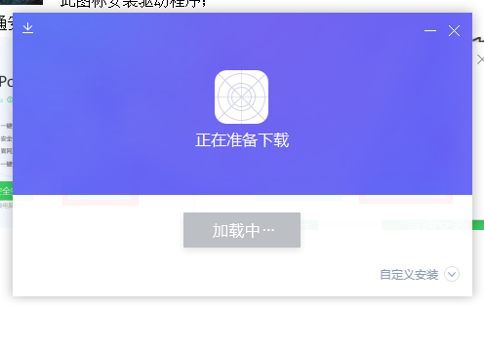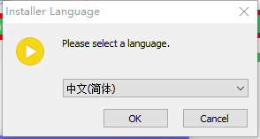

- Click "Next" and "I Accept"
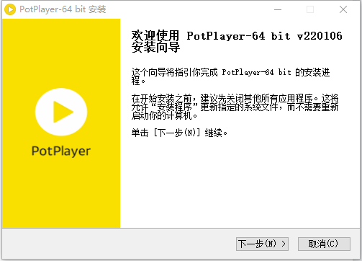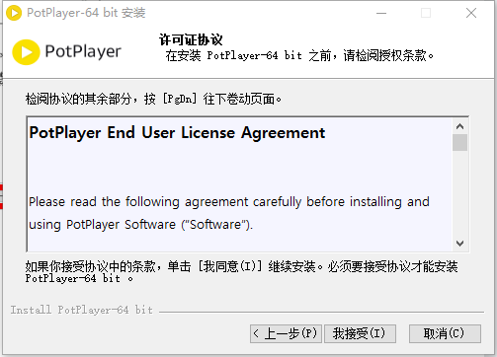
- Click "Next" and "Install"
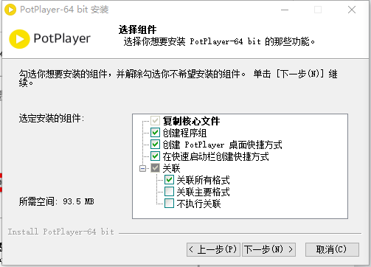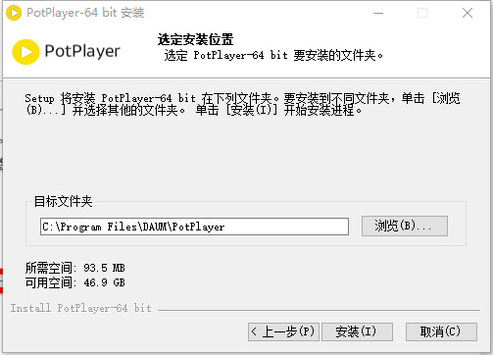
- Click "Close" to complete the software installation.
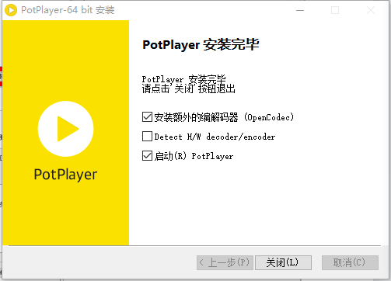
1. Software Usage
- Connect the portable X-ray machine to the computer using a USB cable;
2、Open the installed software, put the mouse in the red box, and right-click the mouse;
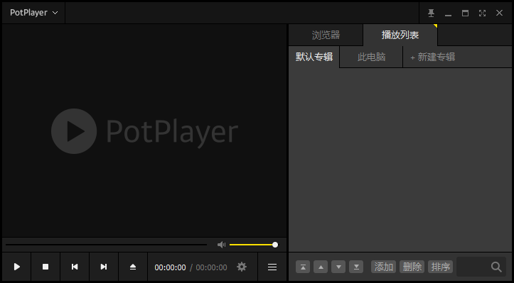

3. Move to "Open" and select "Device Settings";
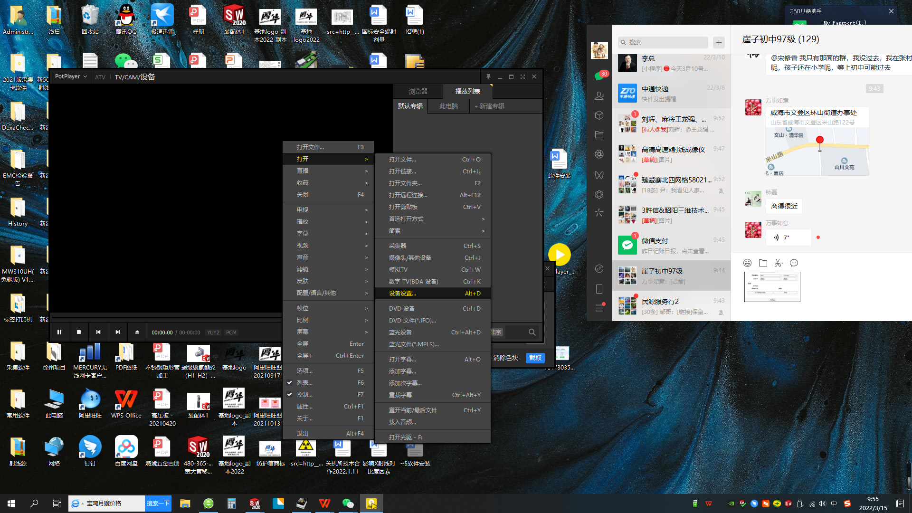
- 点击“模拟TV”,设备下拉框选择“AV TO USB2.0”,点击“打开设备”；4. Click "Analog TV", select "AV TO USB2.0" in the device drop-down box, and click "Open Device";

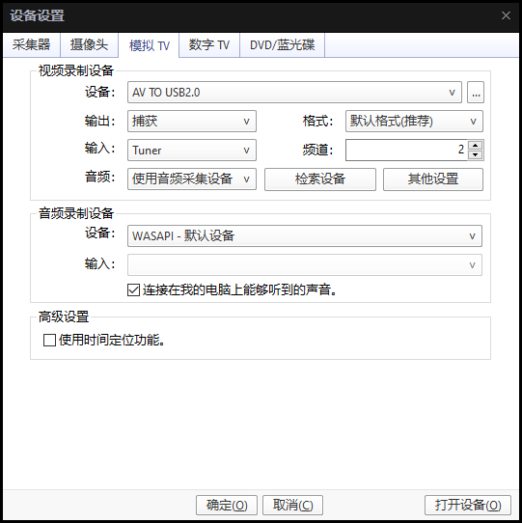

- 点击设置按钮，弹出的控制窗口点击视频，选中“锐度”，按下图调节“亮度、对比度、饱和度、颜色”参数后按“截取”即可保存图像。
In the pop-up control window, click the video, select "Sharpness", adjust the "Brightness, Contrast, Saturation, Color" parameters as shown below, and press "Capture" to save the image.
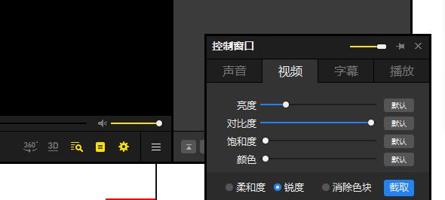

- 保存图片和录制视频保存路径选择，可在桌面先建立一个存储图片和视频的文件夹备用。To save pictures and recorded videos, you can choose a save path. You can create a folder on the desktop to store pictures and videos for backup.
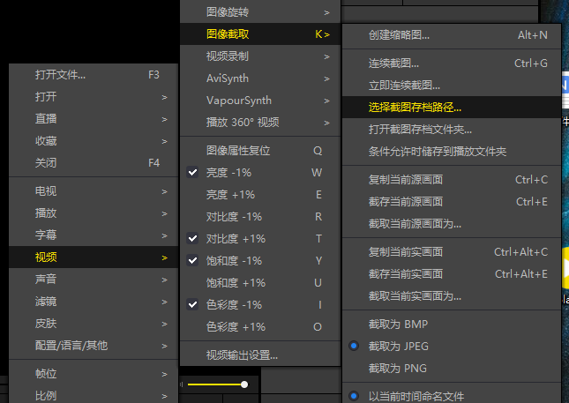

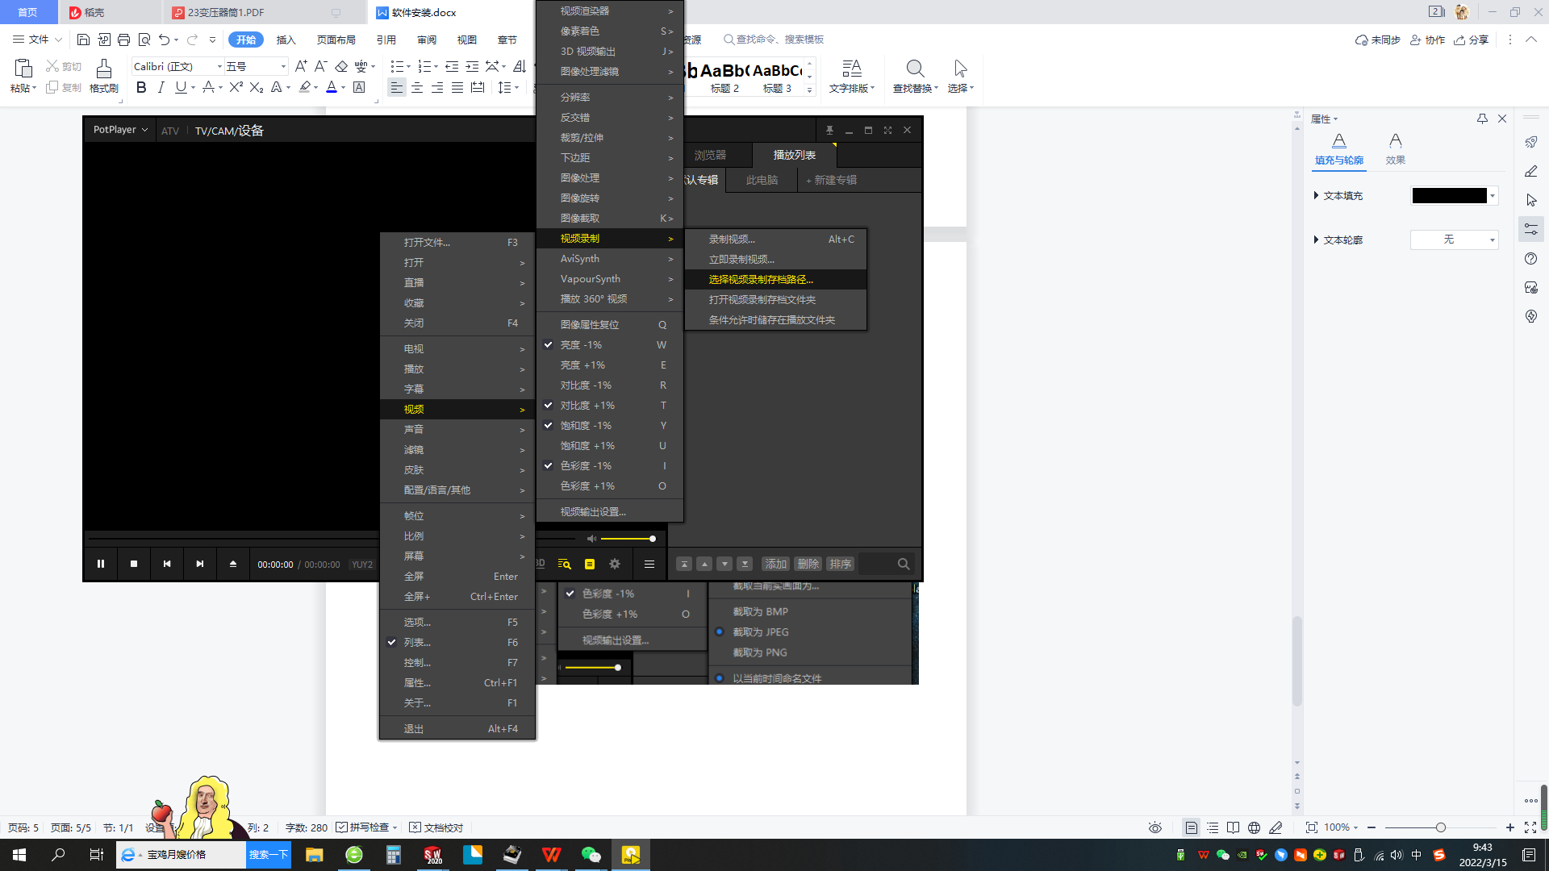
- 保存图片快捷键“Ctrl+E”直接保存在路径文件夹里，或者点击设置里面“截取”可以编辑图片名称后保存；
Press the shortcut key "Ctrl+E" to save the image directly in the path folder, or click "Intercept" in the settings to edit the image name and save it;
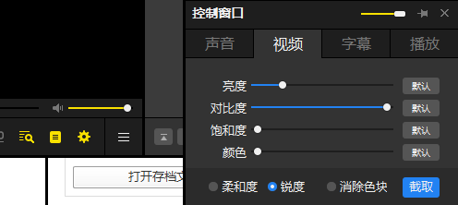

- 录制视频快捷键“Alt+C”后点击“开始”
Press Alt+C to record the video and then click Start.

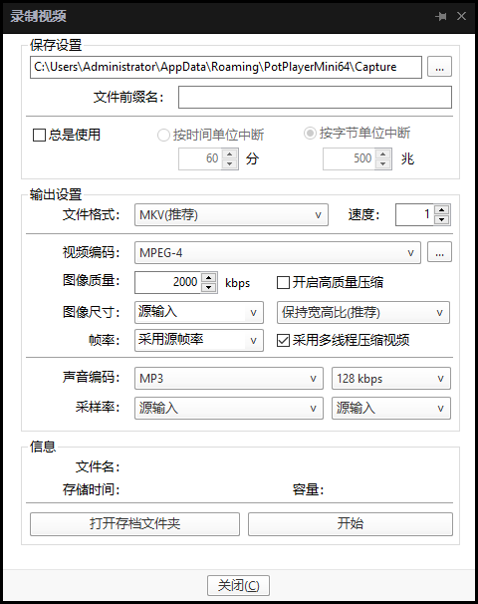

Ⅰ、Brief Introduction
Low-Intensity Portable X-Ray Imaging Scope (the following in short X-Ray Imaging Scope), a new type of X-Ray medical instruments in the world, consists of main engine and power supply. From the appearance, the main engine adopts the structure of C-Type-Arm, which amplifies the radius of observation. At the same time, the materials select ABS engineering plastics, heightening the insulation capacity.
Because of adopting MCP-X-Ray imagine strengthening device, having compact texture, high gain, high resolution, the scope can produce clear real-time images without darkroom. The advance technology of widening pulse is used to control electrical appliance of X-Ray tube, which has many measures to be protected, so it has high working stability and no noises.
In addition, the scope takes strict precautions, the leak of X-Ray reducing, and then the operators do not need any protections. This scope applies to orthopedics and pediatrics in the hospitals , it applies to various field rescues in such as industry materials and apparatus quality inspection, athletes, armies, field working and safety checking, and so on.
The scope belongs to Ⅱ Class Equipment.
Ⅱ、Specifications and Conditions
1. Specifications
Output image size: 5〞
Survey thickness: ≤320 mm
X-Ray tube voltage: 45~90kv continual adjust
Voltage accuracy: ﹣10%
Tube current: 0.25~0.5mA continual adjust
Current accuracy: ﹣20%
Resolution: ≥30Ip/cm
Brightness : ≥200lm
Gray level: ≥7 level
2. Conditions
Temperature: 10ºC～40ºC
Relative humidity: ≤75%
Atmospheric pressure: 700～1060hpa
3. Power supply
Supply voltage： AC220V
Power frequency： 50Hz±1Hz
Power consumption: ≤200VA
Resistance maximum: 0.5Ω
Releasing current machine: 1 A
4. Shape size and weight
Host volume: 560×210×380(mm)
Aluminum box volume： 610×190×470(mm)
Main engine: 5Kg
Gross weight: 11.5Kg
Ⅲ、Working principle
X-Ray Imaging Scope is made up of different parts in the pictureⅠ. When put through power supply, turn on “start” button, and then the scope begins to work. The pulse signal from main engineⅠamplified through efficiency reaches to X-Ray tube anode, while the pulse signal from main engineⅡ amplified reaches to X-Ray tube wick, which releases X-Ray. Then the corresponding number KV/μA will come out on the board. This moment the object is laid between X-Ray source and image strengthening machine, on whose monitor we will see the clear image. In order to work stability, the system adopting the technology of widening pulse, makes tube current and tube voltage stable, and the X-Ray tube works in good condition. Due to the function of high voltage starting slowly, the X-Ray tube anode doesn’t have the phenomenon of high voltage being too high. The main control machine with the mini-slice equipment working at the frequency of the 20KHz, improves the entire system’s efficiency and clears away the noises, and it supplies workers for quite environment with a smaller volume. The power supply of perspective device adopts a switch with high frequency and high efficiency, having overall protections. To ensure the safety of perspective device, the scope takes different measures, so the device is safe and reliable.
Ⅳ、The picture of the main engine structure
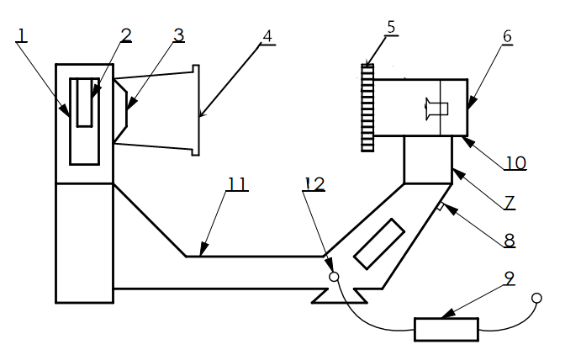
Picture Ⅰ The structure of X-Ray Imaging Scope
- Lead bobbin 2．X-Ray tube 3．Collimator 4．Focus distance 5.ray-guard 6.X-Ray image strengthening machine 7. Fluorescent Screen 8. Observation Tube 9. Self-locking Digital Display 10. Startup Button 11. Power Supply of Switch 12.Plug

1 2 3
Portable X-Ray Machine

Overtemperature work

µA µA/KV KV

Z.K. Optoelectronic Technology Co., Ltd.(Weihai)

4 5 6
Picture Ⅱ Sketch Map of Digital Display
1、 Over-temperature Indicator Light
If the instrument is over than work temperature, it will stop and the light will be on.
2、 Digital Meter
It displays voltage and current (KV/μA) of X-Ray Tube.
3、 Work Indicator Light
When it radiates X-ray, the instrument works and the light is on.
4、 Current Adjusting Knob of the Tube
Adjust the current of X-Ray tube clockwise.
5、 Changeover Switch
It displays voltage of X-ray tube normally. Press it down and it will display current of X-ray tube.
6、Voltage Adjusting Knob of the Tube
Adjust the voltage of X-Ray tube clockwise.

Sketch Map of X-Ray Protection
1. Datum Axle 2. Focus 3. Filter (2.5mm / Aluminum) 4. Limiter (1.0mm / Lead) 5. Limitation Line 6. Lead Glass
Parameters of X-Ray Tube:
Nominal Value of Focus: 0.8mm Maximum operating current: 2mA
Target Angle: 19º Peak of Back Voltage: 90KV
Anode heat capacity:7KJ
Ⅴ、Using method
1. Firstly, before using, check the instrument chest and ensure the
appearance is in good condition. Then open it and check the main engine.
After making sure there’s no damage on the main engine, take it out and
fix the ray-guard on the monitor.
2. Turn on power supply. The switch indicator lights ,the digit indicator on the main engine works. Push down the auto-lock button .The KV and μA appear on the digital indicator. This indicates the machine is working in good order ,the color or the LC should be green and yellow .Put the examinee between the X-ray tube and the image strengthening machine. (The examinee should be closer to the image strengthening machine ) The picture of the examinee will appear on the LC .Adjust the μA and KV till the picture satisfies your need. Better to use low μA in order to get the clear picture.
3. Push down the auto-lock starter, the X-ray tube works ,it will appear on the digit board, if starter is pushed down again or the timer is completed then the X-ray tube stops work.(The timer is about one min)
4. The machine should be used alternatively , long time use will result in auto-turn off the machine. Then the high-temp indicator will lights on the digit board .Stop the machine ,until the temp becomes normal before use the machine again.
Ⅵ、Maintenance
The surface should be cleaned by gauze with detergent. Mustn’t use the ethyl alcohol or the acid to clean, which can destroy the smooth finish of the surface.
Ⅶ、The method of removing common breakdown
The X-ray machine is an exactitude set, therefore, it should be mended with the special tools under our experts. The breakdown described here means the breakdown caused by the attachments：such as power supply ,cable, switch button and fuse .
1. If the digit board indicates the X-ray tube KV and currency , it means the X-ray is being produced . If the LC doesn’t light ,it means the strengthening machine should be changed.
2.The digit board is light , but no X-ray tube KV and currency, it means the power supply is normal ,but the mains controller or the may be damaged. This means the machine should be sent back to us to repair it .
Ⅷ、Repair for free in one year after the date of selling
Not including the followings:
Wrongly operate or damage machines on purpose.
Ⅸ、The bill of Al equipment packing
X-Ray equipment main engine 1
Alternating power supply 1
Shield disk 1
Software(Electronic version) 1
Data line 1
Instructions 1
Certificate of leaving the factory 1
Maintenance card 1



东莞市徳亿鑫电子科技有限公司
Dongguan Deyixin Electronic Technology Co., Ltd.

地址(add)：GUANG DONG China
电话(tel/whatsapp):+8613724461580
网址(http)：www.dyxtech.cn

