**第一步：git**  
[官方仓库地址](https://pdfium.googlesource.com/pdfium) 需要科学上网，退而求其次  
[github](https://so.csdn.net/so/search?q=github&spm=1001.2101.3001.7020)上有旧版：https://github.com/PDFium/PDFium  
clone下来即可:

git clone <https://github.com/PDFium/PDFium>

**第二步：构建项目**  
目前还不能直接编译，需要构建  
构建工具gyp（基于python的vs项目生成工具）  
https://github.com/bnoordhuis/gyp  
获取方法1：  
直接放在PDFium/build目录下即可,

cd PDFium/build

git clone <https://github.com/bnoordhuis/gyp.git>

方法2：  
clone后直接安装gyp（使用gyp根目录下setup.py文件+python2.7安装）

git clone https://github.com/bnoordhuis/gyp.git

cd gyp

python setup.py install

接着用gyp去构建PDFium项目

PDFium项目中涉及到v8引擎等内容

舍去v8引擎，注释掉一些javascript相关的代码(v8需要科学上网）

记事本编辑PDFium根目录下的pdfium.gyp文件

找到’javascript’及’jsapi’依赖（47行左右），并删去这两个值

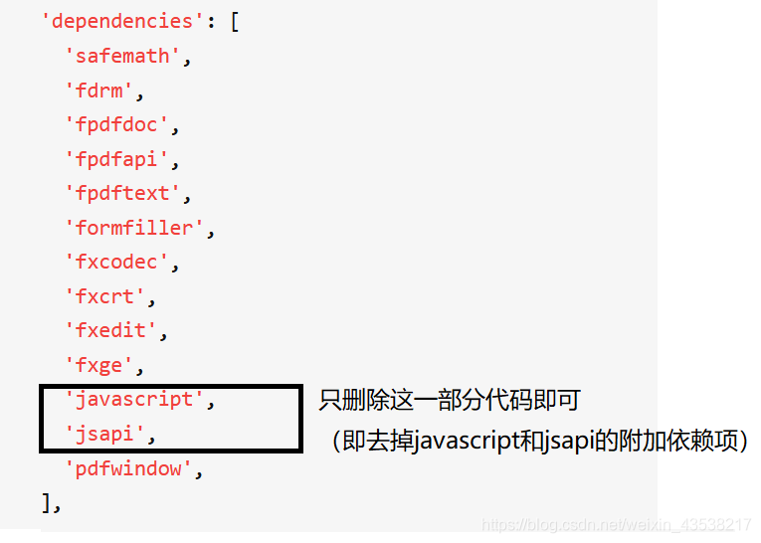

将其移除并删除对应的工程（734行至812行）：

{

'target_name': 'javascript',

'type': 'static_library',

'include_dirs': [

'<(DEPTH)/v8',

'<(DEPTH)/v8/include',

],

'dependencies': [

'<(DEPTH)/v8/tools/gyp/v8.gyp:v8',

'<(DEPTH)/v8/tools/gyp/v8.gyp:v8_libplatform',

],

'export_dependent_settings': [

'<(DEPTH)/v8/tools/gyp/v8.gyp:v8',

],

'ldflags': [ '-L<(PRODUCT_DIR)',],

'sources': [

'fpdfsdk/include/javascript/app.h',

'fpdfsdk/include/javascript/color.h',

'fpdfsdk/include/javascript/console.h',

'fpdfsdk/include/javascript/Consts.h',

'fpdfsdk/include/javascript/Document.h',

'fpdfsdk/include/javascript/event.h',

'fpdfsdk/include/javascript/Field.h',

'fpdfsdk/include/javascript/global.h',

'fpdfsdk/include/javascript/Icon.h',

'fpdfsdk/include/javascript/IJavaScript.h',

'fpdfsdk/include/javascript/JavaScript.h',

'fpdfsdk/include/javascript/JS_Console.h',

'fpdfsdk/include/javascript/JS_Context.h',

'fpdfsdk/include/javascript/JS_Define.h',

'fpdfsdk/include/javascript/JS_EventHandler.h',

'fpdfsdk/include/javascript/JS_GlobalData.h',

'fpdfsdk/include/javascript/JS_Module.h',

'fpdfsdk/include/javascript/JS_Object.h',

'fpdfsdk/include/javascript/JS_Runtime.h',

'fpdfsdk/include/javascript/JS_Value.h',

'fpdfsdk/include/javascript/PublicMethods.h',

'fpdfsdk/include/javascript/report.h',

'fpdfsdk/include/javascript/resource.h',

'fpdfsdk/include/javascript/util.h',

'fpdfsdk/src/javascript/app.cpp',

'fpdfsdk/src/javascript/color.cpp',

'fpdfsdk/src/javascript/console.cpp',

'fpdfsdk/src/javascript/Consts.cpp',

'fpdfsdk/src/javascript/Document.cpp',

'fpdfsdk/src/javascript/event.cpp',

'fpdfsdk/src/javascript/Field.cpp',

'fpdfsdk/src/javascript/global.cpp',

'fpdfsdk/src/javascript/Icon.cpp',

'fpdfsdk/src/javascript/JS_Context.cpp',

'fpdfsdk/src/javascript/JS_EventHandler.cpp',

'fpdfsdk/src/javascript/JS_GlobalData.cpp',

'fpdfsdk/src/javascript/JS_Object.cpp',

'fpdfsdk/src/javascript/JS_Runtime.cpp',

'fpdfsdk/src/javascript/JS_Value.cpp',

'fpdfsdk/src/javascript/PublicMethods.cpp',

'fpdfsdk/src/javascript/report.cpp',

'fpdfsdk/src/javascript/util.cpp',

],

},

{

'target_name': 'jsapi',

'type': 'static_library',

'dependencies': [

'<(DEPTH)/v8/tools/gyp/v8.gyp:v8',

],

'export_dependent_settings': [

'<(DEPTH)/v8/tools/gyp/v8.gyp:v8',

],

'include_dirs': [

'<(DEPTH)/v8',

'<(DEPTH)/v8/include',

],

'ldflags': [ '-L<(PRODUCT_DIR)',],

'sources': [

'fpdfsdk/include/jsapi/fxjs_v8.h',

'fpdfsdk/src/jsapi/fxjs_v8.cpp',

],

},

**第三步：编译**  
开始编译  
进入PDFium/build目录，执行命令：

python gyp_pdfium.py

会发现build目录下出现all.sln文件

使用vs打开后编译

成功后于PDFium/build/Debug/lib生成各个库的静态文件，于PDFium/build/Debug中生成samples的输出程序

当然由于去掉了v8和javascript等内容，所以目前pdfium还不能编译成功

打开pdfium_test.cc文件

去掉所有关于v8的内容，

还有关于FPDFDOC_InitFormFillEnviroument()函数的内容

（直接注释v8头文件，然后根据报错提示将报错内容都注释掉，然后ctrl + f查找FPDFDOC_InitFormFillEnviroument，去掉这个函数，然后将后面所有报错代码注释掉）

防止出错，我将代码挂上:

再编译（我遇到过中间报错缺失了afxres.h文件，百度直接将这个文件下载下来丢到vs安装目录的include目录下即可。

切换到PDFium/build/Debug/目录）

编译成功后输出程序： pdfium_test.exe（位于PDFium/build/Debug目录下）

第四步：运行demo

在pdfium_test.exe目录下, cmd运行这个程序

pdfium_test --bmp test.pdf

–bmp为参数，可以生成bmp图片文件，还可以用–ppm 和 --emf生成对应格式的文件  
test.pdf是我用来测试的pdf，放在pdfium_test.exe同一目录  
可以在当前目录看到test.pdf中每一页的内容都生成了图片。