Lest we be forgotten.

Either write something worth reading

or do something worth writing.

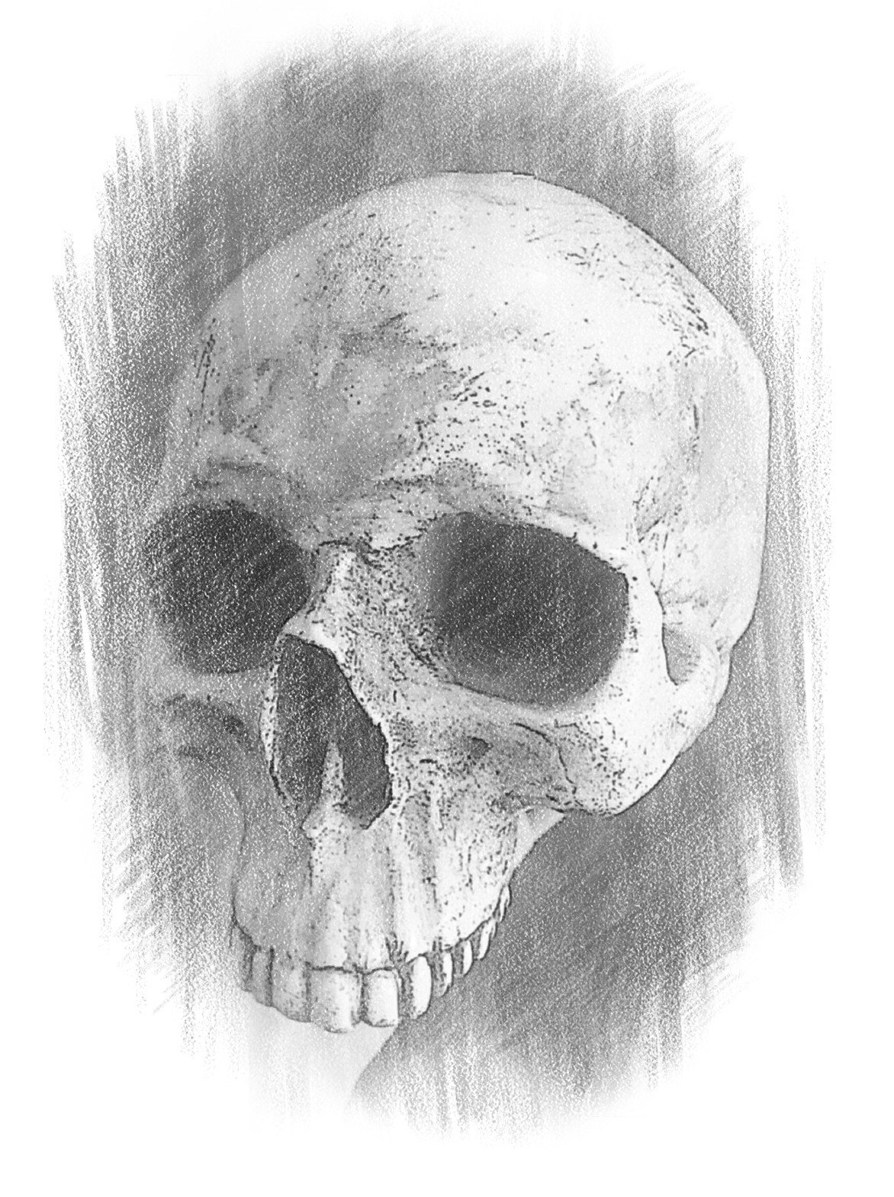
“Alas, poor Yorick!” said Hamlet, holding the skull in his hand. “I knew him well, Horatio; a fellow of infinite jest, of most excellent imagination. Where be your songs now? Or your flashes of merriment?”

Others Worth Writing About

