The Forth
Einstein added the 4th dimension of time into the theory of physics, to give us the physics of spacetime. But, neither mathematicians nor physicists have shown us a simple way to draw a 4 dimensional hypercube.
In this book, using Einstein's axiom, “Everything should be made as simple as possible, but no simpler,” you will learn to draw in four dimensions and beyond.
The steps are so straight forward, a grade schooler could be taught to follow them. Below is a 4 dimensional Einstein cube.

It only has 6 front sides. It's very straight forward to draw.

Your Requirements
To learn the drawing techniques, you must be familiar with the basic geometric shapes:
+ A point to show position, 0 dimensions.
+ A line is for distance, 1 dimension.
+ A square of 2 dimensions, area.
+ A cube of 3 dimensions, volume.

.

Drawing 0 to 3 Dimensions
A 0 dimensional point, is position.
.

A 1 dimensional line segment: a measure of height, length, or depth. It is a measure of distance.

Draw a Square
To draw a square, start with a point. From the point, to the left, draw the 1st dimension: width. To the right, draw the 2nd dimension: length. The dimensional segments are mirrored through the dotted line. Width and length are the 2 dimensional base line segments of the square.

Baseline segments.
The dotted line is for reference

Top left side. It is drawn using the bottom right side as a guideline.

Key drawing tip: opposite sides are parallel to each other.

The top right side is drawn using the bottom left side as a guideline.
The top right side is parallel to the bottom left side.
In summary, drawing a 2 dimensional square.

Draw the 2 baselines.

Draw the sides using the baselines as guidelines.

That completes a square.

Draw a Cube
A cube is a 3 dimensional object. When a cube is printed on paper, or displayed on a phone, or on a computer screen, there are only 2 dimensions. The cube's 3 dimensional shape has to be altered to fit into 2 dimensions.
Below, the 3 dimensional cube that is represented in 2 dimensions.

Each side of a cube is a square. In 3 dimensions, the shape of each square side, is adjusted to fit in 2 dimensions. Below, is the steps to draw the left square side of the above cube.
To draw each of the square sides of cube, use the same steps as drawing a 2 dimensional square.
Draw the 2 dimensional baselines.
Then draw the other 2 sides using the baselines as guidelines. The other 2 sides are drawn parallel to their opposite side.

Each side of a cube,
is a square.

Draw a Square Side of a Cube
Since we are fitting 3 dimensions in 2, the square is skewed.
Draw the 2 baseline segments of the square.

The left side is drawn using the right side as a guideline.
The opposite sides are parallel to each other.

The top side is drawn using the bottom side as a guideline.
The top right side is parallel to the bottom left side.

Draw another Square Side of a Cube

Draw the 2 baseline segments of the square.

The left side is drawn using the right side as a guideline.
The opposite sides are parallel to each other.

The top side is drawn using the bottom side as a guideline.
The top right side is parallel to the bottom left side.

Draw a Cube Side by Side
In the following sequence, the 3D cube is redrawn one square side at a time.
How many dimensional base lines for a 3 dimensional cube?

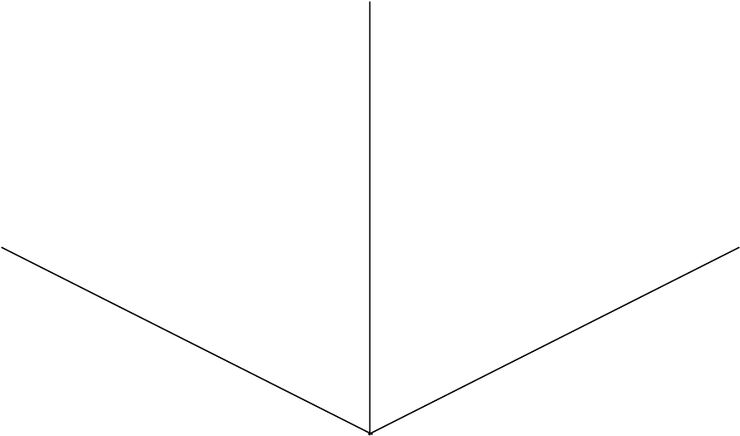

Hidden Lines
For simplicity, draw cubes without hidden lines.
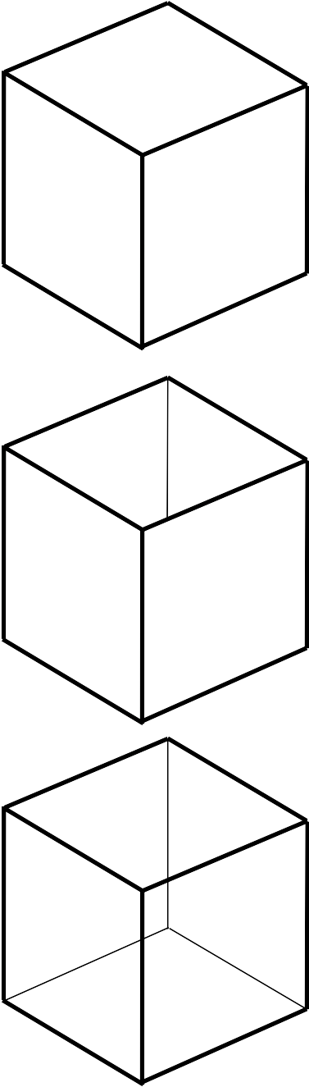

A cube without hidden lines looks like a closed box.

This is a cube box without a top.

A cube with hidden lines is the frame of a box.

Summary to Draw a Cube
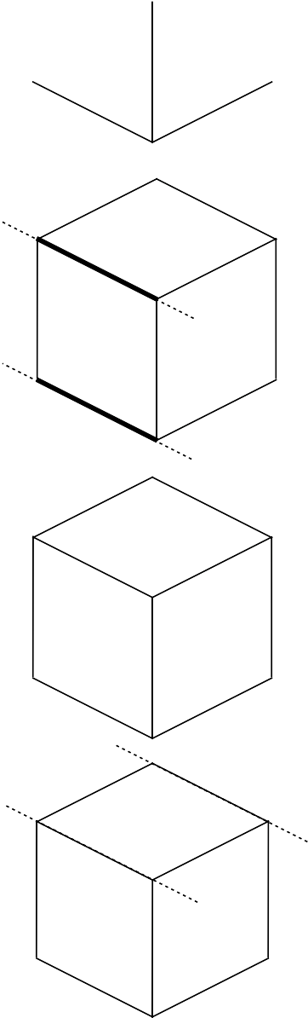
Start with the dimensional base lines.

Each of a cube's square sides, have opposite and parallel sides.

All sides of a cube are square.

Draw a cube without hidden lines.

Drawing 4D Hypercubes
A note before beginning: 1 and 2 dimensional shapes can be drawn on your 2 dimensional screen in proper perspective.
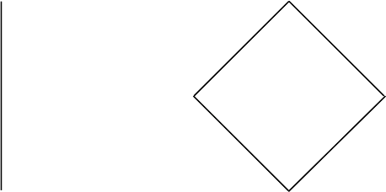

However, 3 and 4 dimensional cubes have to be drawn to fit on a 2 dimensional screen. Examples with dotted perspective lines:
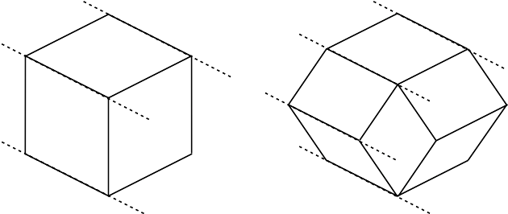

Following, I will draw 2 hypercubes. The first drawing includes detail explanations. Then you will be ready for the quick draw of the 6 front sides of a 4D cube.
To draw a 4D cube, start with a point. 1st dimension: width, a measure of distance. 2nd dimension: height. 3rd dimension: length. 4th dimension: time, a duration of time.

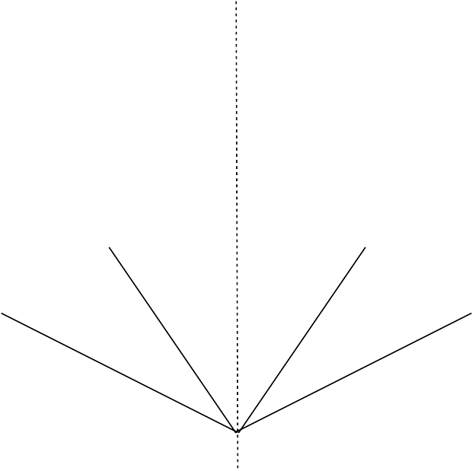

The left segments are mirrors of the right segments.

Key
When drawing a cube of any dimensions, is start with dimensional base lines. A 2D square as 2 base lines. A 3D cube. And a 4D hypercube has how many base lines? Yes, 4 base lines.

Draw a 4D Cube One Square at a Time
Now, find a pen and paper, and be the first person you know, to draw a hypercube by hand.
1. Start by drawing the 4 base line dimensional segments.
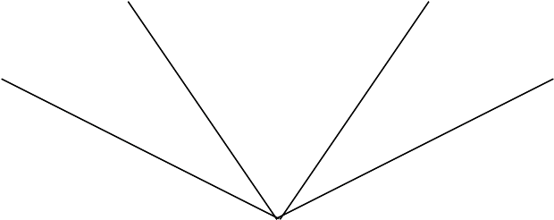

2. Draw the 6 square sides using the base lines, as guide lines. Each of the square sides have opposite and parallel sides. All sides of a cube are square.
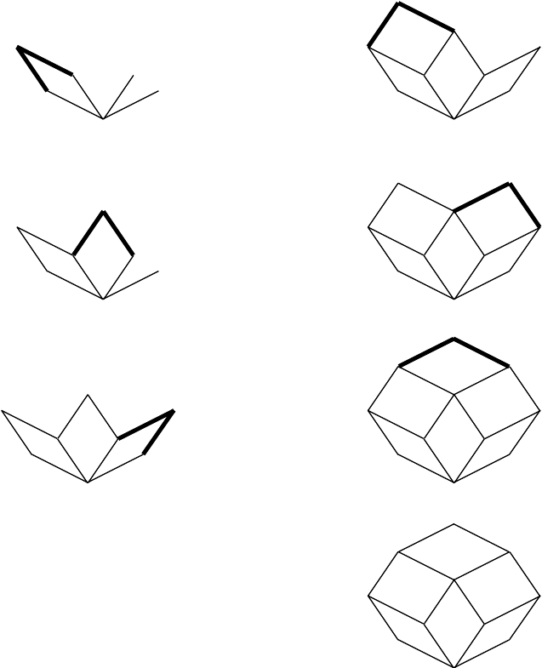

Easy eh?
After all, this isn't rocket science. It's only Einstein science. As he said, “Everything should be made as simple as possible, but no simpler.”
Only 2 instructions:
1. Draw the base dimensional lines.
2. Draw the square sides on top the base lines.
It can't get any simpler than that.
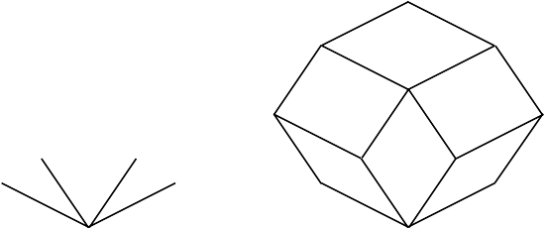

Seeing in 4D
“It would be interesting to see in 4 dimensions,” said my son, Riley.
“You do all the time,” I said. “With a ruler, you can measure the 3 dimensions of an object such as a smartphone. You see 3D objects. With your phone, you can record the 4th dimension of an object by taking a video of it. You watch 3D objects for a duration of time (1D). A video is a recording of 4 dimensions: 3 dimensional objects in 1 dimension of time—spacetime.”
“Okay, that make sense,” he agreed.
Do you agree?

Beyond Spacetime
…

Beyond Spacetime
To draw a 5D hypercube requires only one more skill. With that skill you can draw cubes of any number of dimensions.

1D 2D 3D 4D … 10D

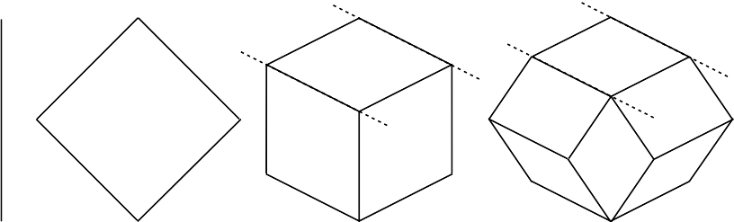
The trick is to find the pattern to higher dimensions.

IQ Challenge
The Pattern to higher dimensions is found in the base line sequence.
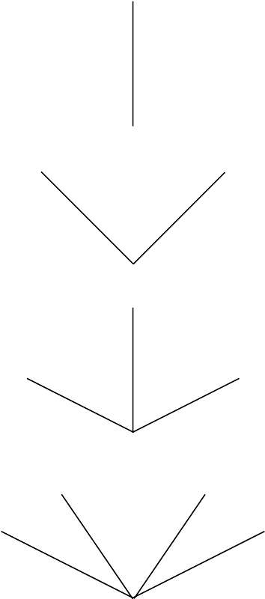
1D

2D

3D

4D

5D The challenge: draw the 5D base lines
before looking at the next page.

The Pattern to higher dimensions can be seen in the base line sequence.
1D

2D

3D

4D

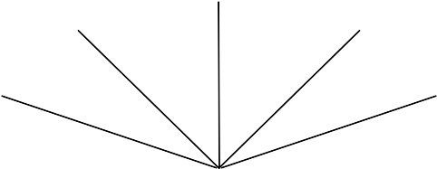
5D

Next IQ challenge is to draw a 5D cube on top of the 5D base lines. All you need do, is draw squares using the base lines as guide lines.

