
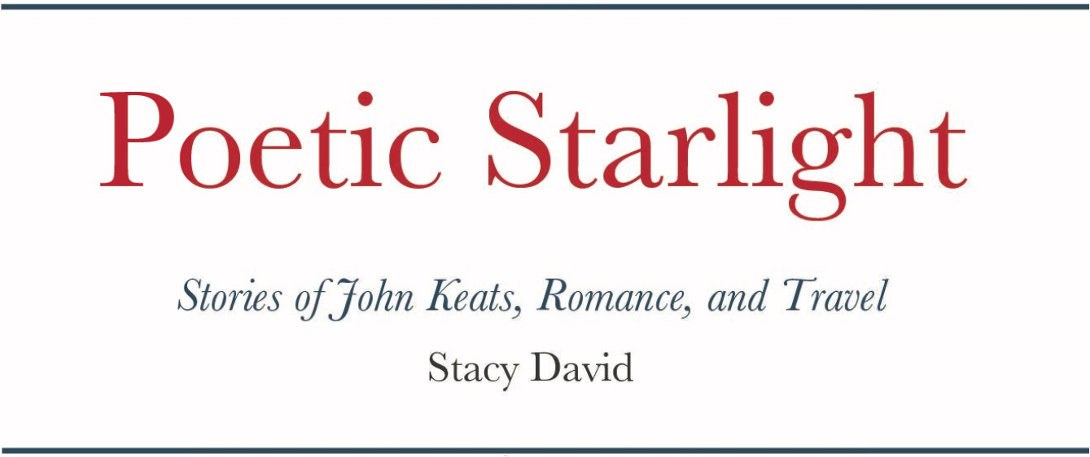


The Age of Romance poetry is known for it's spirited poems inclined on the side of emotions. The poets were supported by the pillars of Nature, imagination, and sublime inspiration.

As a screen writer's writes scripts based on books, this book is based on the writings of Keats, Shelley, Shakespeare and others.

Following are lines from Poetic Starlight.

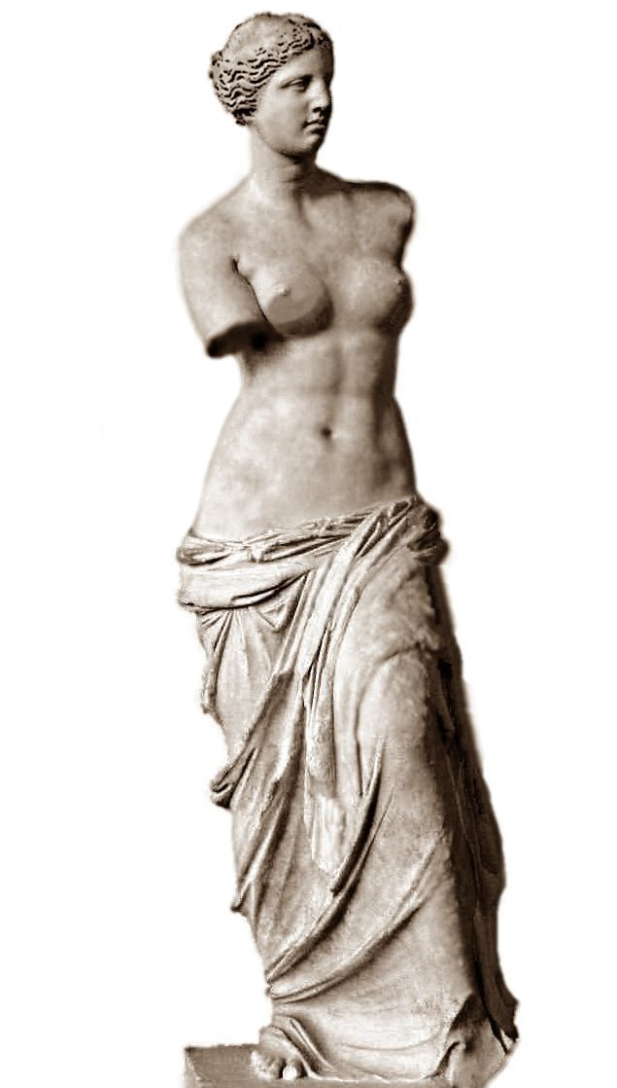
...Poems are soft roses: red, peach, and yellow,
Soothing memories of her gentle fellow.
...As the curtain falls on Twilight's eve,
A lover's dream begins to weave.
...Distracted I drift deep into the forest dim,
Lost in the woods I fear Brothers Grim.
...On rivers of wind, updrafts of airy fountains,
The valley breeze, is the song of mountains.
...My soul's blown away as I'm hit with spice,
Hot sensations are saucy, naughty and nice.



