Introduction
In the Old Vienna hotel—as all the pubs were all in hotels—mid 1960's, my father introduced me as Bill Thurston's grandson. Everyone's eyes lit up as they looked me over.
“Yes, your grandfather Bill. There was a man that could tell a story,” said an old fellow as the rest nodded their heads in agreement.
Since I had story telling in my blood, I decided to write my family history. In the later 1980's, I started while attending the University of Manitoba where people asked me, “Where you from?” I answered, “Ontario and Nova Scotia.” But what they really meant was, what other country I was from. I didn't know, so I asked my family where, and began the recording of our stories of pioneers, poets, and entrepreneurs.
Adventure Story
Uncle Rob Thurston's started flying planes on his family's farm. Making a living flying, he flew up above the Arctic circle, and later, into the jungles of New Guinea where there were actual human head hunters. Difficult to believe, but he had photos of human shrunken heads; and so, I believed him. His photo below is worthy of a National Geographic article.
Rob took the photo on the following page, developed the film and printed the image from the negative onto paper to create the black and white photo. Considerably more work than taking a selfies on a phone and uploading to Facebook.
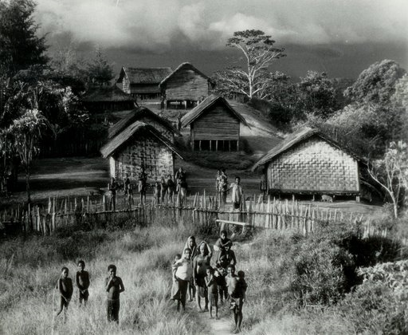
A Classic Story
Fishermen all have their story of the One that got away. Great uncle Bud Thurston's One, was an 800 pound, 15 foot Tuna fish. It didn't get away, he caught it. He was fishing off the coast of Prince Edward Island and reeled it in with a fishing pole. Yeah, a fishing pole.
Outlandish
Sports run in the blood of my cousin Ed Price. He is a soccer wizard. Ed mooned the referee who made an unfavorable call at a High School game.
The Entrepreneur
May's father, Mr. Ip, moved from mainland China to Hong Kong when he was 10, with only 10 cents in his pocket. He became a millionaire through hard work and investing in property.
The Story of Discovery
Grandmother Lulu Thurston wrote of her younger years. I found the hand written documents with some of her other historical items, such as her mother's photo album.
In summary,
Seven generations ago, 200 hundred years ago, my ancestors left Western Europe to live in the British colonies of North America.
My Chinese wife, May, was born and grew up in the British colony of Hong Kong. My sons are descendants of international colonists.
Before the colonies, I'm from the Kingdoms of Scotland, Ireland, and England. And from The Empire's Bavaria, which is now Germany, and from The Netherlands which includes Holland.
I'm from a line of early pioneers. These adventurers removed trees and brush to clear the land for farming in Upper Canada. The pioneers worked to make the land their own after the native Indians had moved on.
The Natives believe the land owns the man, not the man owns the land. They had managed their natural resources wisely out of natural respect. Wise words were posted on the wall, in the bathroom, of Uncle Pete’s farm house:
Before the White man came,
Indian men went forth to hunt and fish,
The women took care of the home.
How could the White man ever think he could
improve on such a system?
When I was a boy, I found Indian arrow heads in the farm fields of Ontario. Grandmother Lulu recalled that they were from the neutral Indians of the 1500's and 1600's. My father recovered canon balls from nearby Lake Erie.
Uncle Rob Thurston flew planes into the Arctic Circle where the first group of white men had reached the North Pole. Later, he had a job building hydro towers in BC. He eventually flew for a company paving roads in the jungles of New Guinea. He was a man on the edge, helping to improve civilization. His daughter, Janice worked in BC conservation. His older son Mark flies helicopters up to Baffin Island, taking after his father in aeronautics.
Uncle Bill Purdy traded fur with native Indians in northern Ontario for the Hudson Bay Company. His place was north of Sioux Lookout. It was disconnected enough from society that he had to fly to the trading post. He often brought us Indian moccasins, hand crafted from animal pelts. The Hudson Bay company has been around the North Americas since the 1600's. Uncle Bill was the last generation to work at these old style trading posts. His son, Josh, lives in a tent in the BC mountains each summer planting trees.
My brother Peter summed up his stay in the Manitoban Canadian Shield:
“Even here in it seems to be getting crowded.”
Geography note: the land, Manitoban Canadian Shield, around the Hudson Bay is in the shape of shield, loaded with Precambrian granite rock.
Cheers,
Stacy David Thurston, family historian

