Poetic Spirit
John Keats had studied and worked to be a surgeon, but instead chose to write poetry.
Imagine giving up surgery for poetry. “Mom, dad, I'm on the last step to become a doctor,” you would say as they smiled proudly. “But, I've decided to be a poet.” Ah, the look on their faces, the shock. They would be mystified by your choice.

The Road Less Taken
Two roads diverged in a wood,
I am one traveler, long I stood.
I took the smaller, to be fair,
It was grassy and wanted wear.
Two roads diverged in a wood, and I -
I took the one less traveled by.
Someday in future, ages hence,
This will have made, all the difference.

And now, ages hence, because of his choice we know the name, John Keats. Sadly, he didn't have the surgeon poet talk with his parents as they had passed away by then.
But why did he choose poetry? Why poetry?
It was a grand undertaking to lift the thoughts of readers, to have them feel and think beyond their own imagination.

Conscience makes cowards of us all, We fear to fly where we know not of.
Shakespeare

Keats began reading the classic poems of Shakespeare, Milton, Spencer, Robert Burns and works by his modern contemporaries, Coleridge, Shelley, and Lord Byron. He started writing sonnets, short poems, and then longer poems.
As a poet he wrote poetic letters. In one letter, he wrote a selfie, “As I write I am sitting with my back to the fire with one foot rather askew upon the rug and the other with the heel a little elevated from the carpet.” He went on to wonder, in what position Shakespeare sat when he began, “To be or not to be.”

Hamlet, Act III, Scene I, Hamlet:
To be, or not to be: that is the question:
Whether ‘tis nobler in the mind to suffer
The slings and arrows of an outrageous life,
Or to take arms against a sea of troubles,
And by opposing them, maybe to die:
To be no more; as if asleep for the rest of time.

For in that sleep of death what dreams may come
When we shuffle off this mortal coil.
To sleep: perchance to dream: ay, there’s the rub,
As we know not what, where no traveller returns;
It be dreams, nightmares, or nothing;
Not knowing must give us pause.

And so we fear to fly where we know not of,
Instead we bear the whips and scorns of time;
Life's inquisition, puzzles the mind,
Fades the brilliant hue of resolution,
Decisions are clouded by the pale cast of thought;
Thus conscience does make cowards of us all.

Imagination makes heroes of us all, We fly to places we dream of.
Keats
A poet's spirit powers their imagination to experience fantastic lives and safely go to mysterious places we know not of. And once experiencing such a life changing imagination, they cannot return to who they were.

Once Keats read and wrote poetry, his egg was cooked.

And so, he decided,

A few years in poetry, so I may do the deed,
Which my own soul has to itself decreed,
That I shall write on my tablet all that's permitted,
All of our human philosophy on pages fitted.

Poetic Spirit
As I listen to the composer's music I know,
All Mozart has written in such a wondrous glow.
Like the sound of music that in my heart I keep,
Melodic poems moving me to laugh, smile, and weep.
A poet captures an exciting moment in a sonnet,
Where in their mind they may think upon it.

When a reader is contented, they have a placid look,
As they sit and hold their recently closed book,
And hail the composer as one of the poet kings,
Who has simply told the most heart-pleasing things.
Poets have the courage to smile and to wink,
As they write what others only dare to think.

Heard by naught on earth but in the poet's ear,
Is the bold call of trumpets sounding loud and clear,
When a poet is in such a trance,
They see white coursers paw and prance,
Ridden by bold knights in armored apparel,
Who charge and tilt in a challenging quarrel.

The poet sees fairies in a rippling stream,
Gracefully dancing on a moonlight beam,
In a flowery spot that is wild and romantic,
Where the poet's heart beats strong and frantic,
Stepping over pebbly crystals on golden sand,
To meet up with a goddess and take her hand.

Sweet are the pleasures to verse belong,
And doubly sweet in a romantic song,
That's great and good and healing,
From the heart felt words is a feeling,
As we marvel when the poet speaks as never told,
Of a flower, of a bird, or a fish of gold.

Climbing to a Heavenly height, the poet kneels,
Upon a majestic mountain-top where he feels,
More powerful, more handsome, more regal,
Like flying on the wings of the rare seen eagle,
On a river of wind and updrafts of airy fountains,
The valley breeze, is the song of mountains.

But it's not of strength alone that a muse is born,
They are as a fallen angel, robes ripped and torn,
On the thorns of life; however poetry in the end,
Is as warm and enchanting as a dear old friend,
Who soothes and lifts the thoughts of women and men;
Poets compose romance as only they can.

A few years in poetry, so I may do the deed,
Which my own soul has to itself decreed,
That I shall write on my tablet all that's permitted,
All of our human philosophy on pages fitted.
May these joys of life be captured before I die,
Before arms crossed, forever lie.

I'm writing with my creative pen,
Imagining poems soon to be written,
As I retrace a pleasant day, while sitting at ease
In a poet’s house where the muse holds the keys,
To the stately pleasure-dome, all around is hung
The glorious writings of the bards who sung.

The brilliant sunshine and crisp air seems to say,
“Write! You will not have a better day.”
And when I compose, I feel a great pleasure,
Bringing to light a hidden treasure;
These lines of which, howsoever they may be done,
I leave them as does, a father his son.

Home of the Muse
In Xanadu did Kubla Khan
A stately pleasure-dome decree:
Where Alph, the sacred river ran
Through caverns measureless to man,
Down to a sunless sea.

While running swiftly in violent burst,
The mighty fountain there was forced,
To dance over rocks, rock 'n rollin' forever,
Flowing hard, the waters of the sacred river,
Through a wide chasm which downward slanted
Into a sacred space, a holy place that was enchanted.

At the edge stood ancient forests towering above the ground.
Within were brilliant flower gardens, all around,
Orchards blossomed many an incense-bearing tree,
Flowing meadows, fields of grassy greenery,
Through wood and dale the sacred river ran,
Into the sea where on the shore, Kubla Khan did stand.

At the entrance I stood watching a ghostly maid,
Her song was echoed, her symphony was played,
Before the cave, into the dome of pleasure,
I heard her singing each haunting measure,
This spirit wailing for her lost lover,
Who had entered, forever held under cover.

If I could revive that music within me,
Such a deep delight would forever win me.
But, oh to see that miracle, that rare device,
The sunny pleasure-dome, the caves of ice,
But all who heard her song, who wandered there,
They also heard her cry, Beware! Beware!
For in that pleasure-dome, in caves of ice,

The last immortal man each day pays the price,
Having closed his eyes to his captive dread,
For on honey-dew he had fed,
And drank in Paradise.

Following, Coleridge describes the circumstance of writing his Kubla Khan poem.
In the summer of 1797, in ill health, I retired to a lonely farm house on the confines of Somerset and Devonshire. In consequence of a slight indisposition, an opium based painkiller was prescribed, from which I fell asleep in my chair while reading, “Here the Khan Kubla commanded a palace to be built, and a stately garden thereunto: and thus ten miles of fertile ground were inclosed with a wall.”
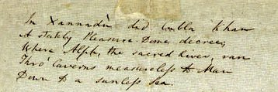
I had the most vivid opium fueled dream. On awakening I had a distinct recollection of the whole, and taking pen, ink and paper, instantly and eagerly wrote down the lines that are here preserved. Unfortunately I was called out on business. On my return I had only a vague and dim recollection, and so, this was all that was written. I have frequently purposed to finish, but the tomorrow is yet to come.
In Xannadu did Cubla Khan (above, Coleridge's hand written first lines)
A stately Pleasure Dome decree;
Where Alph, the sacred river, ran
Thro' Caverns measureless to man
Down to a sunless sea.

Stop and consider, life is an ever changing tale, as mysterious as the uplifting of a maiden's veil.
Keats

He was a Poet, Sure a Lover too
She stood tip-toe upon a little hill,
The air was cooling, and so very still,
Upon her face he stared and gazed,
Hands held back, motionless, and amazed.
Into his mind, pleasurable visions started,
With her beside him, he was light-hearted,
With poetic words, in each moment spoken,
They made silken ties, that were never broken.
His soul was lost in pleasant wanderings,
Flying in blue skies on powerful wings.
To her, he praised above all other glories,
Her smile moved him to tell wonderful stories,
For what has made the sage or poet to write?
But the fair paradise of their love's delight.

Shakespeare wrote,
Shall I compare thee to a summer's day?
Thou art more lovely and more temperate.
As long as I shall be, and have eyes to see,
Your beauty is this, and this gives life to me.

Shakespeare and Keats both wrote poetically of the women they loved and admired.

Imperial Banquet
John Keats met Jane Cox at social events, and paid visits to her home. In a letter to his brother, he wrote of her with such poetry, I wish I had known her.

October 31st, 1818
My dear George,

I have met a woman, the niece of Mrs. Reynolds, a cousin to the Reynolds sisters. She is a Charmian of Shakespeare's Cleopatra. She has a rich Eastern look with fine eyes and fine manners. She is a fine thing, speaking in a worldly way. Talking with her is like having a conversation with an imperial woman whose very “Yes” on her lips, is to me a Banquet.
When she comes into the room she makes the same impression as the beauty of a tigress. The picture before me, gives life an excitement I cannot feel with anyone inferior. At night her image keeps me awake as a tune of Mozart's might do.

Your anxious and affectionate Brother
John.
This day is my Birth day—All sent their remembrances.

An Epic Sonnet for Jane
Selene, goddess of the moon, took the form of Jane, in Keats's epic poem, Endymion.

My wonderful Eastern lady has come,
To share my dream in Elysium,
Her gentle self on soft grass reclined,
Laid back, looking up: starry skies we find.
Beauty surrounds us this cloudless night,
Bathing in the fountain of brilliant starlight.
Together loving words we speak,
Before we dive into the joys we seek;
Tender touch of hands and finger-tips,
Passionately kissing upon responsive lips;
One breathless sigh, one gentle squeeze,
As doves nestled in the summer trees.
Love's a thing of beauty that will keep,
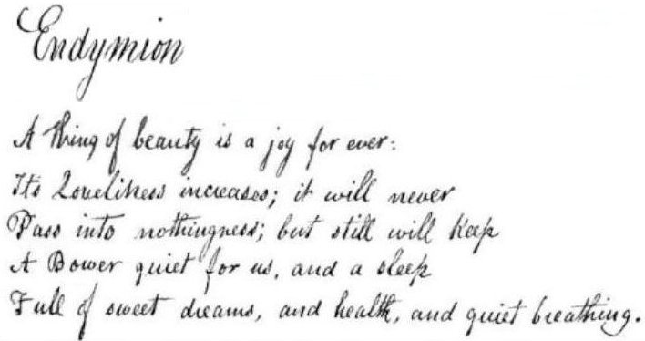
Giving us vivid dreams as we sleep.

Endymion (Above, Keats hand written first lines)
A thing of beauty is a joy for ever:
It's loveliness increases; it will never
Pass into nothingness; but still will keep
A bower quiet for us, and a sleep
Full of sweet dreams, and health, and quiet breathing.

A Summer Rose

She's as brilliant as a red, red rose,
Next to the green, green grass of home.

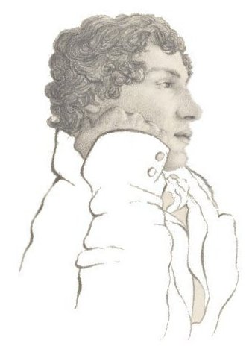

I'm gazing down a country road in June,
Imaging Scottish songs played in tune.
I will come to see you in a while,
Tho' it be far, five thousand mile.
Together we shall enjoy the warm sun,
On the sandy beach we'll walk and run.

Keats drawn by Brown on the Isle of Wight.

Then He Met Fanny
“She is as superior as a rose to a dandelion,” John Keats wrote to his brother and wife, in America. “Mrs. Brawne is a very nice woman. She has taken residence in the other side of Brown's duplex, my friend's house in Hampstead. Her daughter senior, Fanny, is I think beautiful and elegant, graceful, fashionable, yet silly. Strangely, we have a tiff now and then—after, she behaves a little better.”
In time, Keats moved in with Charles Armitage Brown. Fanny's room was at the front of the house. Keats room was at the back of the house on the other side.
1819
My dearest Lady,
I am now at a pleasant Cottage window, looking onto a beautiful hilly country, with a glimpse of the English Channel; this very fine morning. What pleasure I might have in living here as free as a bird about this beautiful Coast if the remembrance of you did not weigh so upon me. Each day, for you, I scrawl some blank verse or tag rhymes, when not writing my poetic love story, Lamia.
Here I must confess, I love you the more in that I believe you have liked me for my own sake and for nothing else. I have met with women whom I really think would like to be given away by a Novel when being married to a Poem.
I live upon Hope and Chance until next we meet. You must write immediately, and do all you can to console me—make it rich as a draught of Guinness to intoxicate me.
There is no delivery to this place, Eglantine Cottage in Shanklin, so you must address Post Office, Newport, Isle of Wight.
Ever yours, my love,
John Keats

For Valentine's Day
She walks in beauty, like the night
Of cloudless climes and starry bright,
And all that’s best of dark and light
Meet in the aspects of her eyes;
Thus mellowed by the tender skies
Which heaven too sunny, day denies.

On her cheek, over and below,
So soft, so calm, the tints that glow,
The smile that wins, it does show,
The brilliant highlights of her face,
Her sassy serene stylish grace,
How dear she is in Beauty's place.

One shade the more, one ray the less,
Which waves in every raven tress;
Where thoughts serenely sweet express,
A mind at peace that's eloquent,
It tells of days in goodness spent,
With a heart whose love is innocent.
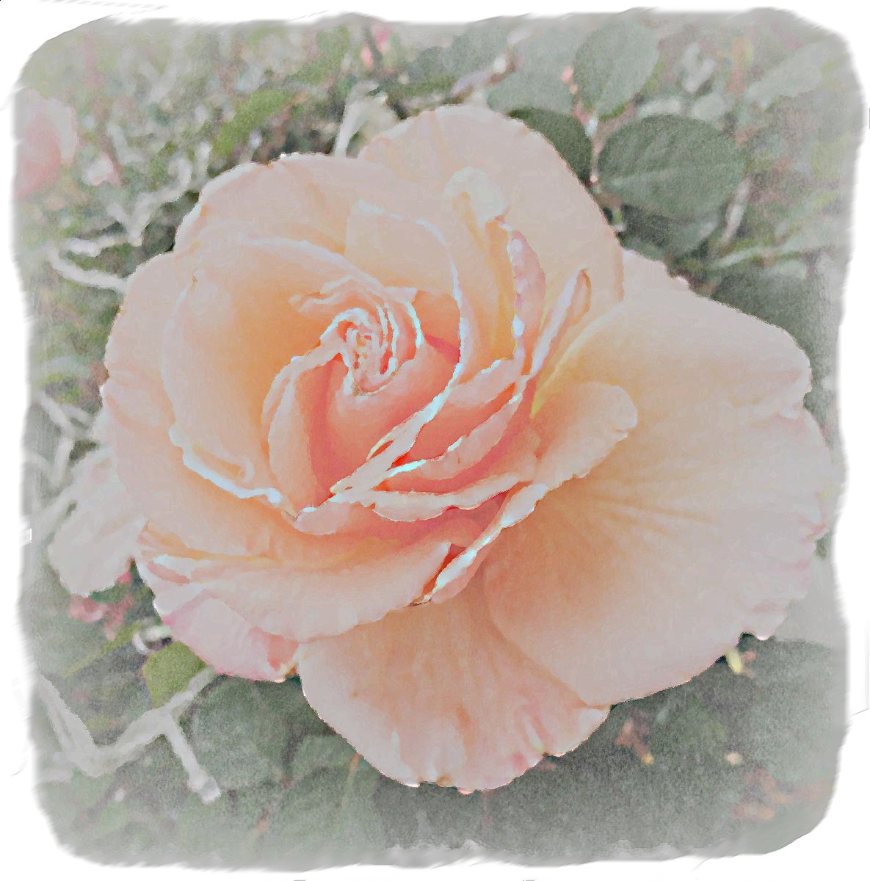

The Composition of a Kiss
Cupid, if legend tells the story right,
Once framed a rich elixir of delight.
A chalice over love-kindled flames he fixed,
And in it honey nectar and ambrosia mixed,
With the magic dew which evening brings,
Brushed from the rising stars by faery wings;
Daydreams of hope add a brilliant glow,
Having removed sad sorrow and woe.
The wizard Chemist heard the process rise,
The steamy chalice bubbled up in sighs;
Sweet sounds transpired, as a cooing dove,
Pouring in the soft murmuring of responsive love.
Stirring in passion's heat for desire to inflame,
Finished the composition; “Kisses” was its name.
The goddess Venus did taste, and then blest,
And breathed on Fanny's lovelier lips the rest.

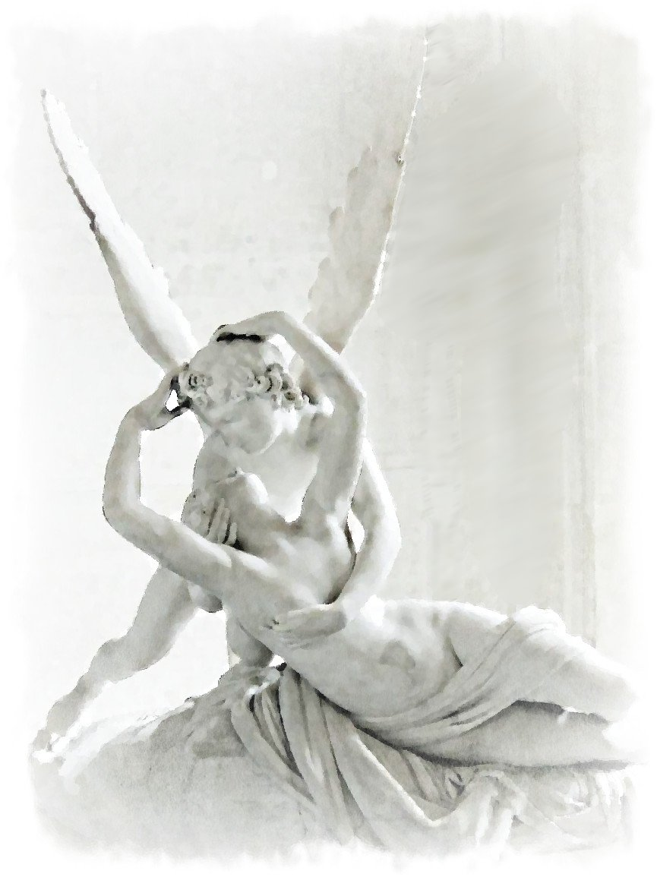

Cupid's Kiss, in the Louvre Museum

How Do I Love Thee?
How do I love thee? Let me count the ways.
I love thee to the level of every day's
Most quiet need, of sun and candlelight,
Then I love thee purely in the darkness of night.
I love thee to the depth and breadth and height,
That my soul can reach, it's a feeling out of sight.
I love thee with a passion put to good use
Removing old griefs, all pain let loose.
I love thee freely, as you strive for Right;
For being my graceful guiding starlight.
I love thee forever with a love I shall never lose;
Smiles, tears, all of my life!—and, if God choose,
I shall but love thee better after death,
As I have loved thee always with every breath.

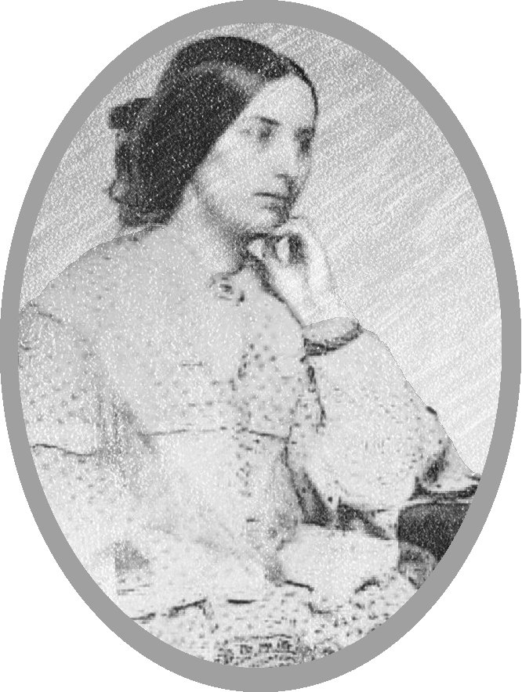
Fanny Brawne

Engagement
John Keats and Fanny Brawne's engagement began December 25th 1818. Alas, the poet’s social standing was such that he could not actually afford to marry her. They kept their union a secret from all but their closest friends. Early 1820 the poet gave his ring to Fanny as a statement of his true intention to marry her.

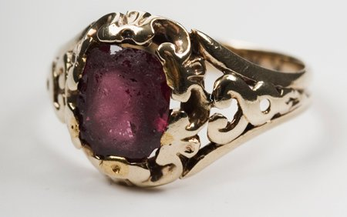
Image credit: Engagement ring of Fanny Brawne, The City of London, Keats House, Hampstead.

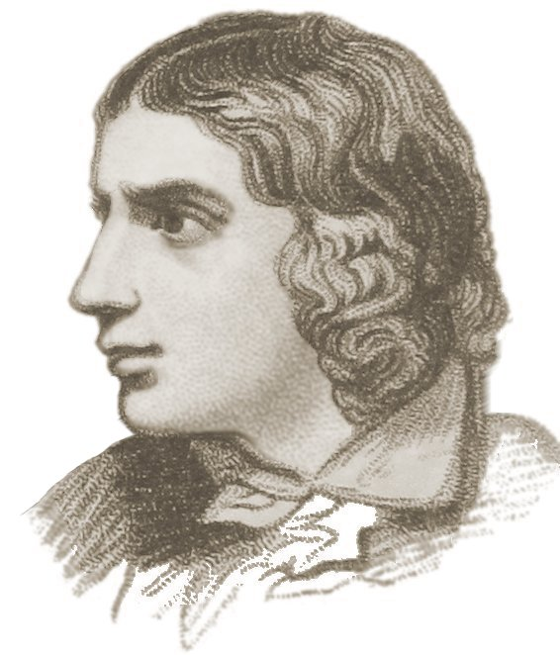

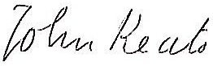

As I am composing, pleasant words freely flow, I am writing a book of life, my poem portfolio.

Keats House
In Hampstead, north part of London, Keats House is a museum for poetry lovers to visit, wander through and hang out. Or attend poetry speaking engagements and other events.
It's the place where John Keats and Fanny Brawne became engaged and lived. It's a place where memorable poems were written.
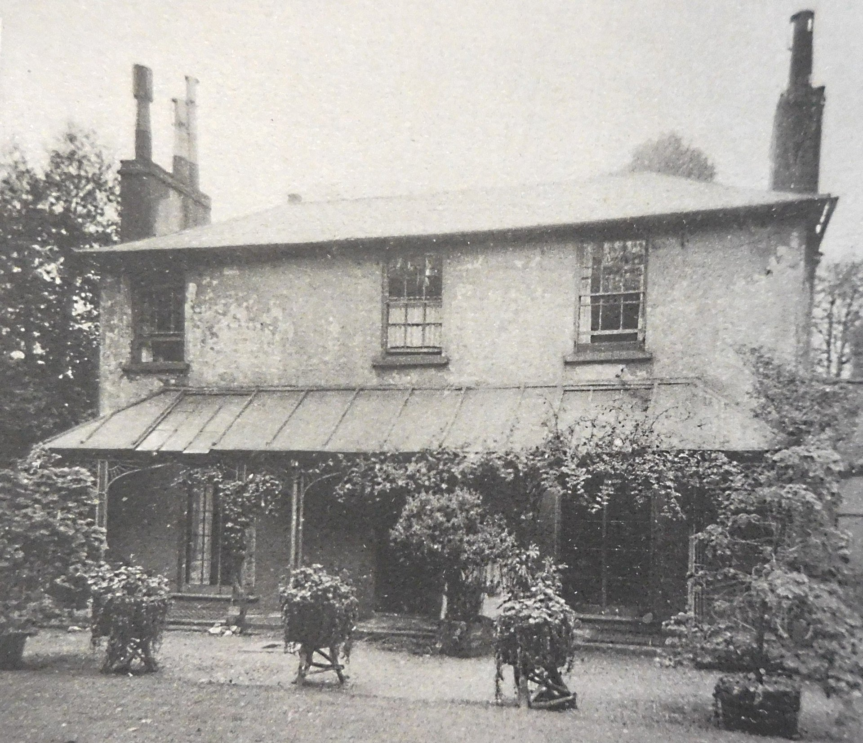
The photo was taken in 1920, from the backyard garden. The bottom right window was Keats parlor, the top right was his bedroom. Top left, facing the front garden, was Fanny's room.

Early 1820

My dear lady
I read your note in bed last night, and that might be the reason of my sleeping so much better.
I love you ever and always without reserve. The more I have known you the more I have loved you. The last of your kisses was ever the sweetest; your last smile the brightest; your last movement the most graceful.
When you passed my window home yesterday, I was filled with as much admiration as if I had then seen you for the first time. I wonder the more at the Beauty which has kept up the spell so fervently.
When I send this round I shall be in the front parlor watching to see you. This evening Brown is gone out. Show yourself for a minute in the garden, and when Mrs Wylie is gone, I shall be awake for you.
J. Keats
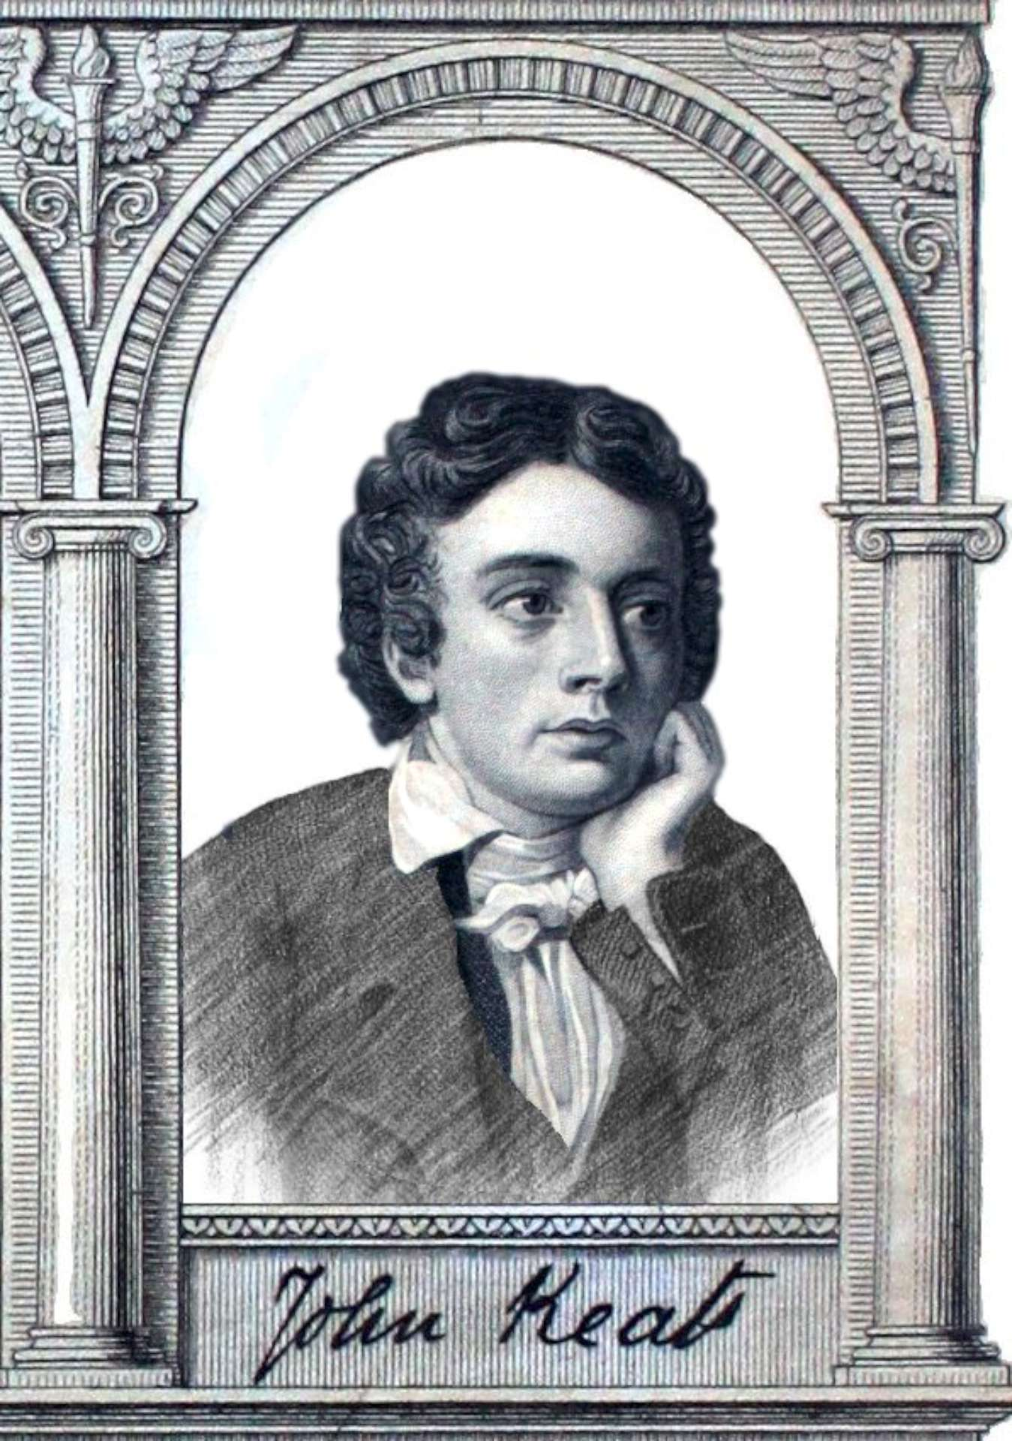

What Dreams are Made Of
Oh let me have all of you—all be mine!
Your love, your kisses,—those eyes divine.
To see your bright smile of passionate zest,
To touch your soft hands and softer breast,
To hear your sweet whispers in tender tone,
But at the end of day, all your sweets are gone.
As the curtain falls on Twilight's eve,
A lover's dream begins to weave,
A dream of being in each other's arms,
The flowering of your budding charms,
Your softest gasps of sensuous sighs,
Your beauty reflected in my pixie dust eyes.
At night we stroll beside a bubbling stream,
Joined asleep in A Midsummer's Night Dream.

Fanny strolling in the garden.
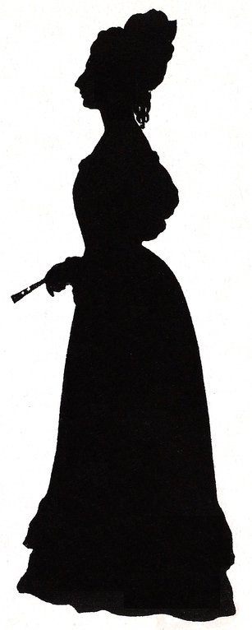

One fine spring evening Keats went out to his backyard where song birds were singing in the trees. The next morning he returned to the yard and wrote his Ode to a Nightingale.

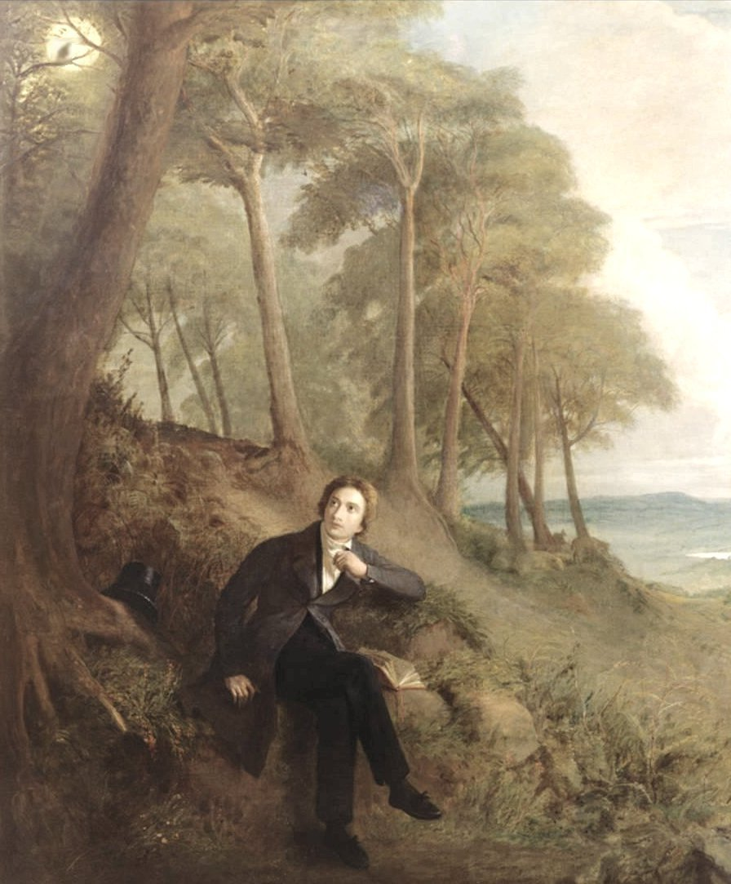

Ode to a Nightingale's Lament
My heart aches, a lonely lover's pain,
As I tip my glass, my senses drain;
Down and Death-wards I sink,
As though of hemlock I drink.
Distracted I drift deep into the forest dim,
Lost in the woods, I fear Brothers Grim,
In the air is the nightingale's haunting song,
In the wind I hear three witches sing along,
“Double, double, toil and trouble;
Fire burn, caldron bubble.”

Darkling I whisper to the Reaper in rhyme,
Calling out the specter's name many a time,
I have been half in love with quiet Death,
To take into the air, with my last breath,
Rising in ecstasy, in a melancholy high,
Now more than ever it seems rich to die,
To cease upon the midnight, to end with no pain,
Hearing only Silence as thou sings in vain,
Pouring forth a lament, as you must,
A majestic requiem, as I become dust.

You were not born for death immortal Bird!
The voice I hear this passing night was heard,
In ancient days by king, queen, and clown;
No hungry generations have hunted you down.
Perhaps your same sad song helped to find the path,
Over troublesome lands that Dorothy oft-times hath,
Desperately traveled searching for home,
Down the yellow brick road she was forced to roam,
With Scarecrow amid the alien corn,
A Stranger in a Strange Land, forlorn.

Forlorn! the very word is like a bell,
Tolling me back to my soul's dark well,
Back to the fears which you have never known,
Down where we sit to hear each other groan,
Sad for weak limbs and thinning gray hair,
Long life nearing end as we fall into despair,
Where youth grows pale, specter-thin and dies,
Where Beauty cannot keep her illustrious eyes,
Where love pines far beyond tomorrow;
To think of lost time, is to be full of sorrow.

I should fly away with you, far away to forget,
Life's weariness, mistakes, and every dark fret.
Thankfully there are flowers at my feet,
On the trees spring blossoms, colorful and sweet,
Which refresh my thoughts on this mystic night,
Here under the glowing evening sky light,
Where the Queen-Moon sits high upon her throne,
Where the heaven's ethereal breezes are blown,
Cluster'd around by all her starry Fays,
Orbiting above trees and winding pathways.

Close is my light-winged pixie of the trees,
Singing of hope with meditative ease.
As I listen to the Nightingale's melodic song,
I am envious how in twilight she sings along,
With forest spirits in their happiness,
Of oaken green and shadows numberless,
Where Nature's incense hangs upon the boughs,
Where with the seasonable month endows,
The grass, the fields, the orchard trees wild,
With the wonder of Mid-May's flower's child.

I stand on a hillside with rows of grapevines,
The fruits of red, white, and sparkling wines.
Carrying my bottle of vintage that hath been
Aged with tastes of Flora in fields of green,
Cool'd a long age in the deep-delved earth,
I dream of country songs, dance, and mirth,
And pour my glass full of the valley's west,
Where the country's wines are fermented best;
Aromatic, full-bodied, decadence obscene,
That I might drink and step away unseen.

Through forest gloom on poetic wings,
My soul is lost in pleasant wanderings,
But the muse takes flight away from myself,
As she is famed to do, that amusing elf.
Adieu! adieu! your charming anthem fades,
Into the next valley, into the dark glades,
Past the near meadows, ‘tis now buried deep,
Fled is that music—Am I awake or asleep?
On a hill-side; overlooking a still stream,
Was it a vision, or an evening's daydream?

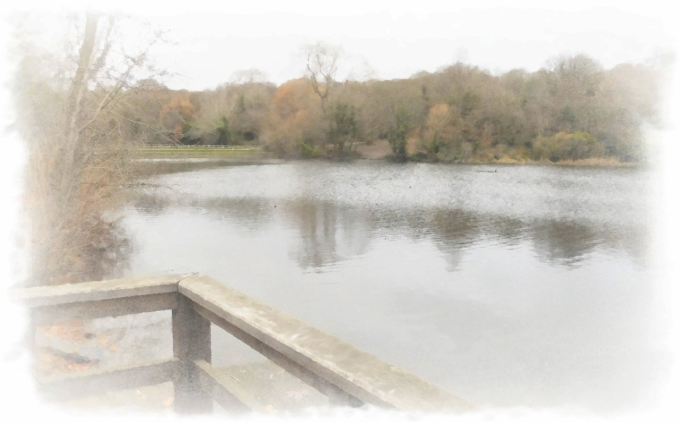
After writing his ode, he had lunch and walked Hampstead Heath.
When Keats came home late one night, Brown asked, “What is the matter? You are fevered.”
“Yes, yes,” Keats answered. “I was on the outside of the stage this bitter day till I was severely chilled.”
He yielded to Brown's request and went up to bed. On entering the sheets, he slightly coughed, and said, “That is blood from my mouth. Bring me a candle, Brown; and let me see this blood.”
After regarding it steadfastly, he looked up and into Brown's face, and with a calmness of countenance that Brown never forgot, said, “I know the color of that blood. It is arterial blood. It is my death-warrant. I must die.”
John was no stranger to consumption, he had nursed his younger brother while he was sick, and until his death.
Written by Brown.

Mid 1820
My dear lady,
I must make myself as good a Philosopher as possible. For now illness stands as a barrier betwixt me and you. To see you happy and in high spirits shall be a great consolation to me.
J. Keats

His doctor said, “With consumption set in, Keats may not live through another England winter.” A warmer climate was suggested. It was decided Keats should travel to Italy.

Mrs. Brawne, Fanny's mother, promised Keats, “Should you return, you and Fanny can marry.”

Bright Star
Keats composed a sonnet while sailing to Italy, not knowing when, or if, he would ever return. He dedicated his sonnet, Bright Star, to the love of his life.

Starlight
Star Bright, would I were as stedfast at night,
Each evening rising into the sky with delight,
Above the forest canopy of dark green leaves,
Listening to cricket music on warm summer eves,
To glide above valleys and over mountains,
To nourish angel souls in starlight fountains.
For my love I will forever shine bright,
Be her twinkle twinkle little star night light,
To be awake forever in sweet silent rest,
Pillowed upon my fair lover's breast,
To feel its gentle soft fall and swell,
To feel always calm, glowing and well.
To lay still and listen to her soothing breath,
And to be immortal in sweet loving rest.
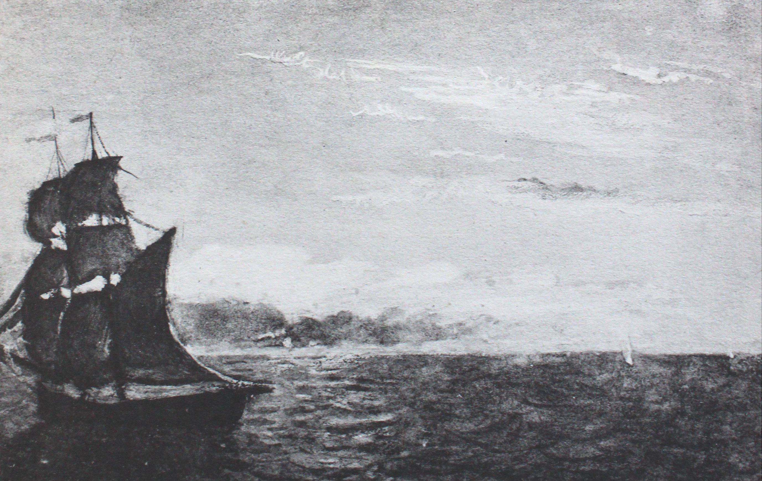
Joseph Severn's painting of the ship
which they travelled in, to Rome.

We are such stuff as dreams are made on,
and our little life is rounded with a sleep.
Shakespeare

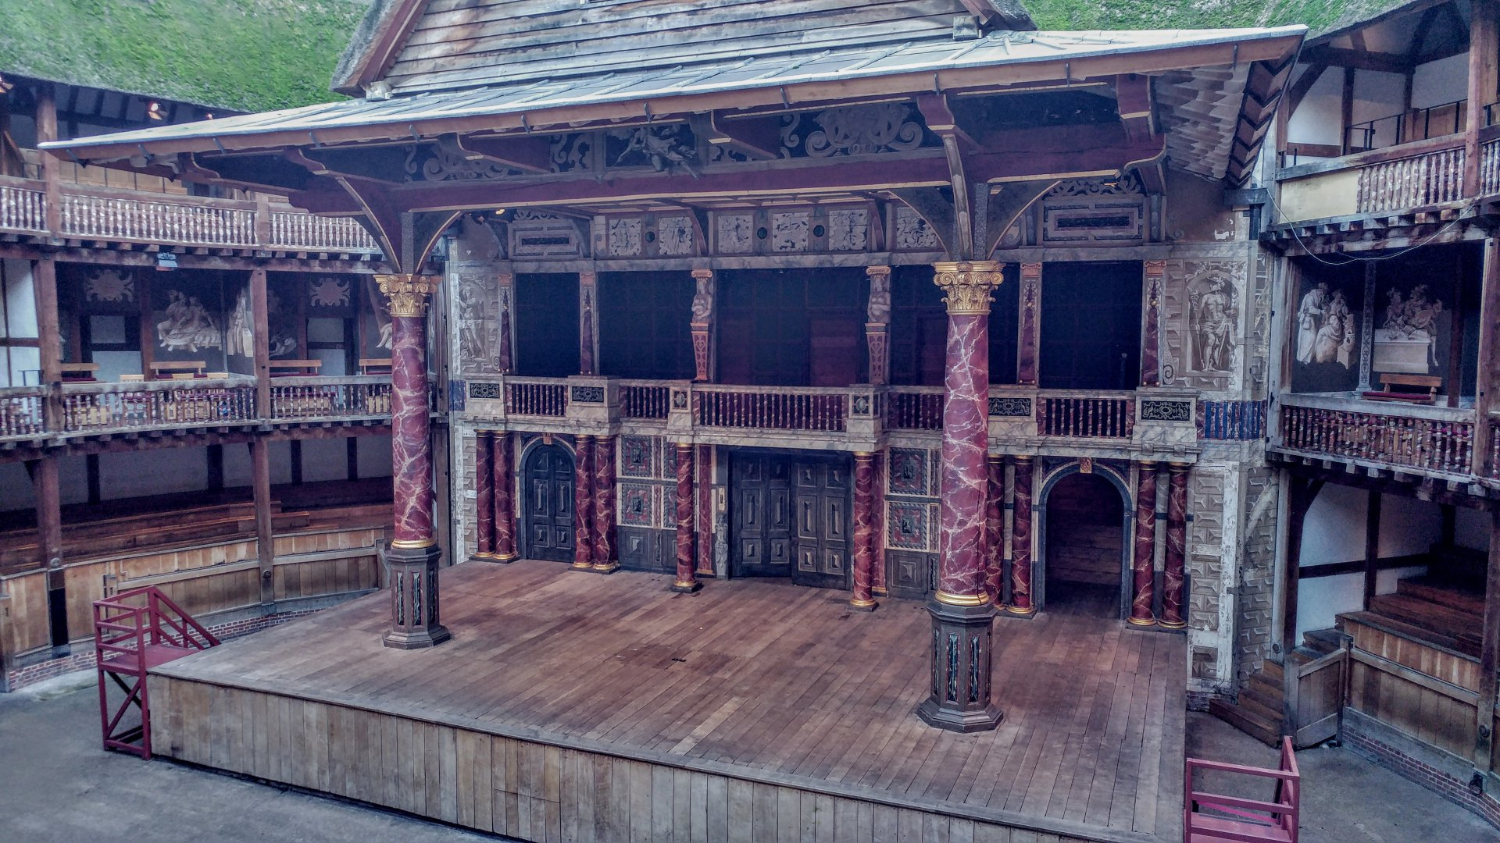
The Shakespeare Globe Theatre stage.
For a player, all the world's a stage.
After receiving news of his death, Fanny cut her hair short and donned black clothing for years. Keats was not famous during his life time, and so, Fanny had only personal reasons to keep his letters, even after marrying and having children. As well, she wore his ring for the rest of her life.
Joseph Severn had taken care of Keats while traveling and while staying in Rome. Percy Bysshe Shelley offered to have Keats stay at his Roman house, which is now the Keats-Shelley Memorial House. Shelley was a fellow poet who was close in age to Keats and admired his poetry saying, “He is destined to become one of the first writers of the age.”
In a prose piece by Shelley, he had quoted Shakespeare, “such stuff as dreams are made.”

The Tempest
Act 4, scene 1, has a play within the play. Prospero:
Our play has ended, and our actors as I foretold,
Were mere spirits on the stage
Having melted into air, into thin air.
And like the baseless fabric of that vision
Are the high towers, the gorgeous palaces,
The solemn temples, and the great Globe itself;
They shall all in the depth of time, dissolve.
As all the world’s a stage,
And all the men and women merely players;
We have our entrances and our exits,
And like this insubstantial play,
We players shall fade leaving not a trace behind.
Life is the stuff that dreams are made of,
And our little life is rounded with a sleep.

For the last line of the 1941 film, The Maltese Falcon, Humphrey Bogart—one of the coolest guys ever—suggested to the director the final line, which he said in closing the movie, “The stuff that dreams are made of.”

Poetic Starlight
The shadow of Death had knocked on his door,
Laying as if asleep he will awake, never more.
The Sound of Silence is his disembodied song,
Dust to dust, no envy, no hate, no longer wrong.

Sad maiden, Fanny Brawne, whom he had cherished,
Feels dazed and confused now her dearest has perished.
Her love flies into the shadows as sunlight pines away,
No longer amorous birds perched together at close of day.

Her evening desires become Twilight Phantasies,
Her life's hopes and dreams only veiled destinies.
A rain of tears clouds the light in her eyes,
Her tear drops echo as melancholy sighs.

Lost are her dreams of a life in paradise,
Like dew upon a delicate flower, tears she cries.
Her love, her sorrow, her sweet heart in pain,
She has faded like a cloud who has out wept its rain.

He has yielded to Death, he has finished his part,
But connected to Life, she could not depart.
Outside of time and change, he is gone forever,
Now Death divides what Life had joined together.

In life his god like mind had soared to a Heavenly height,
Their Earthly pleasures were unveiled in muse delight,
Now his poems are bright stars this dark desolate night,
Kindling her sweet dreams into brilliant morning light.

He had listened to the song of the nightingale bird,
Its beauty bursting forth, every evening it was heard,
Its loveliness made more lovely in Heaven's light,
His Ode of rhythm and rhyme is poetic delight.

He gave her Nature's music before he was Heaven bent,
Sweet lyrics of poetic music into her life he had sent.
He was the phantom lyricist in this world's wilderness,
A Poet King who had gazed on Nature's naked loveliness.

Wearing his ring she will always remember,
Their romantic engagement that Sweet December,
They lived and loved, days and nights together;
Love's memories are a thing of beauty, a joy forever.

Poems are soft roses: red, pink, and yellow,
Soothing memories of her gentle fellow.
Smiling through her tears, her eyes of blue,
Sweet flowers refreshed in morning dew.

His sunlight words make Earthly shadows fly,
His books shine starlight from the Heavenly sky;
He wrote poem castles for them to live together,
Love's poems are a thing of beauty, a joy forever.

For her he wrote long letters lovely and fair,
That she may read and smile, and not despair.
His words each night she enjoys anew,
Happier her, for the happiness she knew.

Spring and hope return each revolving year,
The flowers, the bees, and the song birds reappear.
Through wood and field and over Ocean,
A quickening life of change and motion.

Now centuries have past and Fanny Brawne is gone forever,
No more Life divides what Death has joined together.
Flying through Heaven's veil they became a Bright Star,
A beacon for mortals from where the lovers, forever are.

July 1819
My dearest Lady,

I almost wish we were butterflies and lived but three summer days—three such days with you I could fill with more delight than fifty common years could ever contain.
Ever yours, my love,
John Keats

John Keats died at the age of 25. Since he had his 3 days with Fanny, which was worth 50 years, Keats had lived 75 romantic years.

Memory's Treasure
I hold it true, whatever may befall;
I feel it when in sorrow, most of all,
‘Tis better to have loved and lost,
Than never to have loved at all.

1820

My dear Fanny,

“If I should die,” said I to myself, “I have left no immortal work behind—nothing to make my friends proud of my memory—but I have loved the principle of beauty in all things, and if I had time I would have made myself remembered.”

God bless you,
Love,
John Keats

The great end of poetry is that it should be a friend to soothe the cares of humankind.
John Keats, 1816

