Crashed
Unfortunately, each decade has heroes who crash and burn. In the 70's, Jim Morrison. In the 90's, Kurt Cobain. This decade had Robin Williams, Anthony Bourdain, and my friend Mark Langland.
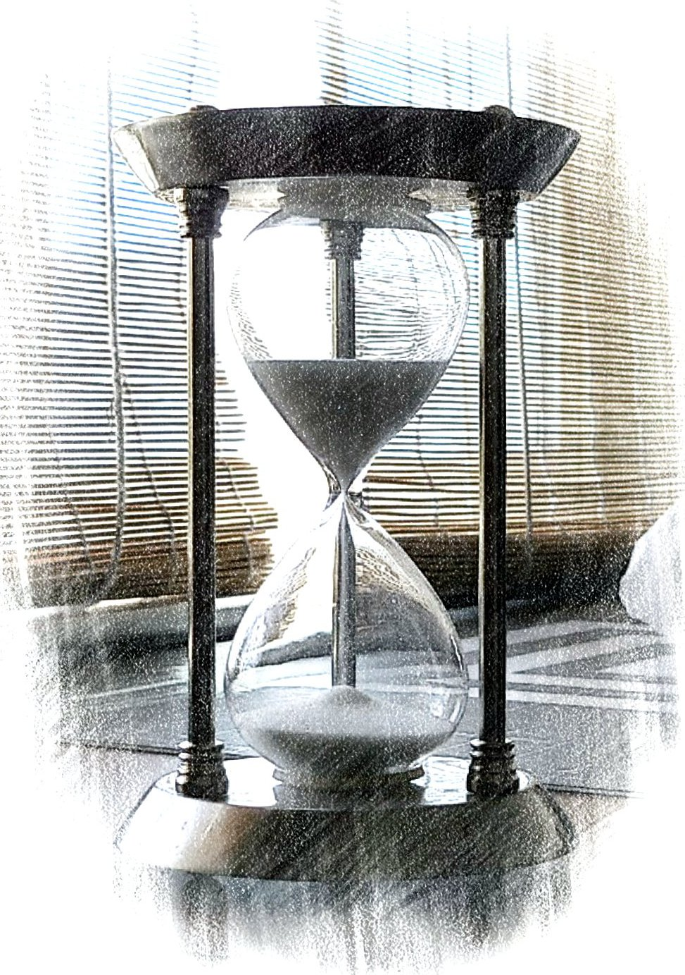
His mind was in trouble, he was depressively pained,
Each time he tipped his glass, his senses drained,
Down and Death-wards he sank,
As though of hemlock he drank.
Forlorn, how his emotions were like a bell,
Tolling him back to his soul's dark well,
Back to fears, darker than we've ever known,
Where standing alone, he would shake and groan.
His mind was a tangled forest, the light grew dim,
Lost in the woods, he feared Brothers Grim.
In the air was the night owl's haunting song,
In the wind he heard three witches sing along,
“Double, double, toil and trouble;
Fire burn, caldron bubble.”
Darkling he whispered to the Reaper in rhyme,
Calling the Specter's name too many a time;
He was half in love with easeful Death,
To take into the air, with his last breath,
And in a moment of delusion, he ended his pain!
We only heard silence as his soul screamed in vain.
Wishing my friend with me as I drift and roam
Down country roads where I'm far from home,
I pine for his friendship beyond tomorrow,
Aware of lost time, I am lost in sorrow.
Sad are we, whom he had at one time cherished,
We feel dazed and confused that our friend has perished.
Thankfully there are flowers at our feet,
On the trees spring blossoms, colorful and sweet,
Which refresh our thoughts on this new day,
Together wishing our friend on heaven's way.
Spring and hope will return each revolving year,
The flowers, the bees, and the song birds reappear.
His bright eyes and laughter, we will remember anew,
Happier are we, for his happiness we knew.

Crashed, copyright © 2021, an original poem by Stacy David Thurston, California, United States of America.

My Writing Credits
My poem, I am Canadian, was published in my alma mater's magazine, 2007 issue, University of Manitoba.
Getting Started with Sun ONE, is my computer book published 2004 by Prentice Hall.

Crashed, was inspired by reading, Ode to the Nightingale, by John Keats, published 1820.

