EDUCATION
Unlocking opportunities for the next generation of game makers through Science, Technology, Engineering, Art and Math-related programs
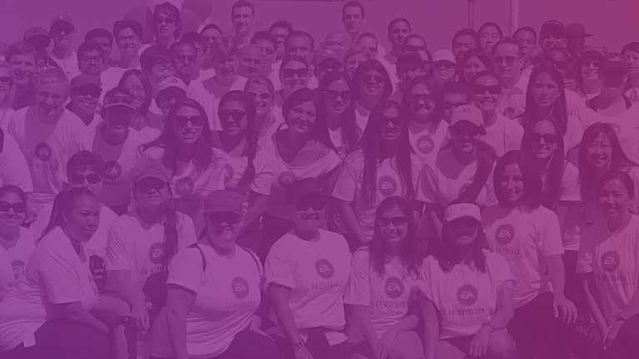

INCLUSION
Providing resources and tools that aim to serve diverse communities in and out of the gaming industry
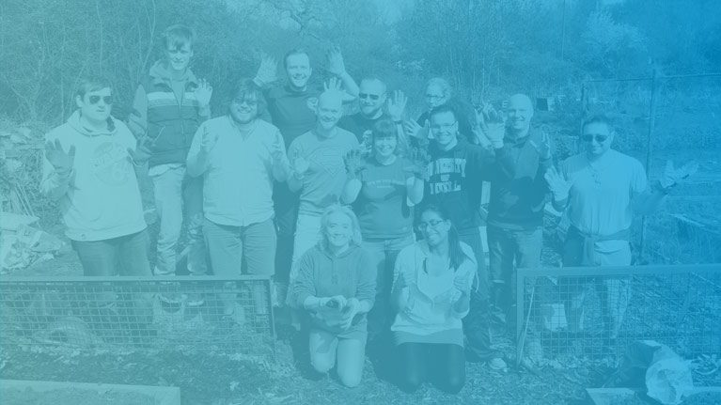

COMMUNITY
Supporting employees and players to give back to the causes that they care about

