1. Student表

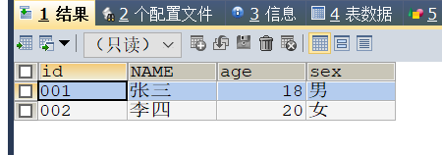

CREATE TABLE student(

id VARCHAR(3) NOT NULL ,

NAME VARCHAR(3) NOT NULL,

age INT(3)NOT NULL,

sex VARCHAR(1) NOT NULL,

PRIMARY KEY (id)

)

INSERT INTO student (id,NAME,age,sex) VALUES ("001","张三",18,"男")

INSERT INTO student (id,NAME,age,sex) VALUES ("002","李四",20,"女")

1. Subject表

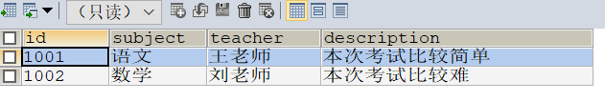

CREATE TABLE SUBJECT(

id VARCHAR(4) NOT NULL ,

SUBJECT VARCHAR(2) NOT NULL,

teacher VARCHAR(3)NOT NULL,

description VARCHAR(10) NOT NULL,

PRIMARY KEY (id)

)

INSERT INTO SUBJECT (id,SUBJECT,teacher,description) VALUES ("1001","语文","王老师","本次考试比较简单");

INSERT INTO SUBJECT (id,SUBJECT,teacher,description) VALUES ("1002","数学","刘老师","本次考试比较难")

1. Score表

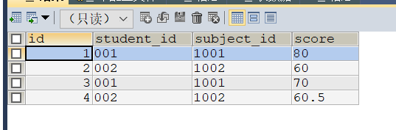

CREATE TABLE score(

id INT(3) NOT NULL AUTO_INCREMENT ,

student_id VARCHAR(3) NOT NULL,

subject_id VARCHAR(4)NOT NULL,

score VARCHAR(5) NOT NULL,

PRIMARY KEY (id)

)

INSERT INTO score (student_id,subject_id,score) VALUES ("001","1001","80");

INSERT INTO score (student_id,subject_id,score) VALUES ("002","1002","60");

INSERT INTO score (student_id,subject_id,score) VALUES ("001","1001","70");

INSERT INTO score (student_id,subject_id,score) VALUES ("002","1002","60.5");