Salesforce Agent Flow
Project: C:\Users\tiger\project\salesforce-agent
This document captures the implemented workflow in the current agent backend. The two diagrams below are generated project assets and embedded directly into this Word file.

End-to-End Flow
This view shows the main runtime path from user request through FastAPI, LangGraph, MCP access, approval, and final response.
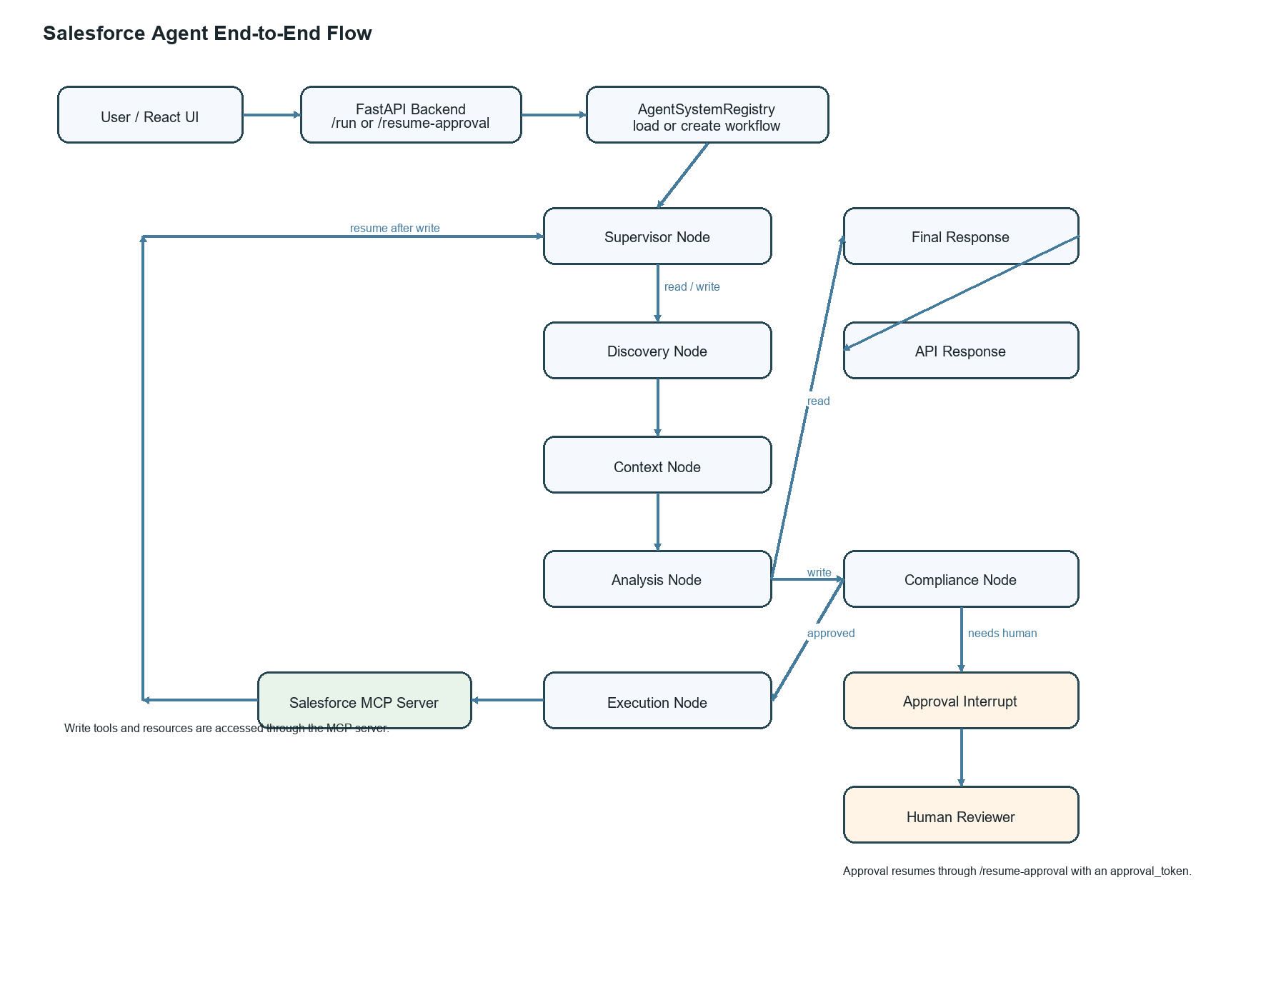

Component View
This view shows the higher-level system boundaries: UI, API, registry, graph, LLM, and MCP server.
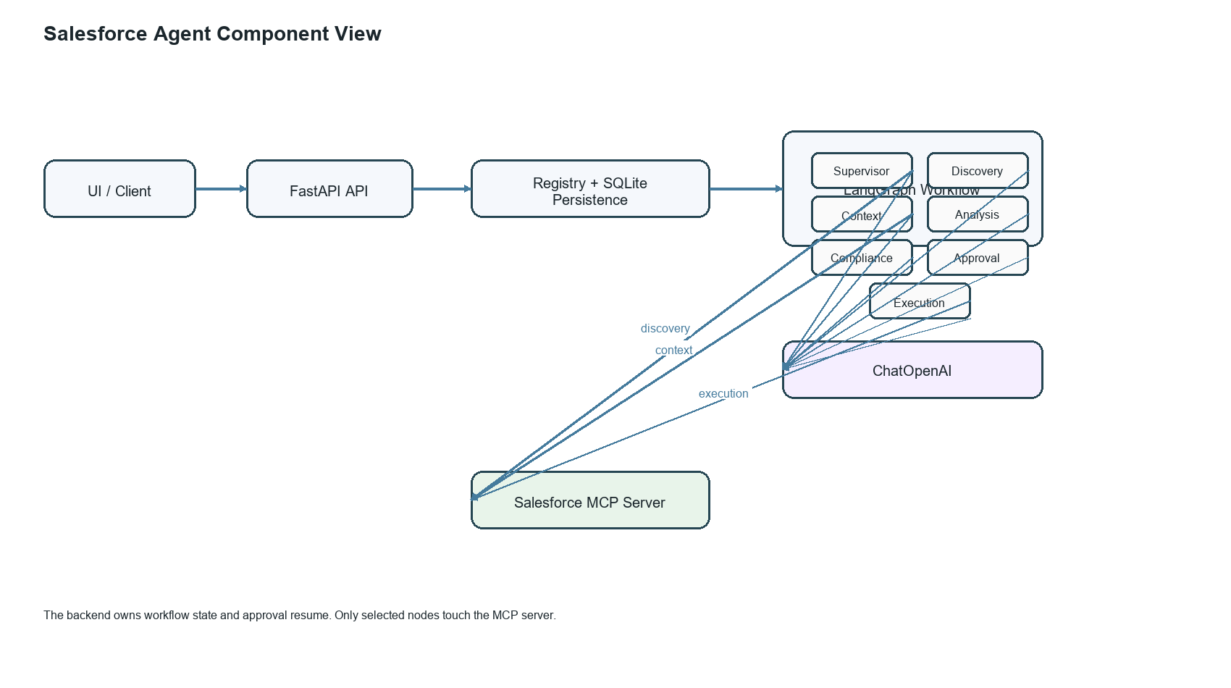

Implemented Node Order
- supervisor
- discovery
- context
- analysis
- compliance on write path
- approval for high-risk writes
- execution
- back to supervisor for final response

Routing Rules
- supervisor: read -> discovery, write -> discovery, terminal phase -> end
- analysis: error -> end, read intent -> supervisor, write intent -> compliance
- compliance: blocked -> end, approved -> execution, needs human -> approval

Main Files
- C:\Users\tiger\project\salesforce-agent\agents\system.py
- C:\Users\tiger\project\salesforce-agent\agents\routing.py
- C:\Users\tiger\project\salesforce-agent\agents\nodes\supervisor.py
- C:\Users\tiger\project\salesforce-agent\agents\nodes\discovery.py
- C:\Users\tiger\project\salesforce-agent\agents\nodes\context_agent.py
- C:\Users\tiger\project\salesforce-agent\agents\nodes\analysis.py
- C:\Users\tiger\project\salesforce-agent\agents\nodes\compliance.py
- C:\Users\tiger\project\salesforce-agent\agents\nodes\approval.py
- C:\Users\tiger\project\salesforce-agent\agents\nodes\execution.py

