报表文件说明书
Report Documentation
Report ID： RPT9997
报表名字  Report Name | RPT9997-电子秤销售异常明细表 | 报表位置  Source | Share/商品销售/RPT9997-电子秤销售异常明细表/会员参与报表
创建人  Created Person | Kingsley | 创建时间  Created time | 2013-11-22
需求部门  Request Department | 运维部 | 需求人  Request Person | 林勇
需求时间  Request time | 2013-11-22 | 使用频率  Frequency | Everyday
必选条件  Necessary condition | Date、store | 可选条件  Optional condition | NULL
报表表头
Full Title：
日期 | 流水号 | POS机台号 | 门店编码 | 门店名称 | 商品代码 | 商品名称 | 大类 | 经营方式 | 正常售价 | 成交单价 | 销售数量 | 销售单价 | 称重标识 | 扫描码

SQL语句
SQL Query：
SELECT T1.STORE,
T3.STORE_NAME,
T6.BUSINESS_DATE,
T1.ITEM,
T5.ITEM_DESC,
T1.DEPT,
T2.BUSINESS_MODE,
T1.ORIG_UNIT_RETAIL,
T1.UNIT_RETAIL,
T1.QTY,
T1.STANDARD_UOM,
T1.CATCHWEIGHT_IND,
T1.REF_NO6,
T4.TRAN_SEQ_NO,
T4.REGISTER
FROM sa_tran_item t1,
cmx_item_loc_info t2,
store t3,
sa_tran_head t4,
item_master t5,
SA_STORE_DAY t6
WHERE (t1.unit_retail >= 1000 OR t1.unit_retail < 0.1)
AND t1.ref_no6 LIKE '24%'
AND T1.ITEM = T2.ITEM(+)
AND T1.STORE = T2.LOC(+)
AND T1.ITEM = T5.ITEM(+)
AND T1.STORE = T3.STORE
and T4.STORE_DAY_SEQ_NO=T6.STORE_DAY_SEQ_NO
and t4.day=t6.day
and T4.STORE=T6.STORE
AND T4.tran_seq_no = T1.tran_seq_no
AND T6.BUSINESS_DATE >= :PM_STDATE
AND T6.BUSINESS_DATE <= :PM_DATE
AND T1.STORE = DECODE(:PM_STORE, '', t1.store, :PM_STORE)
ORDER BY T1.STORE, T4.TRAN_DATETIME
计算公式
Function：
报表截图
Picture：
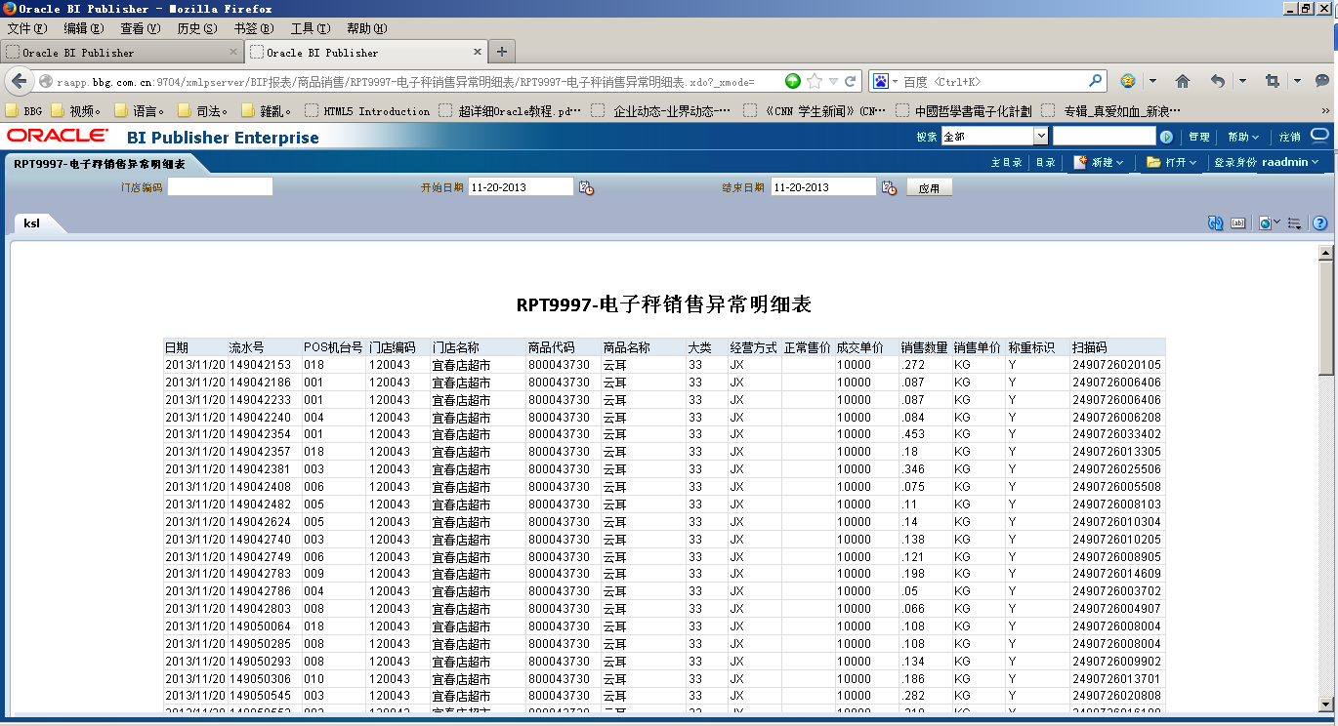
备注
Notes：

