G9a Cancer Isoforms Differential Gene Expression Analysis

Sicheng Yi (Tiger Yi)

Introduction
Breast cancer is a major cause of death globally especially among women. The gene EHMT2, or commonly known as G9a, is very related to cancer. According to prior studies, G9a acts like an oncogene which transforms cells into tumor cells. G9a is over expressed in several tumor types and likely a biomarker of poor prognosis in patients. G9a possibly also represses the tumor repression genes which contributes to tumor progression. The goal of this project is to explore the role of G9a isoforms alternative splicing in breast cancer.

Data
The data is bulk RNA-seq in cancer cell BT474 in the format of fastq files with average size of 4-5 GB each. Each sample is a replicate to the following conditions: WT, WT+M, KO, KO1, KO2, KO3, KO4. The given fastq files have already been trimmed, by running: bash trimmomatic.txt

WT is the Wild Type. It is the baseline reference of the cancer sample.
KO is the Knock Out. It knocks out the G9a cell line.
WT+M is the Morpholino treatment. It suppresses G9a gene expression in Exon 10.
KO1 is the G9a isoform with short First Exon (FE) and Exon 10 (E10).
KO2 is the G9a isoform with short First Exon (FE) without Exon 10 (E10).
KO3 is the G9a isoform with long First Exon (FE) and Exon 10 (E10).
KO4 is the G9a isoform with long First Exon (FE) without Exon 10 (E10).

Method & Approach
In the following section, I will outline how to run the bash code to get the preliminary result on the BU SCC super computing cluster. The detailed code is available at projectnb/hybrids/tigeryi.

I. Gene wide analysis
1. Download GTF annotation and primary Assembly Genome.
bash download_genecode.txt
bash download_ensembl.txt

2. Build map between the Gene ID and Gene name.
bash run_build_gene_map.txt

3. Build the Star Index for full alignment.
qsub build_star_index.txt

4. Run Star Alignment to get the BAM and BAI index files.
qsub run_star_array.txt

5. Get the raw Gene Counts
qsub run_featureCounts.txt

6. Clean up the Gene Counts matrix
qsub run_featureCounts.txt

7. DESeq Analysis
DE.R is the main code for differential gene expression analysis

II. Splicing analysis

1. Build GSL 2.7 library
qsub build_gsl.txt

2. Build RMATS turbo
qsub rmats_build.txt

3. Run RMATS to get rmats_results
qsub run_rmats_array.txt

Result
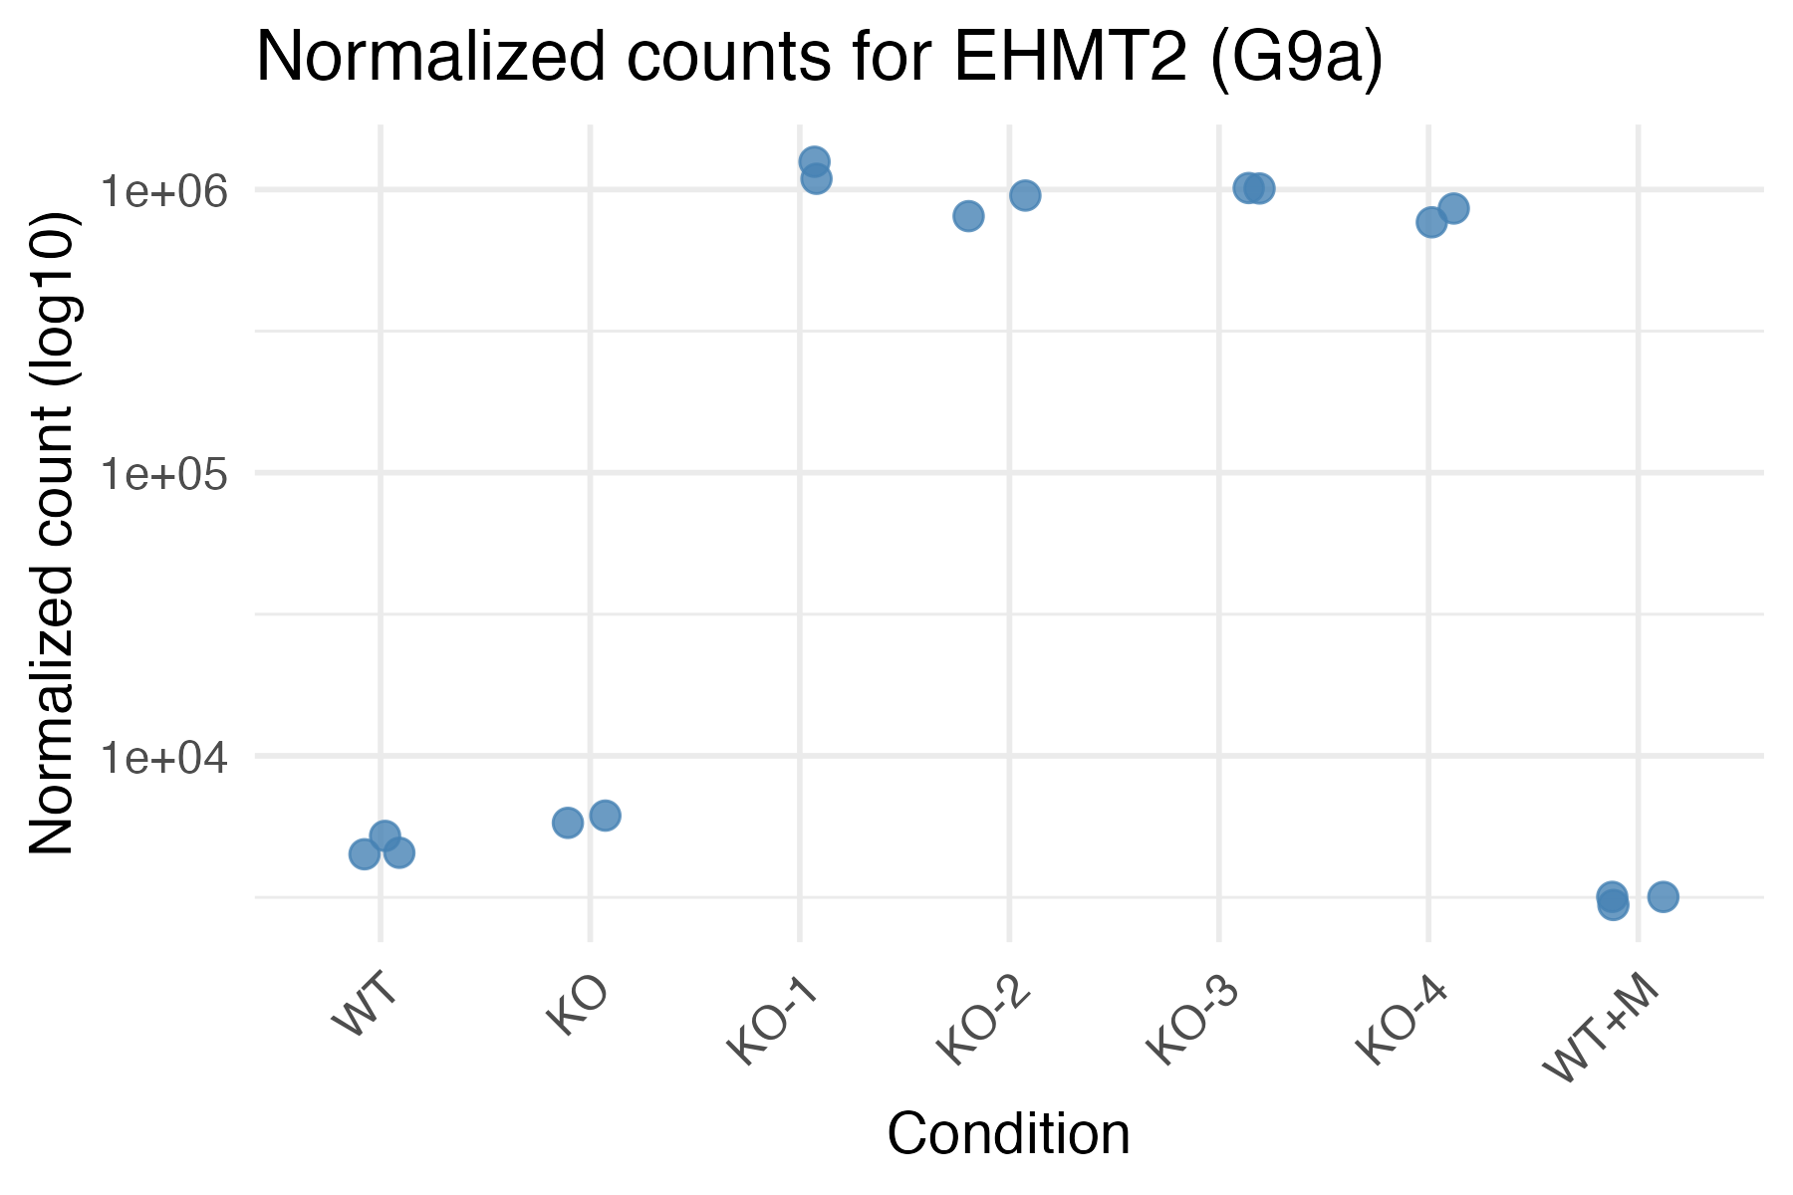
First off, the 2 graphs on the left show the gene counts and log fold change across the condition.

The 4 G9a isoforms have much higher gene counts than in the Wild Type, Knock Out, and M treatment.

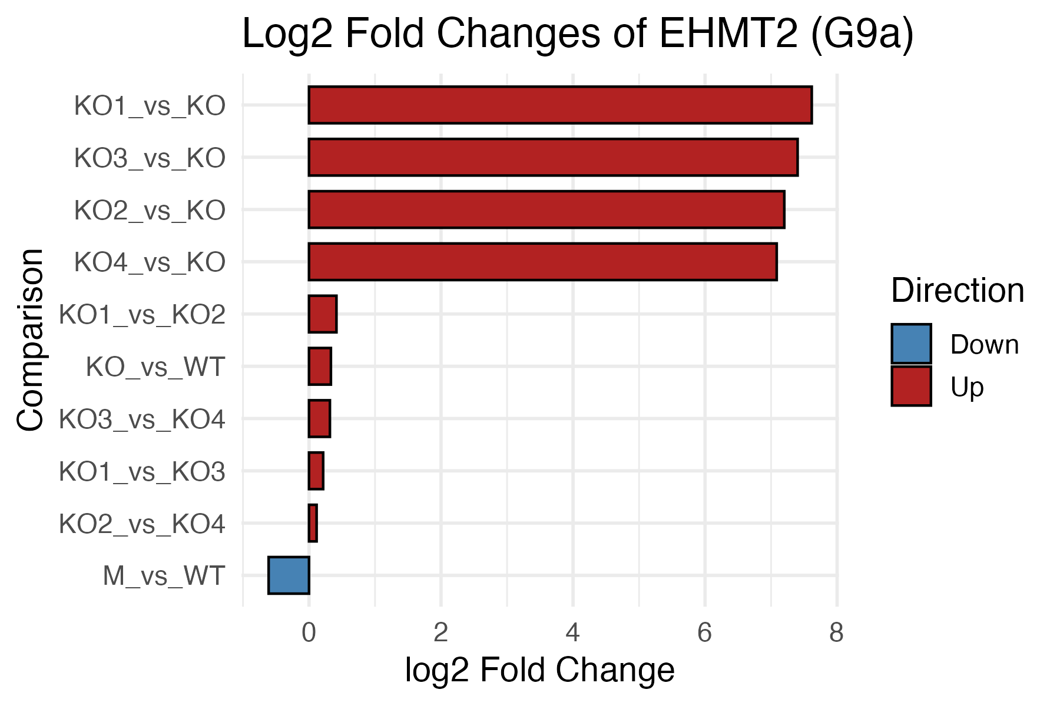
Now look at the log fold change of G9a.

The surprising part is the KO vs WT, it shows that Knock Out is slightly more upregulated than Wild Type which contradicts with the experimental setup.

M vs WT show that morpholino down regulates G9a expression effectively.

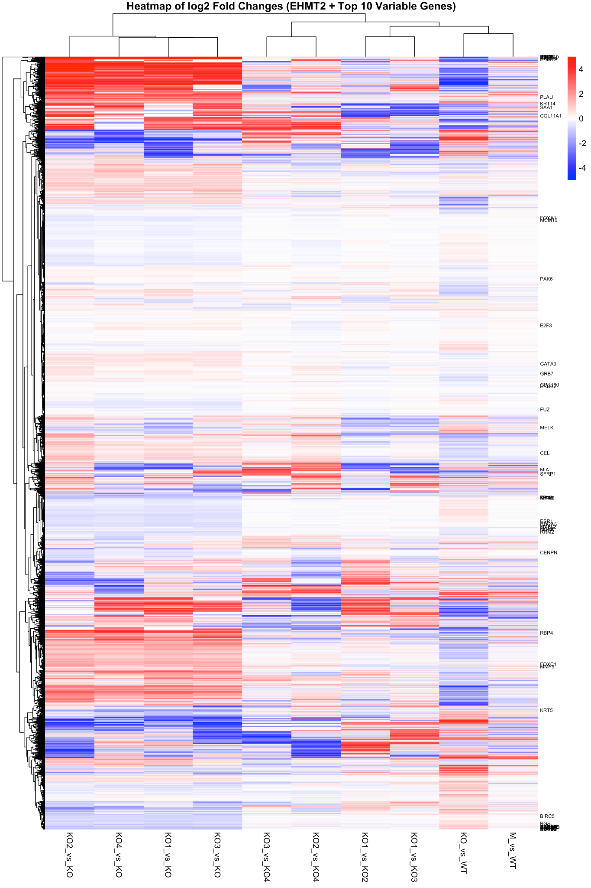
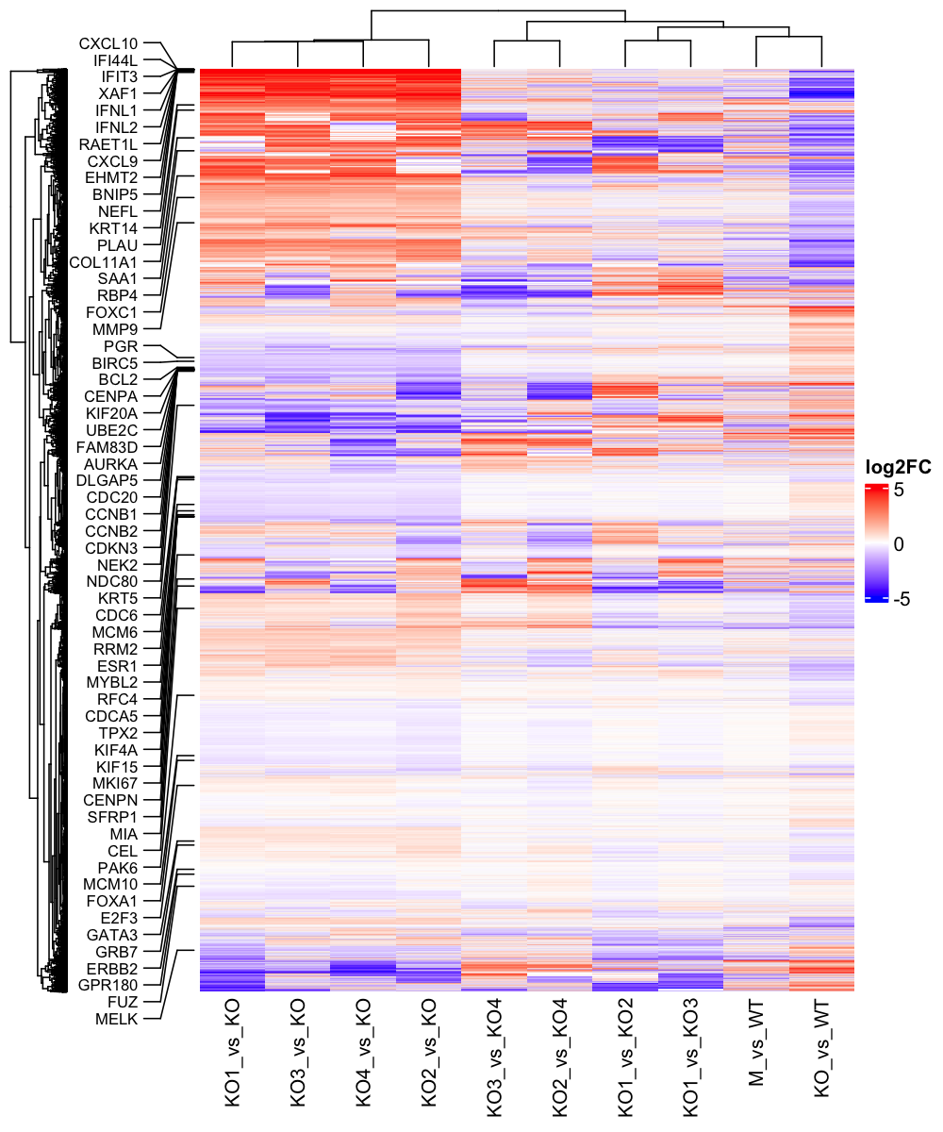

In the heat maps above, we can see clear sub biological modules from the G9a knock out and its isoforms. Gene G9a or EHMT2 are in the top red region where it is massively up regulated in the KO# vs KO groups. Interestingly, in the top red region, genes highlighted there are mostly interferon stimulated genes ISGs, such as CXCL10, IFI44L. This result is interesting as those immune response genes were suppressed by G9a then released in the isoforms groups. Most of these genes are immune-related or tumor suppressive, and many are known or likely targets of G9a-mediated repression. G9a is a histone methyltransferase that adds H3K9me2, a repressive chromatin mark that silences gene expression, especially in the Immune-related genes, such as in the cases here, as well as the tumor suppressor genes, which makes perfect transition to the next group of genes.

The genes at the middle and bottom blue regions of the first graph are the canonical cancer gene markers. Most of the cancer genes from this block are up (red) in KO vs WT contrast but down (blue) in KO# vs KO contrasts, which goes in the opposite direction of the ISGs immune genes earlier.

| GeneName | KO_vs_WT | KO1_vs_KO | KO2_vs_KO | KO3_vs_KO | KO4_vs_KO |
|----------|-----------|-----------|-----------|-----------|-----------|
| AURKA | 1.134475 | -1.3223282 | -1.2898586 | -1.3670584 | -1.2156566 |
| FAM83D | 1.246193 | -1.2196827 | -1.1821336 | -1.3653781 | -1.2847458 |
| KIF20A | 1.801371 | -1.3544022 | -1.4124385 | -1.4322691 | -1.3251963 |
| CENPA | 1.505602 | -1.1901036 | -1.2376746 | -1.3492164 | -1.1201799 |
| CDC20 | 1.173708 | -0.7487832 | -0.7682232 | -0.8740434 | -0.7455549 |
| DLGAP5 | 1.576825 | -1.5593609 | -1.5466311 | -1.6138743 | -1.4459539 |
| CCNB1 | 1.260061 | -1.0336644 | -0.9853948 | -1.0478979 | -0.9596304 |
| CCNB2 | 1.220873 | -1.0962125 | -1.0052886 | -1.1773298 | -1.0800754 |
| CEL | -0.752565 | NA | NA | 0.601072 | NA |
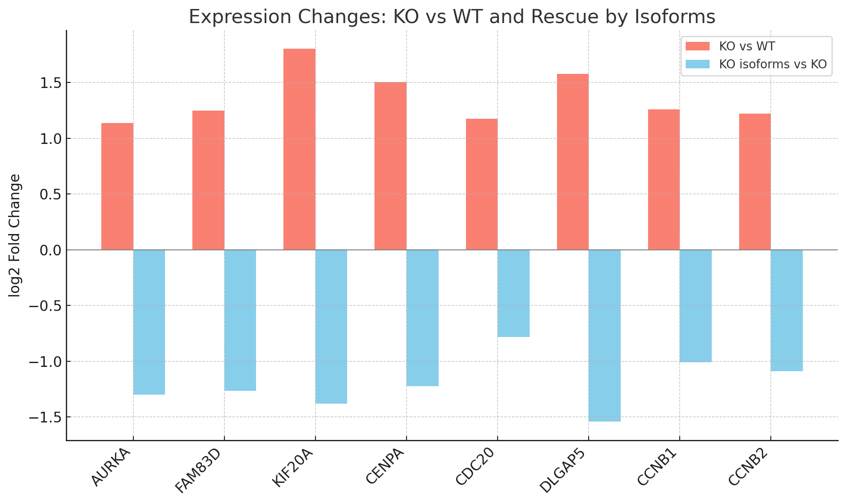

By looking at the log2fc log fold change of those cancer genes in detail, many of the genes shown here are showing strong “rescue” effects from the isoforms. During the G9a knock out (KO vs. WT), the suppressive H3K9me2 from G9a is removed, thus releasing the suppression effect of the cancer gene markers. Then when adding back the G9a isoforms (KO# vs KO), many of the cancer related gene markers are re-suppressed and bring the expression back to the wild type level.

AURKA gene is the Oncogene with the function of Aurora kinase that regulates mitosis and centrosome separation. KIF20A gene is also Oncogene to function as Kinesin motor protein, cytokinesis and proliferation. Most of these cancer related gene markers show G9a had a strong repression effect on the cancer genes, and the suppression is lost when it gets knocked out, but the repression is reintroduced in the 4 G9a isoforms.

The following volcano plots also clearly show the rescue effects on the cancer related gene markers in greater detail.

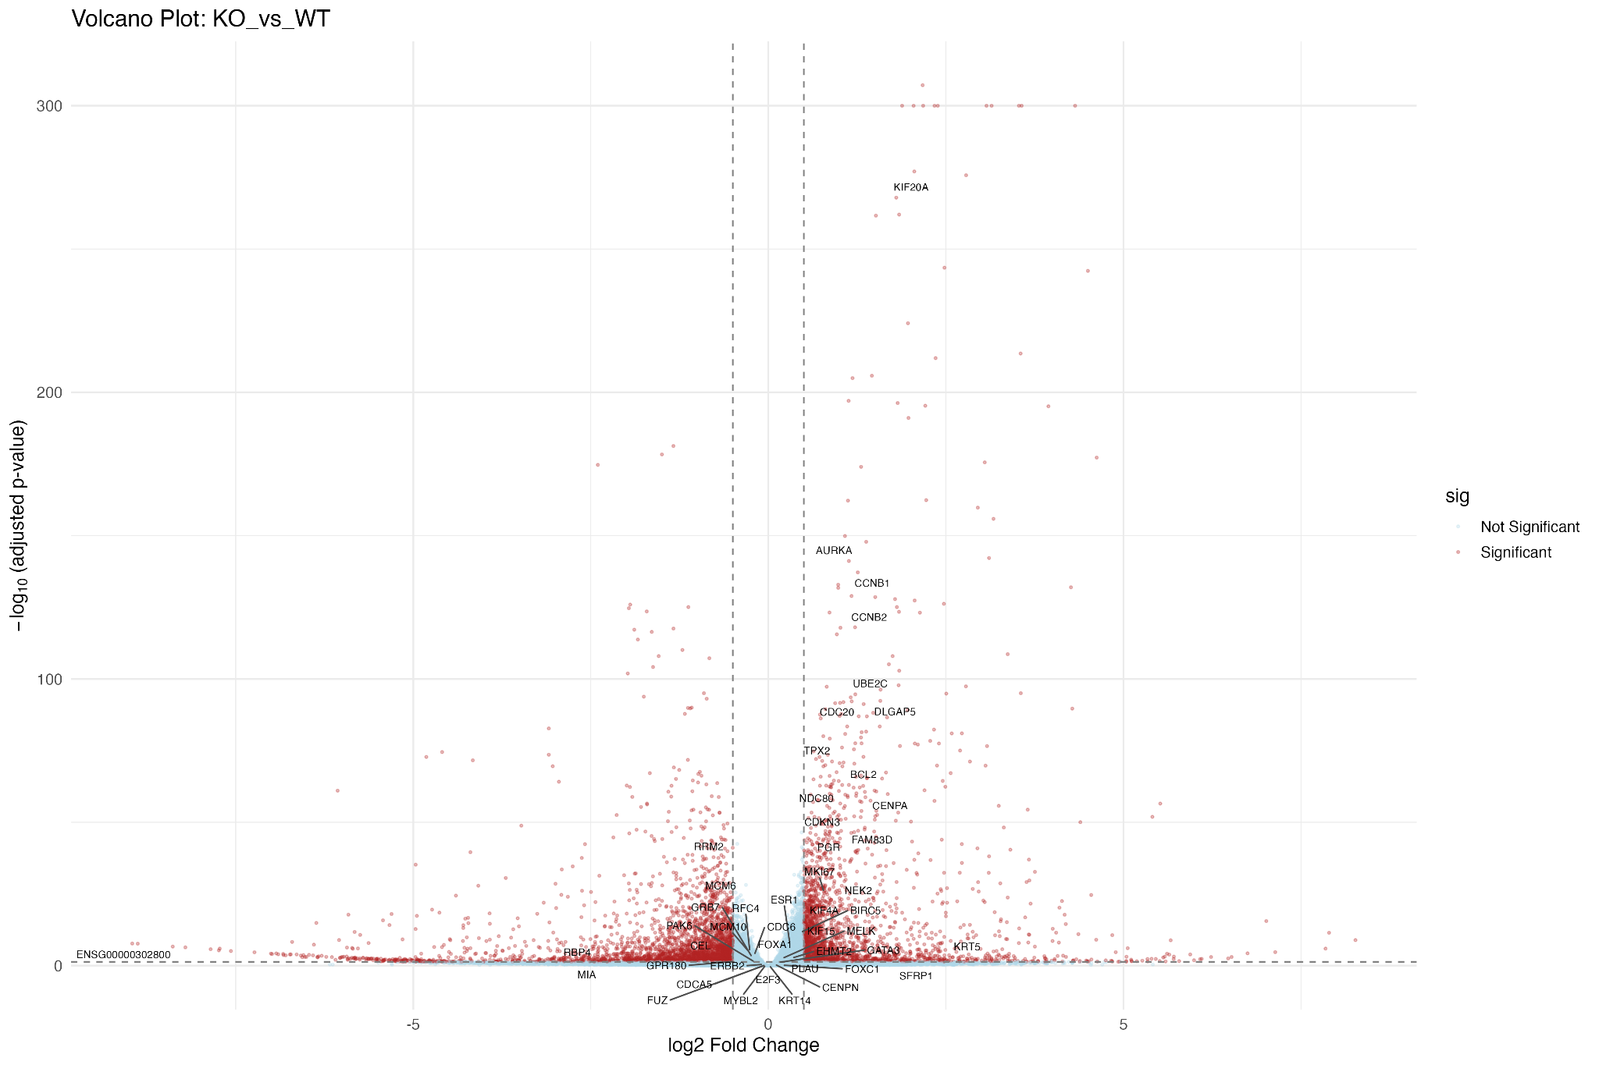
Here in the KO vs WT volcano plot, G9a or EHMT2 is just slightly up regulated in KO vs WT, which is not expected, but not statistically significant in the difference according to the volcano plot. Many of the cancer related genes are up in the Knock out compared to the Wild type, which shows the expression of those genes were suppressed by G9a but now are released.
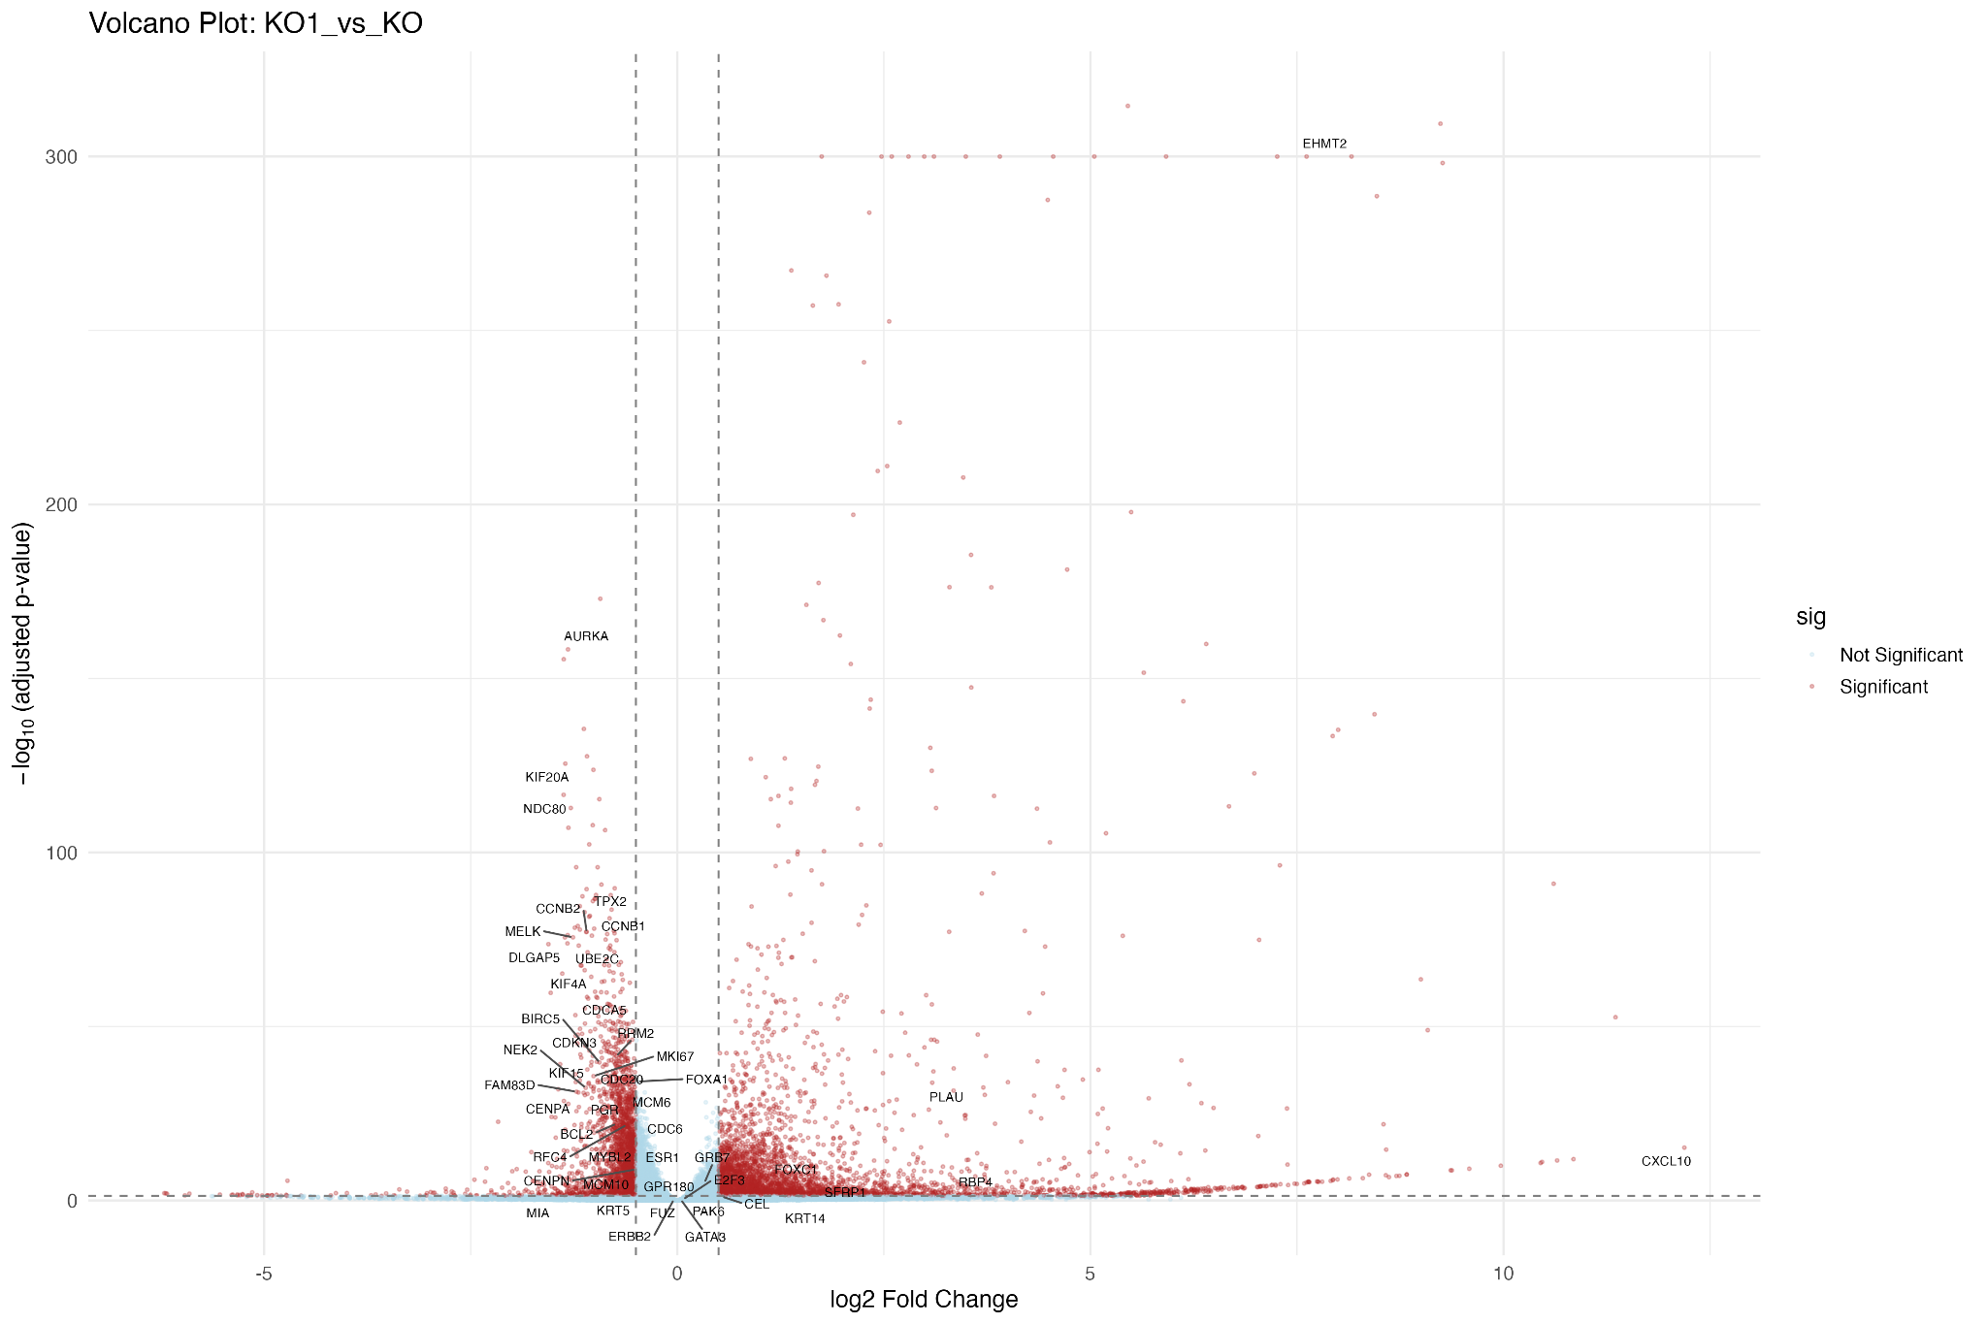

The KO1 vs KO volcano plots are largely similar to other KO# vs KO contrasts. Most of the cancer related genes in highlight are down in the G9a isoform KO1 group compared to the Knock Out group. This shows by adding back the G9a isoforms, it re-introduces the suppression effect of the G9a from H3K9me2, a repressive chromatin mark.
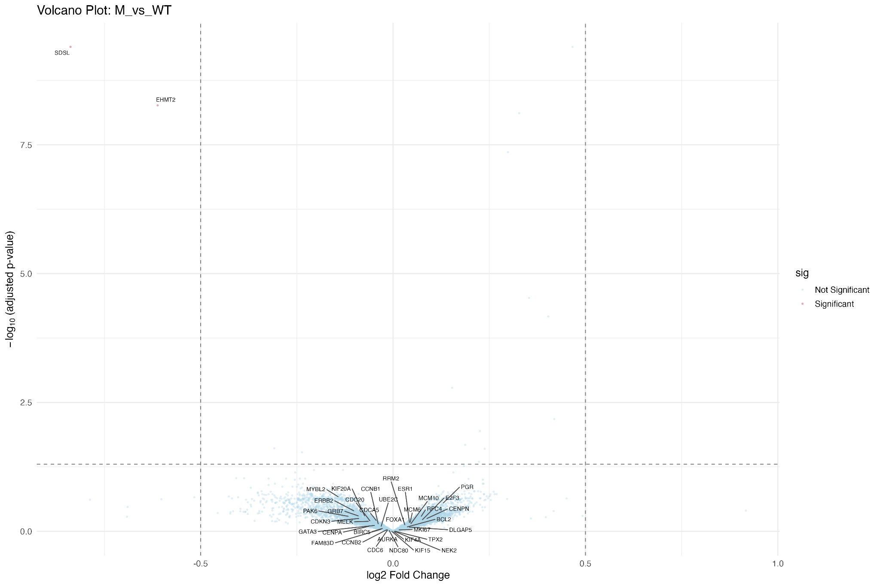

In the M vs WT contrast, this volcano plot shows that EHMT2 or G9a is moderately down regulated with Morpholino targeting the Exon 10 of the G9a gene expression. This shows that Morpholino is an effective therapeutic drug candidate to remove the suppression effect from G9a, while not impacting greatly on the expression of other cancer related genes here.

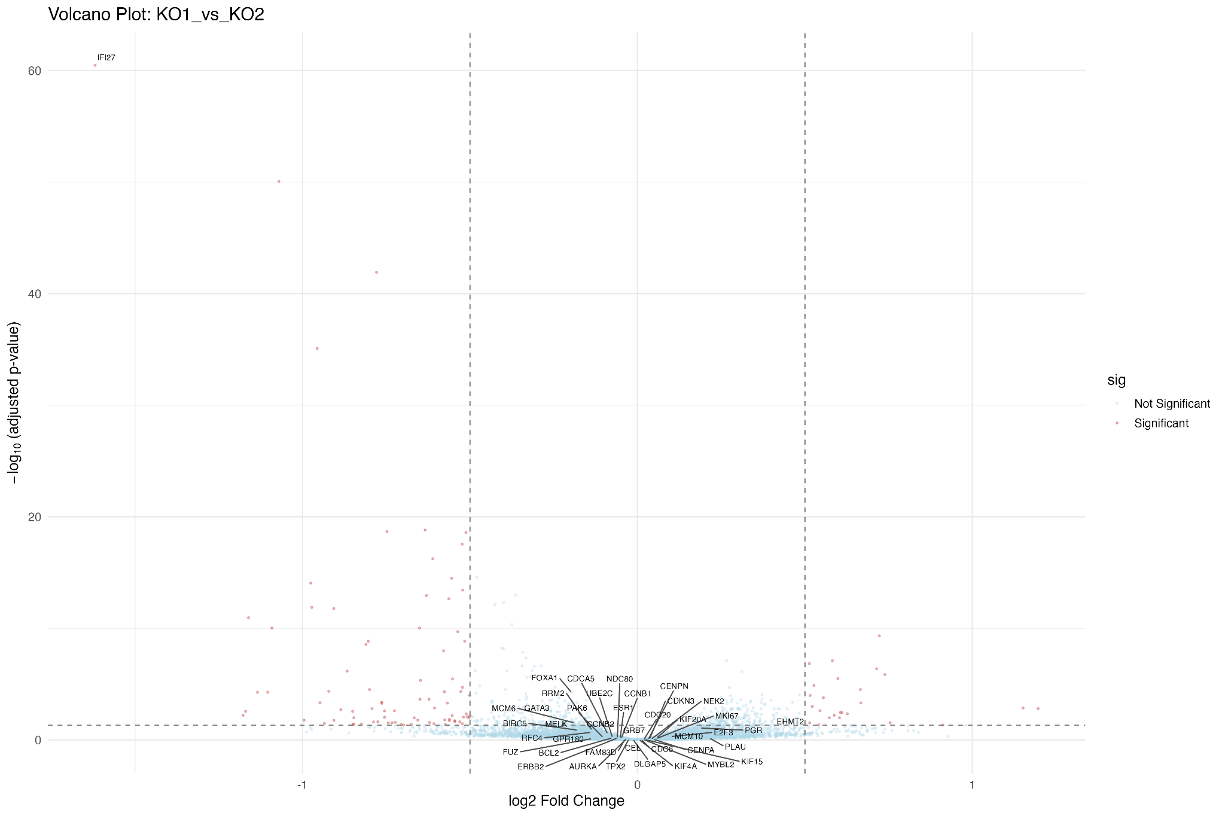

In KO1 vs KO2 contrast, both are with the short first exon but with or without the Exon 10, the cancer marker genes show no statistically significant difference between the G9a isoforms.

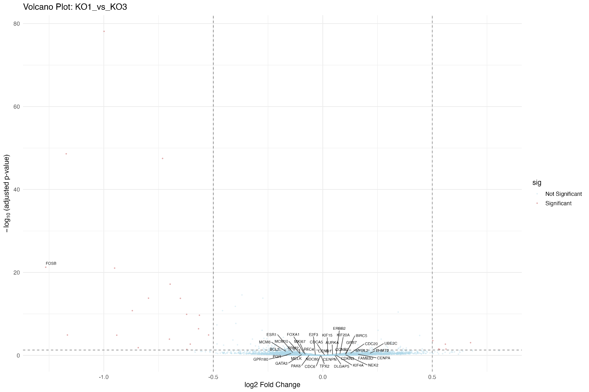

In KO1 vs KO3, both are G9a isoform with the Exon 10, but KO1 is the short First Exon while KO3 is the long First Exon. As we can see from this volcano plot, again the cancer marker genes show no statistically significant difference between the G9a isoforms.

Conclusion
This project studies the effect of gene EHMTS or G9a and its 4 isoforms on cancer. Through differential gene expression analysis, several breast cancer related gene markers are identified and studied with the “rescue” effect. Many of the cancer marker genes were suppressed by G9a and its H3K9me2 repressive chromatin mark. The suppression effect is then removed in the Knock Out, but suppression is reintroduced in the 4 isoforms. The differences between each of the 4 isoforms are not very pronounced and none of the breast cancer related gene markers exhibit statistically significant differences across the isoforms.

