NEW STITCHING – FASTER

For 1x
sigma == 4.272
thresh == 0.00904

For 2x
sigma == 2.182
thresh = 0.00974

For 2x – medium dim
sigma == 2.182
thresh = 0.00645

For 2x dim
sigma == 1.801
thresh == 0.00401

For 4x
sigma == 1.326
sigma == 0.00645

- thinned
- do not group anything!!!
Fast descriptor based with rotation invariance

Chromatic aberration correction
20 px, low number of points, 16/16/4 downsampling

20 px gross movement, average num points, 8/8/2 downsample

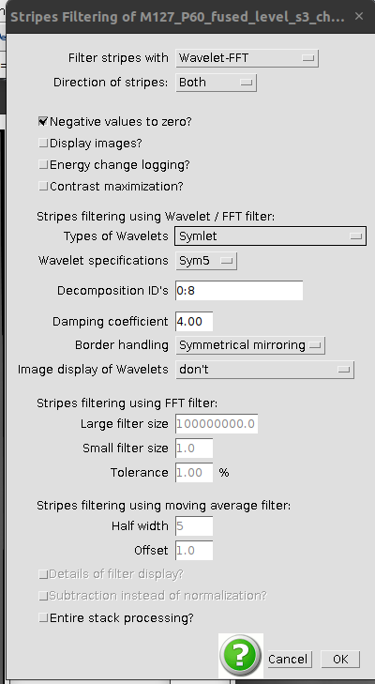
For 20x with AAVs images:
Steps:

Raw data -

Sigma = 1.8

Threshold = 0.008
***DO NOT USE SAME MAX MIN INTENSITY FOR ALL FRAMES

Distance thresh of 10

Then do group by channel only, use distance of 2 to pool nearby points at the very end

For interactive --- use FOV 23 or something

***INTEREST POINT THRESHOLDS ARE RELATIVE TO MAX INTENSITY OF IMAGE I BELIEVE

For 96 rik:
Sigma = 1.346
Thresh = 0.01203

For 4x ***CAREFUL, crashes when trying to stitch???
Sigma = 1.517
Thresh = 0.00799
^^^ignore group illumination and tiles --- or else will make a whole fused image during "interactive" mode

For actual registration --> try "Fast descriptor-based (translation invariant)" first... and then do the "Precise" version??? --> ICP may be overkill and is supposedly "agnostic"?

For 8x
Sigma - 0.946
Thresh - 0.00401

Max num = 3000
set min – 100, max - 1000

ICP – is faster?
- no grouping → helps with interactive mode
- with no set min max, but use same min, max for interest point detection everywhere
- ICP with max pixel correspondance of 20
***then run again with ICP max pixel == 5? do I need to detect points again?...

→ also do not fix tiles and do not map back!

***group by channel → and then group interest points between channels (but interest points will only be detected from 1st channel!

Group channels??? --> MAKE SURE TO SELECT BOTH CHANNELS
### Use "precise version"
default
2
3
Tile view fixed group 22 with "precise"

DO NOT GROUP INTEREST POINTS

Latest: → set to default for precise, 8x, with filtering 30 as thresh

then try second round → with only the corresponding points → allowed is 3, 2, 2 precise
