Comparison to Other Websites
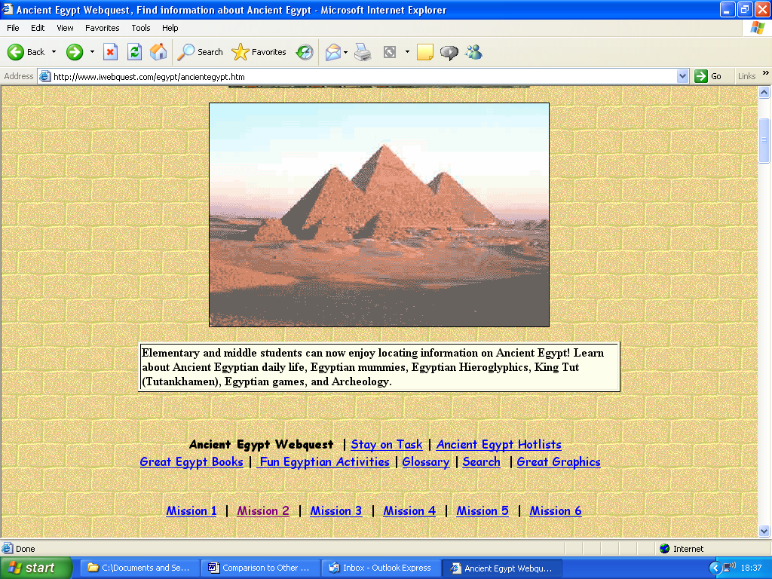
This site is made for interaction. It requires the visitor read the information on the site and complete ‘quests’ which are basically quizzes on Egypt. It is similar to my site as it is decorated with the theme of Ancient Egypt which is quite attractive. Also both sites use a similar colour scheme. It is quite an attractive presentation however I think my site makes better use of hover buttons and pages to enhance navigation and make it easier to browse the site.

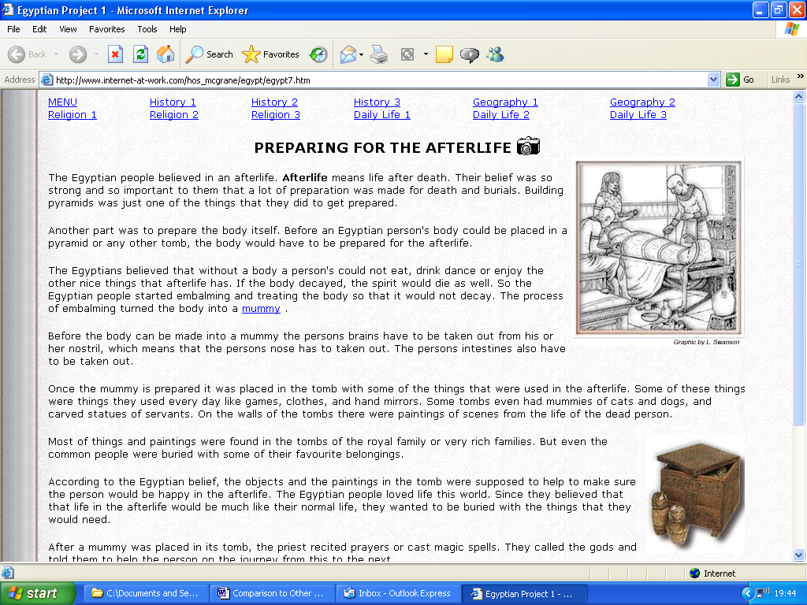

One similarity between my site and this site is that both use a large variety of graphics with the text, this makes the sites more fun to view and more interesting. This site contains a lot more text and whilst this obviously supplies a lot more information however I find it a lot harder to read and it’s not very easy to concentrate on.
A big difference is that this site uses very little colour. The text is black on a white background and most of the images are also black and white. However my site utilizes a large variety of colours as I find it is a lot more attractive and more fun to use.

