Main Menu Page weaknesses

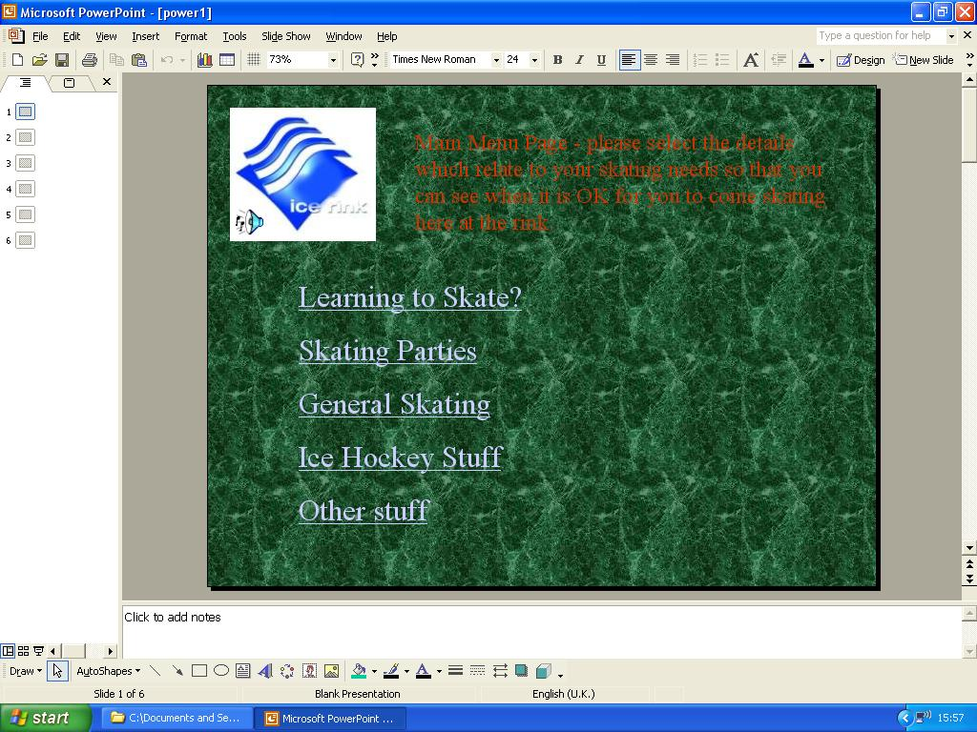
Using my design checklist I recognised the weaknesses of the Main Menu page:
Red text is difficult to read and the colour isn’t relevant to the theme.
Green background fill isn’t relevant.
Links would use space better if they were aligned to the centre of the page.
Sound file does not work when clicked.

- Another image could be inserted to make the page more attractive.
- There is not enough contrast between the font colour and the background colour.
- The colour scheme isn’t very relevant to the theme of the presentation.
- The background image/colour is not relevant to the ice rink
- No animation.
- The red text on the green background would not be readable for colour blind users.

