Page 1 – Learning to Skate?

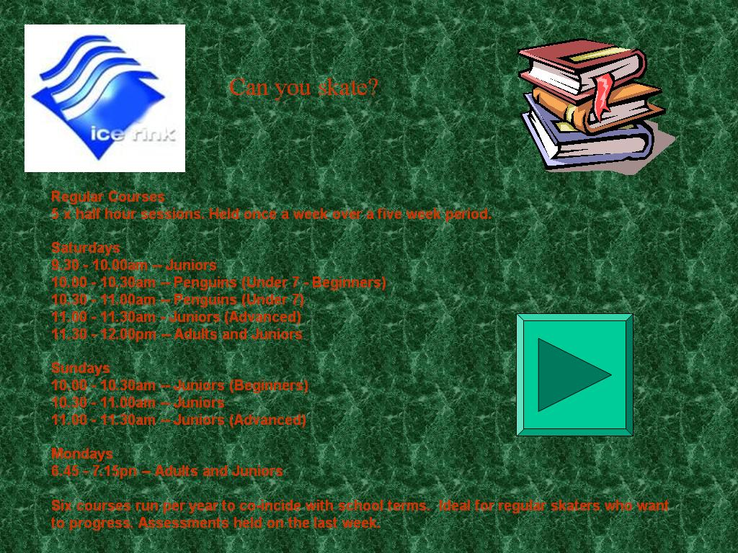
Using my design checklist I recognised the weaknesses of the Learning to Skate page:
It isn’t clear what this button does.
Page title is different to the link to this page from the main menu “Learning to Skate?”
Image of books isn’t relevant to the Ice rink.
Spelling mistake; should be ‘coincide’.
Red text is hard to read over the background; not enough contrast.

Consistent weaknesses:
- The background image/colour is not relevant to the ice rink
- The red text is hard to read due to the lack of contrast over the green background.
- The cyan button isn’t labelled and it is not clear what it does as there aren’t any buttons on the main page so it may confuse the browser. It appears to be a ‘go forward’ button but instead it returns the browser to the main menu.
- No animation.
- The red text on the green background would not be readable for colour blind users.

