Page 3 – General Skating

Using my design checklist, I recognised the weaknesses of the General Skating page:
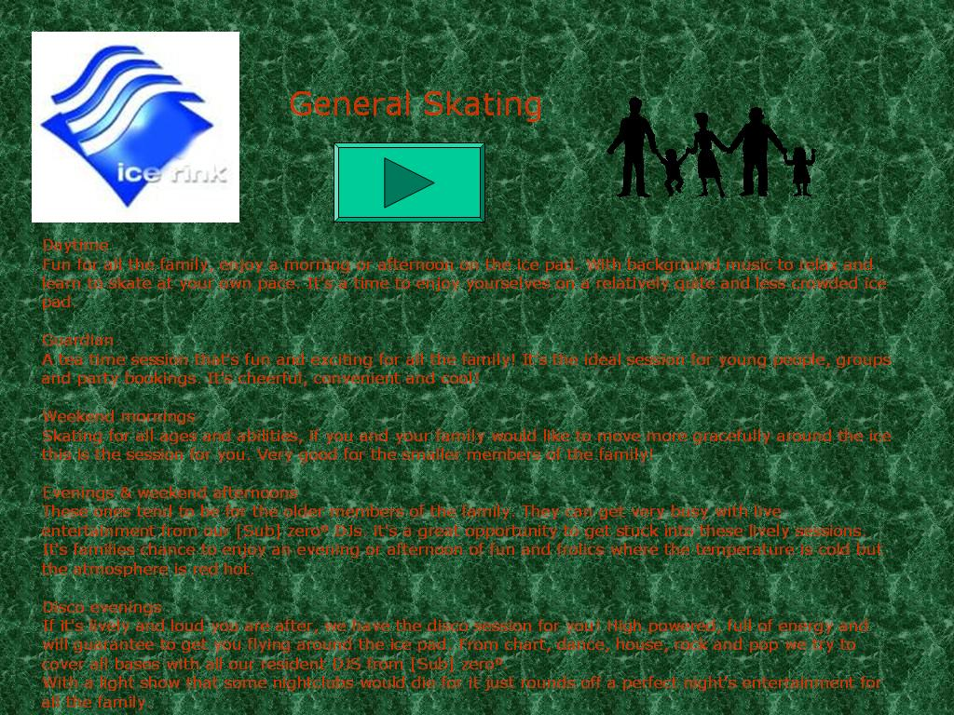
Black image is not very attractive; should be replaced with a photo of family at the ice rink.
Font of all text has been changed to Verdana. This is inconsistent with the previous pages which use Ariel and Times New Roman.
Button has moved and is a different shape/size which may confuse the browser.

The body of the text is very large which is quite tedious to read and not very attractive; it puts the browser off from reading more. Less text and/or more images could make the page more attractive.

Consistent weaknesses:
- The background image/colour is not relevant to the ice rink
- The red text is hard to read due to the lack of contrast over the green background.
- The cyan button isn’t labelled and it is not clear what it does as there aren’t any buttons on the main page so it may confuse the browser. It appears to be a ‘go forward’ button but instead it returns the browser to the main menu.
- No animation.
- The red text on the green background would not be readable for colour blind users.

