Page 4 – Ice Hockey Stuff

Using my design checklist, I recognised the weaknesses of the Ice Hockey Stuff page:
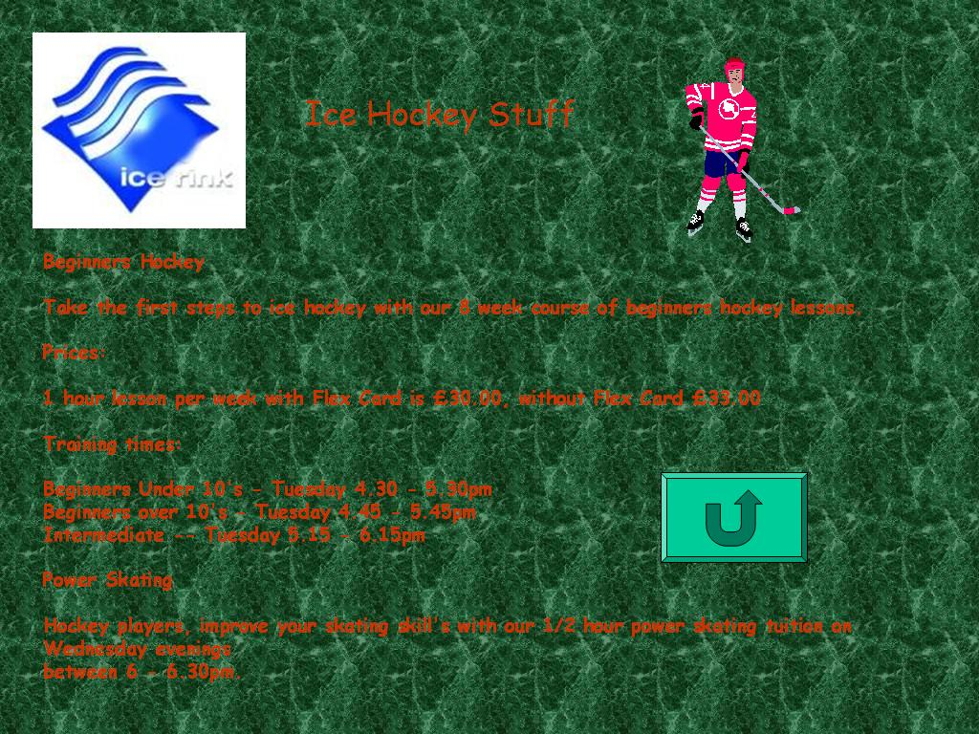
Font has changed again to Comic Sans MS which is inconsistent with the previous pages.
Button icon has changed but the use is the same; this will confuse the browser.
Title isn’t very professional; “stuff” is not necessary.

To make this page more attractive an image could be used for each subtitle corresponding to the subject. For example, an image of a pound sign (£) could be used next to ‘Prices’.

The cyan button has the ‘return’ or ‘back’ icon which is inconsistent with the other pages but when clicked it links to the same page (main menu). This will confuse the reader.

Consistent weaknesses:
- The background image/colour is not relevant to the ice rink
- The red text is hard to read due to the lack of contrast over the green background.
- The cyan button isn’t labelled and it is not clear what it does as there aren’t any buttons on the main page so it may confuse the browser.
- No animation.
- The red text on the green background would not be readable for colour blind users.

