Page 5 – Other Stuff

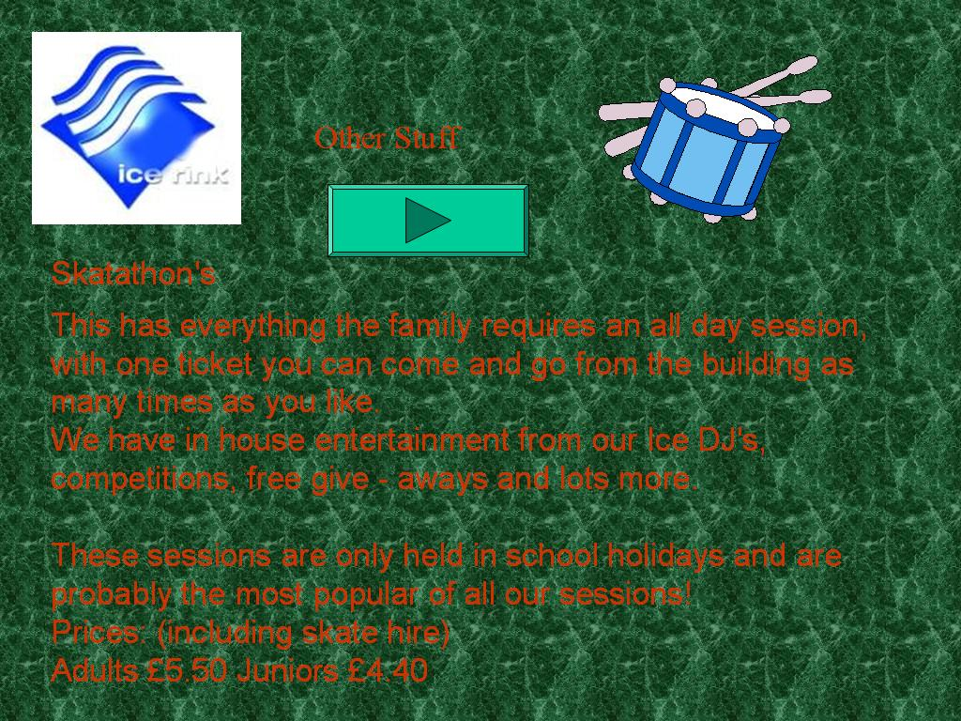
Using my design checklist, I recognised the weaknesses of the Other Stuff page:
Button has moved and is a different shape/size which may confuse the browser.
Title isn’t very professional; “stuff” is not necessary.
Image of drums isn’t relevant to the Ice rink.
Font is much bigger than any other font in the presentation. It is also bigger than the title. This is inconsistent and unattractive.
‘Giveaways’ is one word.

Consistent weaknesses:
- The background image/colour is not relevant to the ice rink
- The red text is hard to read due to the lack of contrast over the green background.
- The cyan button isn’t labelled and it is not clear what it does as there aren’t any buttons on the main page so it may confuse the browser. It appears to be a ‘go forward’ button but instead it returns the browser to the main menu.
- No animation.
- The red text on the green background would not be readable for colour blind users.

