Slide 1 – Main Menu
In the first slide I wanted to catch the user’s attention and provide the main navigation for the Human Computer Interface (HCI).
The original slide had a dark green background fill which was both irrelevant and not very attractive; it made it also quite difficult to read the text above the background. To fix this I replaced the background image with a light blue icy image fill. The introduction was written in red text which was both difficult to read and an irrelevant colour for the subject, but also I felt the need to anthropomorphise in the introduction was not necessary so I replaced the paragraph with “Please choose an option from the menu”. I thought giving the user too much text to use straight away would put them off. To make the new ‘introduction’ stand out I gave it a custom animation motion path to go from the page title downwards to finally rest at the top of the menu and image.
There was a sound-icon on top of the Ice rink logo which didn’t work so I removed it, I didn’t replace it with another sound/music because it was not needed and the user probably wouldn’t think to click on it.
The Ice-Rink logo now blended in too much with the light blue background so I opened the master view and gave it a thick black outline to make it stand out. I thought it was important to give the page a title that stood out so I used Word Art to insert an attractive title ‘Main Menu’.
The main menu now seemed very empty and boring so I inserted an image of an Ice-rink.
I thought the font of the hyperlinks on the page should be kept the same as the light-blue font indicated ice. But to make the text stand out above the light-blue background I changed the text box background to dark blue with a thick white outline. Having a ‘table of contents’ menu like this allows users to make decisions on the system quicker.
I thought it was important to have a consistent blue colour-scheme as it was a relevant colour for the subject but to make sure there was enough variety in colours and make different items stand out from one-another I used varying and contrasting shades of blue.
I added three action buttons next to the ice-rink logo; a ‘previous slide’ button, a ‘home button’ and a ‘next slide button’. I also gave the action buttons sounds when hovered over and when clicked. I added these to every slide.

Problems and Solutions
I wanted to add sounds to the links in the main menu when they were clicked but when I came to test the link the sound worked but the hyperlink didn’t.
This was because when I selected the sound to be played, the ‘hyperlink to’ option became automatically un-ticked:
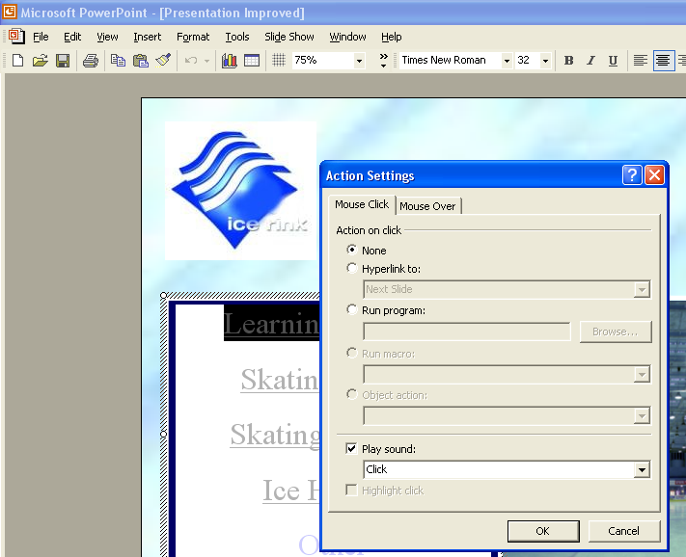
To fix this I highlighted the text, right clicked it and chose ‘action settings’. Then I ticked the hyperlink option and chose the corresponding slide.

I had no other problems in testing my main menu page.
I think adding sounds on button hovers or mouse clicks adds satisfaction to using the hyperlinks/buttons, it also aids to perception by providing feedback to the user that the hyperlink/task was initiated/completed.

Slide 2 – Learning to Skate
Throughout my HCI I wanted to keep the font-scheme consistent so I used Verdana (13pt bold, white) for all the body text and Trebuchet (18pt bold, pale blue) for all the headings but sometimes I made exceptions. I used Trebuchet for some other text that I wanted to stand out above the other text and I used Verdana (not bold) when there was too much body text on the page for it to be bold.
I kept all the themes of my HCI consistent to increase its ‘memorability’ and learn-ability.
I once again used Word Art to insert my title “Learning to Skate”.
I inserted the timetables into tables with yellow outline to make them stand out; I thought using a table to contain this information would make it more attractive and improve its legibility.
I found a storyboard image of an Ice-skater skating and falling over. The image was in 3 parts so I used custom animations to make each part disappear and appear accordingly.
I had no problems testing this slide.

Slide 3 – Skating Parties
I wanted this slide to be child-like to coincide with the subject of the slide. I reduced the amount of body text by deleting some unnecessary information and made the text box smaller. I aligned the text box to the left side of the page and inserted a small photograph of a child being assisted by a ‘Party buddy’. To the right side of the page I drew a large circle with the ‘auto-shapes’ tool. I drew a curved line from the balloon to replicate the string and inserted some body text into the balloon. I thought this would add the slide’s appeal, especially to children who may be with their parents when looking at the HCI.
I used Word Art to insert the page title “Skating Parties”.
I found an animation graphic in my Clip Art Organiser of a man helping a little girl skate, I gave this a custom animation motion path to make them skate off the page, come back on the page and then stop underneath the balloon. This makes the slide more attractive and catches the user’s attention.
I had no problems in testing this slide.

Slide 4 – Skating Sessions
On the original HCI this slide was very busy; it was full of body text and it overwhelmed the user this was because the HCI tried to anthropomorphise too much. I managed to reduce to word count on this slide from 249 to 121; this made the slide much easier to look at and increased its legibility.
However there were still too many words to use Verdana (bold) for the body text so I could not use the bold font style for the body text on this page.
The last 2 paragraphs of information on the page mention the ice-rink discos so I inserted an image of people enjoying a disco at an ice-rink that I found on Google images.
Although there was still much body text I felt that the image would stimulate the user to read on. The image also aids to the user’s perception.
I inserted another image of a man ice skating and positioned it just below the slide title; I then added a custom animation motion path that made it fly off the page and then back on from the opposite side, I looped the animation. The image is eye catching but small enough not to distract the user.
Once again I had no problems testing this slide.

Slide 5 – Ice Hockey
I separated the text on this slide into 2 text boxes so that I could move them around the page; I placed the first text box to the top left underneath the ice-rink logo and the other text box to the bottom right of the slide. As this page is about ice hockey I inserted 2 relevant pictures. I inserted an image of people playing ice hockey in a rink on the bottom left of the slide. I found an animation graphic on the Clip Art website of a hockey puck being hit into a hockey net; I inserted this into the slide above the training times. I believe this animation is eye catching but does not take the attention away from the important information.
I had no problems testing this slide.

Slide 6 – Skatathons
This page tells the user about an all day session called a skatathon. This includes entertainment from the DJ and competitions. So to aid to the user’s perception of what the page is about I found a watermarked image of a DJ playing a record. I also found a ‘trophy’ image to symbolise the competitions and to the left I inserted an animation of 2 men skating, I did this to make it appear that the men were skating towards the trophy. As well as these images there are 2 text boxes so I arranged the 4 items in a checker-box type formation; the images in the top right and bottom left and the text boxes in the top left and bottom right. I think this breaks up the body text to make it easier to read and understand.
Once again I had no problems in testing this slide.

