Slide 1 – Main Menu
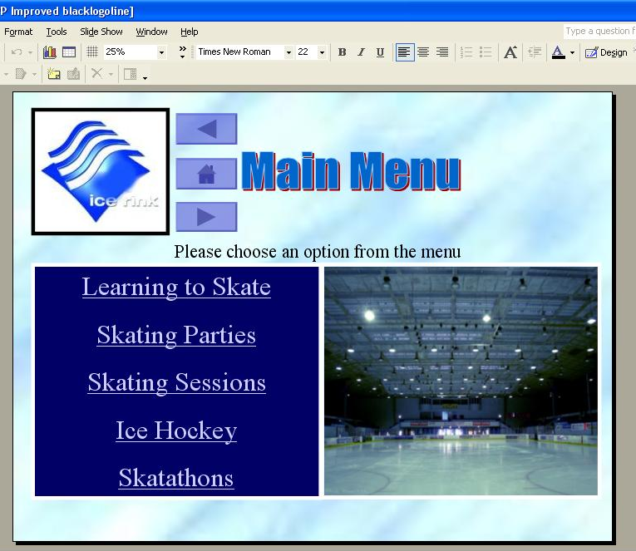
Ice-rink logo is outlined in black to make it stand out.
Table of contents with hyperlinks to the other slides. Trebuchet, bold, pale blue, 18pt. This increases the HCI’s usability.
Word Art used to display slide title to stand out.
No need to anthropomorphise; text reduced to this simple instruction. Easier to read doesn’t put the user off.
Large image of ice rink to add to the appeal of the main menu but as this is the only image on the slide it doesn’t distract the user.
Dark blue fill and thick white outline makes the text box stand out.

The short introduction “Please choose an option from the menu” has been given a motion path to move slightly to catch the user’s attention, this helps make it clear to the user what to do next.

On the action buttons and hyperlinks there are sounds when they are hovered over or clicked. A ‘whoosh’ sound is used to give the user feedback when the mouse cursor is hovered over the link and a ‘click’ sound is used to give the user feedback for one the links are actually clicked. The feedback aids to the user’s perception; it tells them that the hyperlink worked.

The background fill is an image of the surface of some ice. This is translucent as to not make the slide feel too ‘busy’ but it also allows easy distinction between that and the other items on the page.

Slide 2 – Learning to Skate

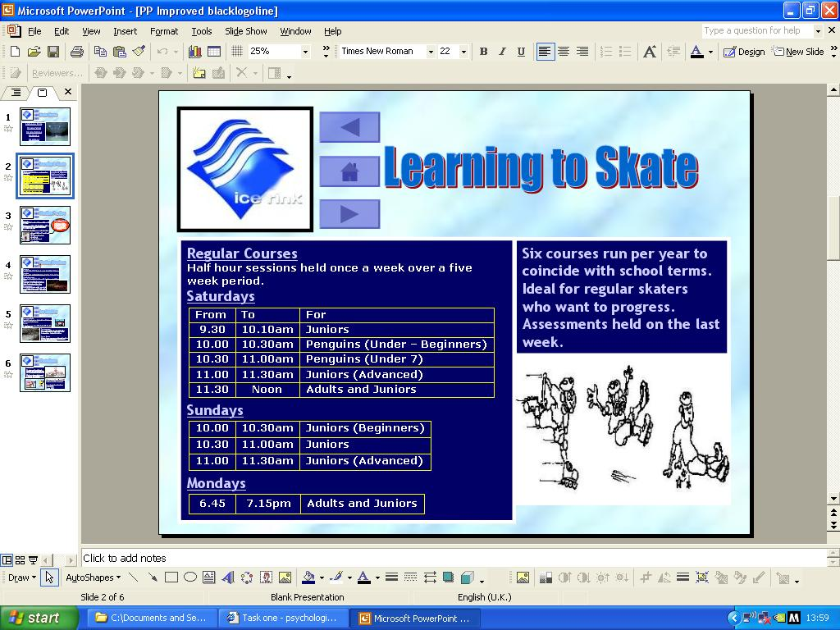
Sub headings’ font = Trebuchet, 18pt, bold, pale blue. This makes the text stand out whilst keeping to the colour-theme.
Drawing of ice skater falling over is cut into three parts and using custom animations each part is made to appear and disappear accordingly.
This is eye catching but does not distract the user as it does not loop.
Table outline is yellow as it contrasts well with the text box.

I used tables to contain the timetables for the ‘learning to skate’ sessions as it organises the information well and improves its legibility.

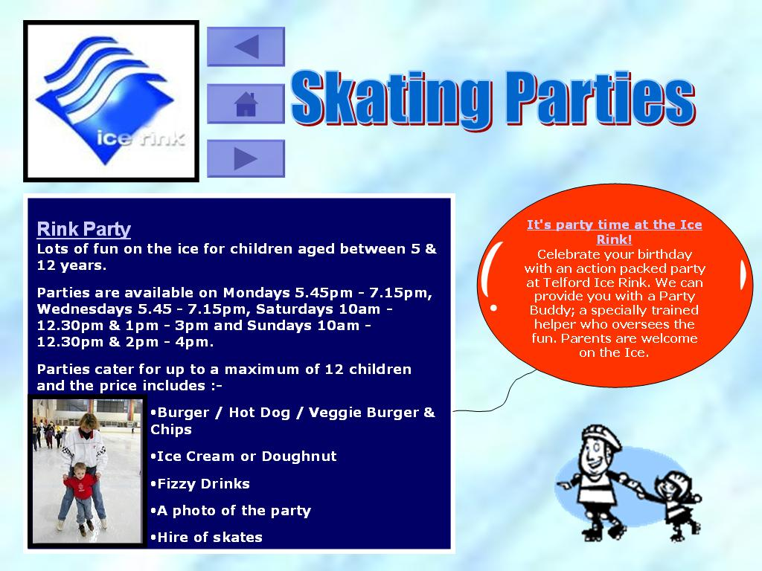
Slide 3 – Skating Parties
Balloon corresponds to theme of the page (parties) but has a red fill to stand out. I wanted to separate this slide’s body text into 2 parts so it wasn’t so overwhelming to the user.
Image of a ‘party buddy’ helping a child to skate; it is small as to not distract the user.
Clip Art animation of man helping a girl to skate. Once again it is small and pale so it doesn’t distract the user but it also make the page more attractive. It helps compensate for the amount of information on the page.

Again, the original HCI tried to anthropomorphise too much with the user and it amounted to too much text. I kept some of the ‘casual text’ to keep the user interested but removed most of it to reduce the word count.

The red balloon text box also aids to the user’s perception as it symbolised the slide’s subject.

Slide 4 – Skating Sessions

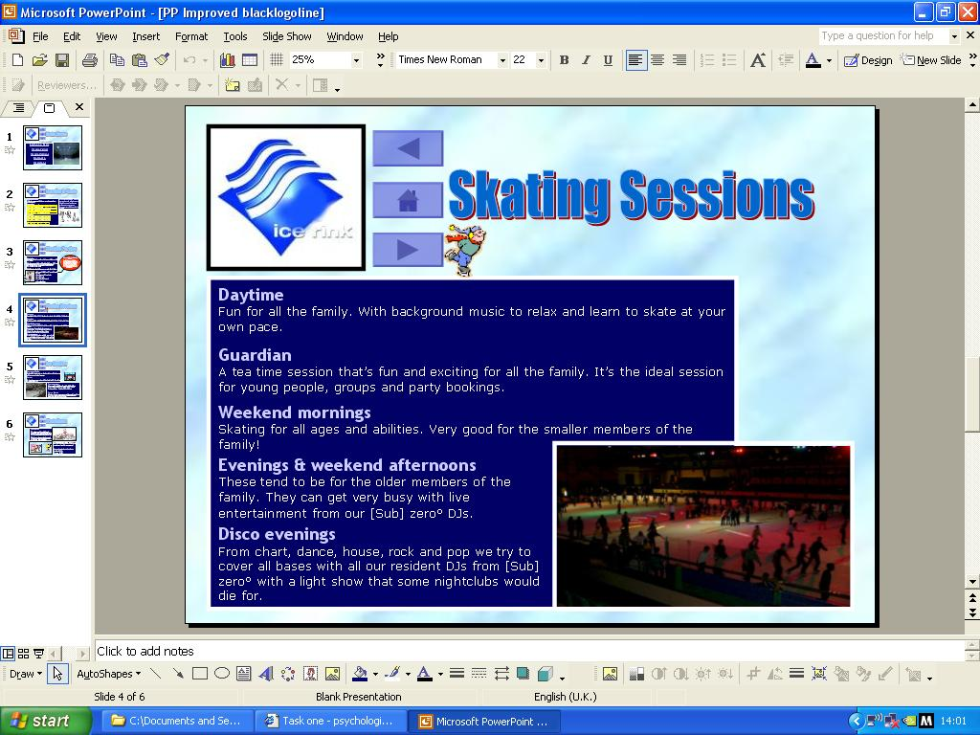
There’s a lot of text here so I decided to again insert an image that signified the subject of the slide, in this case it was a disco/light show.
The image is quite big to break up the body of the text.
Clip Art image of a man ice skating. Custom animation motion path (flies off and then back onto page, then loops). It is small so it doesn’t distract the user but it improves the slide’s graphical design and makes it more attractive.

This slide had a very high word count which would put the user of from reading on. To fix this I removed much of the anthropomorphism which sometimes became tedious however there still remained a large amount of text so to fit it all on the same slide I had to use Verdana without bold font style. Although this made the font inconsistent with the previous pages, I feel it actually improves the slide’s legibility.

Slide 5 – Ice Hockey
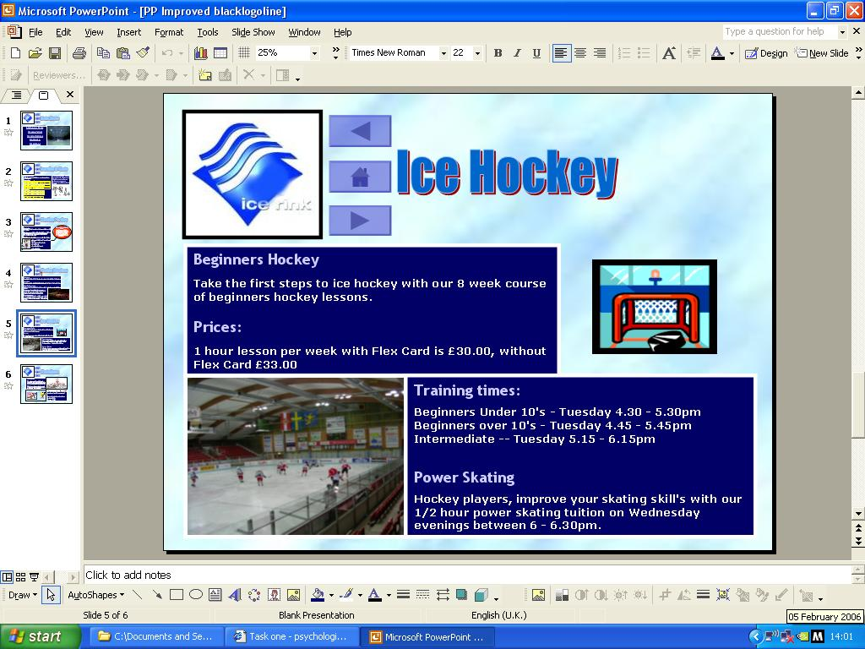
Ice hockey game image is consistent with this slide’s theme (ice hockey). This aids to the user’s perception of the slide’s subject, improves the slide’s appeal and breaks the body text up.
The Clip Art image of the hockey puck being hit into the net makes the slide more exciting to use and is a visual aid for the subject of the slide.
Body text was separated into 2 text boxes to improve its legibility. It makes the text easier to read but also makes the page layout more attractive and organised.

Slide 6 – Skatathons

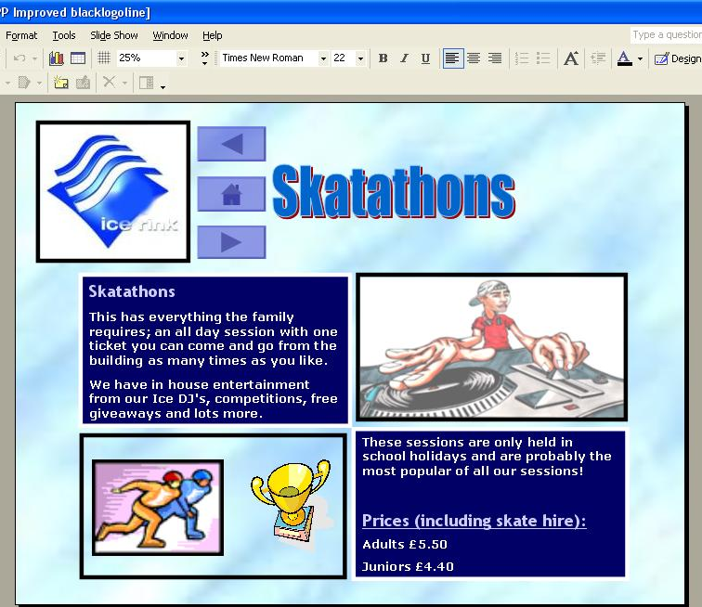
Drawing of DJ from Google images is faded out so it does not distract the user but it still increases the slide’s appeal. It also acts as a visual aid.
I inserted 2 separate Clip Art images to work together to act as an attractive visual aid. The ice-skater animation is placed to the left of the trophy to make it appear that they are racing to win it.

I organised this slide into the ‘checker-board’ formation to give it a unique and exciting appearance. The images separated the text boxes well without making the page look too busy or too empty. The visual aids add to the overall graphical design and enables the user to skim through the body text already knowing the subject of the slide.

