A good Human Computer Interface should take into consideration all human requirements in order to increase its ease of use, legibility and the satisfaction of using the HCI. Physiological and psychological constraints must be accounted for in order to get maximum usability and efficiency; links, action buttons, text and graphics should be easily accessible for people with any types of constraints such as the colour-blind; colour themes should be revised to make sure the user can make distinctions between different items and colours on the page.
The HCI must have high learn-ability and the navigation and themes should be consistent to be easily memorable.
The system should have a low error rate and allow the user to recover easily from errors that do occur. A good mix of graphics and test should be utilised to make the system more attractive and add to the user’s satisfaction of using the HCI; visual and audio aids give feedback for the user to recognise when a task has been completed.

I believe the HCI I have produced has been successful and meets all of the requirements on my design checklist as well as others mentioned above. The feedback from the questionnaires I gave to test-users also suggests that my HCI has struck a balance in attractiveness and efficiency whilst taking into account any possible human constraints.

I used a consistent colour scheme throughout my HCI to aid to its learn-ability and although the base colour for the presentation was primarily blue I gave the different items on the slides varying and contrasting shades of blue in order to make them stand out and be distinct from one-another.
I also used consistent font-themes in order to aid the user in recognising and distinguish subheadings from links and body text.
I used an animation on every page to catch the user’s attention but they were kept small and subtle as to not distract the user from the important information. The animations work in conjunction with theme-based images to improve the HCI’s overall graphical design.

The feedback from the questionnaires tells me that my HCI is very easy and enjoyable to use. I think this is due to the balance between the graphics and information as every one of the images is relevant to the slide that it is on; this acts as a visual aid helping the user to recognise what the slide is about and possibly making them more comfortable while reading the body text.
When asked what their favourite part was the users were quite consistent; two of the users said they enjoyed the ‘Skatathons’ page the most, others said they couldn’t choose a favourite part but other users also appreciated the noises and animations in the HCI. I think the ‘Skatathons’ page was so popular because it is organised in a checker-board style layout which places as much emphasis on the relevant images as well as the body text.

The majority of the users said they didn’t have a least favourite part of the HCI but the users that did were quite consistent; the noises when you click the action buttons and links were commented upon but I think noises are essential for links and action buttons as they provide feedback to the user for when the links are clicked or hovered over, this aids to perception and satisfaction. However I think the suspect may actually be the sounds used; the ‘whoosh’ sound when the cursor is hovered over the action buttons can become quite monotonous so it may be advantageous to change the sound.

Fortunately none of the users could find any mistakes or errors within the system which shows the information has been kept accurate and the HCI has a very low error rate. Also all of the users said that the information was easy to understand which shows the system has good legibility.

Again the users’ answers were consistent when asked if enough graphics/animations were used; one user said more could be used but I agree with the other users that the HCI would appear too clustered if any more graphics were used. Again the majority of the users agreed that the system utilised sound well although following previous feedback some of the sounds could be changed. I think more sounds or graphics would distract the user too much from reading the important information which would decrease its efficiency.

Two of the users suggested improvements could be made; the opinions correlate with previous feedback about the sounds and animations. However the majority of the users found the balance of the sounds and animations was just fine so I think changing it could do more harm than good.

Improvements:
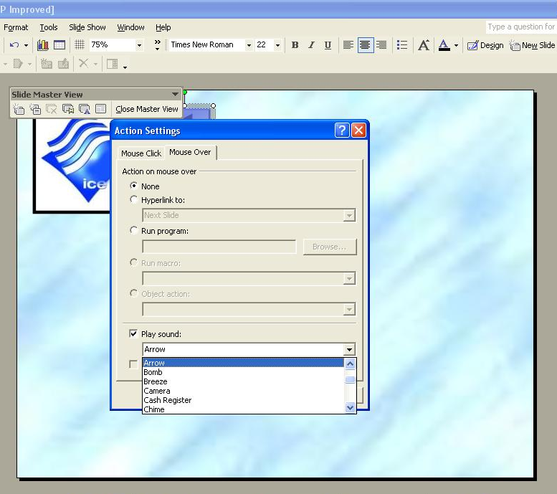
Following the suggestions for improvements from the user feedback I decided to change the action-button mouse-hover sound from ‘whoosh’ to ‘arrow’.

To change the sound I went into master view, right clicked the action button > clicked on ‘mouse over’ > play sound and then chose the ‘arrow’ sound from the scroll list. I did this for all three action buttons.

This ‘arrow’ sound is much quieter than the ‘whoosh’ sound and I think the users will find it a lot less irritating when they hover the cursor over the action button. The arrow sound is much less tedious to hover over even when the user navigates between the buttons regularly. I didn’t remove the mouse-over sound completely as I thought it was important to give the user feedback for when the cursor hovers over the action button.

