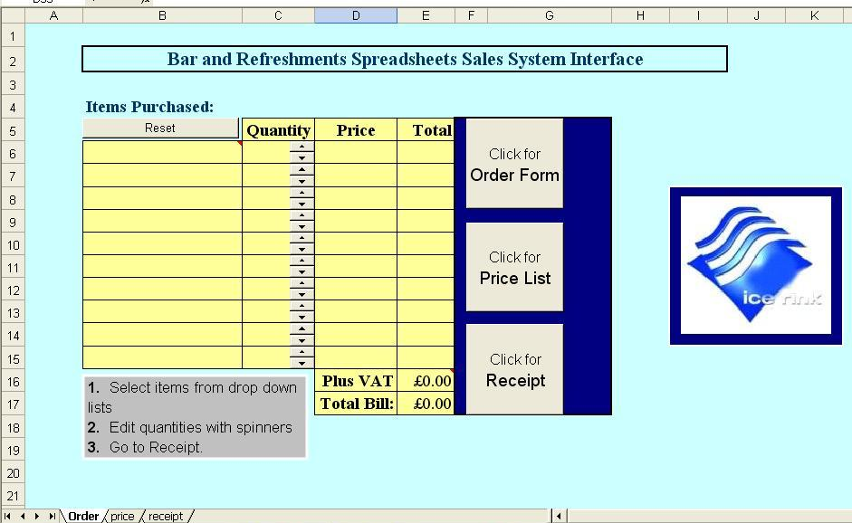
Border round title to stand out. Used 16pt bold font to separate it from other text on the page.
Used blue and yellow colour scheme as they contrast well but are attractive when used together.
Logo acts as visual representation of the Ice Rink; it is attractive and professional. The cells surrounding the logo were given blue fill to make the logo stand out. (icerink_logo.jpg).
Reset macro button clears the ‘items purchased’ column.
Comment box instructs the user what to do.
I used drop down lists in the items purchased column for the user to choose from a list of products.
Text box used to give the user instructions. I gave it a grey fill to catch the user’s attention.
Macro buttons used as the spreadsheet’s navigation. They are attractive and easy to use.
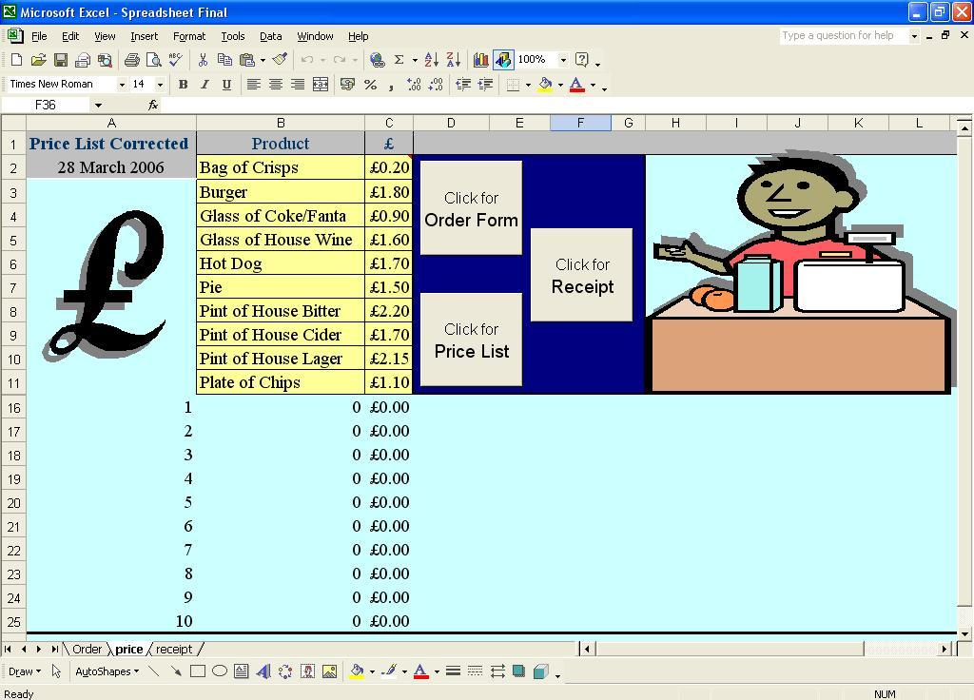
Image of Pound sign is a visual representation of the subject of the sheet. I gave it a shadow to make it stand out.
Used formula =today() to display the date in this cell.
Image improves the graphical design of the sheet and makes it more enjoyable to use. Again I gave it a shadow to make it stand out.
Combination of Vlookup and cell links used to calculate data to be automatically inputted onto the receipt and order form.
I used a consistent ‘font-scheme’ of 14pt Times New Roman and 14pt Arial for Macro Buttons. Consistency in design and layout improve the ‘learn-ability’ of the HCI.
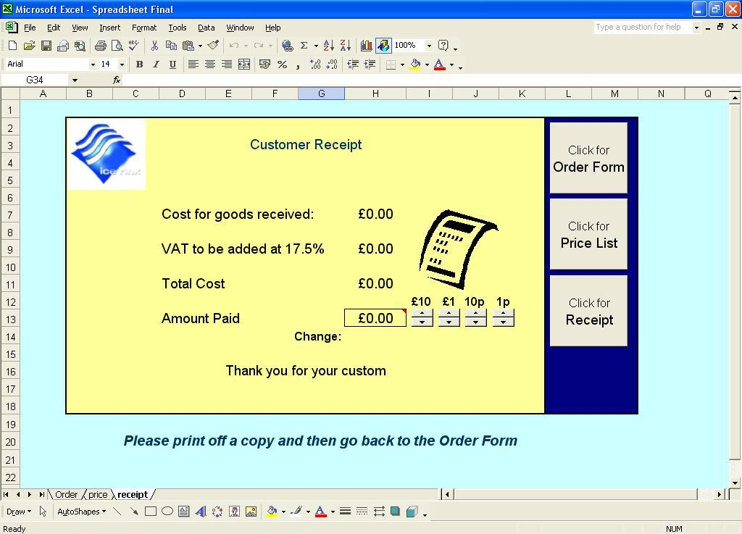
Spinners are used to modify quantity by incremental change of 1.
Once again the ice rink logo is used to make give the receipt a professional appearance.
This message changes depending on the amount paid.
Spinners are used to modify the amount paid. They reduce the risk of incorrect data being inputted and they are enjoyable to use.
Cell links are used to display data from cells in the other sheets.

