The purpose of my Spreadsheet was to produce an easy to use, attractive HCI for the new employee at the ‘Have-an-Ice-Day’ Ice Rink. To do this I used the original ‘unsuitable’ Spreadsheet HCI provided and improve on it by ensuring that it met the requirements of the new employee.

The HCI was produced with common and some less common physiological and psychological constraints in mind whilst covering the specific needs of the Ice Rink’s new employee.

Based on my Design Checklist I feel my website suits the purpose that it was intended for:
The interactive interface responds within 2 seconds of receiving user input; while I utilised macro buttons well, I understood that overuse of macro buttons can significantly reduce the response rate of the spreadsheet HCI. It is for this reason I thought it was important to use Vlookup to automate most of the input needed while keeping the response time fast and error rate low.
I used a range of stimuli within my HCI including images, colours and fonts. Although there are not many graphics in my HCI I felt that too many images would confuse the user and clog the system up so I felt that less is more when it came to the graphical design of my spreadsheet.
I used a variety of different colours in my spreadsheet whilst keeping the colour scheme consistent which in turn increases the productivity of the HCI making the user more comfortable with the system. Throughout the spreadsheet I used ‘cyan’ fill for the background, navy blue for the cells surrounding images and buttons (to make them stand out) and a faint yellow fill for the cells in the body of the page (the tables/receipt).
I feel the macro buttons have been utilised well as the navigation of my HCI. I took into consideration that a person that was less familiar with spreadsheets would not find it so easy to navigate using the small tabs but the macro buttons are much bigger and have been made to stand out.

I feel the use of colour and font schemes, macro buttons and formulas including cell links, IF and Vlookup functions, spinners and drop down lists all aid to the ease of use of my HCI.

I feel that my Spreadsheet meets all of the needs of the new employee;
I utilised macro buttons, spinners, drop down lists, Vlookup and IF formulas to make inputting data easy as the user cannot use the keyboard very well. Using these functions and features reduce the chance of errors and incorrect input.
I used large, highly defined fonts as the new employee finds it difficult to read text below 14pt and finds some fonts hard to read. It is for this reason I chose to use Times New Roman as it is very clear and conventional which makes it a good body font.

The results from my ‘Test Plan’ show that my Spreadsheet has a very low error rate and all of the features in the HCI function properly.

HCI Usability Questionnaires
The feedback from my usability questionnaires was very positive with only a few areas needing some slight attention.
When asked about the ease of use of my HCI every user said provide very position feedback stating that they found the spreadsheet easy and enjoyable to use. Another positive sign was that every user had written something different as their favourite part of the HCI, the colour scheme, the spinners on the Order form, the spinners on the receipt, the ease of use and the drop-down lists were all pointed out showing that my HCI has several useful and enjoyable features.
More importantly none of the users could pick out a least favourite part of my HCI; this shows that the spreadsheet is well rounded and although the system was built primarily for the needs of the new employee, the preferences of the every day user were not compromised. Despite choosing fonts and colours to suit the requirements of the new employee the fonts and colour scheme have also shown to be friendly to all users; the completed questionnaires state that each user found all of the text easy to read and understand.

None of the users could highlight any errors or mistakes in my system which shows the HCI has a very low error rate in turn improving the user’s efficiency with the interface.

When asked if more sound should be used each of the users agreed that enough sound was utilised and any more would become irritating and unnecessary.

Usability Scores
Within each questionnaire I also placed a usability score table for each user to fill in; this gives me a better idea of the efficiency of each feature and what could be improved.

Each of the users agreed that the text in my HCI is clearly visible, free from spelling and grammatical errors and has good legibility. To coincide with this each questionnaire gave positive feedback for the scan-ability of the information in the spreadsheet and that the presentation of information is very clear. The users also indicated that the items on each sheet are easy to distinguish from one another.

The usability scores also indicate that the layout and colour schemes are consistent which adds to the ‘learn-ability’ and productivity of the HCI.

However, one user did suggest that the layout could be better after giving it a score of 3. I believe the reason for this is that the body of data on each sheet is at different eye levels for example on the Order form the order table is on the left centre of the sheet but on the price page the price table starts in row 1 column B… again the cell-location slightly differs on the receipt page. I agree that while the user is forced to look in slightly different directions to read the body information on each sheet to change the spreadsheet’s layout would be unnecessary. However, I did add a shade effect to consistent items on each sheet to make them recognisable and easily memorable.
The same user also suggested that they hesitated with the instruction and once the problem was point out I realised the instructions on how to use the spreadsheet needed to be improved.

Improvements:
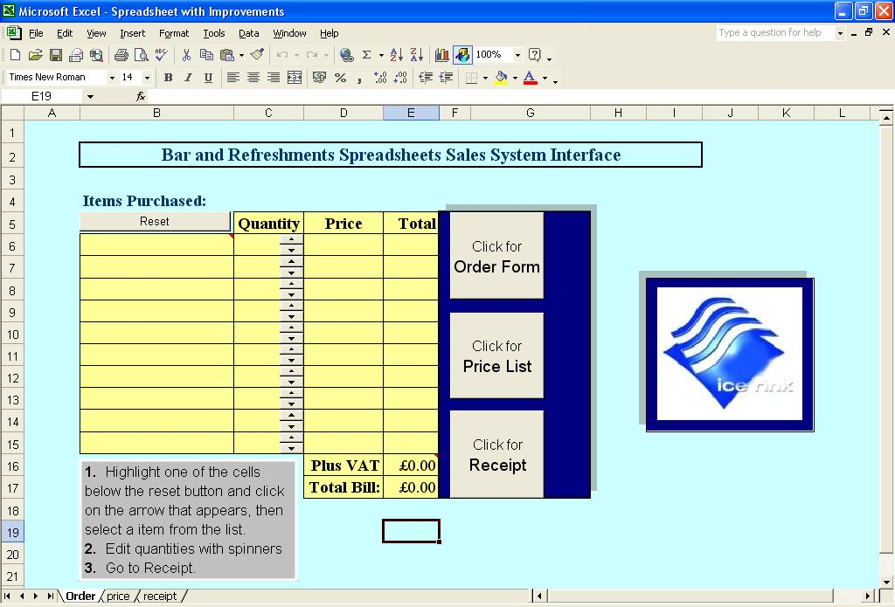
In an attempt to aid the user’s perception, I decided to utilise ‘shadow’ effects around the corners of the tables and around the dark blue cells that surround the macro buttons.
I believe this slight change increases the aesthetic appearance of my spreadsheet as well as making them stand out; making the same items stand out on every sheet increases the learn-ability of the HCI.

I also decided to increase the detail of instructions to further aid the user in learning how to use the system. Instructions increase the productivity and efficiency of the HCI.

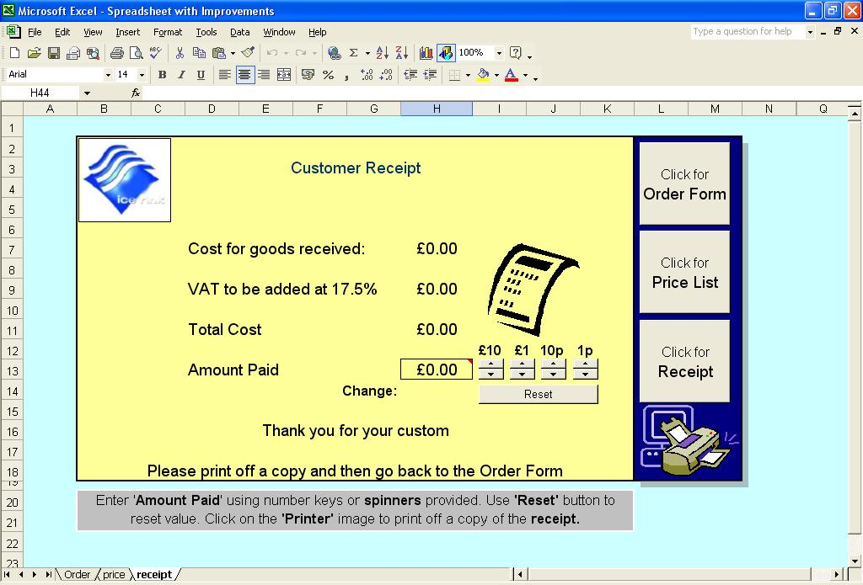
On the receipt sheet I also reviewed the instructions and thought it was necessary to add a bit more detail.

I also realised somebody who is not familiar with Microsoft Excel may not find it very obvious how to print off a copy of the sheet. It is for this reason I made a macro to select the print area and print the sheet off, I then assigned this macro to a Clip Art image of a printer.

I believe that following the improvements I have made to my spreadsheet my Human Computer Interface suits its purpose of meeting the needs of the new employee at the Ice Rink shop and the very positive feedback from my HCI Usability Questionnaires and Usability Scores gives me the same impression.

