Basic Design (Consistent Items)
The following ‘consistent items’ can be found identically on every page of the website.

I wished to design my website with a simple and appealing layout with a basic but attractive navigation structure. As the site consists of only 5 pages, I decided that the links between each page would be situated in the same positions on every page. I used buttons (images) to display the links in the menu; I created the button in Macromedia Fireworks MX and used the same button as a template to create a ‘hover over’ button, this hover over button would replace the initial button image when the cursor was hovered over it. To do this I inserted the initial button image and added a Dynamic HTML effect>on hover>swap image> and selected the appropriate hover button.
I made 5 of these buttons and a hover ‘variant’ for each page of the site.
These buttons not only act as links but also as a visual aid, the ‘hover over’ effect helps the user recognise that the image is a link. I then gave each button a hyperlink to their corresponding pages.

Next, I inserted the logo into the top left corner of the page. I would have liked to use a different logo as the logo supplied was distorted and is not very attractive however I wasn’t certain whether I would be allowed to change it. I assigned the logo a hyperlink to Index.htm.

I feel it is important to make a website’s layout as attractive yet as simple as possible and adding shape to the background is the easiest and most convenient way to do so. First, I made the page’s background fill navy blue then I inserted a rounded rectangle and resized is to cover the majority of the page, this gave the website its rectangular shape, I assigned the background image fill “ice.jpg” to the text box to reference the topic of the website (ice skating).
I then added another rounded rectangle text box to the page and positioned it to the right of the menu. This text box would act as a ‘frame’ in a way as it would be the only item to change throughout each page of the website; each pages’ corresponding information would be held inside this text box; everything outside of this text box would be identical on every page. I thought this was important as it shows consistency and consistency in layout increases the usability of the HCI. I assigned a background image fill “icegray.jpg” to this text box; it is similar to ice.jpg but 60% transparent so it is easily distinguishable from the other text box.

I thought it was important to show the user different images of the Ice Rink and activities available. To do this I used a Banner Ad Manager Web Component. I chose 3 images; Bannerad2.png (Ice pad), Bannerad1.png (ice hockey), Bannerad3.png (DJ and party buddy). I wanted to use a Banner Ad Manager because they can be found on almost every professional site on the web; it looks professional and attractive but also acts as a graphical aid which introduces the reader what the site is about. I gave the Banner Ad a hyperlink to Index.htm.

In the top right corner of the page, I wanted to put the address and contact information of the Ice Rink. To do this I inserted a text box and gave it a white background fill to make the text and image stand out. I wrote the text in small font so it didn’t take attention away from the main items on the page but as the small font size is compensated by the black font colour on top of white background fill, the text stands out as its legibility is increased. Also, a colour-blind person would find it difficult to perceive the blue and yellow email image on top of the blue background.

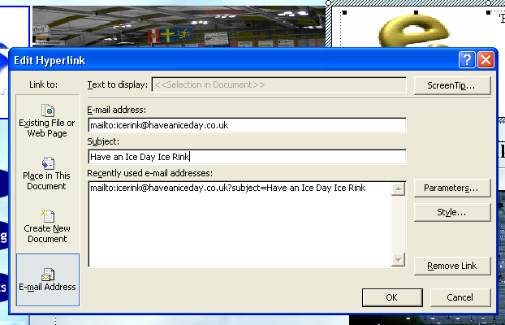
I also wanted to put contact information such as phone number and email address. I wrote the phone number below the address but I thought it was important to make emailing the Ice Rink easy. I inserted an animated image from Clip Art and aligned it to the left of the address. The image is of an envelope with a rotating letter E just above it, this tells the user that there is an email address for the ice rink. I inserted a hyperlink onto the image so that when the user clicks on it a new email is created with the email address and subject already in place.
I also gave this image a screen-tip “Email Ice Rink”. These acts as another visual aid and tells the user to click the image to email the ice rink.

Index.htm, Home page
On the home page I wanted to introduce the reader to the ‘Have-an-Ice-Day’ ice rink and entice them to read on and browse the site. I wrote the page header at the top of the text box and centre aligned using the ‘heading 1’ font style (Times New Roman, 18pt, bold). To separate this text box from the rest of the page I put an ‘overline’ on the header text and inserted a horizontal line below the header. This helps the user identify where the appropriate information is and improves the website’s ‘learnability’ as readers will know where to look on the next page for new information.
I decided it was important to keep the text a decent size to make it easy to read but be small enough to allow me to give a detailed description of everything the ice rink can offer. I centre aligned the body text and separated it into 4 small paragraphs to make it easier to read. To help the text stand out I made the 2nd and 4th paragraph bold; not only does this improve its legibility but also looks more attractive. I used black for the font colour as it is the easiest colour to read, it easily distinguishes itself from the background and other items on the page so it stands out more but also colour-blind users will have no trouble reading the black text on the translucent blue background.

I felt a graphical representation of the Ice Rink would be just as important to the reader as the descriptive paragraph is so I inserted an image of the empty ice rink and right aligned it. The body text now works like a caption to the image but the image also helps break up the text and make the page more enjoyable to use.
I had no problems testing this page.

Public_Skating.htm, Public Skating page
As public skating is the activity most associated with an ice rink there was a lot of information to portray to the user on this page. Due to the large body of text I decided to insert the text into a table of 1 row and 2 columns; I separated the text into 2 body texts, 1 in each column. I did this because I didn’t want the user to have to scroll down the page to read on, this is inconvenient and can put the reader off. I found that by putting the text into a table of 2 columns all of the text could be displayed without making the reader scroll down the page, without having to resize the text box and without having to reduce the font size. I removed the border and lines from the table as I thought it was not necessary because the only purpose of the table is to change the layout of the text.
In total there are 6 small paragraphs of information (Daytime skating, guardian sessions, weekend mornings, evening & weekend afternoons, disco evenings, regular courses). Again, all the text was written in black font as it is easy to read and is especially important to enable colour-blind users to distinguish text from the other items on the page.
I separated each paragraph by giving each paragraph title the ‘heading 2’ font style (Trebuchet MS, 12pt, bold). The body text is written in Times New Roman 11pt and aligned to the left in both columns.

The large amount of text on this page didn’t leave much room for an image but I thought it was important to insert an image to break up the text and make the page more attractive. I decided to insert a background image fill into one of the table columns (cells). However, I found that the background image made the text very difficult to read and would probably be impossible for a colour-blind person to tell the image from the text. To fix this I removed the background fill and inserted a simple animated image from Clip Art (j0283669.gif).

I inserted other tables in the text box to display the ‘regular courses’ time table. As the text is small, I decided to only use a black border around the perimeter of the tables as the intersecting lines could reduce its legibility.
I had no problems testing this page.

Refreshments.htm, Refreshments and Bar Facilities page

This page informs the reader of the refreshments and bar facilities available at the ice rink.
I wanted to use another Banner Ad Manager to display images of several different refreshments available, the Banner Ad would flick (fade) between each of the images every 4 seconds. However, when I tried to insert the Banner Ad Manager the ‘Web Components’ button in the ‘insert’ toolbar was greyed out. I found there was no way to insert a web component directly into a text box. However, I found a simple way around the problem. I opened a new page, created the Banner Ad, cut it (ctrl + x) and pasted it into the text box; I aligned it to the right of the text box.

As there was only a small amount of information to display on this page, I found it a good opportunity to increase the font size (to 14pt Times New Roman) and therefore make it easier to read. By displaying the images with relevant text, it increases the page’s usability because if somebody can’t read the text, they can see the image and if somebody can’t see the image, they can read the text.
I had no other problems testing this site once I had fixed the Banner Ad Manager problem.

Private_Parties.htm, Private Parties page
On this page I wanted to inform the reader about Private Party bookings at the ice rink. The body text was once again written in Times New Roman 11pt and aligned to the left. I began by displaying the times that parties are available and then telling the users what is included in the party ‘package’.
I used the heading “Parties cater for up to a maximum of 12 children and the price includes:” (font = Trebuchet, 12pt, bold). Then I listed the items included in a party package using bullet points.
I wanted to give a visual aid to the list so I used a picture of a child with a professional skater (to represent a ‘party buddy’), I aligned the image to the left so that the list was wrapped to its right-hand side.
The picture breaks up the body text and makes the page more attractive.
I then wrote a small description of a party buddy with the heading “It’s party time at the Ice Rink!” (Font = Trebuchet, 12pt, bold).

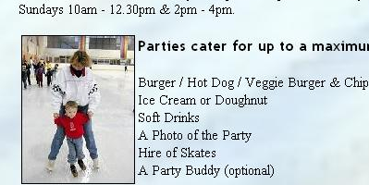
When testing the Private Parties page, I found that the bullet points were hidden behind the image of the child skating with the party buddy (Party buddy.jpg).

To fix this I right clicked each item on the list > clicked > selected ‘paragraph’ from the list and put 15 into the ‘indent first line’ in the indentation section.
Then when I tested the page again the bullet points appeared to the right of the image.

I had no other problems testing this page.

Ice_Hockey_Club.htm, Ice Hockey Club page
I wanted this page to be exciting and enjoyable to use to represent the subject (Ice hockey) well.
The body text on this page is all written in Times New Roman, 12pt and is centre aligned.
I wrote a small introductive description of ice hockey at the ice rink to entice the reader and try to put across the excitement of the sport. To help with this I used 2 images to act as visual aids and make the page more attractive.
I found an animated gif (j0300541.gif) on Clip Art of an ice hockey puck being hit into a net; it has a thick black border so it is easily distinguishable from the background colour of the page and so that colour-blind people’s perception of the image is not reduced due to the lack of contrast between the image colour and the background colour.
I then inserted another animated gif (AG00589_.gif) and right aligned it so that the introduction sat in the middle of the 2 animated gifs. This 2nd animated gif from Clip Art shows a man skating with a hockey stick. These visual aids again make the page more attractive and fun to browse.

Below the images and introduction, I inserted a table of 1 row and 3 columns; each column contains information about a different subject (Prices, training times, power skating). I assigned the table a thin (size 1) black border to separate each paragraph of information.
The border aids the user’s perception by increasing the distinction between the different paragraphs of text and the background.

I added a background sound to this page (j0074830.wav). The sound is of hockey practice, you can hear skating and a hockey puck in the background. I thought this would be a good ‘audio’ aid for the user and it would also make the page more enjoyable to use.

I had no problems testing this page.

