Index.htm, Home Page
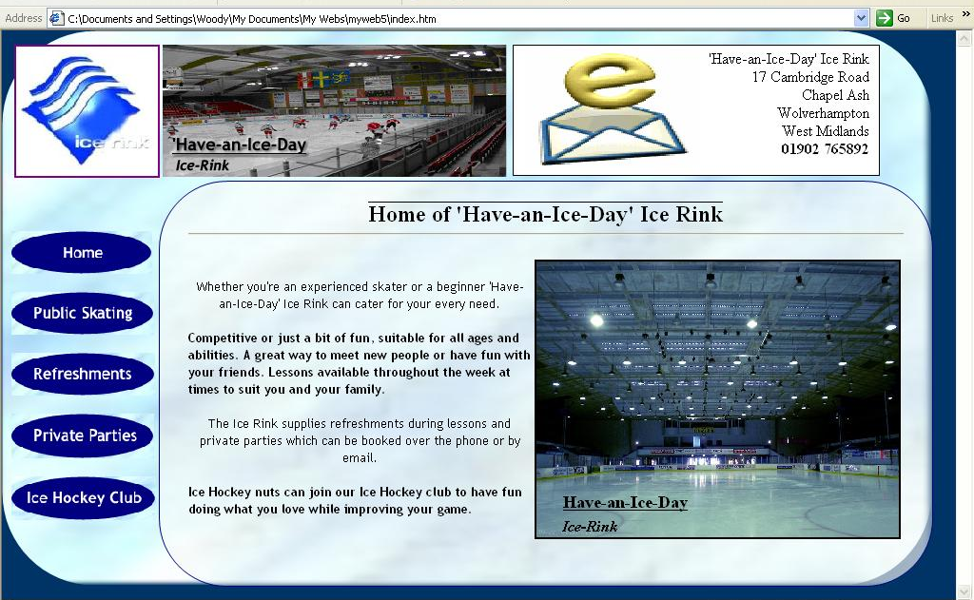
Used consistent blue colour scheme but utilised different intensities and shades to increase contrast between items on the page.
Used consistent font scheme but kept font colour black to keep the site colour-blind-‘friendly’; black is the best colour for text as it stand out.
I used bold font style on every other paragraph to make the text stand out and seem easier to read.
Many small paragraphs are easier to read than one large body of text.
Times New Roman, 12pt.
Image introduces user to the ice rink. It is large because I wanted it to stand out and catch the user’s attention.
Image file: icerink pic.jpg
I produced these buttons in Fireworks MS, I created a ‘hover over’ alternate image for each button. Then I used Dynamic HTML effects to image swap each button with its corresponding ‘hover over’ button when the user hovers the cursor over the button.
Heading 1 style – Times New Roman, 18pt, centre aligned, bold. I wanted this to stand out from other items on the page as it is the page title.
Horizontal line used to separate heading from rest of page.
Logo used to represent the ice rink.
Banner Ad Manager used to switch between several images related to the ice rink; attractive and professional, used on many advertisements and official websites.
2 Text boxes act as ‘frames’ to hold all the items of the page. Outer text box holds all the ‘consistent’ items and inner text box holds each page’s new information.
Text box contains animated gif of an envelope with a spinning E above it. Catches the users attention, visual aid; once clicked a new email to the ice rink is automatically composed.
Address of ice rink in black font on top of the black fill of the text box. Black on white stands out. Phone number is bold style to stand out.
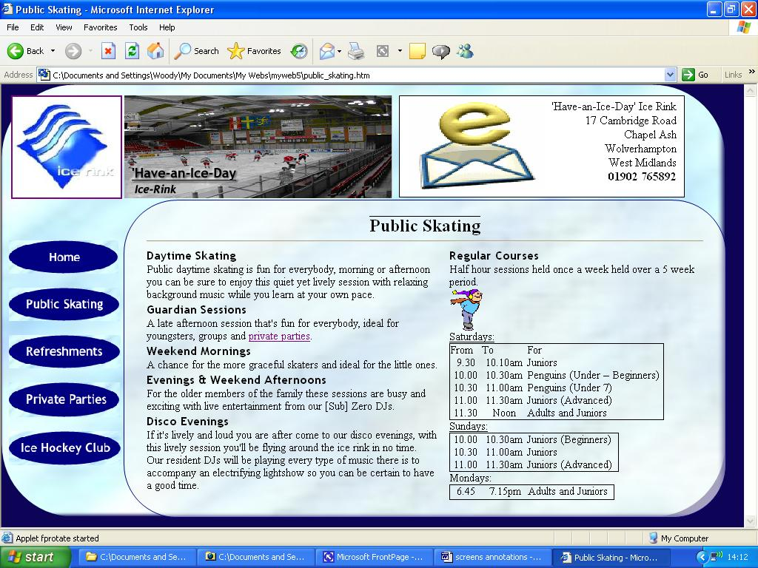
Public_Skating.htm, Public Skating page
Paragraph headings are written in:
Heading 2 – Trebuchet MS, 12pt, bold.
This makes them stand out above the body text.
Whenever I mentioned a page on my site I added a hyperlink to the corresponding page for ease of use and reference purposes.
All body text written in Times New Roman, 11pt. I thought it was important to have a scheme of at least 2 different fonts in my website to add variation and make reading more enjoyable. Again I used black text as black more than any other colour improves your visual perception between different items of a page.
I used a table to separate the body of text on the page into 2 parts. The table does not have a fill and does not have a border so it is invisible. This makes the page more organised.
I used tables to display the training session timetable. The table keeps the information organised and improves its legibility.
The tables’ borders are round the perimeter and not across each row and columns to keep the small text as visible as possible.
After the body text was added there wasn’t much room for images. However I thought it was important to have at least one image on the page to make reading all of the text more enjoyable. I added this little animated gif of a man skating because it is small, relevant to the subject and attractive.

Refreshments.htm, Refreshments & Bar Facilities Page
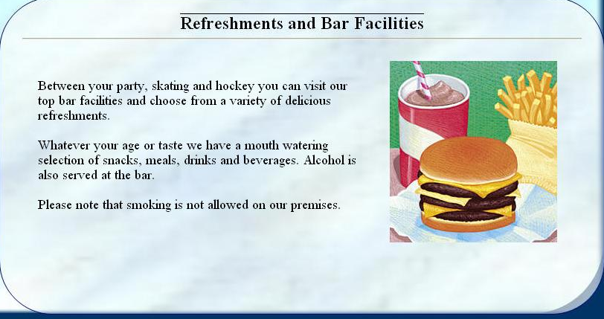
As this was an ‘advertising’ page I thought it would be relevant to advertise the refreshments available in a Banner Ad Manager. This web component flicks through the images you assign to it like a slide show. Banner Ads can be found on many websites on the internet because they are a professional and attractive way to display many images with just a small area of a page.
Due to the smaller amount of body text on this page I thought it was a good opportunity to increase the font size. Although the font size will now not be consistent with the rest of the website it doesn’t matter because many websites, advertisements and other media often use increased font sizes or different fonts for text they want to emphasise, especially the body text of an advertisement.
Private_Parties.htm, Private Parties Page
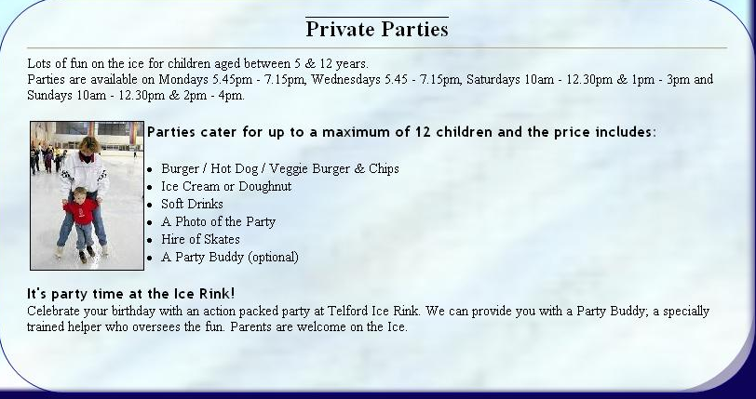
The first three pages of my website were quite busy so I wanted this page to be more of a light read yet remain informative.
To achieve this I reverted back to the Times New Roman 11pt body text and once again used Trebuchet MS 12pt bold for paragraph headings.
Now the font theme is restored and
Bullet points look organised and keep big lists in a neat layout.
Image of a party buddy used as a visual aid as to the subject of the page. It also breaks up the text and makes it easier to read.
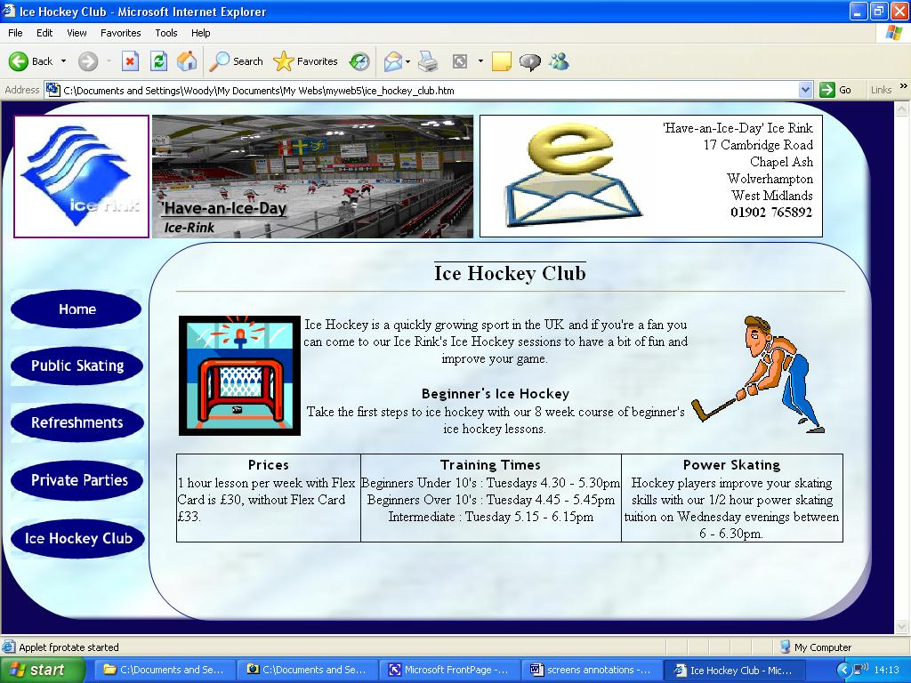
Ice_Hockey_Club.htm, Ice Hockey Club Page
Animated gif of ice hockey puck being hit into the net is attractive and relates to the page so it works as a visual aid too.
Animated gif of ice hockey player skating is attractive and relates to the page so it works as a visual aid too; together with the animated gif of the ice hockey net they improve the overall graphical design of the page.
The table is used to separate the 3 paragraphs of information and make them stand out. The table improves the information’s legibility.

