Navigation Chart

This chart shows the navigation within my website; the links between each page and the home page.
The home page links to the 4 children pages and each of those pages links back to the home page and to each other.
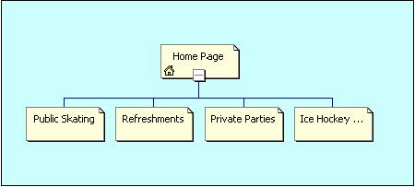
A simple main menu is used to keep the same navigation menu on every page.

