Search 1 - Search Engine used: www.Google.co.uk

Search Criteria and Syntax: +headrest +dvd -eBay –kelkoo
Website found: http://www.gapsecurity.co.uk/catalog/index.php?cPath=34

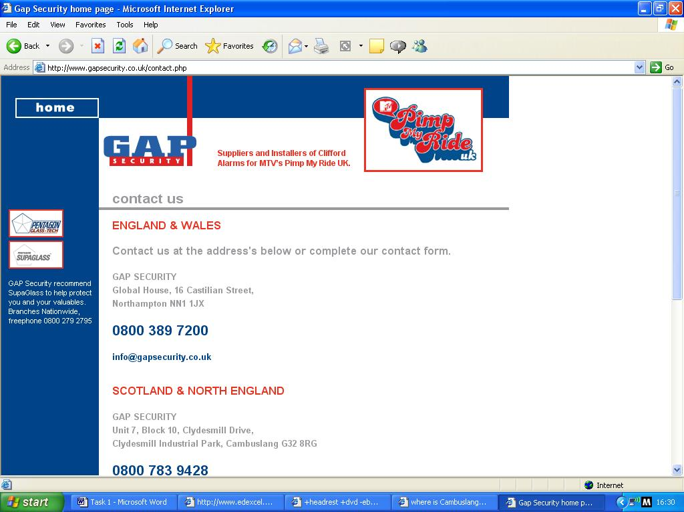
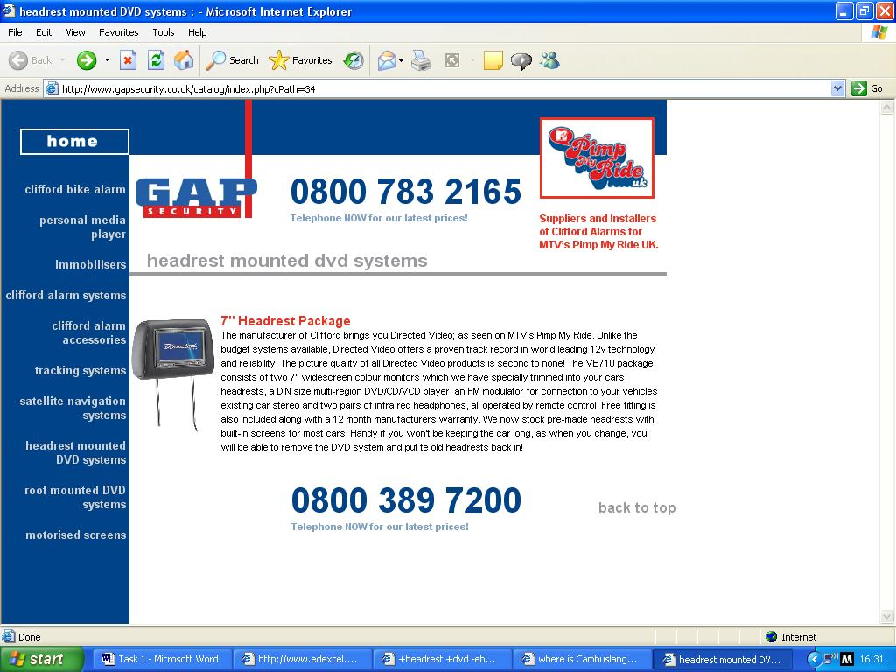
Search 2 – Search Engine used: www.ask.com.uk
Search Criteria and Syntax: manufacturers DVD headrest -china -Asia –Taiwan
Website found: http://www.sonicelectronix.com/item_4379.html
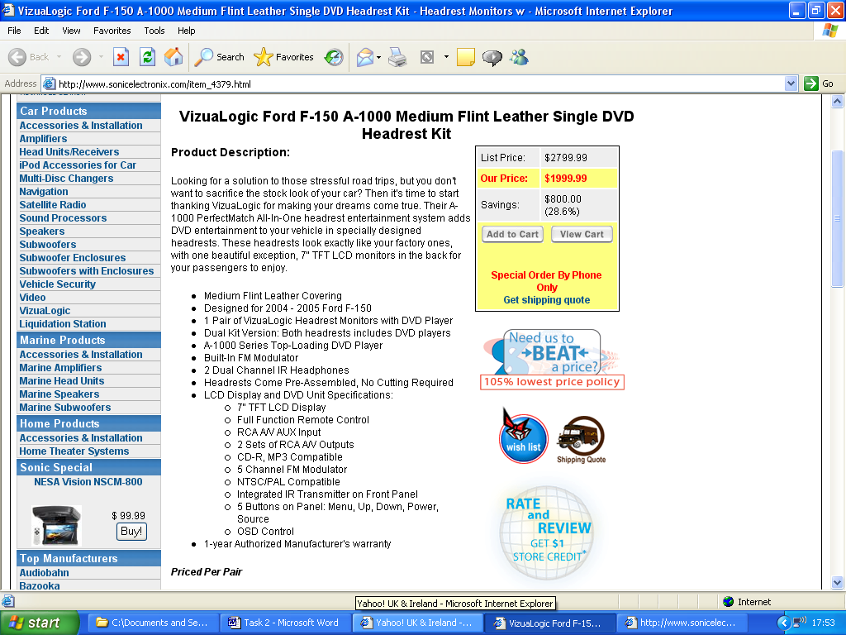
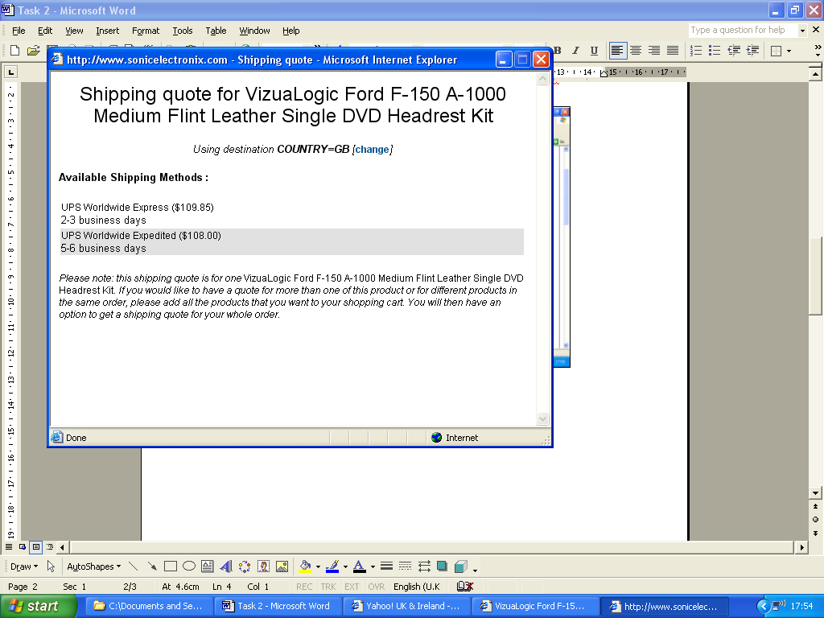
Search 2 – Search Engine used: www.yahoo.co.uk
Search Criteria and Syntax: Portable DVD Player monitor +Sony "visual entertainment"
Website found: http://www.sony.co.uk/view/ShowProduct.action?product=MV-700HR&productsku=MV700HRB.EUR&site=odw_en_GB&pageType=Features&category=ICM+Visual+Entertainment

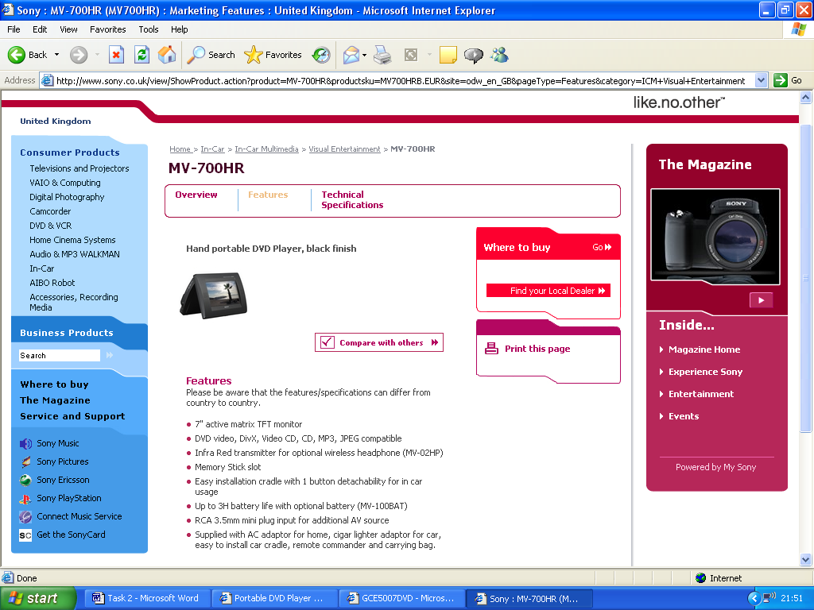
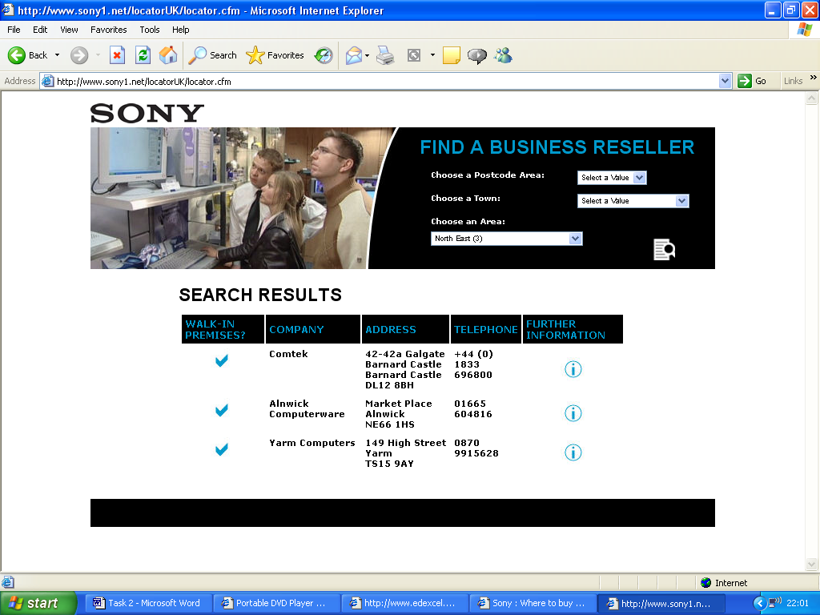
Search 2 – Search Engine used:
Search Criteria and Syntax: In-Car DVD Player “full mounting"
Website found: http://search.lycos.co.uk/searchFrame/searchframe.html?url=http%3A%2F%2Fwww.goodmansdigital.co.uk%2FIn_Car_Vision%2FGCE5007DVD.htm&query=In-Car%2BDvd%2BPlayer%2B%2522full%2Bmounting%2522&SITE=uk&cat=loc&qstr=query%3DIn-Car%2BDvd%2BPlayer%2B%2522full%2Bmounting%2522%26cat%3Dloc%26enc%3Dutf-8
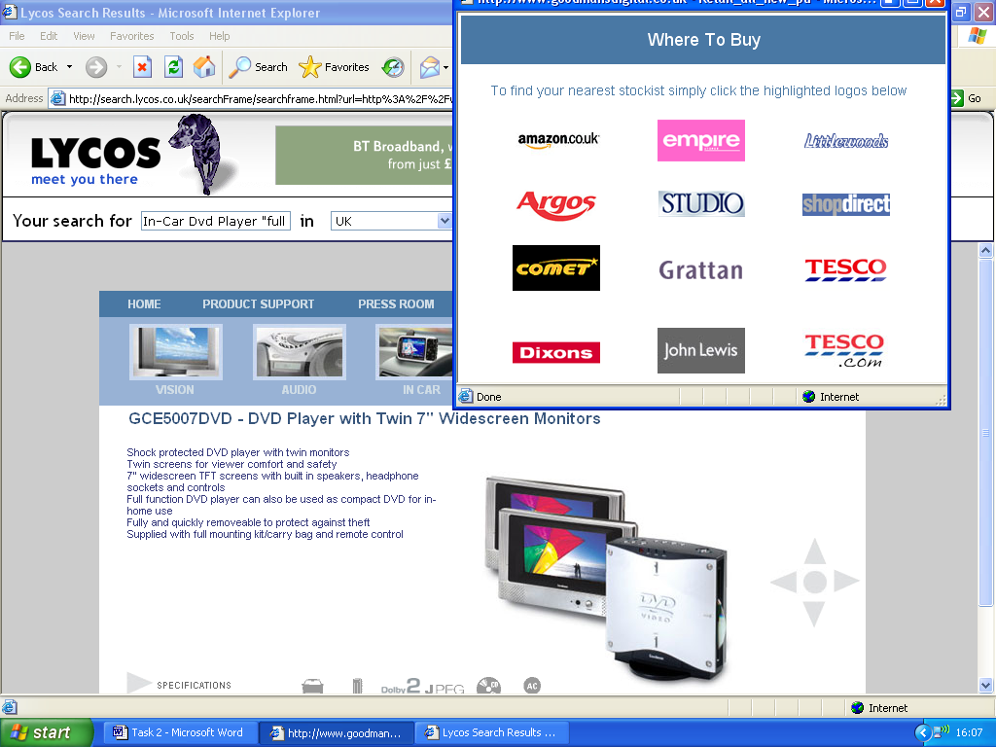

Domain Name: www.klagarages.co.uk
Obtained from: www.Cheapdomainnames.co.uk
Cost for purchase for 2 years: £5.48
Free with hosting

A domain name is needed because it increases the recognition of your business and gives it a more professional impression. Also, with a domain name you don’t have to change your website’s address if you change your internet service provider.
With a domain name you can assign keywords to link to your site when those keywords are searched on search engines.
Domain Names also make people more feel comfortable using your site as it gives the company integrity and credibility.

