User Guide

Contents
User Guide 1
Contents 1
1. Introduction 2
2. Opening the Spreadsheet System 3
3. Introduction Sheet 4
4. Navigation between sheets 5
5. Other Buttons 5
6. Product Details Sheet 6
7. Order Form 7
8. Customer Details 8
9. Stock 8
10. Stock Graphs 9
11. Invoice 10
12. Saving and Exiting 10

1. Introduction

The Sports Catalogue Group is a small sized company that sells footballs. The company supplies a variety of different types of footballs, with a range of different colours and sizes. They also sell a range of footballs for different surfaces.
This spreadsheet has been produced to hold all of the information and to add new data. Orders can be placed in the spreadsheet using Excel functions and formulae and all the calculations are completed and checked accurately automatically by the system itself. The spreadsheet can record products, customer details, generate graphs based on orders and be used to produce order forms or an invoice. The spreadsheet will make managing the company a lot easier and a lot less time consuming. The new system also enables the users to make backup copies of the document just in case the document gets damaged or destroyed.

This user guide will demonstrate how all these functions and tasks can be completed quickly and easily in the spreadsheet.

2. Opening the Spreadsheet System

To open the system, turn on the computer, if you have multiple users on your computer or if you are in a network of computers, you will be required to log in to your user’s name. Once the computer has loaded you will see the ‘Sports Catalogue Group’ icon on your desktop as seen below:


Using the left mouse button double click the icon and wait for it to load up. If you have enabled macro security you may be presented with the following window:
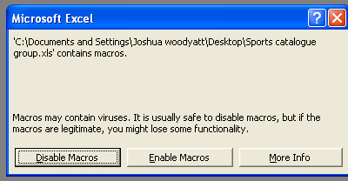

For the spreadsheet to function you must click ‘Enable Macros’.
The system will now load and you will be directed to the introduction page.

3. Introduction Sheet

The introduction sheet is principally the main menu of the system, as well as giving a brief description of the company and how to contact us it contains a link to every page. The date is also displayed in the top left-hand corner. To navigate from the introduction sheet to the other sheets simply click on your required link in the menu on the right.
The introduction page is shown below:
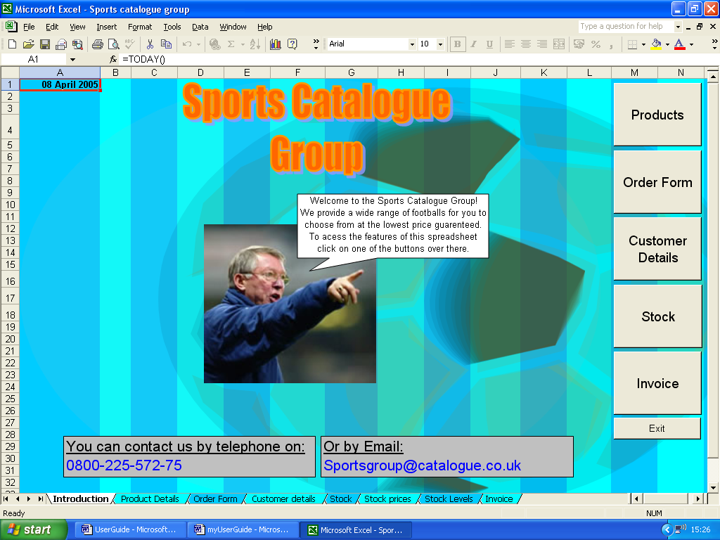
Click one of these links to move to the corresponding sheet.

The next page explains moving between sheets in a bit more detail.

4. Navigation between sheets

There are buttons on every sheet that link to every page in the system. Alternatively, you can use the ‘tabs’ at the bottom of the sheet however the buttons are easier to use. To use one of the buttons just left click on the button that is labelled corresponding to your required page and you will be immediately directed to the new sheet.

5. Other Buttons

There are also buttons on some sheets that carry out other functions other than linking to pages. They are listed below with a brief description of where they can be found and what they do:
- Exit –
Found on the Introduction page only. This button saves and exits the workbook automatically.
- Clear -
Found on the product details page only. This button clears certain cells in the system that has been modified; this is explained more later on in the user guide.
- Confirm -
Found on the product details page only. This button sorts the data on the order Form in alphabetical order that can be found in the order form table. This is explained more later on in the user guide.
- Stock Level Graph -
Found on the stock page only. This is just a link to the corresponding graph but can only be found on the stock page.
- Stock Prices Graph -
Found on the stock page only. This is just a link to the corresponding graph but can only be found on the stock page.
- Print Invoice -
Found on the invoice page only. This prints off the invoice automatically.
- Print Stock Levels –
Found on the Stock levels graph sheet only. This prints off the corresponding graph.
- Print Stock Prices -
Found on the Stock prices graph sheet only. This prints off the corresponding graph.

6. Product Details Sheet

This sheet contains all of the information about the available products. This is the main page that the user will use. The product details sheet is shown below:
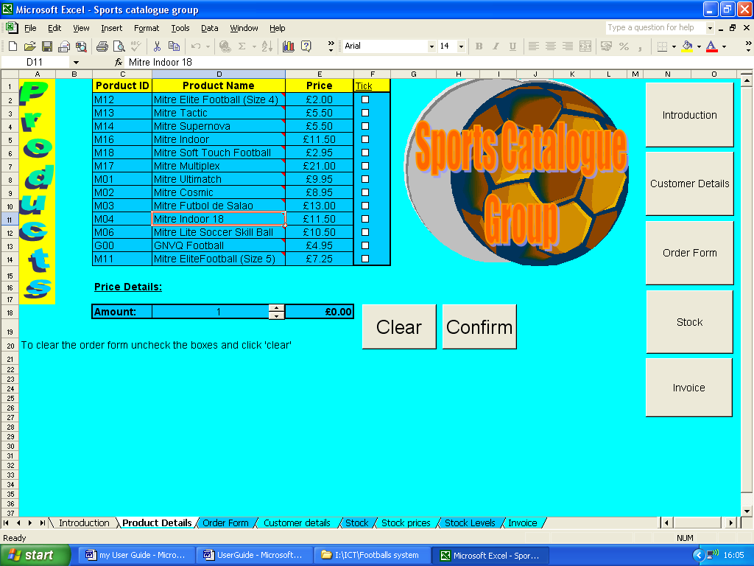
This is the page where you choose the products to purchase. To do this select your required items by ticking the tick boxes in the corresponding column that can be seen in the table.

Please do not click on the same tick box twice and if you wish to change your choices you must un-tick the marked tick boxes and click the large clear button and start over.

When you click one of the tick boxes you should notice some information has been copied into the ‘price details’ below the table. That is there to check the price of a single product depending on the quantity you chose using the spinner. For example, I selected the Mitre Tactic ball as shown below:
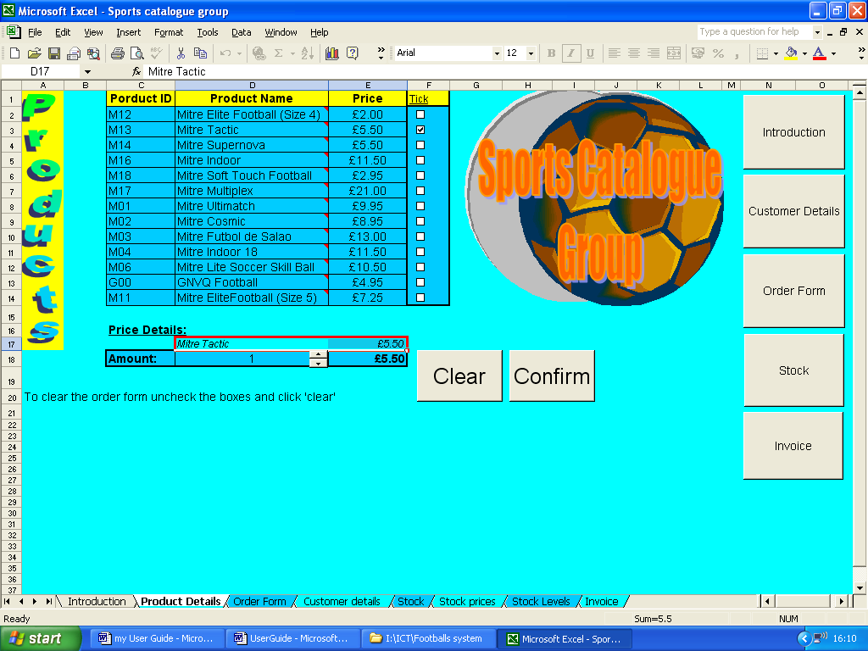

The appropriate information is then copied into the price details as shown below:
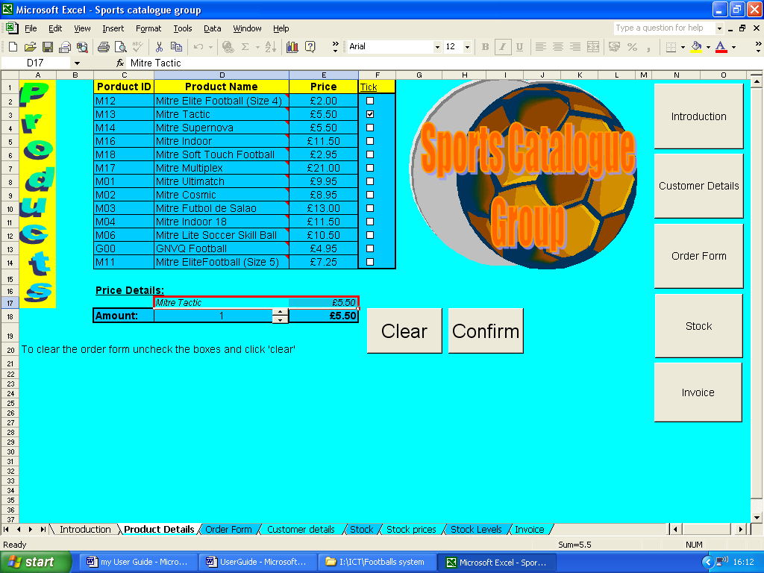

This is a spinner; use it to change the number (the quantity of the chosen product) which is initially 1. This then automatically calculates the cost for that quantity for the chosen football.

When you are happy with your choices click the large confirm button to go to the order form to go to the next step to processing the order.

7. Order Form

The order form is used by the system to produce the invoice which will be explained later on. The only task the user has in this sheet is to customize the ‘quantity’ of each product to the required amount and choose a user ID from the drop-down list. The Order Form is shown below:
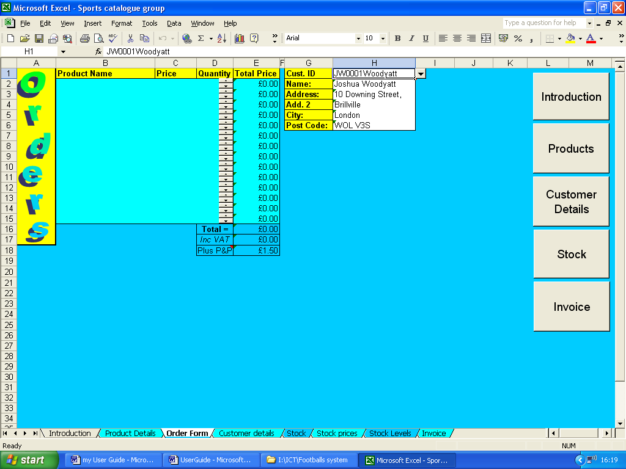
Spinners once more. Use these in the appropriate cell where the product is shown in the same row. Press up to increase quantity by 1 and down to decrease quantity by 1.
Here the details for the customer are shown. To change the customer, click on the cell where the user ID is displayed and a small drop-down list icon will appear to the right. Simply left click on that and choose the customer ID accordingly.

Once you have completed choosing the quantities and the appropriate customer ID you can click on the stock button to view stock levels and prices or Invoice to proceed with the order process.

8. Customer Details

It is not necessary for the user to modify this page in any way as it is there in order for the System to automatically carry out certain functions, however if you wish to change the customer details it is possible.
To do this just simply type the appropriate information in the required fields.

9. Stock
This sheet contains all of the relevant stock information such as prices and stock levels. This again does not require any modification by the user or customer. The stock page is shown below:
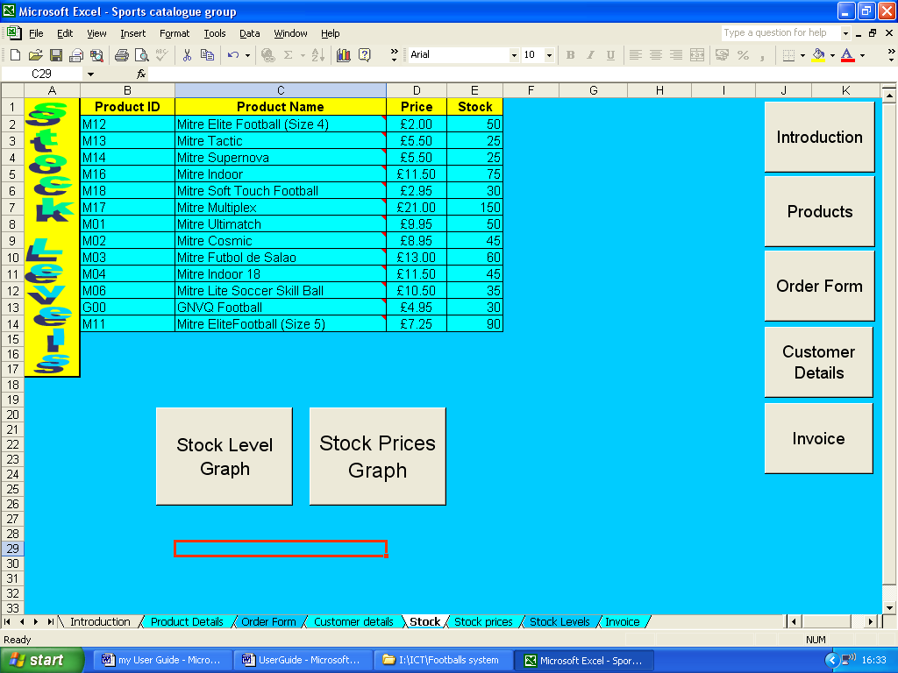
If you would prefer to see the information in a graph, click the corresponding button below the table.

Left click once one of the large buttons depending on the graph you want to see.

10. Stock Graphs
There are two stock sheets that display graphs based on stock information:
- Stock Level Graph
- Stock Prices Graph
Again, no modification by the user or customer is needed.
These pages are quite different to the other sheets in that they only have two buttons as shown in the image below:
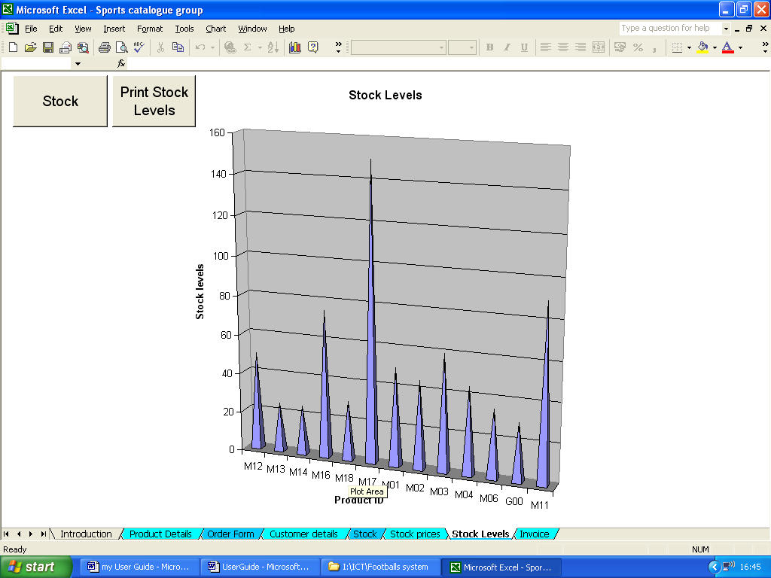
The stock button returns you to the stock page. This can be done by clicking it once with the left mouse button.
This button prints off the graph. There is a print button on each of the graph sheets. Click the button once to print off a single copy of the graph.

11. Invoice

The invoice sheet displays all of the finalized information. Once again, this page requires no manual input. The invoice calculates the prices and total costs automatically.
Post and Packaging is only added if the total cost of the orders is equal or less than £50.
The Invoice page is shown below:
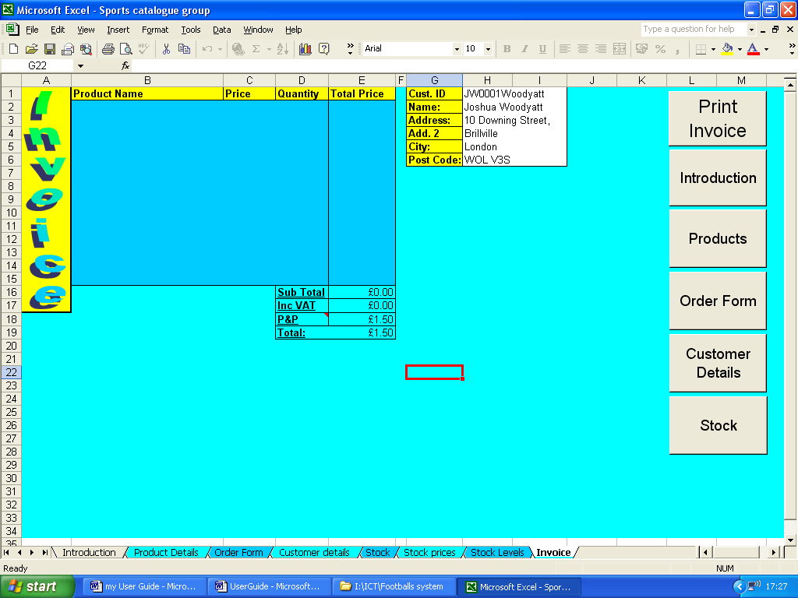
You can print the invoice by clicking the ‘print invoice’ button once with the left mouse button.

A single copy of the invoice will be printed.

12. Saving and Exiting

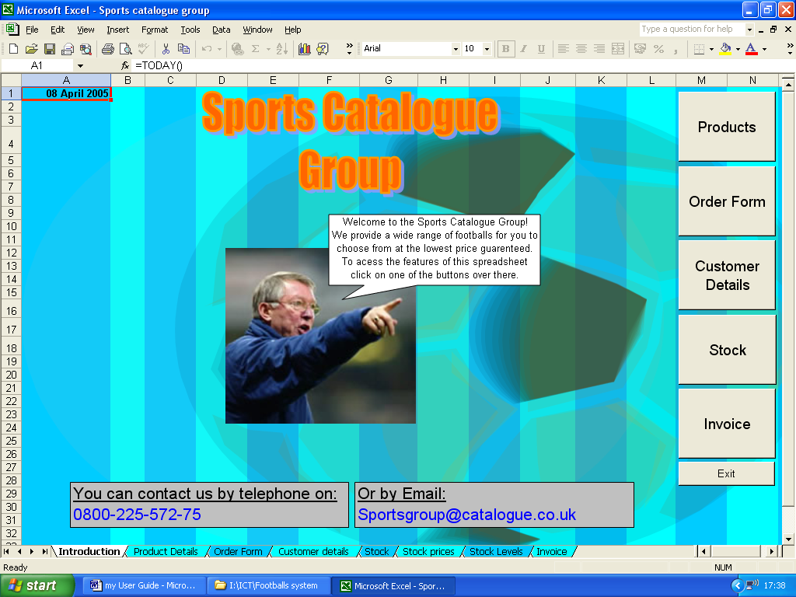
When you are happy with your choices and changes to the system you will want to exit the system. The only way to exit the system is through the introduction page. To exit click on the link to the introduction sheet, when the sheet is opened click on the Exit button in the bottom right.

