User Guide Contents

- Introduction
- Opening the system
- How to use the Introduction Sheet
- Moving between sheets
- How to use the Product Details and Customer Details Sheet.
- How to use the order form
- How to print and use the invoice
- How to view price of balls and number of balls in stock graphs
- How to exit the program

1. Introduction

The Sports Catalogue Group is a small but expanding company that sells different types of balls to the public. The Company currently use a paper-based system to run the business and take orders, but due to the popularity of the business increasing, a spreadsheet system has been created to allow them to keep up with the growing customer interest.

The system has been created to allow the user to take orders, store product and customer details, produce invoices and view stock levels and Price of Products in the format of a graph.

The users are required to know how to take orders using the spreadsheet and how to create invoices, know how to print off the graphs and invoice which is included in the spreadsheet.

This user guide will explain how to perform all the required tasks above in a simple and effective manner.

2. Opening the system

Turn the computer on and wait for it to log on. Once the computer has loaded a shortcut icon will appear on the desktop that is named
‘Shortcut to Sports Catalogue Group’. Like the one below.
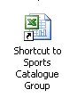

Double click the icon with the left mouse button, this opens the document.
As the document is loading a window appears like the one below.
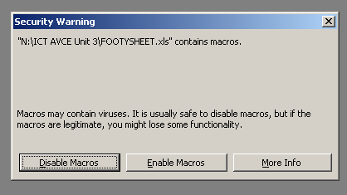

Click on the enable macros button.
The system will then carry-on loading and will eventually appear ready for use.

3. How to use the Introduction Sheet

The introduction sheet is very much like a Main Menu. It is used in this spreadsheet as a navigation sheet. It allows you to move to all the sheets in the spreadsheet by simply clicking the buttons. Below is the introduction sheet.

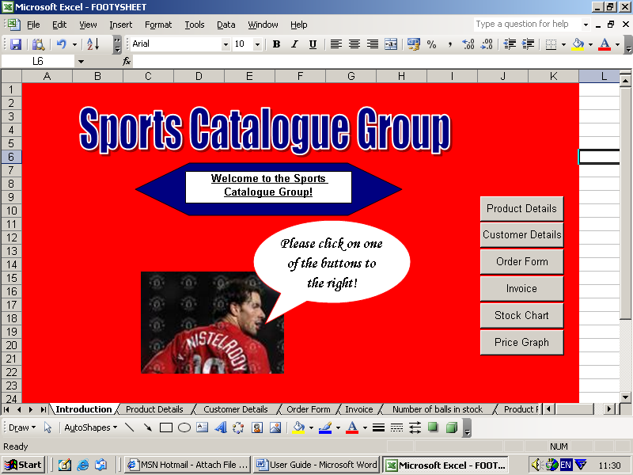

These are the buttons that are clicked to move to each corresponding sheet.

This explained more in the next section: 4. Moving between Sheets

4. Moving Between Sheets

There are buttons on every sheet in the spreadsheet especially designed to make moving to other sheets in the spreadsheet easy. The buttons are labelled with the name of the sheet they will take the user to if they are clicked.
Below is an example of this. This is the introduction sheet.
This takes you to the Product Details sheet when clicked.

This takes you to the customer details sheet when clicked.
This takes you to the Order Form when clicked.
This takes you to the invoice sheet when clicked.
This takes you to the Number of Balls in Stock sheet when clicked.
This takes you to the Product Prices Graph when clicked.
All of the other sheets in the spreadsheet have exactly the same buttons (although not in exactly the same position) so, for example when you are on the Customer Details sheet you can go back to the Introduction sheet simply by clicking the introduction button.

5. How to use the Product Details and Customer Details Sheet

The Product Details and Customer Details sheets are not for user use. The Product Details sheet can be used as reference for the user as to how much products cost, how many there are in stock and to check Product ID’s. The Customer Details Sheet can be used as a reference for the user as to the details of each customer. However, no data needs to be inputted. Because the user doesn’t need to type anything the sheets are data protected. Therefore, the values in each cell cannot be changed, if this attempted an error like the one below will appear.
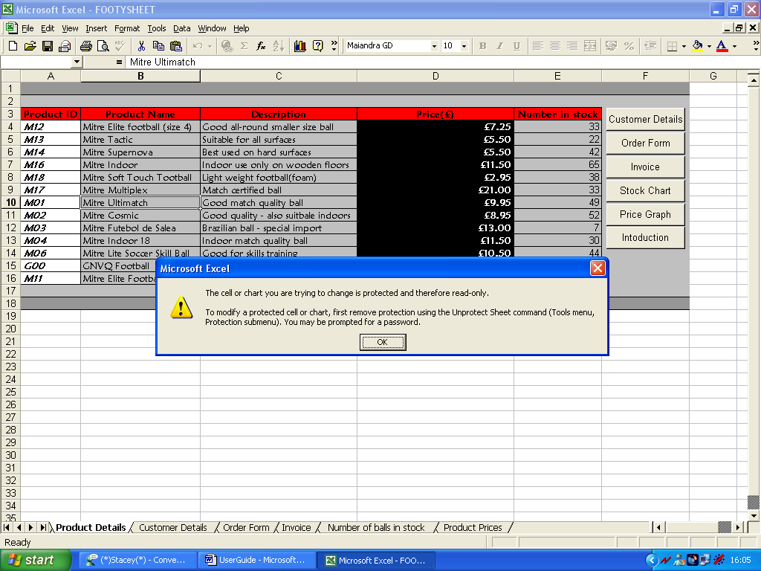
Doesn’t allow the user to change the value in each cell
The user can scroll up and down the sheet simply by click the arrows on the scroll at the side of the sheet. The box in the screenshot below highlights the scroll bar.
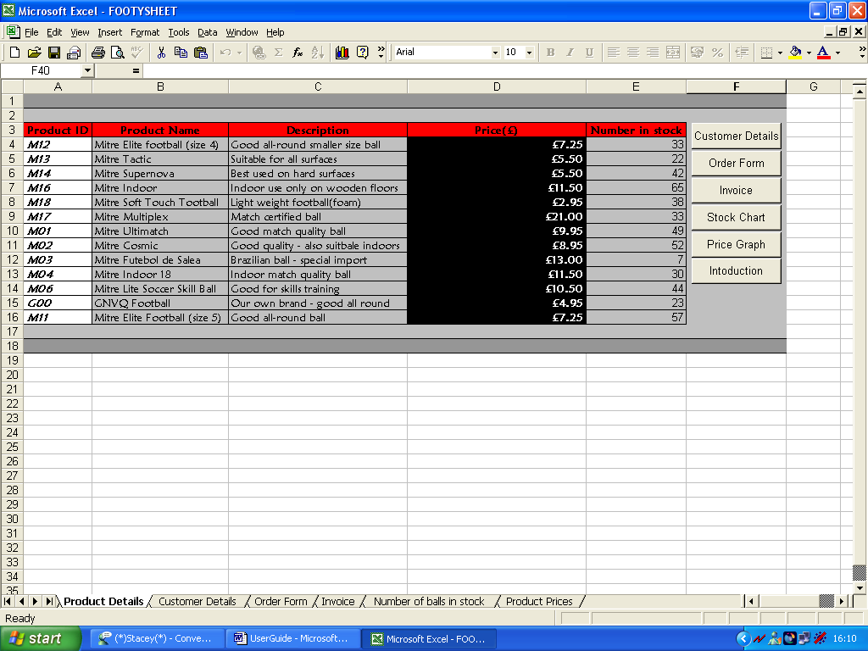
Scroll Up
Scroll Down
These buttons are clicked so they user can get to other sheets in the spreadsheet.
The user can also get to other sheets by clicking the appropriate button. These are highlighted above.
6. How to use the Order Form

The Order Form is for user use. For the user to place an order this form needs to be used. Only a certain amount of data can be inputted. For an order to be placed the invoice sheet has to be used as well, you can find out about this in the next section of this guide.
The only data that is inputted into the order form sheet is the quantity of the products the customer is buying. The Order form shows the total price the customer would have to pay depending on what has been ordered, the individual prices of each product, the name of the product and description of product. These are displayed purely for user reference.
The order form is easy to use, mainly because the user can only change the cells in F4 to F16.
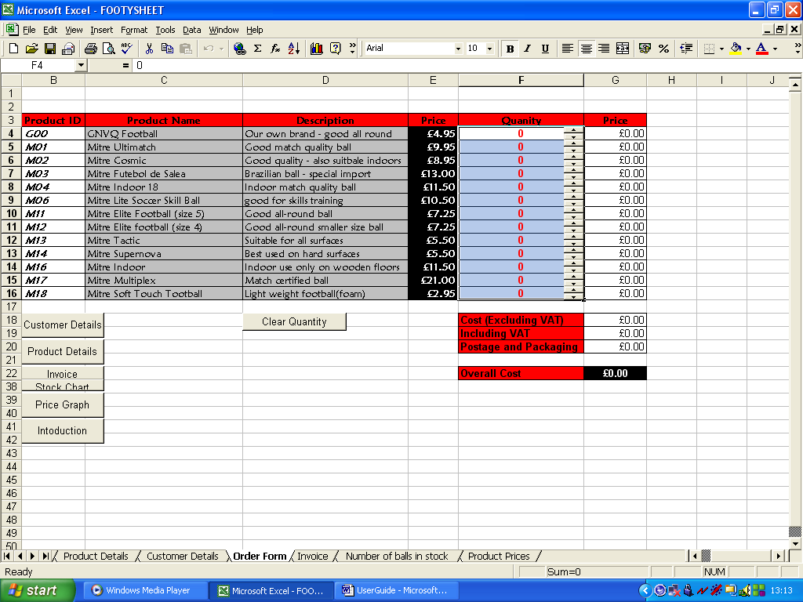

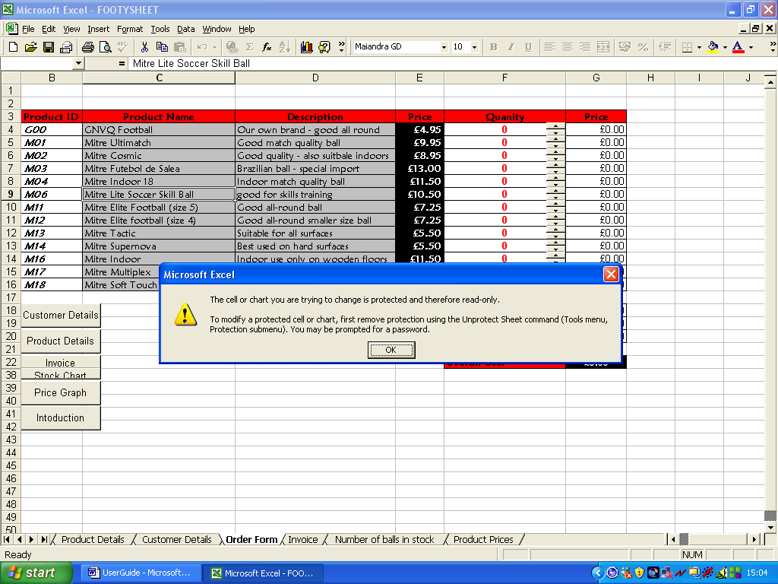
This is because all the other cells on the sheet are cell protected. Therefore, the values in cells other than F4:F16 cannot be changed, if this attempted an error like the one below will appear.

Doesn’t allow the user to change the value in each cell

To change the quantity of each product so that an order can be placed use the up and down arrows shown below.
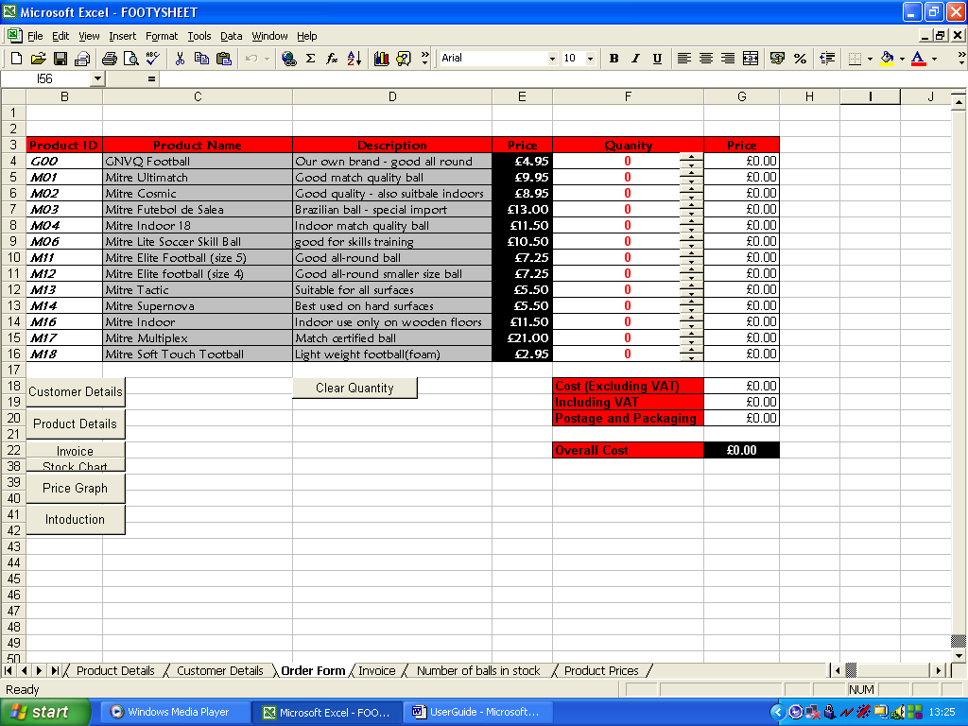

Arrows

Clear quantity

These will change the values in the cell they are in. If a customer wants 4 GNVQ footballs, you simply Press the up arrow by the corresponding cell 4 times. Every time you click the arrows the value will be changed by 1. You can change the quantities of more than 1 product. If you want to reset all of the values in the quantity column, click the button labelled clear quantity and all values will be reset to 0.
However only certain things can be inserted into the quantity column. This is because the cells are validated. Only certain values are allowed. To stop people ordering to many balls only numbers between 0 and 50 can be added into these cells (F4:F16). If invalid data is entered the error alert below will appear. This means that value is not allowed and must be changed.
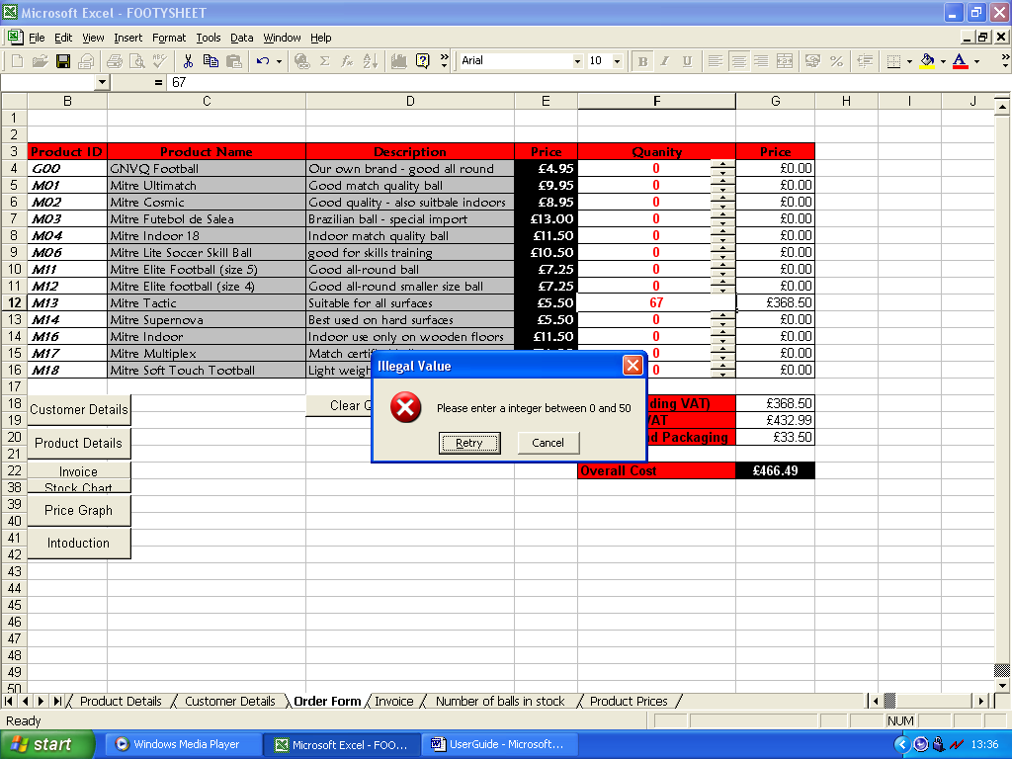

Once you have entered all the desired quantities for each ball click the Invoice button to complete the second step of submitting an order.

7. How to Print and use the Invoice

The invoice is also for user use. However, it is only of use to the user once all the necessary data on the order form has been inputted (see previous section of this guide for help). Data has to be inserted on the Order Form sheet so that the correct information will appear on the invoice sheet.
The Invoice is extremely easy to use. Only 1 click of the mouse is needed to enter the necessary data that is why the entire sheet is cell protected, except for cell B4. If the user tries to change any of the values in these cells an error like the once below will appear.

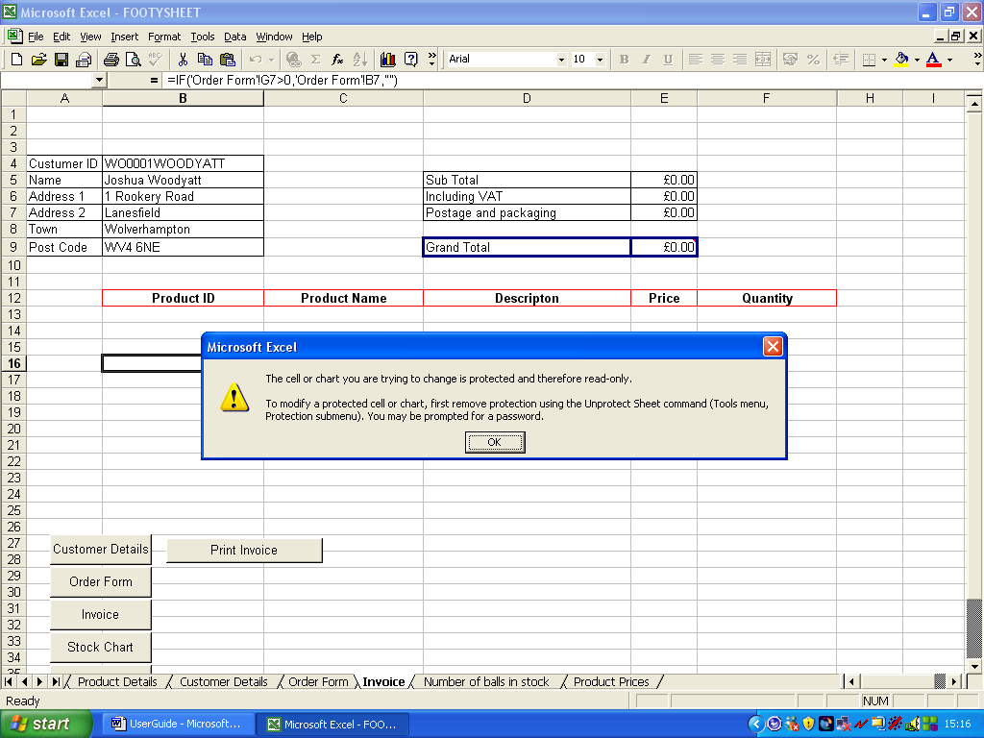

Doesn’t allow the user to change the value in each cell

Cell B4 is where the user has to input data. To do this click on cell B4 and a little comment box will appear like show below. This comment box gives the user instruction of what to do. It tells the user to select the desired customer id. This is done by clicking the arrow in cell B4. (Highlighted below)
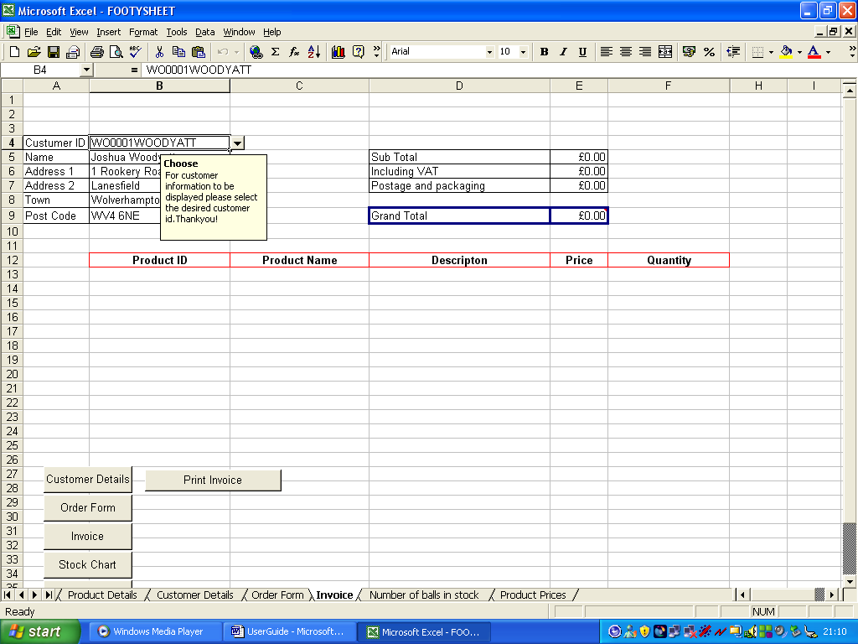

This arrow is clicked

A list of customers ids then appears. The user has to then select one by left clicking on the appropriate one.
An order has then been completed. The invoice displays are the necessary data needed for an order. To print out the invoice simply click the Print Invoice button.

8. How to view price of balls and number of balls in stock graphs

The ‘Price of Balls’ and ‘Number of balls in stock’ graphs are not for user use. However, the user can view them and print them to use as reference.
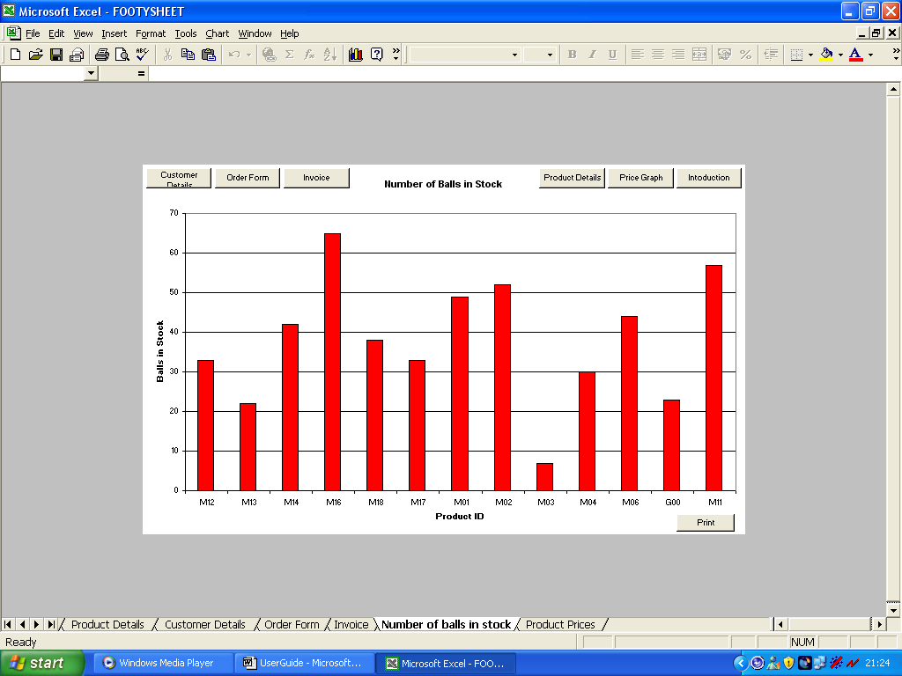
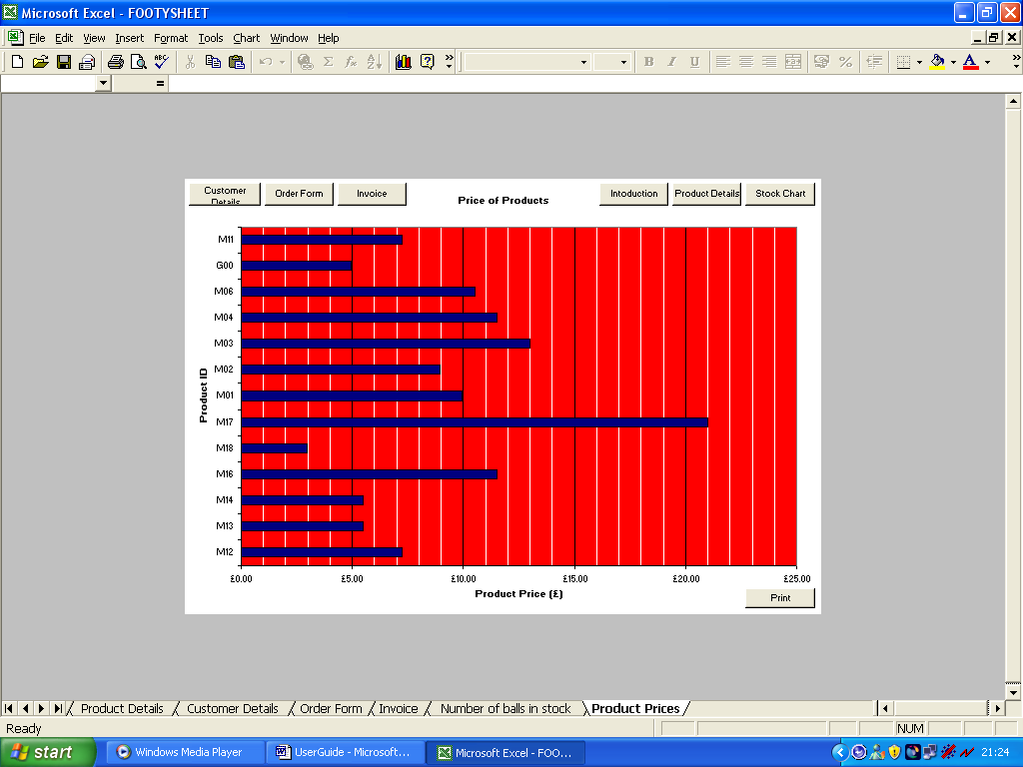
To view the graphs simply click either the ‘Stock Chart’ or ‘Price graph’ buttons on any sheet in the spreadsheet. These will take the user to the corresponding graphs. (Shown below).

Print button

To print the graphs simply click the Print button. (Shown the screenshots above).
Due to the graphs being for user reference both of the sheets are protected, therefore the user cannot change the graphs. If this is attempted the error shown below with appear.
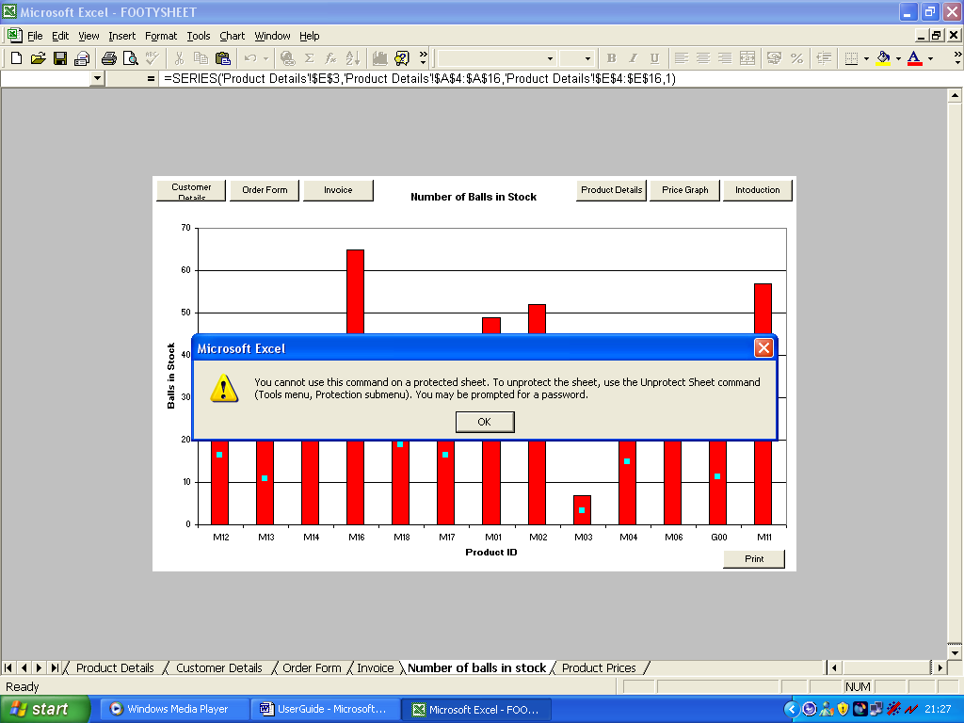

9. How to exit the Program

Once the user has finished taking orders, the program needs to be closed.
To exit the program simple, click the X at the top right corner of the window. (Shown below). A window may appear asking the user if the changed that have been made are wished to be saved. Click no. The program is then closed.
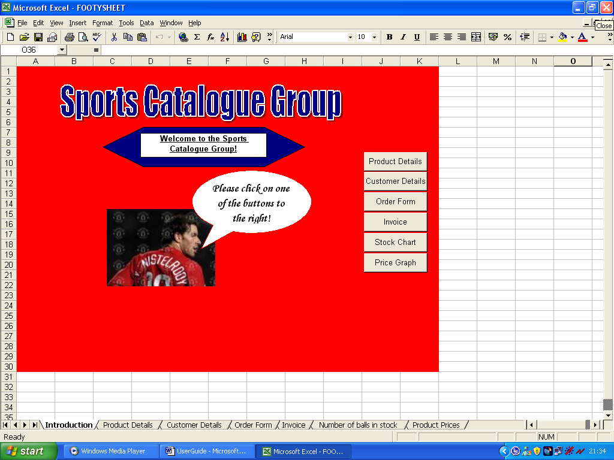

Click this to exit program

