|  |  |  |
| --- | --- | --- |
| Checkpoint IV | Checkpoint IV: First Prototype | |
| Group: | G02 |
| Date: | 2020/11/25 |
|  |  |

# Layout

The interface is composed by the “Deaths/Kills” button and the filter menu on top, to allow to select the information that will be visualized. This will aggregate the deaths or kills by season, books, character, house, killing method, gender, nobility or animals.

The visualization is divided in 5 idioms, those being the heatmap and bar chart on the left, the treemap and the map in the center, and the chord diagram on the right.

# 

# Visual Encoding

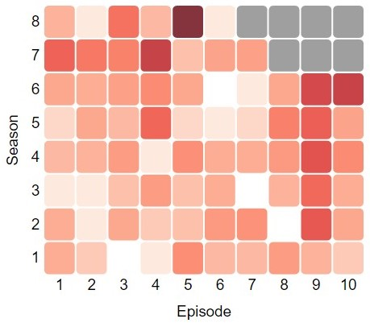Currently implemented, there is the **heatmap** where the x-axis corresponds to the episodes and the y-axis to the seasons. **Hovering** eachsquare will show the number of deaths or kills for the episode. By **clicking** on one of the squares, the heatmap will only show the kills/deaths for that episode. When a **character** is **filtered**, the approximate book death season and episode will appear in a red border.

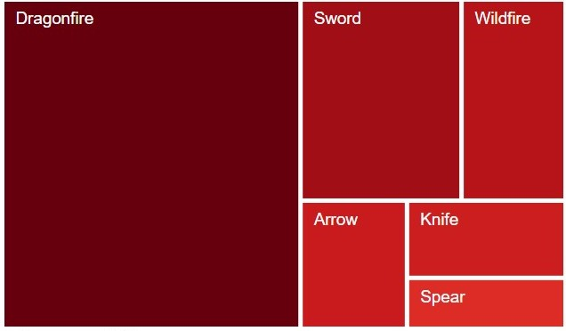The **treemap** represents the six most frequent killing methods for the applied filter where the size of each square corresponds to quantity of occurrences. **Clicking** on each square will only show the selected method. **Hovering** each square will show the number of deaths or kills for the method.

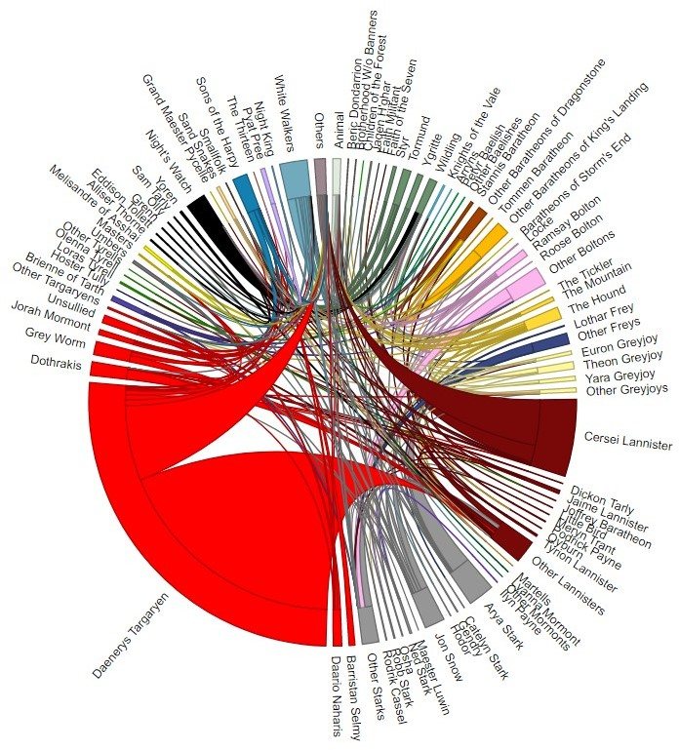In the **chord diagram**, each node represents the characters with the most kills, with the rest of them being aggregated by their house for legibility purposes. Each link connects the killer with the deceased. By **hovering** a **border** **or** a **name**, it will show the total percentage of kills of the character or group. **Hovering** a **border** will also fade the arcs of the remaining characters. **Hovering** an **arc** will show the percentage of kills between the two characters or groups represented by it, fading the remaining ones. **Clicking** on a **border** **or** a **name** will only show the arcs for that character or group, fading the remaining ones.

# Implementation of Linking Mechanism

By clicking on the **heatmap**, it will filter all idioms to show only the selected episode in all idioms.

By clicking on the **treemap**, it will filter all idioms to show only the selected killing method in all idioms.

By clicking on the **chord diagram**, it will filter all idioms to show only the selected house in all idioms.

Clicking on the selected option will remove that filter in all idioms.

The **bar chart** and **map** that we are going to implement will be also clickable, filtering all idioms to show only the selected book (in the case of the bar chart), and only the selected location (in the case of the map).

The **filter menu** contains the previously mentioned filters, and when one of them is active it will filter all idioms to only show the selected information. The **kills/deaths** button is used to choose whether kills or deaths are shown, in cases where there is a difference between them (a specific house’s kills is different from their deaths, but a season has the same amount of kills and deaths).