**TOWER**

**By Team 6 (the sole creators of the Worms series)**

Tihomir, Krasen & Ivan

This is a game about building a tower, or towering, or towering a building. WELL IN SHORT SKYSCRAPING? Maybe not so short…

Anyway, enough of this. We’re three unexperienced programmers who simply decided to have fun building towers.

What do you need to know?

* **AWESOME INTRO PAGE with old school “rendering” – a tower with our team name on it and a ASCII art. If you have the proper equipment IT EVEN PLAYS SOUNDS!!!1111!!!1 Cuz we are that ООСЪМ ~**  
  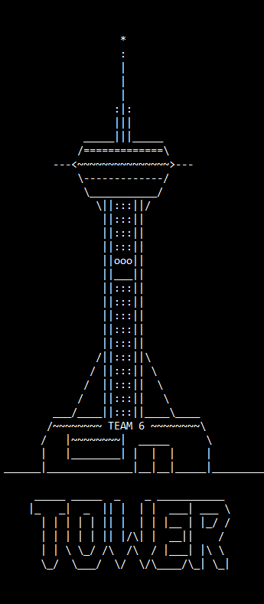
* **Three game modes –** 
  + **Swing** -> left to right, right to left and that’s it. Simple as that. The floor moves from one end of the UI to the end and returns back.
  + **Glitch** -> left to right to left to left to right to left to right to right to GLITCH AND WE ARE SORRY TO THE PEOPLE IN THE ROOM FOR THE THINGS WE SAID DURING DEBUGGING OF THIS MODE!!!1111! So yeah, this is the mode that the floor moves up and down, duh.
  + **Overfall** -> kind of like skyfall and overwatch, a mixture of both, basically this mode displays the moving floor above the main construction and then you can see it falling to the base. It’s only three modes, by they are ОТ СЪРЦЕ! And soon, when we get bought by Activision we will make even more modes, $1 each, cuz… MICROTRANZACTIONZ!

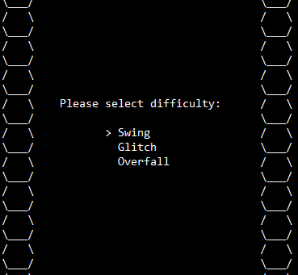

* **ALSO – again an awesome ASCII frame, which is again ООСЪМ! The integrated UI consists of the current score of the player, how many floors has he amassed, the current game type (difficulty). Also, a very nice hack is that the score is made of three different dictionaries, which are saved every time a new high score is set and are again displayed once you enter the game again, because, like we said, HACKS!**

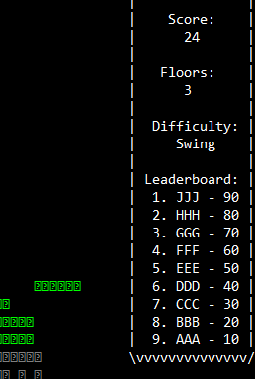

* **Depending on how many floors you reach the thread sleep WOOPS WE MEAN THE SPEED of the floor increases, so the higher you go building your tower, the faster it will be.**
* **Once you die (NOOB!) you are then redirected to the Game Over screen, which is again made old school with picking letters arcade old school – by pressing up, down and enter.**

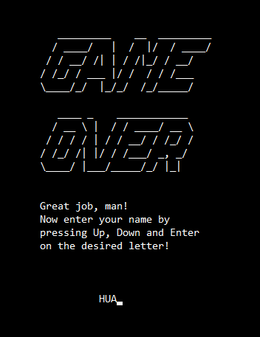

* **The player is then returned to selecting the game type mode and can start playing again, because that’s what we gamers do – we play! And we never stop being ООСЪМ, and we input crazy names like ЕЙЧ Ю АЙ as top scorers!**

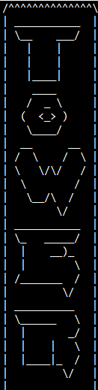

* **So, a bit about the code… it consists of classes files, lots of comments (because we’re that dumb and need to remind ourselves wtf is goin’ on), as well as for multiple GitHub pushes so everyone else know what’s going on.**

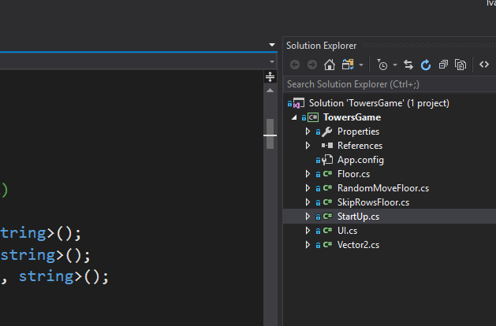

* **Class Floor -> consists of Swing mode!**
* **Class RandomMoveFloor -> for the glitchhChh mode!!**
* **Class SkipRowFloor -> for the OVERWATC… errrrm, we mean Overflow mode!**
* **Class StartUp -> for shutting down the game… nah, just kidding – this is the main class, lots of updates, whiles, for cycles and integers shmintegers!**
* **Class UI – for displaying how this awesome awesome AWESOME game looks!**
* **Class Vector2 – for diagonals, baby!**

**THAT’S ALL, FOLKS! WE HOPE YOU LIKED OUR GAME AS MUCH AS WE SUC… DID!**